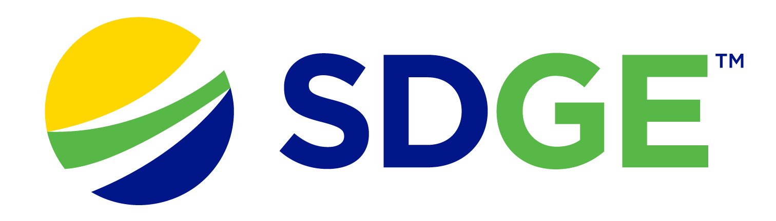

SDG&E® RESIDENTIAL AND SMALL BUSINESS CONTENT PACKAGE | JANUARY 2023
As a trusted community partner, we thank you for sharing our content and digital assets with your audiences – including residents, customers and employees – to help amplify our key messages in your email communications, websites or newsletters.
Best practices for using our content, social media posts and images
- IMAGES
Choose IMAGES that are relevant for your audience and feel free to mix and match what we provide. For alternate IMAGES, Unsplash.com and Canva.com offer free IMAGES that you can download.
- SDG&E logo
You’re welcome to mention our name but, due to legal requirements, please do not use our logo in any marketing materials that you create. Please only use the SDG&E logo if we provide it to you in this package or it’s publicly available online like a social post or video. You can also retweet our public posts which you’ll find on twitter.com/sdge.
- Videos
We have a library of videos you can share in your communications and SOCIAL POSTS when you visit youtube.com/c/SanDiegoGasElectric/videos. If you’d like to sort our videos by topic, visit youtube.com/c/SanDiegoGasElectric. Some videos are in Spanish. You’ll see some on TV, too!
Follow us
Find us on Facebook, Instagram, Twitter, YouTube and LinkedIn. When sharing our digital assets and content, feel free to tag SDG&E’s social media and direct your audience to sdge.com.

This month’s topics: Natural gas savings tips for residential and business customers, assistance programs, gas appliance checks, energy webinars
ARTICLE: TEN TIPS TO USE LESS NATURAL GAS AND SAVE ON YOUR ENERGY BILL
Reducing natural gas use at home may contribute to energy savings and it’s better for the environment. Check out these energy-saving tips to help you save on your bill during the cold weather.
- Block the chill: Caulk and weather-strip around drafty doors and windows. Use a door sweep, door sock or towel at the bottom of doors with a gap.
- Keep your furnace and air filters clean: Check furnace filters once a month and replace them regularly. A dirty air filter can increase your energy costs and cause problems with your equipment.
- Set your ceiling fan to run clockwise: This causes the fan to produce an updraft, forcing the hot air that rises to your ceiling down and into the rest of the room. In the summer, you can switch the fans to counterclockwise to keep the room cool.
- Schedule a no-cost gas appliances check with SDG&E: Book an appointment online at sdge.com/MyAccount or learn more at sdge.com/GasCheck.
- Lower your thermostat: Try lowering your thermostat a few degrees and throwing on a cozy sweater and socks or cuddling with your fur baby! You can also invest in a smart thermostat. Rebates are available at sdge.com/rebates.
- Lower your water heater thermostat: Lowering the thermostat on your water heater to 120°F, if possible, will save energy and avoid scalding. Find water heater rebates from $75 to $500 at sdge.com/rebates.
- Use the “energy saver” switch on your dishwasher: Set it on a low temperature setting when feasible. Also, think about turning off the heat drying cycle – you don’t need it! Only run full loads and turn the appliance off after the dishes are washed. And make sure to run it during off-peak hours before 4 p.m. or after 9 p.m.
- Keep your blinds and curtains open during the day and closed at night: During the day, let the sunlight and warmth in. When the sun goes down, close your blinds to keep the warm air in.
- Make sure your home is well-insulated: Without good home insulation, the hot air your natural gas heating system emits can escape through cracks, doors, windows, the attic and garage.
- Use water efficiently: Take shorter showers and wash clothes in cold water. Consider installing low-flow fixtures, insulating your hot water pipes and using a water heater timer.
Visit sdge.com/MyEnergy for more bill-saving and energy management resources.

SOCIAL POSTS: TEN TIPS TO USE LESS NATURAL GAS AND SAVE ON YOUR ENERGY BILL
Use any of the tips in the above article, then add:
Visit sdge.com/MyEnergy for additional winter energy-savings tips. #sdge #SDGEassist

IMAGES: TEN TIPS TO USE LESS NATURAL GAS AND SAVE ON YOUR ENERGY BILL

ARTICLE: NEED HELP WITH YOUR ENERGY BILL?

After the holidays can be a difficult time for many people financially. If you are having trouble paying your energy bill, you might be eligible for programs and services that can provide immediate financial assistance and help you avoid interruptions to your service. Flexible payment arrangements are also available to help you pay down past due balances. Learn more at sdge.com/Payment-Arrangements.
Check out these energy assistance programs:
- California Alternate Rates for Energy (CARE) Program: Save 30% or more every month on your bill. Find out if you qualify at sdge.com/CARE.
- Family Electric Rate Assistance (FERA) Program: If you don’t qualify for CARE and your household has 3 or more people, you may qualify for FERA. You could receive an 18% discount on your electric bill. Visit sdge.com/FERA to learn more.
- Energy Savings Assistance (ESA) Program: You may qualify to receive free energy-saving improvements for your home, like new appliances, lighting, insulation and more. Find details at sdge.com/ESA.
- Arrearage Management Plan (AMP): If you have outstanding bills and you are a CARE or FERA customer, you may be eligible for debt forgiveness. See if you qualify at sdge.com/AMP.
Even if you made a recent payment or set up a flexible payment plan with SDG&E, there may still be assistance programs available to help you. For a complete list of available offerings, visit sdge.com/assistance.

SOCIAL POSTS: NEED HELP WITH YOUR ENERGY BILL?
- If you’re behind on your energy bill, you may qualify for financial assistance. Learn more at sdge.com/assistance. #sdge #SDGEAssist
- Hardship is everywhere right now – the last thing you need to worry about is your energy bill. Get help with your bill at sdge.com/assistance. #sdge #SDGEAssist
- SDG&E provides assistance programs to help you with your monthly energy bill which can include up to a 30% discount. Find out if you qualify at sdge.com/assistance. #sdge #SDGEAssist
- Whether you rent or own, you could be eligible to receive no-cost, energy-efficient home improvements that can make your home more comfortable and help reduce your energy bill. Find out if you qualify at sdge.com/ESA. #sdge #SDGEAssist

ARTICLE (translated): ¿NECESITA AYUDA CON SU FACTURA DE ENERGÍA?
Usted puede calificar para un descuento en su factura o mejoras en el hogar. Hay programas de asistencia que pueden ayudar a reducir su factura mensual de energía mientras mantiene su hogar cómodo.
- Programa de Tarifas Alternativas de Energía de California (CARE, por sus siglas en inglés): Ahorre un 30% o más cada mes en su factura. Averigüe si califica en sdge.com/CAREesp.
- Tarifa Eléctrica Familiar (FERA, por sus siglas en inglés): Si no califica para CARE y su hogar tiene 3 o más personas, puede calificar para FERA. Podría recibir un 18% de descuento en su factura de electricidad. Visite sdge.com/FERAesp para obtener más información.
- Programa de Asistencia para el Ahorro de Energía (ESA, por sus siglas en inglés): Puede calificar para recibir mejoras gratuitas para el ahorro de energía en su hogar, tales como electrodomésticos nuevos, iluminación, aislamiento y más. Encuentre los detalles en sdge.com/ESAesp.
- Arrearage Management Plan (AMP): Si tiene facturas pendientes y es participante en el programa de CARE o FERA, puede ser elegible para la condonación de deudas. Averigüe si califica en sdge.com/AMPesp.

Las aplicaciones en línea son fáciles, rápidas y convenientes. Para obtener más información, visite sdge.com/asistencia.

POSTAS SOCIALES: ¿NECESITA AYUDA CON SU FACTURA DE ENERGÍA?
- Si está atrasado en su factura de energía, puede calificar para asistencia financiera. Obtenga más información en sdge.com/asistencia. #sdge #SDGEAssist
- En este momento, las dificultades se encuentran en todas partes - lo último que necesita es preocuparse por su factura de energía. Obtenga ayuda con su factura en sdge.com/asistencia. #sdge #SDGEAssist
- SDG&E ofrece programas de asistencia para ayudarle con su factura mensual que puede incluir hasta un 30% de descuento. Descubra si califica en sdge.com/asistencia. #sdge #SDGEAssist
- Si alquile o es propietario, podría ser elegible para recibir mejoras de eficiencia energética en su hogar, sin costo, que pueden hacer que su hogar sea más cómodo y ayuden reducir su factura de energía. Descubra si califica en sdge.com/ESAesp. #sdge #SDGEAssist

IMAGES: NEED HELP WITH YOUR ENERGY BILL?

ARTICLE: SCHEDULE A FREE GAS APPLIANCES SAFETY CHECK THROUGH SDG&E
In the colder months, the use of natural gas appliances like water heaters, furnaces and ovens can go up. Schedule a free gas appliance check with SDG&E to make sure your appliances are working properly and efficiently to help keep gas bills lower. Getting your appliances inspected is a great way to help prevent carbon monoxide poisoning too.

One of SDG&E’s gas technicians will come to your home or business to inspect your natural gas appliances. There are several complimentary services:
- Light and inspect gas pilot lights. Make sure pilot lights and burner flames are a clear blue.
- Check that gas appliances are operating safely and efficiently and not emitting carbon monoxide.
- Ensure gas furnaces are working properly and inspect the condition of the filter which improves the furnace’s heating ability.

Visit sdge.com/GasCheck for details. You can schedule your appointment at sdge.com/MyAccount or on SDG&E’s mobile app. When in My Account, select “Services,” “Services Overview” then “Gas Appliances Check.” If you’re in the app, select the “More” tab. From “Services,“ select “Gas Appliances Check.” If you are an NEM customer, make sure to select your gas account before scheduling an appointment.

SOCIAL POSTS: SCHEDULE YOUR FREE GAS APPLIANCES SAFETY CHECK WITH SDG&E
- Did you know SDG&E can inspect your gas appliances for safety, make minor adjustments and light heater pilots? Schedule your free inspection at sdge.com/MyAccount or in SDG&E’s mobile app. If you’re an NEM customer, select your gas account before you schedule your appointment. When in My Account, select “Services,” “Services Overview” then “Gas Appliances Check.” If you’re in the app, select the “More” tab, “Services,“ then “Gas Appliances Check.” #sdge #SDGEassist
- Get your gas appliances evaluated to help prevent carbon monoxide poisoning. Schedule your free SDG&E inspection at sdge.com/MyAccount or in SDG&E’s mobile app. When in My Account, select “Services,” “Services Overview” then “Gas Appliances Check.” If you’re an NEM customer, select your gas account before you schedule your appointment. If you’re in the app, select the “More” tab, “Services,“ then “Gas Appliances Check.” #sdge #SDGEassist
- SDG&E will visit your home and check that your gas appliances are safe. Schedule your free SDG&E inspection at sdge.com/MyAccount or in SDG&E’s mobile app. When in My Account, select “Services,” “Services Overview” then “Gas Appliances Check.” If you are an NEM customer, select your gas account before you schedule your appointment. If you’re in the app, select the “More” tab, “Services,“ then “Gas Appliances Check.” #sdge #SDGEassist

IMAGES: SCHEDULE YOUR FREE SDG&E GAS APPLIANCE SAFETY CHECK

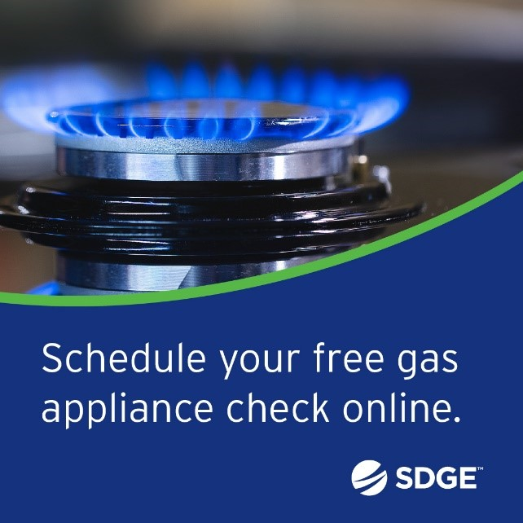
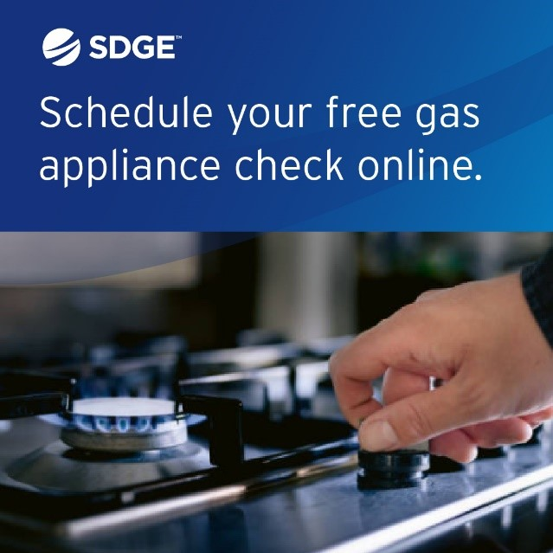

ARTICLE: TAKE ADVANTAGE OF NO-COST TRAINING FROM ENERGY EXPERTS
Did you know that SDG&E provides webinars for business owners and trade professionals, so you can learn new skills at your own pace? And most are at no cost. You or your employees can learn about the latest in green building practices, technology and energy-saving solutions from industry experts. Certifications and continuing education units are available for many classes. Check out the class listing at sdge.com/EnergyClasses.
SOCIAL POSTS: TAKE ADVANTAGE OF NO-COST TRAININGS FROM ENERGY EXPERTS
- Did you know SDG&E provides energy education and training webinars at no cost? These on-demand webinars are offered at introductory, intermediate and advanced levels. See the webinar list at sdge.com/EnergyClasses. #sdge #SDGEassist
- Learn the latest in green building design, operations, maintenance and technology at no-cost energy webinars led by industry experts. See the on-demand webinar list at sdge.com/EnergyClasses. #sdge #SDGEassist
- Enroll in a no-cost, on-demand energy topic webinar. Energy education and training can give you and your employees the knowledge and skills that customers value. Check out the webinar list at sdge.com/EnergyClasses. #sdge #SDGEassist

imageS: TAKE ADVANTAGE OF NO-COST TRAININGS FROM ENERGY EXPERTS
ARTICLE: WAYS YOUR BUSINESS CAN SAVE ON NATURAL GAS COSTS

It's important for businesses to be both eco-friendly and cost-effective. Saving natural gas is a smart move! From using energy-efficient technologies to making simple changes in how things are done every day, these ideas guide businesses towards a more planet- and budget-friendly path.
- Get a tune-up on your heater to ensure your system is operating efficiently. New, clean air filters can improve airflow and heating. Check out water heater rebates up to $500 on the purchase of new, qualifying energy-efficient gas water heaters at sdge.com/rebates.
- Add weatherstripping, caulking or foam insulation around windows and doors to help reduce drafts.
- Caulk ducts, plumbing openings, recessed lighting fixtures and other spaces that leak air into walls, floors and ceilings.
- Ensure that the furnace damper works correctly to avoid heating cold, outside air.
- Check your HVAC filters monthly and clean it or replace it if it’s dirty. Keeping your HVAC system properly maintained can help save on heating costs.
- Sealing and insulating air ducts can help improve system efficiency.
- Could your business benefit from customized recommendations on how to save energy? SDG&E’s Business Energy Solutions Program can help identify ways to lower utility bills through energy-efficient upgrades. Program contractors audit the site, identify available upgrades and install the new equipment – many at no cost! Learn more at sdge.com/BES.
- Did you know ceiling fans help in the colder months too? Change the rotation of your fan blades to clockwise, which will pull warm air down and spread it throughout the room.
- Lower your office’s temperature. Your business can keep comfortable without cranking up the heat. Don’t completely turn off your heat overnight though – you’ll use more energy to heat the building again in the morning. Find rebates on smart thermostats at sdge.com/rebates.

Visit sdge.com/MyBusiness for more helpful energy-saving tips, tools and programs for your business.

SOCIAL POSTS: WAYS YOUR BUSINESS CAN SAVE ON NATURAL GAS COSTS
Use any of the tips above and then add:
Visit sdge.com/MyBusiness for more helpful energy-saving tips. #sdge #SDGEassist

IMAGES: WAYS YOUR BUSINESS CAN SAVE ON NATURAL GAS COSTS
JUST POSTS – Residential
- Wash with cold water. Using warm water instead of hot can cut a load's energy use in half; using cold water will save even more. Bonus, cold water helps your clothes last longer. Get more tips at sdge.com/MyEnergy. #sdge #SDGEassist
- Upgrade your lighting. The sun sets earlier in the winter, prompting you to use more lighting. Along with LED light bulbs, use ENERGY STAR light fixtures, which use less energy. Get more tips at sdge.com/MyEnergy. #sdge #SDGEassist
- Keep your fridge full. A full fridge works more efficiently than an empty one. Pack cold items together to keep your fridge and freezer cool. Consider storing a supply of emergency water to fill space. Get more tips at sdge.com/MyEnergy. #sdge #SDGEassist
- Shift to save. If you aren’t on a Time-of-Use pricing plan, shift your energy use outside of 4-9 p.m. to make use of cleaner, renewable energy sources when they are more available to the grid. Get more tips at sdge.com/MyEnergy. #sdge #SDGEassist
- Blanket energy loss. Wrap older water heaters with proper insulating jackets and set the temperature to 120 degrees F (or lower). Get more tips at sdge.com/MyEnergy. #sdge #SDGEassist
- Lower your thermostat. Save as much as 10% a year on heating and cooling by turning your thermostat back 7°-10°F for 8 hours a day from its usual setting, health permitting. Maximize your savings by using a smart thermostat to reduce heating during on-peak hours. Get more tips at sdge.com/MyEnergy. #sdge #SDGEassist
- Only heat the rooms you use. Close doors and vents in rarely used rooms and concentrate heat in your living spaces. Get more tips at sdge.com/MyEnergy. #sdge #SDGEassist
- Optimize the display on your television. Turning down the brightness on your TV can save on energy use. Get more tips at sdge.com/MyEnergy. #sdge #SDGEassist

JUST POSTS – Business
- Ensure that the furnace damper works correctly to avoid heating cold, outside air. Find more tips at sdge.com/MyBusiness. #sdge #SDGEassist
- Do you own a small business? Receive energy-efficient upgrades like lighting, water heaters and refrigeration controls when you sign up for a no-cost energy assessment. One of SDG&E’s contractors will come to your business, make recommendations on where to save energy and install new equipment – many items at no cost! For more information, visit sdge.com/BES. #sdge #SDGEassist
- Looking for ways to save energy at your business or office? Check out sdge.com/MyBusiness for energy-saving tips. #sdge #SDGEassist
- Insulate water heaters and hot water supply pipes to save energy. For more energy-saving tips, visit sdge.com/MyBusiness. #sdge #SDGEassist
- Caulk ducts, plumbing openings, recessed lighting fixtures and other spaces that leak air into walls, floors and ceilings. For more energy-saving tips, visit sdge.com/MyBusiness. #sdge #SDGEassist

