SDG&E RESIDENTIAL CONTENT PACKAGE | JANUARY 2022
As a trusted community partner, we thank you in advance for sharing these digital assets with your audiences, including residents, customers and employees to help amplify our monthly messages. Here are social media posts, articles and photos you are welcome to use in email communications, websites or newsletters. There are several images with each posting. Please choose images that fit your audience and feel free to mix and match.

Follow Us
You can find us on Facebook, Instagram, Twitter, YouTube and LinkedIn. When sharing these messages in your social posts, feel free to tag SDG&E’s social media accounts and direct your audience to sdge.com.

This month’s topics: Winter energy-saving and safety tips at home, customer assistance programs

Article 1: make a resolution to save energy this winter
Lower temperatures and spending extra time at home means more heating, streaming and electricity use. Here are some ideas to help you save energy and lower your bill while staying comfortable during the colder winter months.
- Reset your hot water heater: After heating and cooling systems, water heaters are the second highest source of energy usage in the home. It takes a lot of energy to heat water and most people have the thermostat on their water heater set too high. Your water heater heats water to a set temperature, then maintains that temperature 24/7. That means that your water heater just cycles on and off, continually reheating water to that temperature, whether you use it or not. Even lowering the temperature a few degrees will help lower your energy costs.
- Insulate your home: Properly insulating your home provides resistance to heat loss and lowers heating costs while improving your comfort level. Find the best insulation for your home when you visit energy.gov/EnergySaver/insulation.
- Adjust the temperature: When you are asleep or not home, turn your thermostat back 7 to 10 degrees for eight hours and save around 10% a year on your heating bills. A smart or programmable thermostat lets you set it and forget it. Learn about SDG&E’s Smart Thermostat Program at sdge.com/thermostat.
- Weatherize your home: Sealing leaks with caulk, weatherstripping and expanding foam is a quick and easy way to lower your heating expenses. Inspect these areas for any cracks or gaps that could cause air leaks – doors, windows, places where plumbing and wiring pass through the walls, mail slots, foundation seals, baseboards, attic hatches and mounted air conditioners.
- Maintain your heating systems: Heating your home uses more energy than any other system in your house so it’s important to properly maintain your equipment. Replace your HVAC filter around once a month. A dirty filter can increase your electricity costs because your HVAC system needs to work harder to pump warm air into your home. Get more tips at energy.gov/EnergySaver/home-heating-systems.
- Reduce heat loss from the fireplace: Keep your fireplace damper closed unless a fire is burning. Keeping the damper open is like keeping a window wide open during the winter; it allows warm air to go right up the chimney. When you use the fireplace, reduce heat loss by opening dampers in the bottom of the firebox (if provided) or open the nearest window around one inch and close doors leading into the room. Visit epa.gov/BurnWise for fire-burning tips.
For more tips on how to save energy this winter, visit sdge.com/winter.

Social posts: make a resolution to save energy this winter
- Use a heavy-duty, clear plastic sheet on a frame or tape clear plastic film to the inside of your window frames during the cold winter months. Make sure the plastic is sealed tightly to help reduce the amount of cold air outside from coming inside. For more winter energy-savings tips, visit sdge.com/winter. #sdge #SDGEassist
- Keep your fireplace damper closed unless a fire is burning. Keeping the damper open is like keeping a window wide open during the winter; it allows warm air to go right up the chimney. For more winter energy-savings tips sdge.com/winter. #sdge #SDGEassist
- Open curtains on your south-facing windows during the day to allow sunlight to naturally heat your home. For more winter energy-savings tips visit sdge.com/winter. #sdge #SDGEassist
You can use any of the article tips as social posts, too. Just add #sdge #SDGEassist

Images: make a resolution to save energy this winter

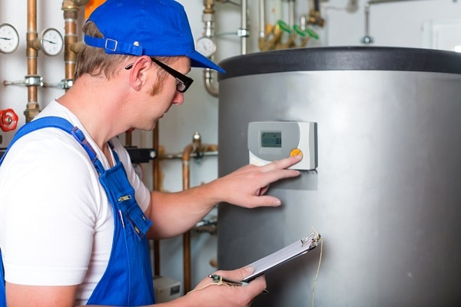
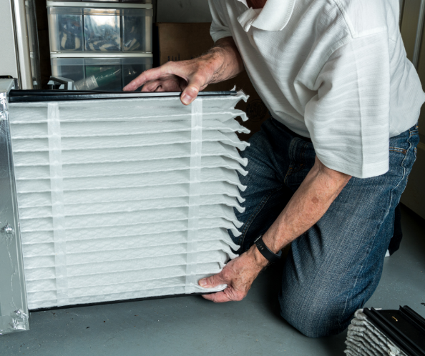

Article 2: WINTER SAFETY TIPS FOR YOUR HOME
Safety should come first every season. Your home depends on electricity, which provides you with power to cook, heat water, for lighting and more. Did you know every year about 51,000 electric fires occur in homes resulting in nearly 500 deaths? Here are some helpful safety tips for your home.
- Carbon monoxide safety: Keep your family safe from this odorless, colorless gas.
  - Install a battery-operated carbon monoxide detector.
  - Never use your oven to heat your home.
  - Always operate portable generators outdoors.
- Appliance safety tips: Give your appliances the attention they need this winter.
  - Remember to clean or replace your furnace filter every month.
  - Have a fireplace? Start winter with a clean chimney flue.
  - Clean out dryer lint to lower the chance of a fire.
- Power off: Power down when you’re not around.
  - Turn off lights, computers, TVs and other electronic devices when not in use to reduce risk of fire.
  - Use a smart power strip to make powering off easy.
- Keep electrical cords away from heat sources and foot traffic and don’t place them under rugs where damage can go unnoticed.
- If you only need to heat a small area, try using a space heater. Electric space heaters are an energy efficient way to stay warm because there is no heat loss through ducts. Space heaters are excellent for heating closed-off areas that you occupy for shorter periods.
For more tips on using energy safely, visit sdge.com/safety.

Social posts: WINTER SAFETY TIPS FOR YOUR HOME
- Extension cords under carpets can overheat. Keep them away from rugs and avoid running them over furniture or door thresholds. Get more safety tips at sdge.com/safety. #sdge #SDGEassist
- Keep electric heaters a safe distance from furniture, blankets, curtains and other objects that could catch fire. Get more safety tips at sdge.com/safety. #sdge #SDGEassist
- Use light bulbs that match the recommended wattage on the light fixture. If it has no wattage listed, use 60-watt bulbs or lower. A higher wattage can cause overheating. Get more safety tips at sdge.com/safety. #sdge #SDGEassist
- Give your home an electrical checkup: circuits, breakers, switches and outlets. Get more safety tips at sdge.com/safety. #sdge #SDGEassist
- Periodically check the condition of the plugs and sockets in your kitchen. Look for burnt or frayed wires on appliances. Ideally, only one appliance should be plugged into each outlet to avoid overloading the outlet, wiring and circuit breaker. #sdge #SDGEassist

Images: WINTER SAFETY TIPS FOR YOUR HOME
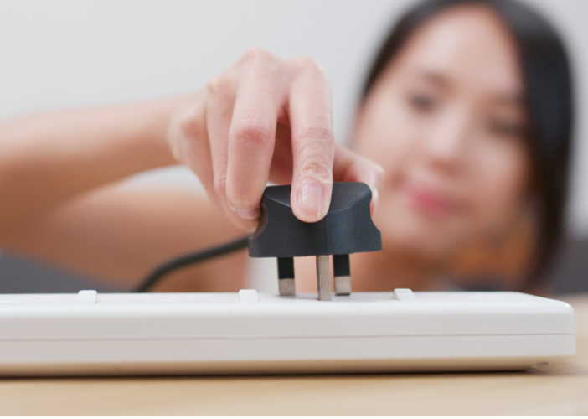

Article 3: NEED HELP WITH YOUR ENERGY BILL?
SDG&E recognizes that this is still a challenging time for many customers and wants to help. Check out these energy assistance programs.
California Alternate Rates for Energy (CARE) Program: Save 30% or more every month on your bill. Find out if you qualify at sdge.com/CARE.
Family Electric Rate Assistance (FERA) Program: If you don’t qualify for CARE and your household has 3 or more people, you may qualify for FERA. You could receive an 18% discount on your electric bill. Visit sdge.com/FERA to learn more.
Energy Savings Assistance (ESA) Program: You may qualify to receive free energy-saving improvements for your home, such as new appliances, lighting, insulation and more. Find details at sdge.com/ESAP.
Arrearage Management Plan (AMP): If you have outstanding bills and you are a CARE or FERA customer, you may be eligible for debt forgiveness. See if you qualify at sdge.com/AMP.
Business customers: Set up a flexible payment plan, so you can rest easy knowing you’re covered. Visit sdge.com/recovery to learn more.
Online assistance program applications are easy, fast and convenient. For more information, visit sdge.com/assistance.
Social posts: NEED HELP WITH YOUR ENERGY BILL?
- If you’re behind on your energy bill, you may qualify for financial assistance. Learn more at sdge.com/assistance. #sdge #SDGEassist
- Hardship is everywhere right now – the last thing you need is to worry about your energy bill. Get help with your bill at sdge.com/assistance. #sdge #SDGEassist
- SDG&E provides assistance programs to help you with your monthly bill which can include up to a 30% discount. Find out if you qualify at sdge.com/assistance. #sdge #SDGEassist
- Whether you rent or own, you could be eligible to receive no-cost, energy-efficient home improvements that can make your home more comfortable and reduce your energy bill. Find out if you qualify at sdge.com/ESAP. #sdge #SDGEassist
Article 3 (translated): ¿Necesita ayuda con su FACTURA de energía?
Usted puede calificar para un descuento en su factura o mejoras en el hogar. Los programas de asistencia de SDG&E ayudan a reducir su factura mensual de energía mientras mantiene su hogar cómodo.
Programa de Tarifas Alternativas de Energía de California (CARE, por sus siglas en inglés): Ahorre un 30% o más cada mes en su factura. Averigüe si califica en sdge.com/CARE.
Tarifa Eléctrica Familiar (FERA, por sus siglas en inglés): Si no califica para CARE y su hogar tiene 3 o más personas, puede calificar para FERA. Podría recibir un 18% de descuento en su factura de electricidad. Visite sdge.com/FERA para obtener más información.
Programa de Asistencia para el Ahorro de Energía (ESA, por sus siglas en inglés): Puede calificar para recibir mejoras gratuitas para el ahorro de energía en su hogar, tales como electrodomésticos nuevos, iluminación, aislamiento y más. Encuentre los detalles en sdge.com/ESAP.
Arrearage Management Plan (AMP): Si tiene facturas pendientes y es cliente de CARE o FERA, puede ser elegible para la condonación de deudas. Averigüe si califica en sdge.com/AMP.
Clientes comerciales: Configure un plan de pago flexible, para que pueda estar tranquilo sabiendo que está cubierto. Visite sdge.com/recovery para obtener más información.
Las aplicaciones en línea son fáciles, rápidas y convenientes. Para obtener más información, visite sdge.com/asistencia.
Postas sociales: ¿Necesita ayuda con su FACTURA de energía?
- Si está atrasado en su factura de energía, puede calificar para asistencia financiera. Obtenga más información en sdge.com/asistencia. #sdge #SDGEassist
- En este momento, las dificultades se encuentran en todas partes - lo último que necesita es preocuparse por su factura de energía. Obtenga ayuda con su factura en sdge.com/asistencia. #sdge #SDGEassist
- SDG&E ofrece programas de asistencia para ayudarle con su factura mensual que puede incluir hasta un 30% de descuento. Descubra si califica en sdge.com/asistencia. #sdge #SDGEassist
- Ya sea que alquile o sea propietario, podría ser elegible para recibir mejoras de eficiencia energética en su hogar, sin costo, que pueden hacer que su hogar sea más cómodo y reducir su factura de energía. Descubra si califica en sdge.com/ESAP. #sdge #SDGEassist
Images: NEED HELP WITH YOUR SDG&E BILL?

