SDG&E RESIDENTIAL AND SMALL BUSINESS CONTENT PACKAGE | JANUARY 2023
As a trusted community partner, we thank you for sharing our content and digital assets with your audiences – including residents, customers and employees – to help amplify our key messages in your email communications, websites or newsletters.
Best practices for using our content, social media posts and images
- Images
Choose images that are relevant for your audience and feel free to mix and match what we provide. For alternate images, Unsplash.com and Canva.com offer free images that you can download.
- SDG&E logo
You’re welcome to mention our name but, due to legal requirements, please do not use our logo in any marketing materials that you create. Please only use the SDG&E logo if we provide it to you in this package or it’s publicly available online like a social post or video. You can also retweet our public posts which you’ll find on twitter.com/sdge.
- Videos
We have a library of videos you can share in your communications and social posts when you visit youtube.com/c/SanDiegoGasElectric/videos. If you’d like to sort our videos by topic, visit youtube.com/c/SanDiegoGasElectric. Some videos are in Spanish. You’ll see some on TV, too!
Follow us
Find us on Facebook, Instagram, Twitter, YouTube and LinkedIn. When sharing our digital assets and content, feel free to tag SDG&E’s social media and direct your audience to sdge.com.

Article: Natural gas prices AT HISTORIC HIGH
Natural gas prices are at a historic high and winter bills could soar due to extraordinary market conditions nationally. SDG&E has programs and services to help mitigate these increases. Visit sdge.com/assistance or sdge.com/asistencia to find out if you qualify for debt forgiveness, one-time payments, monthly bill discounts and more. And, for more information, you can read this article on SDG&E’s NewsCenter page at sdgenews.com.
Wholesale prices for natural gas – a major source of fuel for winter home heating and electric generation – continue to surge and drive household energy bills higher nationwide. SDG&E does not mark up the cost of gas it buys for its customers so they do not make a profit from these rising market prices. SDG&E recognizes that no one wants to see their energy bills go up, especially now. Still, SDG&E also recognizes its responsibility to be transparent with its customers and help prepare them for higher energy bills this winter.

SDG&E has natural gas energy-saving tips to help you save on your bill during the cold weather.
- Block the chill: Caulk and weather-strip around drafty doors and windows. Use a door sweep, door sock or towel at the bottom of doors with a gap.
- Keep your furnace and air filters clean: Check furnace filters once a month and replace them regularly. A dirty air filter can increase your energy costs and cause problems with your equipment.
- Set your ceiling fan to run clockwise: This causes the fan to produce an updraft, forcing the hot air that rises to your ceiling down and into the rest of the room. In the summer, you can switch the fans to counterclockwise to keep the room cool.
- Schedule a no-cost SDG&E gas appliance check: Book your appointment at sdge.com/MyAccount or on SDG&E’s mobile app available in the App Store or Google Play.
- Lower your thermostat: Try lowering your thermostat a few degrees and throwing on a cozy sweater and socks. Invest in a smart thermostat. There are rebates on sdge.com/rebates.
- Lower your water heater thermostat: Lowering the thermostat on your water heater to 120°F, if possible, will save energy and avoid scalding. Check out water heater rebates on sdge.com/rebates.
- Use the “energy saver” switch on your dishwasher and set it on a low temperature setting when feasible. Think about turning off the heat drying cycle – you don’t need it! Also, run full loads only and turn the appliance off after the dishes are washed. Run it during off-peak hours before 4 p.m. or after 9 p.m.
- Try out meal prep: Take advantage of an already-warm oven by cooking multiple things at once or in big batches. Whether you have a natural gas oven or electric, you’ll save money on your bill — and have a well-stocked fridge with quick meals to boot.
- Clear blocked vents: The arrangement of the furniture and appliances in your home may block vents and restrict air flow. The natural gas heating system is likely worker harder because it’s harder to heat your home when vents are blocked.
- Keep your blinds and curtains open during the day and closed at night: During the day, keep them open to let the sunlight and warmth in. When the sun goes down, close them to keep the warm air in.
- Make sure your home is well-insulated: Without good home insulation, the hot air your natural gas heating system emits can escape through cracks, doors, windows, the attic and garage.
- Reduce the use of personal heaters: Space heaters use up a lot of energy and they’re an inefficient way to warming up large areas. If you want to heat up a small space, consider a radiant personal heater which is more energy-efficient than other models.
- Keep vents and interior doors open to promote airflow: It is commonly thought that closing vents and doors to unused rooms will reduce energy use but air will build up inside of your ducts because there will be less vents available to release that air. The increased pressure in your ducts will make it harder for your air handler to blow air into the ducts and the restricted airflow will cause efficiency problems similar to a dirty air filter. Also, if your ducts have leaks, the increased pressure in your ducts will push air out of those leaks and force your system to work longer to compensate.
Visit sdge.com/MyEnergy for more bill-saving and energy management resources.

Social posts: Natural gas prices AT HISTORIC HIGH
- SDG&E may be able to help customers who are struggling to pay their bill. Information about assistance programs ranging from bill discounts, bill payment plans and debt relief, can be found at sdge.com/assistance or sdge.com/asistencia. #sdge #SDGEassist
OR
Use any of the tips in the above article, then add:
Visit sdge.com/MyEnergy for additional winter safety and energy-savings tips. #sdge #SDGEassist

Images: Natural gas prices AT HISTORIC HIGH

Article: SEALING IN SAVINGS AND COMFORT
Are there areas in your home that are too hot or too cold, no matter the thermostat setting? If the answer is yes, it could be conditioned air escaping through gaps in your home. Sealing those gaps is one of the cheapest and most effective ways to save your energy dollars and increase comfort.

Finding leaks
Start by locating where air leaks are occurring. It could be any place where two materials meet, such as the foundation walls and the flooring or where there's an opening to the outdoors. Gaps can also occur around exterior doors and cracked caulking around window frames. Another area to check is in the attic — gaps around ceiling fans, recessed light fixtures and electrical outlets.

Fixing leaks
Once you've found the leaks, sealing them is a simple project you can do yourself with supplies available from your local retailer.
- Windows: Seal windows with exterior caulk. Your best bet is silicone or siliconized caulk.
- Where the window meets the frame, scrape out any existing caulk and make sure the area is clean and dry.
- Cut the tips of the caulk at a 45-degree angle and load it into the caulking gun.
- Run the tips slowly and evenly along the base of the crack.
- Finish by running a wet fingertip along the bead of the caulk to smooth it out.
- Doors: Fix gaps around exterior doors with weatherstripping and a door sweep.
- Measure the top and sides of the door and cut pieces of weatherstripping to fit each.
- Peel back the covering from the adhesive and press the weatherstripping to the inside of the doorstop, ensuring a snug fit.
- Cut the sweep (if needed) to match the width of the door and attach it with adhesive or screws.
- Attic: Ceiling fans, recessed lighting fixtures and electrical outlets in the ceiling below your attic are potential sources of air leakage.
- From the attic, pull back the insulation to find the cutouts and seal them with caulk or expandable foam.
- Check for and seal gaps around plumbing vents, furnace flues and ductwork.
- Seal the attic door or access with weatherstripping.
Social posts: SEALING IN SAVINGS AND COMFORT
Use any of the tips in the above article, then add:
Visit sdge.com/MyEnergy for additional winter safety and energy-savings tips. #sdge #SDGEassist

Images: SEALING IN SAVINGS AND COMFORT
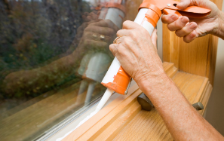

Article: NEED HELP WITH YOUR ENERGY BILL?
SDG&E recognizes that this can be a challenging time for many customers and may be able to help if you are having trouble paying your bill. You may be eligible for programs and services that can provide immediate financial assistance and help you avoid interruptions in your service. Flexible payment arrangements are available to help you pay down past due balances. Learn more at sdge.com/Payment-Arrangements.

Check out these energy assistance programs:
- California Alternate Rates for Energy (CARE) Program: Save 30% or more every month on your bill. Find out if you qualify at sdge.com/CARE.
- Family Electric Rate Assistance (FERA) Program: If you don’t qualify for CARE and your household has 3 or more people, you may qualify for FERA. You could receive an 18% discount on your electric bill. Visit sdge.com/FERA to learn more.
- Energy Savings Assistance (ESA) Program: You may qualify to receive free energy-saving improvements for your home, such as new appliances, lighting, insulation and more. Find details at sdge.com/ESA.
- Arrearage Management Plan (AMP): If you have outstanding bills and you are a CARE or FERA customer, you may be eligible for debt forgiveness. See if you qualify at sdge.com/AMP.
- Low-income Home Energy Assistance Program (LIHEAP): This program offers up to $1,000 towards your energy bill. This Federal assistance program also provides support for energy-related home improvements. Learn more at sdge.com/LIHEAP.
Even if you made a recent payment or set up a flexible payment plan with SDG&E, there may still be assistance programs available to help you. For a complete list of available offerings, visit sdge.com/assistance.

Social posts: NEED HELP WITH YOUR ENERGY BILL?
- If you’re behind on your energy bill, you may qualify for financial assistance. Learn more at sdge.com/assistance. #sdge #SDGEAssist
- Hardship is everywhere right now – the last thing you need to worry about is your energy bill. Get help with your bill at sdge.com/assistance. #sdge #SDGEAssist
- SDG&E provides assistance programs to help you with your monthly bill which can include up to a 30% discount. Find out if you qualify at sdge.com/assistance. #sdge #SDGEAssist
- Whether you rent or own, you could be eligible to receive no-cost, energy-efficient home improvements that can make your home more comfortable and help reduce your energy bill. Find out if you qualify at sdge.com/ESA. #sdge #SDGEAssist

Article (translated): ¿NECESITA AYUDA CON SU FACTURA DE ENERGÍA?
Usted puede calificar para un descuento en su factura o mejoras en el hogar. Los programas de asistencia de SDG&E ayudan a reducir su factura mensual de energía mientras mantiene su hogar cómodo.
- Programa de Tarifas Alternativas de Energía de California (CARE, por sus siglas en inglés): Ahorre un 30% o más cada mes en su factura. Averigüe si califica en sdge.com/CARE.
- Tarifa Eléctrica Familiar (FERA, por sus siglas en inglés): Si no califica para CARE y su hogar tiene 3 o más personas, puede calificar para FERA. Podría recibir un 18% de descuento en su factura de electricidad. Visite sdge.com/FERA para obtener más información.
- Programa de Asistencia para el Ahorro de Energía (ESA, por sus siglas en inglés): Puede calificar para recibir mejoras gratuitas para el ahorro de energía en su hogar, tales como electrodomésticos nuevos, iluminación, aislamiento y más. Encuentre los detalles en sdge.com/ESAP.
- Arrearage Management Plan (AMP): Si tiene facturas pendientes y es participante en el programa de CARE o FERA, puede ser elegible para la condonación de deudas. Averigüe si califica en sdge.com/AMP.
- Clientes comerciales: Configure un plan de pago flexible, para que pueda estar tranquilo sabiendo que está cubierto. Visite sdge.com/recovery para obtener más información.
Las aplicaciones en línea son fáciles, rápidas y convenientes. Para obtener más información, visite sdge.com/asistencia.
Postas sociales: ¿NECESITA AYUDA CON SU FACTURA DE ENERGÍA?
- Si está atrasado en su factura de energía, puede calificar para asistencia financiera. Obtenga más información en sdge.com/asistencia. #sdge #SDGEAssist
- En este momento, las dificultades se encuentran en todas partes - lo último que necesita es preocuparse por su factura de energía. Obtenga ayuda con su factura en sdge.com/asistencia. #sdge #SDGEAssist
- SDG&E ofrece programas de asistencia para ayudarle con su factura mensual que puede incluir hasta un 30% de descuento. Descubra si califica en sdge.com/asistencia. #sdge #SDGEAssist
- Si alquile o es propietario, podría ser elegible para recibir mejoras de eficiencia energética en su hogar, sin costo, que pueden hacer que su hogar sea más cómodo y ayuden reducir su factura de energía. Descubra si califica en sdge.com/ESA. #sdge #SDGEAssist

Images: NEED HELP WITH YOUR ENERGY BILL?

Article: WAYS BUSINESSES CAN SAVE ON NATURAL GAS COSTS
National and global natural gas supply shortages are contributing to higher natural gas prices. SDG&E passes through the cost of gas and electric supply directly to its customers and does not mark the costs up. Here are some practical tips to help keep your business’s energy costs down.
- Get a tune-up on your heater to ensure your system is operating efficiently. New, clean air filters can improve airflow and heating. SDG&E has instant in-store rebates up to $500 on the purchase of new, qualifying energy-efficient electric heat pump water heaters and gas water heaters. Learn more at sdge.com/rebates.
- Add weatherstripping, caulking or foam insulation around windows and doors to help reduce drafts.
- Caulk ducts, plumbing openings, recessed lighting fixtures and other spaces that leak air into walls, floors and ceilings.
- Ensure that the furnace damper works correctly to avoid heating cold, outside air.
- Hire a contractor to check your central heating and cooling ducts for leaks. Sealing and insulating air ducts can help improve system efficiency by up to 20%.
- Replace windows with high-efficiency ENERGY STAR windows. This can help reduce your heating and cooling costs by up to 15%.
- When you’re in the office, set your thermostat as low as is comfortable. At night or when you’re out, turn your thermostat back 10 – 15 degrees to save around 10% annually.
Visit sdge.com/Business-Winter for more helpful energy-saving tips, tools and programs.

Social Posts: WINTER ENERGY-SAVING TIPS FOR SMALL BUSINESSES
- Check your HVAC filters monthly and clean it or replace it if it’s dirty. Keeping your HVAC system properly maintained can help save on heating costs. Visit sdge.com/Business-Winter for more helpful energy-saving tips. #sdge #SDGEassist
- Did you know ceiling fans help in the colder months too? Change the rotation of your fan blades to clockwise, which will pull warm air down and spread it throughout the room. Visit sdge.com/Business-Winter for more helpful energy-saving tips. #sdge #SDGEassist
- Lower your office’s temperature. Your business can keep comfortable without cranking up the heat. Adjust your thermostat by a few degrees to help reduce your energy bill. Don’t completely turn off your heat overnight though – you’ll use more energy to heat up the building again in the morning. Visit sdge.com/Business-Winter for more helpful energy-saving tips. #sdge #SDGEassist
- Open blinds and sunshades to allow sunlight to heat up the room, especially on south- or west-facing windows. Natural light can warm the space and reduce the need for lighting. When you need to turn on lights, save energy by using energy-efficient LED bulbs. Visit sdge.com/Business-Winter for more helpful energy-saving tips. #sdge #SDGEassist
- Is your business looking for ways to save energy during the colder months? Visit sdge.com/Business-Winter for helpful energy-saving tips. #sdge #SDGEassist
- Make sure cold air isn’t drifting into your building by checking weather stripping on your doors and caulking on your windows and other areas that outside air can seep inside. This is especially important in older buildings. You can also put clear, inexpensive plastic sheeting on your windows to add more insulation and reduce cold drafts. Visit sdge.com/Business-Winter for more helpful energy-saving tips. #sdge #SDGEassist

Images: WINTER ENERGY-SAVING TIPS FOR SMALL BUSINESSES
Social Posts: Gas Appliance Checks
- With cooler weather moving in, now is the time to get your gas furnace inspected to ensure you and your family are safe. Schedule your no-cost SDG&E inspection in My Account. Login to sdge.com/MyAccount, select Services, Services Overview and then Gas Appliance Check. #sdge #SDGEassist
- Get your gas appliances evaluated to help prevent carbon monoxide poisoning. Schedule your no-cost SDG&E inspection in My Account. Login to sdge.com/MyAccount, select Services, Services Overview and then Gas Appliance Check. #sdge #SDGEassist
- SDG&E can inspect your gas appliances for safety, make minor adjustments and light heater pilots. Schedule your no-cost SDG&E inspection in My Account. Login to sdge.com/MyAccount, select Services, Services Overview and then Gas Appliance Check. #sdge #SDGEassist
- SDG&E will visit your home and check that your gas appliances are safe. Schedule your no-cost SDG&E inspection in My Account. Login to sdge.com/MyAccount, select Services, Services Overview and then Gas Appliance Check. #sdge #SDGEassist

Images: Gas Appliance Checks
Twitter:
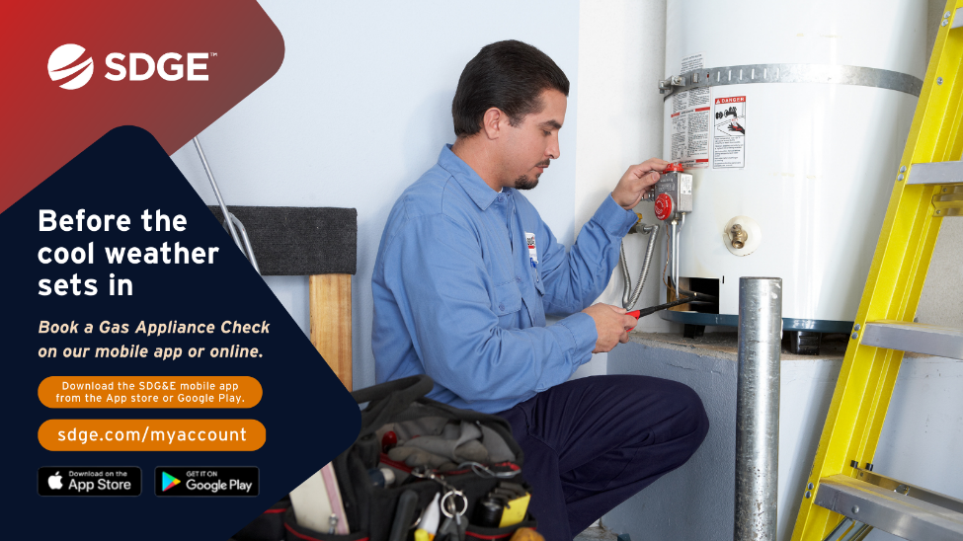

Social posts promoting rebates:
The new Golden State Rebates give qualifying customers rebates toward the purchase of energy-efficient products such as smart thermostats, gas tank water heaters, heat pump water heaters and more. Learn more at sdge.com/rebates. #sdge #SDGEassist

Los nuevos reembolsos de Golden State brindan a los clientes calificados recibir reembolsos para la compra de productos de eficiencia energética, como termostatos inteligentes, calentadores de agua con tanque de gas, calentadores de agua con bomba de calor y más. Obtenga más información en sdge.com/rebates. #sdge #SDGEassist

