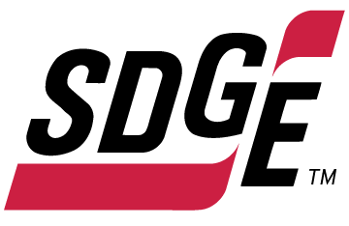
SDG&E BUSINESS CONTENT PACKAGE | JANUARY 2022
As a trusted community partner, we thank you in advance for sharing these digital assets with your audiences, including residents, customers and employees to help amplify our monthly messages. Here are social media posts, articles and photos you are welcome to use in email communications, websites or newsletters. There are several images with each posting. Please choose images that fit your audience and feel free to mix and match.

Follow Us
You can find us on Facebook, Instagram, Twitter, YouTube and LinkedIn. When sharing these messages in your social posts, feel free to tag SDG&E’s social media accounts and direct your audience to sdge.com.

This month’s topics: winter energy-saving and safety tips at work, on-demand energy webinars

Article 1: PREPARE YOUR BUSINESS FOR WINTER CONDITIONS
As a last resort, SDG&E may need to temporarily turn off the power when gusty winds and dry conditions, combined with a heightened fire risk, threaten public safety and the electric system. Power outages can happen with little to no warning when there’s stormy weather so it’s important to be ready. Learn more about power outages at sdge.com/Outage-Center.

Check out these ten tips to help keep your business running and employees and customers safe during inclement weather.
- Ensure your contact information is up to date for both yourself and your business at myaccount.sdge.com. Then, sign up for power outage notifications via text or email under Account/Notifications Settings.
- Create an emergency action plan. There’s no better time to prepare for an emergency than now. Visit sdge.com/emergency to learn more about emergency preparedness ideas for your home and business.
- Prepare your facility or office for severe weather by inspecting the building for drafts, leaks and cracks. Also, regularly check emergency lighting, such as exit signs.
- Create digital copies of important documents like your employee roster and emergency phone numbers. This allows your team to easily reach one another.
- Identify backup charging methods such as portable battery packs for mobile phones and other digital devices. Consider investing in a backup electric generator to keep your business open during power shutoffs. Learn more at sdge.com/generator.
- Build or restock an emergency kit to last at least three days and include flashlights, batteries, a first aid kit, food, water and cash. Recommend your employees create emergency kits to stay safe at home, too. Build your kit with these tips on sdge.com/emergency.
- Track the weather with SDG&E’s detailed map at sdgeweather.com. You’ll find local temperatures, the fire potential index, National Weather Service messages, safety messages and more.
- If your power is out, view outage details and estimated restoration times at sdge.com/Outage-Map.
- It’s critical that you stay away from downed power lines and treat them as if they are energized. Visit sdge.com/safety/Keeping-Safe-Stormy-Weather for tips on how to stay safe during a storm.
- Keep a mobile phone or land line phone at hand. Cordless phones don’t work without electricity.

Social Posts: PREPARE YOUR BUSINESS FOR WINTER CONDITIONS
- Use any of the ten tips above and then add: Get more tips at sdge.com/My-Business. #sdge #SDGEassist
Images: PREPARE YOUR BUSINESS FOR WINTER CONDITIONS

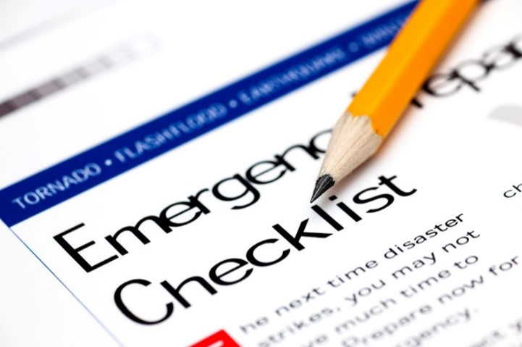

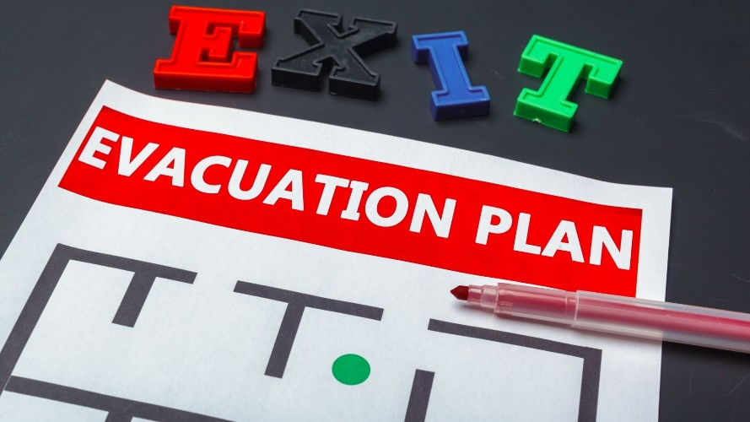

Article 2: 6 WINTER ENERGY-SAVING TIPS FOR THE OFFICE
This winter, you’ll want to keep your customers and employees warm. Did you know that by implementing a few tips your business can save on its energy use? From regulating your temperature to involving employees in your energy-saving objectives, there are collaborative ways to lower your energy bills this winter.
Here are 6 tips that can help reduce your costs without having to sacrifice the comfort of your staff or customers:
- Temperature control – adjusting the thermostat can help you save. When you’re in the office, set your thermostat as low as is comfortable. At night, or when you’re out, turn it back 10 – 15 degrees to save about 10 percent a year on your bill. Program a smart thermostat so you can set it and forget it!
- Maintain and repair – the winter season is a great time to fix “energy leaks” or upgrade your building to be more energy efficient. Insulate older water heaters, too.
- Tune your HVAC – just as a tune-up for your car can improve its gas mileage, an annual tune-up for your heating and cooling system can improve its energy efficiency and comfort levels.
- Plug and seal leaks – got leaks? Plug and seal them with weather stripping and caulking to help prevent any heat loss which can be costly in the long run.
- Plant trees around your building – this can help shield your office from weather conditions throughout the year, including winter winds.
- Employee involvement – if you’re looking for new ways to conserve energy, ask your employees for ideas. Educating your employees on ways they can be energy-conscious can help create a collaborative and energy–efficient work culture where everyone benefits.
For more ideas on how to lower your energy use at work, visit sdge.com/My-Business.

Social posts: 6 WINTER ENERGY-SAVING TIPS FOR THE OFFICE
- Want to lower your office’s energy costs? Insulate your water heater – especially if your water heater is older than seven years. For more tips visit sdge.com/My-Business. #sdge #SDGEassist
- Looking for ways to save on your business’s energy bill? Maintain your HVAC system year-round. Changing your filters monthly and tuning your HVAC annually can help improve its energy efficiency. For more tips visit sdge.com/My-Business. #sdge #SDGEassist
- Resolve to become more energy-efficient at your business facility. Visit sdge.com/My-Business for helpful winter energy-saving and safety tips. #sdge #SDGEassist

Images: 6 WINTER ENERGY-SAVING TIPS FOR THE OFFICE

Article 3: TAKE ADVANTAGE OF NO-COST TRAINING FROM ENERGY EXPERTS
Did you know that SDG&E provides webinars for business owners and trade professionals, and most are at no cost? You or your employees can learn about the latest in green building practices, technology and energy-saving solutions from industry experts. Some of December’s topics include:
- Gas heating systems (modules 1 and 2)
- CA Title 24 non-residential energy standards and regulations
- HVAC/R system and equipment basics
Certifications and continuing education units are available for many of the classes. Check out the class listing at sdge.com/EIC.
Social posts: TAKE ADVANTAGE OF NO-COST TRAININGS FROM ENERGY EXPERTS
- Did you know SDG&E provides energy education and training webinars at no cost? These on-demand webinars are offered at introductory, intermediate and advanced levels. See the webinar list at sdge.com/EIC. #sdge #SDGEassist
- Learn the latest in green building design, operations, maintenance and technology at no-cost energy webinars led by industry experts. See the on-demand webinar list at sdge.com/EIC. #sdge #SDGEassist
- Enroll in a no-cost, on-demand energy topic webinar. Energy education and training can give you and your employees the knowledge and skills that customers value. Check out the webinar list at sdge.com/EIC. #sdge #SDGEassist

Images: TAKE ADVANTAGE OF NO-COST TRAININGS FROM ENERGY EXPERTS
