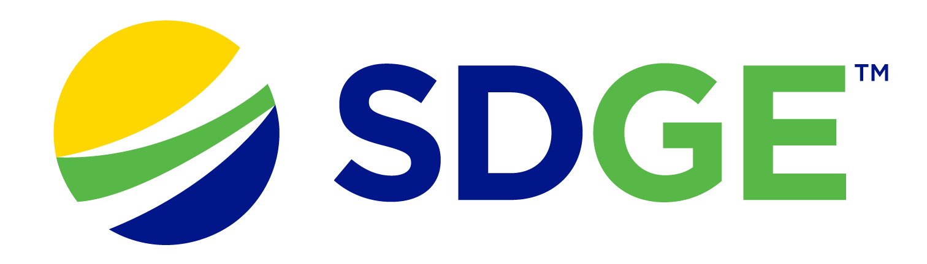

SDG&E® RESIDENTIAL AND SMALL BUSINESS CONTENT PACKAGE | FEBRUARY 2024
As a trusted community partner, we thank you for sharing our content and digital assets with your audiences – including residents, customers and employees – to help amplify our key messages in your email communications, websites or newsletters.
Best practices for using our content, social media posts and images
- IMAGES
Choose IMAGES that are relevant for your audience and feel free to mix and match what we provide. For alternate IMAGES, Unsplash.com and Canva.com offer free IMAGES that you can download.
- SDG&E logo
You’re welcome to mention our name but, due to legal requirements, please do not use our logo in any marketing materials that you create. Please only use the SDG&E logo if we provide it to you in this package or it’s publicly available online like a social post or video. You can also retweet our public posts which you’ll find on twitter.com/sdge.
- Videos
We have a library of videos you can share in your communications and SOCIAL POSTS when you visit youtube.com/c/SanDiegoGasElectric/videos. If you’d like to sort our videos by topic, visit youtube.com/c/SanDiegoGasElectric. Some videos are in Spanish. You’ll see some on TV, too!
Follow us
Find us on Facebook, Instagram, Twitter, YouTube and LinkedIn. When sharing our digital assets and content, feel free to tag SDG&E’s social media and direct your audience to sdge.com.

This month’s topics: Storm safety, paperless billing, energy-savings tips for residential and business customers, assistance programs, energy webinars

ARTICLE: ARE YOU PREPARED FOR STORMS?
The San Diego County of Emergency Services has tips on how to prepare for storms and other emergencies. You should create a plan, build an emergency kit and sign up for alerts. Check out these helpful tips.
- Create a family disaster plan at alertsandiego.org. Practice evacuating with your family to be prepared at a moment’s notice.
- Have an emergency kit ready with necessary items if you had to evacuate, including food and medication.
- Have contingency plans for different times of the day, such as an emergency while some family members are at work or school.
- Check with schools or childcare providers to make sure you are aware of emergency plans and how you will be contacted.
- In case you are separated during a disaster, discuss where to reunite because phone service may not be reliable during a disaster.
- Your pets are part of your family too. Make sure they are microchipped and that you have a pet disaster plan in place. Learn which items to have packed at sddac.com.
- Register your (and other family members’ cellphones) with Alert San Diego at alertsandiego.org to be notified if an emergency is affecting your neighborhood.
- Get free sandbags at locations throughout the County. Find one near you at alertsandiego.org. Sandbags help divert or redirect water, mud and debris from your property and help prevent soil erosion.
Have you been affected by winter storms? You may be eligible for assistance and recovery resources. Learn more at sdge.com/RecoveryResources.

SOCIAL POSTS: ARE YOU PREPARED FOR STORMS?
- Are you prepared for storms? Create a home disaster plan and practice evacuating to be prepared with only a moment’s notice. Learn more at alertsandiego.org. #SDGE #SDGEassist
- Are you prepared for storms? Have an emergency kit ready if you need to evacuate that includes food, water and medication. For ideas on what to include in your kit, visit sdge.com/checklists. #SDGE #SDGEassist
- Are you prepared for storms? Your pets are part of your family too. Make sure they are microchipped and that you have a pet disaster plan in place. Learn which items to have packed at sddac.com. #SDGE #SDGEassist
- Are you prepared for storms? Register your phone and your family’s cell phones with alertsandiego.org. It’s our region’s mass emergency notification system to get information if an emergency is affecting your area. #SDGE #SDGEassist
IMAGES: ARE YOU PREPARED FOR STORMS?
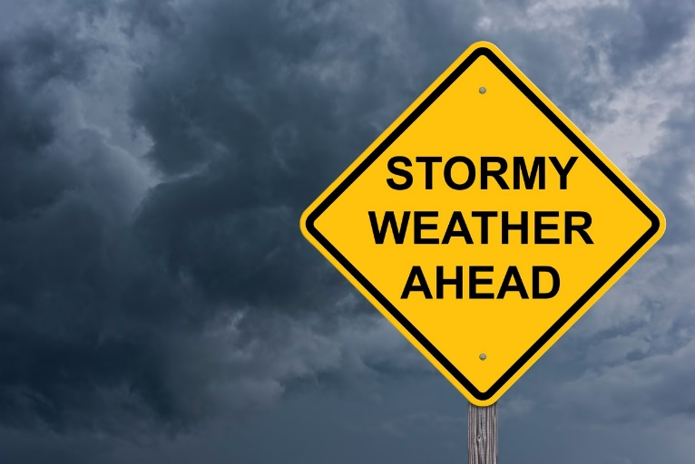

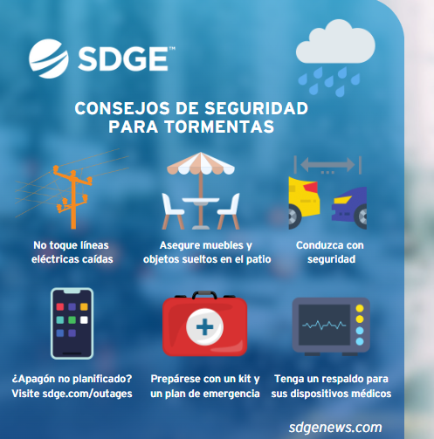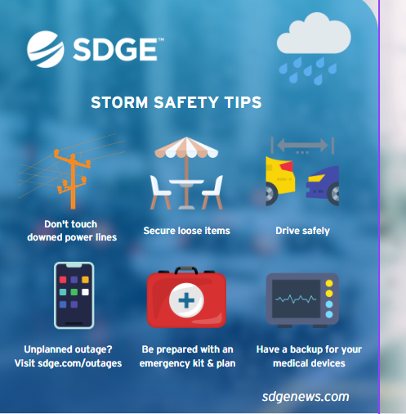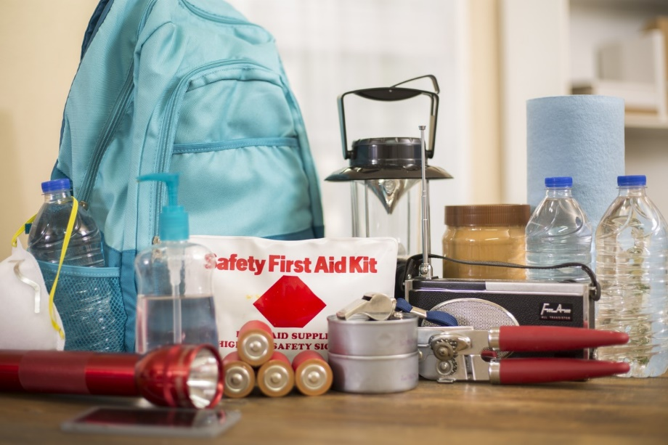

ARTICLE: 5 GREAT REASONS TO CHOOSE PAPERLESS BILLING
Looking for a more convenient way to manage your bills? Enroll in paperless billing! It simplifies the way you manage your energy bill and helps contribute to a greener planet. Here are some key benefits of making the switch to paperless billing.
- Eco-friendly: Going paperless reduces your carbon footprint by cutting down on the amount of pollution caused by making paper, printing and transporting it.
- Convenient: Access your bills and statements online or on an app from anywhere, anytime.
- Saves time: No need to mail your bill, write a check or find a stamp.
- Less clutter: Reduce the mess associated with stacks of paper bills. No more piles of paper to deal with.
- More secure: There’s less risk of lost mail or mail fraud. Paper bills sent through traditional mail are susceptible to theft, while digital statements are more secure.
Switch your energy bill to paperless billing at sdge.com/MyAccount or learn more at sdge.com/paperless.

SOCIAL POSTS: 5 GREAT REASONS TO CHOOSE PAPERLESS BILLING
- Why go paperless? It helps the environment. It's good for the planet because it reduces the need for paper. Enroll in paperless billing for your energy bill now at sdge.com/paperless. #SDGE #SDGEassist
- Why go paperless? It’s convenient. Your bills and energy use info are available anytime online. Enroll in paperless billing now at sdge.com/paperless. #SDGE #SDGEassist
- Why go paperless? It saves time. No need to mail your energy bill, write a check or find a stamp. Enroll in paperless billing now at sdge.com/paperless. #SDGE #SDGEassist
- Why go paperless? It reduces clutter. No more stacks of paper to deal with. Enroll in paperless billing now at sdge.com/paperless. #SDGE #SDGEassist
- Why go paperless? Your information is safe and secure. Enroll in paperless billing now at sdge.com/paperless. #SDGE #SDGEassist
- Why go paperless? Less paper means less waste. Enroll in paperless billing now at sdge.com/paperless. #SDGE #SDGEassist
IMAGES: 5 GREAT REASONS TO CHOOSE PAPERLESS BILLING

ARTICLE: NEED HELP WITH YOUR ENERGY BILL?

If you are having trouble paying your energy bill, you might be eligible for programs and services that can provide immediate financial assistance and help you avoid interruptions to your service. Flexible payment arrangements are also available to help you pay down past due balances. Learn more at sdge.com/Payment-Arrangements.
Check out these energy assistance programs:
- California Alternate Rates for Energy (CARE) Program: Save 30% or more every month on your bill. Find out if you qualify at sdge.com/CARE.
- Family Electric Rate Assistance (FERA) Program: If you don’t qualify for CARE and your household has 3 or more people, you may qualify for FERA. You could receive an 18% discount on your electric bill. Visit sdge.com/FERA to learn more.
- Energy Savings Assistance (ESA) Program: You may qualify to receive free energy-saving improvements for your home, like new appliances, lighting, insulation and more. Find details at sdge.com/ESA.
- Arrearage Management Plan (AMP): If you have outstanding bills and you are a CARE or FERA customer, you may be eligible for debt forgiveness. See if you qualify at sdge.com/AMP.
Even if you made a recent payment or set up a flexible payment plan with SDG&E, there may still be assistance programs available to help you. For a complete list of available offerings, visit sdge.com/assistance.

SOCIAL POSTS: NEED HELP WITH YOUR ENERGY BILL?
- If you’re behind on your energy bill, you may qualify for financial assistance. Learn more at sdge.com/assistance. #sdge #SDGEAssist
- Hardship can hit at any time – when it does, the last thing you need to worry about is your energy bill. Get help with your bill at sdge.com/assistance. #sdge #SDGEAssist
- SDG&E provides assistance programs to help you with your monthly energy bill which can include up to a 30% discount. Find out if you qualify at sdge.com/assistance. #sdge #SDGEAssist
- Whether you rent or own, you could be eligible to receive no-cost, energy-efficient home improvements that can make your home more comfortable and help reduce your energy bill. Find out if you qualify at sdge.com/ESA. #sdge #SDGEAssist

ARTICLE (translated): ¿NECESITA AYUDA CON SU FACTURA DE ENERGÍA?
Usted puede calificar para un descuento en su factura o mejoras en el hogar. Hay programas de asistencia que pueden ayudar a reducir su factura mensual de energía mientras mantiene su hogar cómodo.
- Programa de Tarifas Alternativas de Energía de California (CARE, por sus siglas en inglés): Ahorre un 30% o más cada mes en su factura. Averigüe si califica en sdge.com/CAREesp.
- Tarifa Eléctrica Familiar (FERA, por sus siglas en inglés): Si no califica para CARE y su hogar tiene 3 o más personas, puede calificar para FERA. Podría recibir un 18% de descuento en su factura de electricidad. Visite sdge.com/FERAesp para obtener más información.
- Programa de Asistencia para el Ahorro de Energía (ESA, por sus siglas en inglés): Puede calificar para recibir mejoras gratuitas para el ahorro de energía en su hogar, tales como electrodomésticos nuevos, iluminación, aislamiento y más. Encuentre los detalles en sdge.com/ESAesp.
- Arrearage Management Plan (AMP): Si tiene facturas pendientes y es participante en el programa de CARE o FERA, puede ser elegible para la condonación de deudas. Averigüe si califica en sdge.com/AMPesp.

Las aplicaciones en línea son fáciles, rápidas y convenientes. Para obtener más información, visite sdge.com/asistencia.

POSTAS SOCIALES: ¿NECESITA AYUDA CON SU FACTURA DE ENERGÍA?
- Si está atrasado en su factura de energía, puede calificar para asistencia financiera. Obtenga más información en sdge.com/asistencia. #sdge #SDGEAssist
- Dificultades pueden aparecer en cualquier momento – si aparecen, lo último que necesita es preocuparse por su factura de energía. Obtenga ayuda con su factura en sdge.com/asistencia. #sdge #SDGEAssist
- SDG&E ofrece programas de asistencia para ayudarle con su factura mensual que puede incluir hasta un 30% de descuento. Descubra si califica en sdge.com/asistencia. #sdge #SDGEAssist
- Si alquile o es propietario, podría ser elegible para recibir mejoras de eficiencia energética en su hogar, sin costo, que pueden hacer que su hogar sea más cómodo y ayuden reducir su factura de energía. Descubra si califica en sdge.com/ESAesp. #sdge #SDGEAssist

IMAGES: NEED HELP WITH YOUR ENERGY BILL?

ARTICLE: TAKE ADVANTAGE OF NO-COST TRAINING FROM ENERGY EXPERTS
Did you know that SDG&E provides webinars for business owners and trade professionals, so you can learn new skills at your own pace? And most are at no cost. You or your employees can learn about the latest in green building practices, technology and energy-saving solutions from industry experts. Certifications and continuing education units are available for many classes. Check out the class listing at sdge.com/EnergyClasses.

SOCIAL POSTS: TAKE ADVANTAGE OF NO-COST TRAININGS FROM ENERGY EXPERTS
- Did you know SDG&E provides energy education and training webinars at no cost? These on-demand webinars are offered at introductory, intermediate and advanced levels. See the webinar list at sdge.com/EnergyClasses. #sdge #SDGEassist
- Learn the latest in green building design, operations, maintenance and technology at no-cost energy webinars led by industry experts. See the on-demand webinar list at sdge.com/EnergyClasses. #sdge #SDGEassist
- Enroll in a no-cost, on-demand energy topic webinar. Energy education and training can give you and your employees the knowledge and skills that customers value. Check out the webinar list at sdge.com/EnergyClasses. #sdge #SDGEassist

imageS: TAKE ADVANTAGE OF NO-COST TRAININGS FROM ENERGY EXPERTS
ARTICLE: HOW YOUR BUSINESS CAN SAVE ON energy COSTS
It's important for businesses to be both eco-friendly and cost-effective. From using energy-efficient technologies to making simple changes in how things are done every day, these tips can guide businesses towards a more planet- and budget-friendly path.
- Did you know ceiling fans help in the colder months too? Change the rotation of your fan blades to clockwise, which will pull warm air down and spread it throughout the room.
- Install motion sensors to automatically turn off lights in unoccupied areas.
- Seal gaps and insulate windows and doors to prevent drafts and reduce the need for heating or cooling.
- Use smart power strips to cut off power to electronic devices when they are not in use.
- Encourage remote work to reduce the need for office energy consumption.
- Maximize natural light by positioning workspaces near windows and using light-colored paint to enhance reflection.
- Conduct regular energy audits to identify areas for improvement and implement energy-saving measures.
- Schedule regular maintenance for heating, ventilation, and air conditioning (HVAC) systems to ensure optimal efficiency.
- Embrace digital documentation and communication to reduce the need for paper and printing. Learn more at sdge.com/paperless.
- Set water heaters at lower temperatures and insulate hot water pipes to conserve energy. Check out water heater rebates up to $500 on the purchase of new, qualifying energy-efficient gas water heaters at sdge.com/rebates.
Implementing these energy-saving practices can not only reduce operational costs but also contribute to a more sustainable and environmentally friendly workplace. Visit sdge.com/MyBusiness for more helpful energy-saving tips, tools and programs for your business.

SOCIAL POSTS: HOW YOUR BUSINESS CAN SAVE ON energy COSTS
Use any of the tips above and then add:
Visit sdge.com/MyBusiness for more helpful energy-saving tips. #sdge #SDGEassist
IMAGES: HOW YOUR BUSINESS CAN SAVE ON energy COSTS
JUST POSTS – Residential
- Stream on the right device. When streaming content, choose the smallest device that makes sense for the number of people watching. Game consoles can use 10 times more power than streaming through a tablet or laptop. Get more energy-saving tips at sdge.com/MyEnergy. #sdge #SDGEassist
- Charge while you sleep. Before you go to bed, plug in your devices so they can recharge during super off-peak hours. Get more energy-saving tips at sdge.com/MyEnergy. #sdge #SDGEassist
- Sign up for Level Pay. You can have a more predictable energy bill by signing up for SDG&E’s Level Pay Plan. This budgeting tool automatically evens out the monthly highs and lows so your energy bills are more consistent. When you know what to expect, it’s easier to plan your budget. Sign up at sdge.com/LPP. #sdge #SDGEassist
- Unplug and save. Unplugging small appliances, entertainment systems and electronic devices when not in use can save your household up to $100 per year. Using a power strip with on/off control can help. Save even more if you can power down between 4 p.m. and 9 p.m. Get more energy-saving tips at sdge.com/MyEnergy. #sdge #SDGEassist
JUST POSTS – Business
- Looking for ways to save energy at your business or office? Check out sdge.com/MyBusiness for tips. #sdge #SDGEassist
- Insulate water heaters and hot water supply pipes to save energy. For more energy-saving tips, visit sdge.com/MyBusiness. #sdge #SDGEassist
- Encourage employees to shut down computers, monitors, and printers at the end of the day. For more energy-saving tips, visit sdge.com/MyBusiness. #sdge #SDGEassist
- Set computers to go into sleep mode when not in use and adjust power management settings to conserve energy. For more energy-saving tips, visit sdge.com/MyBusiness. #sdge #SDGEassist
- Print documents only when necessary and use double-sided printing to reduce paper usage. For more energy-saving tips, visit sdge.com/MyBusiness. #sdge #SDGEassist

