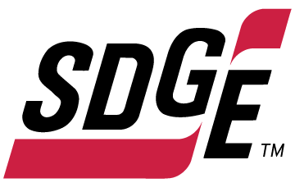

SDG&E RESIDENTIAL CONTENT PACKAGE | FEBRUARY 2022
As a trusted community partner, we thank you in advance for sharing these digital assets with your audiences, including residents, customers and employees to help amplify our monthly messages. Here are social media posts, articles and photos you are welcome to use in email communications, websites or newsletters. There are several images with each posting. Please choose images that fit your audience and feel free to mix and match.

Follow Us
You can find us on Facebook, Instagram, Twitter, YouTube and LinkedIn. When sharing these messages in your social posts, feel free to tag SDG&E’s social media accounts and direct your audience to sdge.com.

This month’s topics: Gas heating bill tips, water heater safety and energy efficient tips, medical baseline assistance program

Article 1: 3 WAYS TO CUT YOUR NATURAL GAS WINTER HEATING BILL
Lower your winter natural gas bill with these energy-saving tips. Check out these quick and easy ways to lower your bill while staying warm and comfortable.
- Control humidity:
Dry winter air pulls moisture from your skin, making you feel colder. Instead of reaching for the thermostat, use a humidifier to keep your home humidity between 30 – 50%. You’ll feel warmer with some humidity in the air.
- Heat efficiently:
You can save as much as 10% per year on heating and cooling by turning your thermostat down 7° – 10°F for 8 hours a day in the winter.
- Use a space heater:
Today’s portable space heaters are energy efficient and can warm the room you’re in so you don’t have to heat the whole house. Make sure your model has a tip-over safety switch, always operate it on a solid, flat surface and turn it off when you leave the room. Plug space heaters directly into wall outlets, not extension cords or power strips. Also, keep space heaters at least three feet away from items that can burn like furniture.
Visit sdge.com/winter for more savings tips.

Social posts: 3 WAYS TO CUT YOUR NATURAL GAS WINTER HEATING BILL
Use any bullets above and add: For more winter energy-savings tips, visit sdge.com/winter. #sdge #SDGEassist

Images: 3 WAYS TO CUT YOUR NATURAL GAS WINTER HEATING BILL
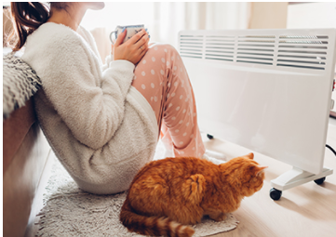

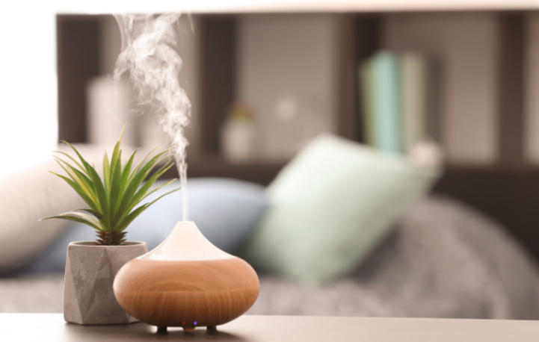

Article 2: WATER HEATER TIPS PUT SAFETY AND SAVINGS ON TAP
Did you know that when you use water, you are using energy? The U.S. Department of Energy found that water heaters account for about 18% of your total energy bill. Here are some water heater tips to help keep you safe and lower your energy bill.
- Set your water heater thermostat to 120 degrees or less. You’ll save energy and avoid scalding your hands and body. Lower temps also slow mineral buildup and corrosion in your water heater and pipes.
- Insulate your storage tank and the first 6 feet of both the hot water and cold water pipes connected to the unit. This helps prevent fires and conserves heat so your system doesn’t have to work so hard to reheat it.
- Install a timer to turn your water heater off when you go to bed. It conserves energy and can add years to the unit’s life.
- If your water heater is more than ten years old and in good condition, consider installing a heat trap. Most modern water heaters have a built-in heat trap.
- Make sure your water heater restraints are secured to the wall studs to prevent movement or toppling over during an earthquake.
- Using cold water for laundry and basic grooming helps reduce your bill.
- Keep the area around the water heater clean, free of items around it and well-ventilated to prevent it from working harder.
- It’s a good practice to drain your water heater every year or so. It helps remove sediment that can impede heat transfer which lowers the efficiency of the unit.
Visit sdge.com/winter for more safety and energy-saving tips.

Social posts: WATER HEATER TIPS PUT SAFETY AND SAVINGS ON TAP
Use any bullet above and add: For more safety and energy-savings tips, visit sdge.com/winter. #sdge #SDGEassist

Images: WATER HEATER TIPS PUT SAFETY AND SAVINGS ON TAP
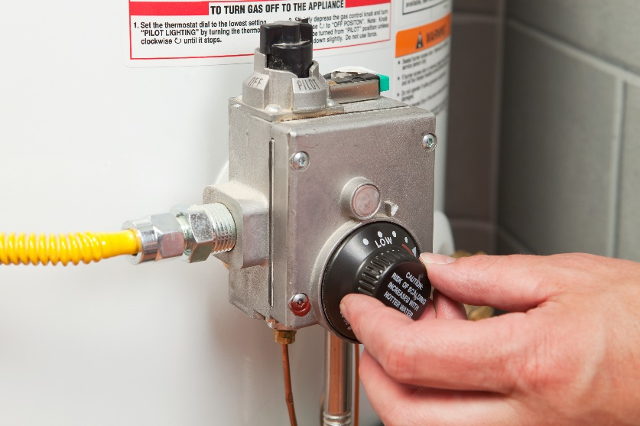
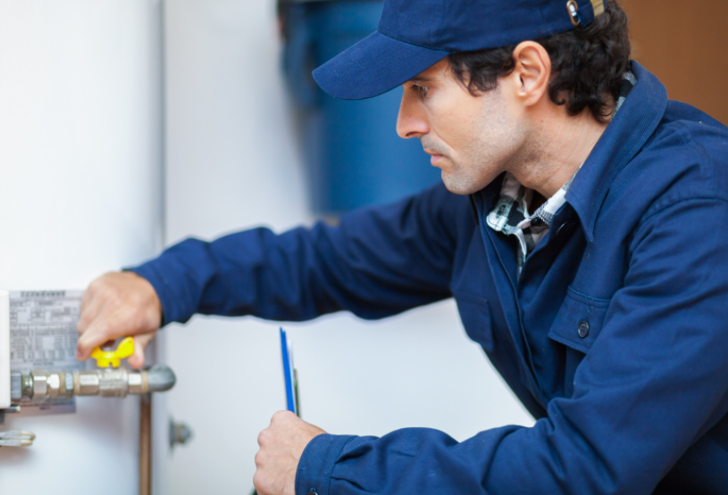
Article 3: Medical needs? Here’s your prescription for savings.
Certain medical needs may qualify you or someone in your home for savings every month on your gas and electric bill. Apply for the Medical Baseline Allowance program if you need to use more energy due to a qualifying medical condition or to prevent an existing condition from getting worse. Examples include:
A requirement for permanent space heating or cooling due to paraplegia, quadriplegia, hemiplegia, multiple sclerosis, scleroderma, a compromised immune system or a life-threatening illness.
Required use of a life-support device, such as an aerosol tent, apnea monitor, kidney dialysis machine, motorized wheelchair or respirator (devices used for therapy don’t qualify; only medical devices that sustain life or are needed for mobility).
To get a Medical Baseline Allowance application and more information, visit sdge.com/medical. Eligibility requirements include having a physician sign your application to certify the medical need.
Social posts: Medical needs? Here’s your prescription for savings.
- If you or someone in your household has a qualifying medical condition or a need for certain medical devices that require electricity, you may qualify for SDG&E’s Medical Baseline Allowance Program. Apply at sdge.com/medical. #sdge #SDGEassist
- SDG&E’s Medical Baseline Allowance Program provides an additional amount of gas and electricity at the lowest energy rates. Get details at sdge.com/medical. #sdge #SDGEassist
- Anyone who uses certain medical devices or needs space heating or air conditioning because of a medical condition may qualify for SDG&E’s Medical Baseline Allowance Program. Learn more at sdge.com/medical. #sdge #SDGEassist

Article 3 translated: ¿Hay necesidades médicas? Obtenga esta receta para ahorrar.
Ciertas necesidades médicas pueden hacer que usted o alguien que vive en su casa cumpla con los requisitos para ahorrar cada mes en su factura de gas y electricidad. Solicite el programa de Asignación Médica Inicial si necesita consumir más energía debido a una enfermedad que cumpla con las condiciones o para evitar que una condición existente empeore. Por ejemplo:
Requerir calefacción o aire acondicionado ambiental permanente debido a paraplejia, tetraplejia, hemiplejia, esclerosis múltiple, esclerodermia, un sistema inmunitario afectado o una enfermedad potencialmente mortal.
Requerir el uso de un dispositivo de soporte vital, como una tienda de nebulización, monitor de apnea, máquina para diálisis del riñón, silla de ruedas motorizada o respirador (los dispositivos usados para terapia no cumplen con los requisitos; únicamente dispositivos médicos que sustenten la vida o se necesiten para movilidad).
Para obtener un formulario de solicitud para el programa de Asignación Médica Inicial y más información, visite sdge.com/programa-medico. Los requisitos para tener derecho a participar incluyen el que un médico firme su solicitud para certificar la necesidad médica.
Postas sociales: ¿Hay necesidades médicas? Obtenga esta receta para ahorrar.
- Si usted o alguien en su hogar tiene una condición médica calificada o una necesidad de ciertos dispositivos médicos, puede calificar para el Programa de Asignación Médica Inicial de SDG&E. Solicite en sdge.com/programa-medico. #sdge #SDGEassist
- El Programa de Asignación Médica Inicial de SDG&E proporciona una cantidad adicional de gas y electricidad a las tarifas de energía más bajas. Obtenga detalles en sdge.com/programa-medico. #sdge #SDGEassist
- Cualquier persona que use ciertos dispositivos médicos o necesite calefacción o aire acondicionado debido a una afección médica puede calificar para el Programa de Asignación Médica Inicial de SDG&E. Obtenga más información en sdge.com/programa-medico. #sdge #SDGEassist

Images: Medical needs? Here’s your prescription for savings.

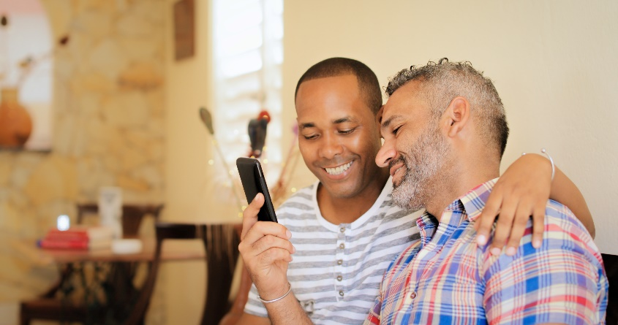
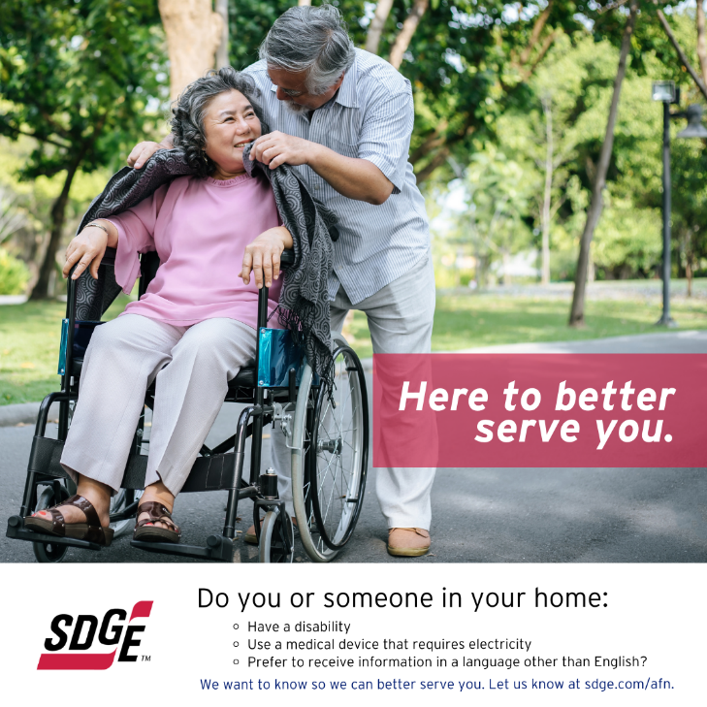
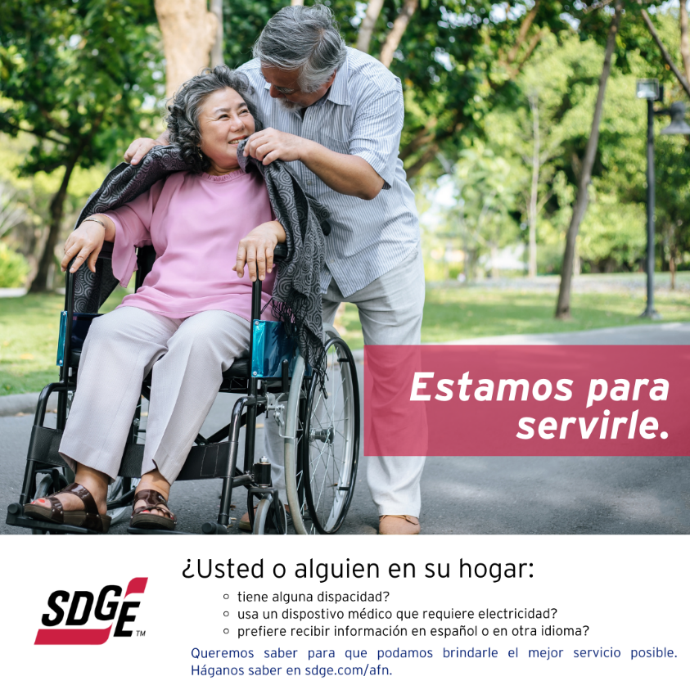

General social post:
