SDG&E RESIDENTIAL AND SMALL BUSINESS CONTENT PACKAGE | FEBRUARY 2023
As a trusted community partner, we thank you for sharing our content and digital assets with your audiences – including residents, customers and employees – to help amplify our key messages in your email communications, websites or newsletters.
Best practices for using our content, social media posts and images
- Images
Choose images that are relevant for your audience and feel free to mix and match what we provide. For alternate images, Unsplash.com and Canva.com offer free images that you can download.
- SDG&E logo
You’re welcome to mention our name but, due to legal requirements, please do not use our logo in any marketing materials that you create. Please only use the SDG&E logo if we provide it to you in this package or it’s publicly available online like a social post or video. You can also retweet our public posts which you’ll find on twitter.com/sdge.
- Videos
We have a library of videos you can share in your communications and social posts when you visit youtube.com/c/SanDiegoGasElectric/videos. If you’d like to sort our videos by topic, visit youtube.com/c/SanDiegoGasElectric. Some videos are in Spanish. You’ll see some on TV, too!
Follow us
Find us on Facebook, Instagram, Twitter, YouTube and LinkedIn. When sharing our digital assets and content, feel free to tag SDG&E’s social media and direct your audience to sdge.com.

Article: how to save on your energy costs
Natural gas prices are at a historic high in the Western U.S. region which means winter energy bills are rising, too. SDG&E has programs and services to help mitigate these increases. Visit sdge.com/assistance to find out if you qualify for debt forgiveness, one-time payments, monthly bill discounts and more. For more information, you can read this SDG&E NewsCenter article at sdgenews.com.
Space heating and water heating are some of the largest energy expenses in any home. SDG&E has natural gas energy-saving tips to help you save on your bill during the cold weather.
- Install a smart thermostat. Lower your thermostat when you are asleep or away from home. You can do this automatically without sacrificing comfort by installing an automatic setback or programmable thermostat. Enroll in SDG&E’s Smart Thermostat Program and earn up to $95 in rewards. Learn more at sdge.com/thermostat. If you are a CARE or FERA customer, you may qualify for a no-cost smart thermostat. Get details at sdge.com/residential.
- Schedule an SDG&E gas appliance check: Book your no-cost appointment at sdge.com/MyAccount or on SDG&E’s mobile app available in the App Store or Google Play.
- Install efficient showerheads. Showering accounts for about 40% of your home's hot water use but you can cut costs without sacrificing comfort. Energy-efficient showerheads can reduce hot water use without compromising water pressure.
- Ensure vents are properly ventilated. Move furniture and drapes to allow for clear circulation. Don’t keep vents closed to save energy because it can change the way the air is distributed and cause an imbalance to your HVAC system – making it work harder.
- Seal and insulate your ducts. Air ducts are an important part of your home and if they are poorly sealed or insulated, it’s likely it’s contributing to higher energy bills.
- Consider investing in a tankless water heater that provides hot water only as it’s needed. They don’t produce the standby energy losses associated with storage water heaters. Tankless water heaters are particularly good for smaller households.
- Be mindful to not waste hot water. To conserve hot water, you can fix leaky faucets, pipes and showerheads, insulate accessible hot water lines and install low-flow fixtures. If you’re in the market for a new dishwasher or clothes washer, consider buying an ENERGY STAR-certified model. Also, aerators are inexpensive to replace and they can be one of the most cost-effective water conservation measures.
Visit sdge.com/MyEnergy for more bill-saving and energy management resources.
SPANISH Article: CÓMO AHORRAR EN SUS COSTOS DE ENERGÍA
Los precios del gas natural han alcanzado un máximo histórico en la región occidental de los EE. UU., lo que significa que las facturas de energía de invierno también están aumentando. SDG&E tiene programas y servicios para ayudar a mitigar estos aumentos. Visite sdge.com/asistencia para ver si califica para la condonación de deudas, pagos únicos, descuentos en sus facturas mensuales y más. Para obtener más información, lea este artículo publicado en el centro de noticias de SDG&E en sdgenews.com.
La calefacción de espacios y el calentamiento de agua son algunos de los mayores gastos de energía en cualquier hogar. SDG&E tiene consejos relacionados con el gas natural para ayudarle a ahorrar energía y ahorrar en su factura durante el clima frío.
- Instale un termostato inteligente. Baje el termostato cuando esté dormido o fuera de casa. Puede hacer esto automáticamente sin sacrificar la comodidad instalando un termostato programable o de reducción automática. Inscríbase en el Programa de Termostato Inteligente de SDG&E y gane hasta $95 en recompensas. Obtenga más información en sdge.com/thermostat. Si es cliente de CARE o FERA, también puede calificar para recibir un termostato inteligente sin costo alguno. Obtenga más detalles en sdge.com/residential.
- Programe una revisión de electrodomésticos de gas de SDG&E: reserve su cita sin costo en sdge.com/MyAccount o en la aplicación móvil de SDG&E, disponible en la App Store o Google Play.
- Instale cabezales de ducha eficientes. La ducha representa aprox. el 40 % del uso de agua caliente de su hogar, pero puede reducir los costos sin sacrificar la comodidad. Los cabezales de ducha de bajo consumo pueden reducir el uso de agua caliente sin comprometer la presión del agua.
- Asegúrese de que las rejillas de ventilación estén correctamente ventiladas. Mueva los muebles y las cortinas para permitir una circulación libre. No mantenga las rejillas de ventilación cerradas para ahorrar energía porque puede cambiar la forma en que se distribuye el aire y resultar en un desequilibrio en su sistema HVAC, haciendo que funcione en exceso.
- Selle y aísle sus conductos de aire. Los conductos de aire son una parte importante de su hogar y si no están bien sellados o aislados, es probable que contribuyan a facturas de energía más altas.
- Considere invertir en un calentador de agua sin tanque que proporcione agua caliente solo cuando sea necesario. No producen las pérdidas de energía de reserva asociadas con los calentadores de agua de almacenamiento. Los calentadores de agua sin tanque son especialmente buenos para los hogares más pequeños.
- Tenga cuidado de no desperdiciar agua caliente. Para conservar el agua caliente, puede reparar grifos, tuberías y cabezales de ducha que gotean, aislar las líneas de agua caliente accesibles e instalar accesorios de bajo flujo. Si está buscando un nuevo lavavajillas o lavadora de ropa, considere comprar un modelo con certificación ENERGY STAR. Además, los aireadores no son costosos de reemplazar y pueden ser una de las medidas de conservación de agua más rentables.
Visite sdge.com/MiEnergía para obtener más recursos para ayudarle a administrar su consumo de energía y ahorrar en sus facturas.

Social posts: how to save on your energy costs
- SDG&E may be able to help customers who are having difficulty paying their bill. Information about assistance programs ranging from bill discounts, bill payment plans and debt relief, can be found at sdge.com/assistance. #sdge #SDGEassist
- Es posible que SDG&E pueda ayudar a los clientes que están teniendo dificultades para pagar sus facturas. Para encontrar información sobre recursos de asistencia, como los programas de descuento, planes de pago y la condonación de deudas, visitesdge.com/asistencia. #sdge #SDGEasistencia

OR: Use any of the tips in the above article, then add:
- Visit sdge.com/MyEnergy for additional winter energy-savings tips. #sdge #SDGEassist
- Visite sdge.com/MiEnergía para obtener consejos adicionales para ahorrar energía durante el invierno. #sdge #SDGEasistencia

Images: how to save on your energy costs
Instagram/Facebook:
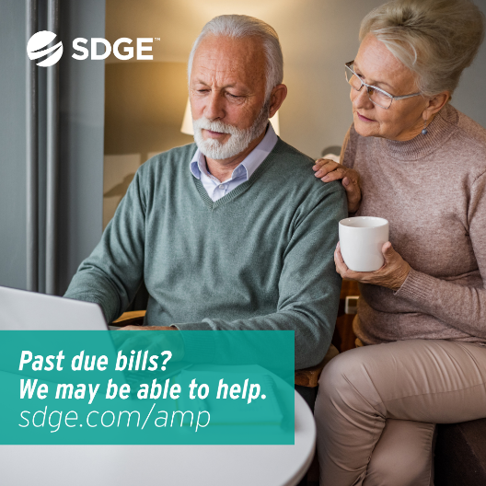
Twitter:
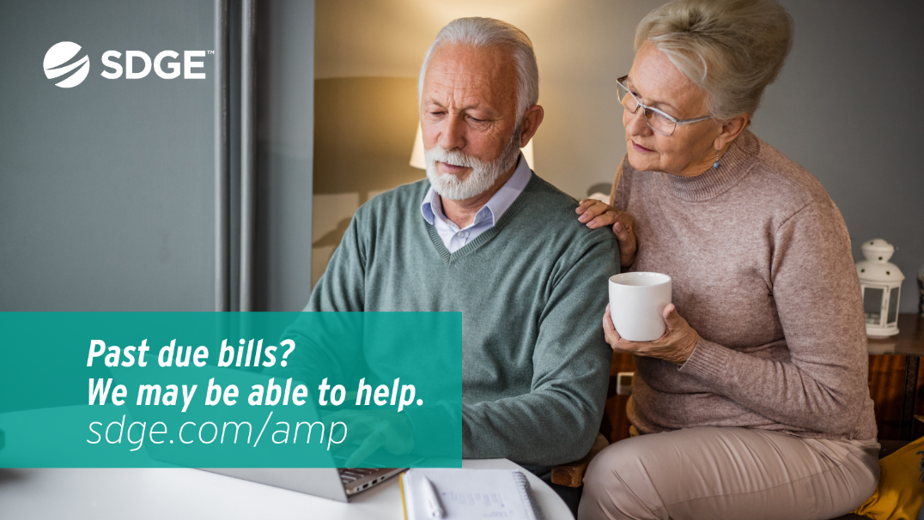

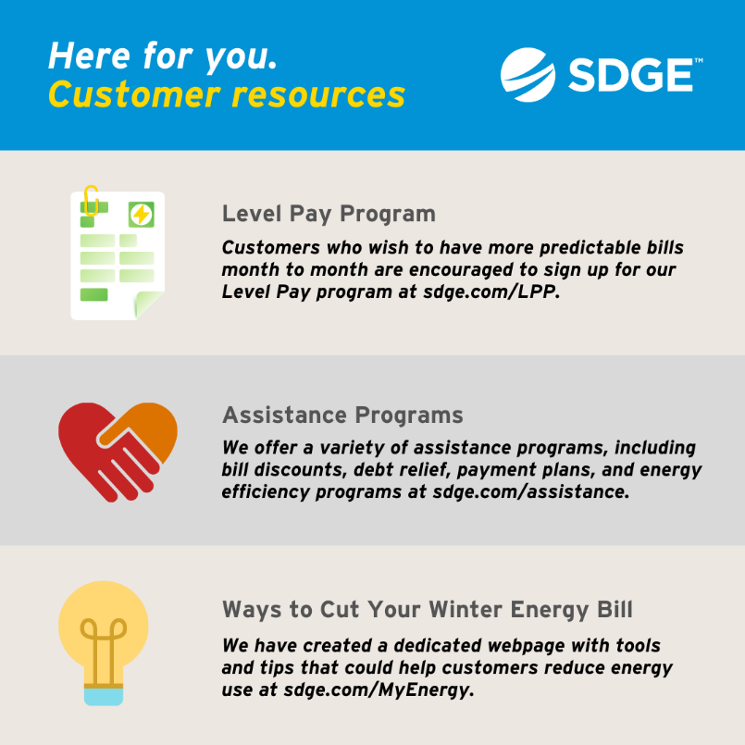
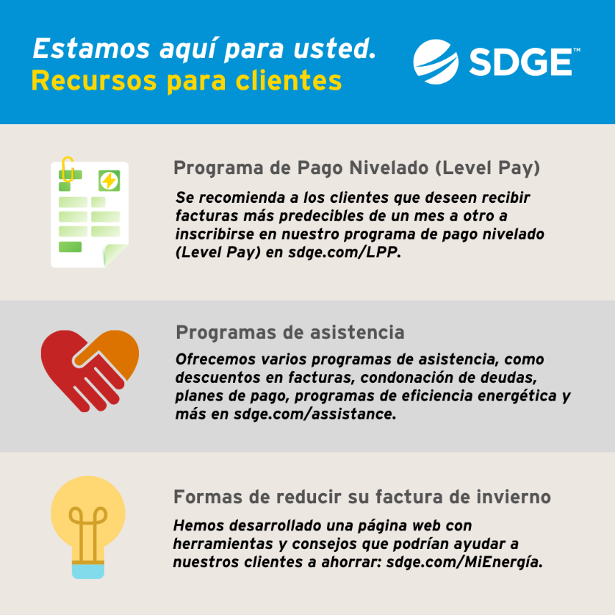
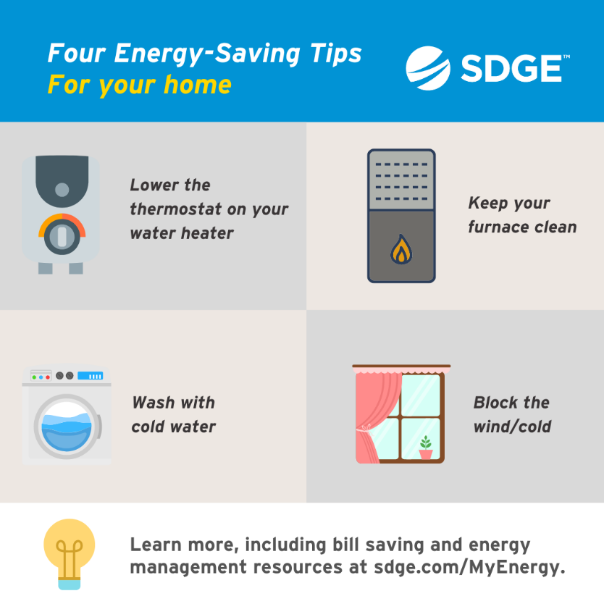
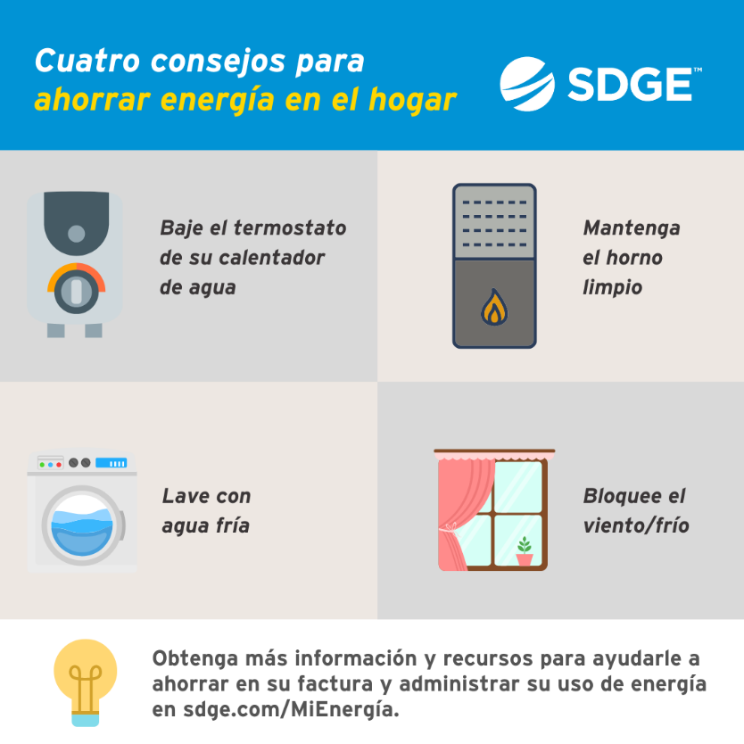
Article: energy bill assistance is available
Visit sdge.com/assistance to find out if you qualify for SDG&E programs and services including debt forgiveness, monthly discounts and payment arrangements. Recently, SDG&E announced the expansion of its Neighbor-to-Neighbor utility payment assistance program, which is making $1 million available in shareholder dollars to offset overdue bills for customers who are at least three months or more behind on payment and do not qualify for the federal Low-Income Home Energy Assistance Program (LIHEAP).
SPANISH Article: HAY ASISTENCIA DISPONIBLE PARA AYUDAR CON LAS FACTURAS DE ENERGÍA
Visite sdge.com/asistencia para ver si califica para los programas y servicios de SDG&E, incluida la condonación de deudas, descuentos mensuales y arreglos de pago. Recientemente, SDG&E anunció la expansión de su programa de asistencia para el pago de servicios públicos Neighbor-to-Neighbor, que está poniendo a disposición $1 millón en fondos de accionistas para compensar las facturas vencidas de clientes que están atrasados al menos tres meses o más ​​en el pago de sus facturas que no califican para el Programa federal de Asistencia de Energía para Hogares de Bajos Ingresos (LIHEAP, por sus siglas en inglés).
Social posts: energy bill assistance is available
- Find out if you qualify for SDG&E programs and services including debt forgiveness, monthly discounts and payment arrangements. Visit sdge.com/assistance. #sdge #SDGEassist
- SDG&E is providing $1M to help offset overdue bills for customers at least three months behind on payments. Get details at sdge.com/assistance. #sdge #SDGEassist
- SDG&E is expanding its Neighbor-to-Neighbor payment assistance program to offset customer overdue bills. Learn more at sdge.com/assistance. #sdge #SDGEassist
Social posts: energy bill assistance is available (translated)
- Vea si califica para los programas y servicios de SDG&E, incluida la condonación de deudas, descuentos mensuales y arreglos de pago. Visitesdge.com/asistencia. #sdge #SDGEasistencia
- SDG&E está proporcionando $1 millón para ayudar a compensar las facturas vencidas de los clientes que están al menos tres meses atrasados en sus pagos. Obtenga más información ensdge.com/asistencia. #sdge #SDGEasistencia
- SDG&E está ampliado su programa de asistencia Neighbor-to-Neighbor para ayudar a sus clientes con sus facturas vencidas. Obtenga más información ensdge.com/asistencia. #sdge #SDGEasistencia

Images: energy bill assistance is available
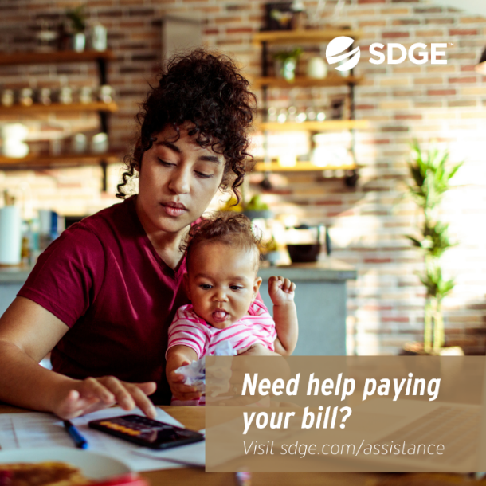
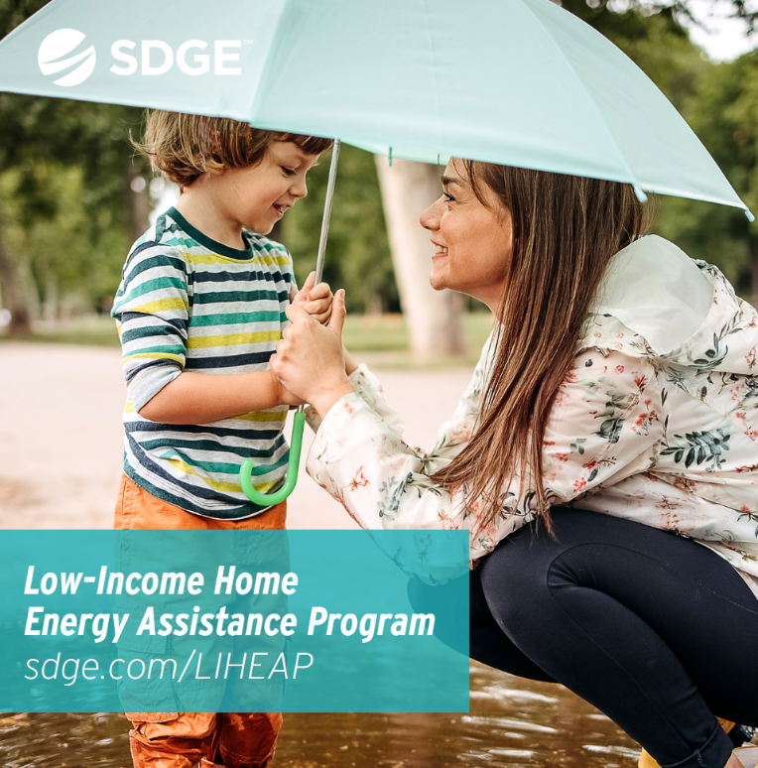

Article: WINTER ENERGY-SAVINGS TIPS FOR YOUR BUSINESS
There are a variety of ways to save money when it comes to your business’s energy use. Try these tips to help trim your winter energy bills.
- Adjust your thermostat. When you’re in your office or workplace, set the thermostat as low as is comfortable. At night or when you’re out of the office, turn it back 10 – 15 degrees to save around 10% a year. Invest in a smart thermostat and enroll in SDG&E’s Smart Thermostat Program. You’ll be rewarded $50 for each thermostat you register (up to four thermostats). Get details at sdge.com/Business-Thermostat.
- Tune your HVAC. Just as a tune-up for your car can improve gas mileage, an annual tune-up of your heating and cooling system can improve efficiency and comfort. Schedule a no-cost energy audit at sdge.com/BES. You may also receive installed energy-efficient products at no cost or a discount!
- Weatherize your business. Insulate your facility and caulk drafty doors and windows to help prevent heat from escaping. Insulating your business also helps keep the cool air in during the warmer months.
- Upgrade your lighting. Using LED lighting could help your business save year-round. They are also sturdier and safer than incandescent bulbs.
- Switch off or power down your electronic devices on unused equipment when not in use. Turning off one computer and monitor nightly and on weekends can save up to $80 a year – savings like those can really add up! Also, use smart power strips.
Get more helpful winter energy-saving and safety tips at sdge.com/MyBusiness.

Social posts: WINTER energy-SAVINGS TIPS FOR YOUR BUSINESS
- Winter bills could soar due to extraordinary market conditions in the Pacific region. SDG&E is offering business customers bill-saving and energy management resources at sdge.com/MyBusiness. #sdge #SDGEassist
- Las facturas de invierno podrían aumentar considerablemente debido a las condiciones extraordinarias del mercado de gas en el oeste del país. SDG&E ofreciendo recursos a nuestros clientes comerciales para ayudarlos a ahorrar en sus facturas y administrar su consumo de energía en sdge.com/MyBusiness. #sdge #SDGEassist
- Unprecedented natural gas market conditions have impacted both electric and natural gas rates in the Pacific region. Get energy-saving tips for your business at sdge.com/MyBusiness. #sdge #SDGEassist
- Las condiciones extraordinarias del mercado de gas natural han afectado las tarifas de electricidad y gas en el oeste del país. A continuación se presentan consejos para ayudarlo a ahorrar energía en su negocio. Obtenga más información en sdge.com/ MyBusiness. #sdge #SDGEassist

Images: WINTER ENERGY-SAVINGS TIPS FOR YOUR BUSINESS
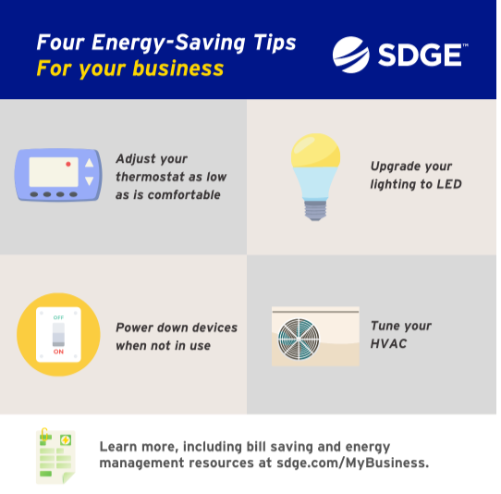
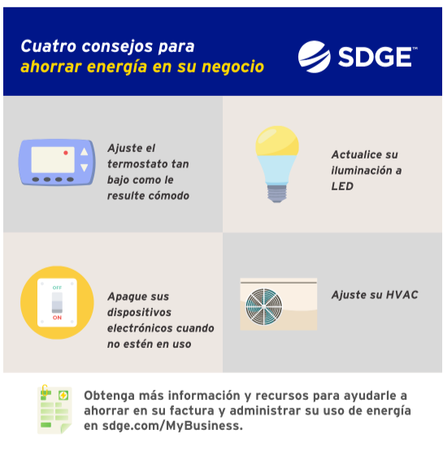

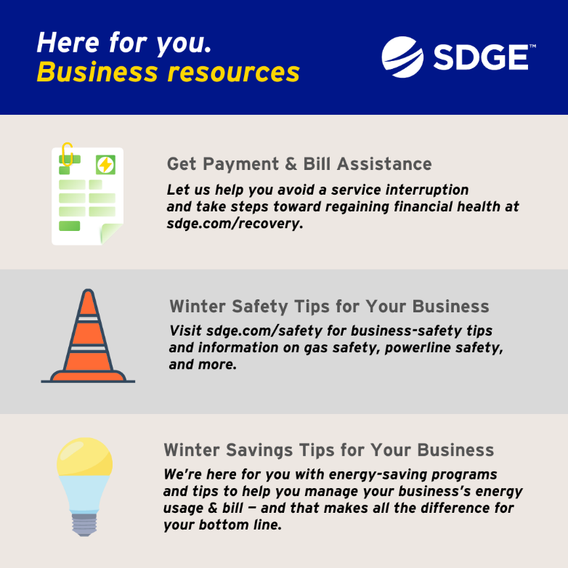

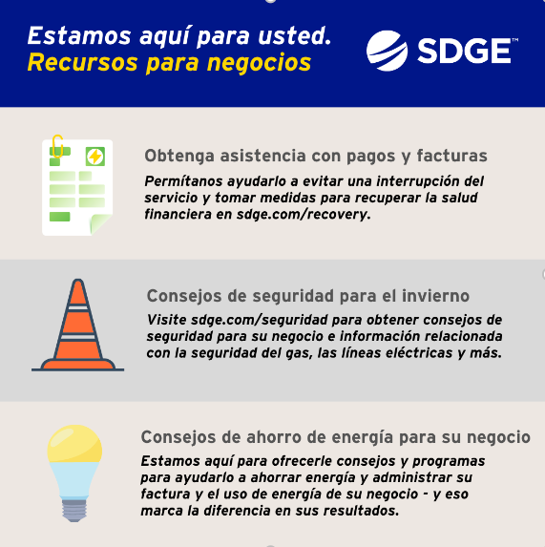
MISC SOCIAL POSTS:
Energy Alerts
- Natural gas prices are at historical highs in the Pacific region. Keep tabs on your energy use and costs with alerts by text or email. Log in to My Account or the SDG&E mobile app to update your alert settings. Download the app on the App Store or Google Play. For more information, visit sdge.com/alerts. #sdge #SDGEassist
- Energy Alerts are a great way to keep track of your energy costs and use. With My Account online and our mobile app, you can manage your Energy Alert preferences. Visit sdge.com/alerts for more info. #sdge #SDGEassist

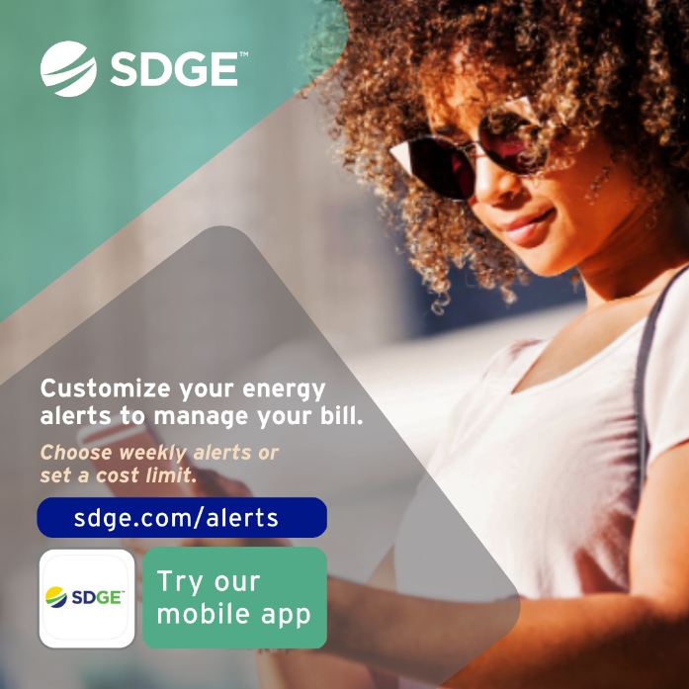
Gas Appliance Checks
- With cooler weather moving in, now is the time to get your gas furnace inspected to ensure you and your family are safe. Schedule your no-cost SDG&E inspection online in My Account. Login to sdge.com/MyAccount, select Services, Services Overview and then Gas Appliance Check. #sdge #SDGEassist
- Get your gas appliances evaluated to help prevent carbon monoxide poisoning. Schedule your no-cost SDG&E inspection online in My Account. Login to sdge.com/MyAccount, select Services, Services Overview and then Gas Appliance Check. #sdge #SDGEassist
- SDG&E can inspect your gas appliances for safety, make minor adjustments and light heater pilots. Schedule your no-cost SDG&E inspection in My Account. Login to sdge.com/MyAccount, select Services, Services Overview and then Gas Appliance Check. #sdge #SDGEassist
- SDG&E will visit your home and check that your gas appliances are safe. Schedule your no-cost SDG&E inspection in My Account. Login to sdge.com/MyAccount, select Services, Services Overview and then Gas Appliance Check. #sdge #SDGEassist

Images: Gas Appliance Checks
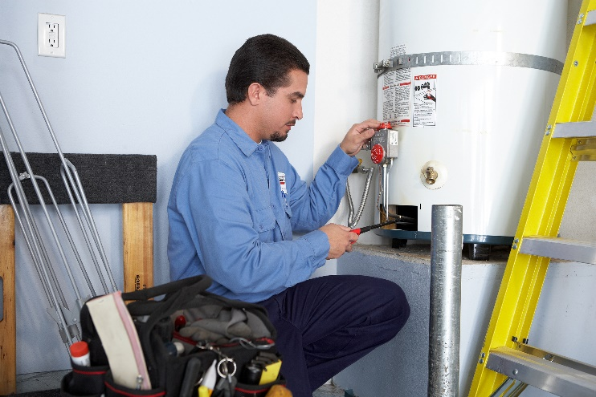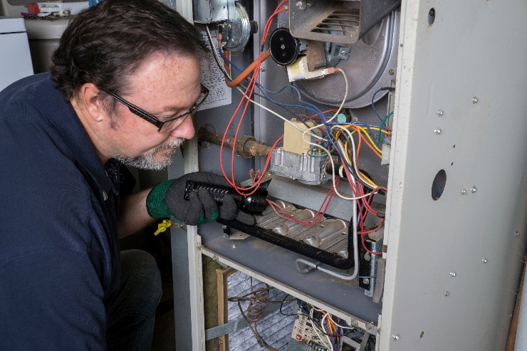

Social posts promoting rebates:
The new Golden State Rebates give qualifying customers rebates toward the purchase of energy-efficient products such as smart thermostats, gas tank water heaters, heat pump water heaters and more. Learn more at sdge.com/rebates. #sdge #SDGEassist

Los nuevos reembolsos de Golden State brindan a los clientes calificados recibir reembolsos para la compra de productos de eficiencia energética, como termostatos inteligentes, calentadores de agua con tanque de gas, calentadores de agua con bomba de calor y más. Obtenga más información en sdge.com/rebates. #sdge #SDGEassist

