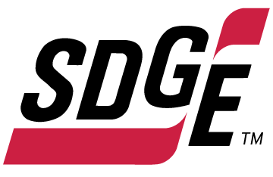
SDG&E BUSINESS CONTENT PACKAGE | FEBRUARY 2022
As a trusted community partner, we thank you in advance for sharing these digital assets with your audiences, including residents, customers and employees to help amplify our monthly messages. Here are social media posts, articles and photos you are welcome to use in email communications, websites or newsletters. There are several images with each posting. Please choose images that fit your audience and feel free to mix and match.

Follow Us
You can find us on Facebook, Instagram, Twitter, YouTube and LinkedIn. When sharing these messages in your social posts, feel free to tag SDG&E’s social media accounts and direct your audience to sdge.com.

This month’s topics: winter energy-saving and safety tips at work, on-demand energy webinars

Article 1: WINTER energy-saving tips for your business
There are a variety of ways to save money when it comes to your business’s energy use. Try these tips to help trim your winter energy bills.
- Adjust your thermostat. When you’re in your office or workplace, set your thermostat as low as is comfortable. At night or when you’re out of the office, turn it back 10 – 15 degrees to save around 10% a year. Invest in a smart thermostat and get a smart deal of $50 back on your purchase of a new, approved smart thermostat – up to four thermostats. Learn more at sdge.com/business-thermostat.
- Tune your HVAC. Just as a tune-up for your car can improve gas mileage, an annual tune-up of your heating and cooling system can improve efficiency and comfort. Schedule a no-cost energy assessment at willdan.com/sdge. You may qualify for simple energy upgrades for your business at little to no cost!
- Weatherize your office. Insulate your facility and caulk drafty doors and windows to help prevent heat from escaping. Insulating your business also helps keep the cool air in during the warmer months.
- Upgrade your lighting. Using LED lighting could help your business save year-round. Another bonus, LEDs are sturdier and safer.
- Switch off or power down your electronic devices on unused equipment when not in use. Turning off one computer and monitor nightly and on weekends can save up to $80 a year – savings like those can really add up! Use smart power strips to easily turn on and off multiple electronic devices.
Get more helpful winter energy-saving and safety tips at sdge.com/business-winter.

Social posts: Article 1: WINTER energy-saving tips for your business
- Plug leaks in your store or facility with weatherstripping and caulking. Locating leaks helps prevent costly heating loss. Weatherizing your business allows you to efficiently manage your property’s ventilation. #sdge # SDGEassist
- Install occupancy sensors to automatically turn off lighting when not in use. Be careful not to install the sensor in an obstructed location, like behind a coat rack, so that it can properly detect motion. #sdge # SDGEassist
- Switch from a desktop to a laptop computer. Laptops use around 80% less energy! To maximize savings with a laptop, put the AC adapter in a smart power strip that can be turned off. The transformer in the adapter draws power even when the laptop isn’t plugged in. #sdge #SDGEassist
- Adjust your thermostat. When you’re in your office or workplace, set your thermostat as low as is comfortable. At night or when you’re out of the office, turn it back 10 – 15 degrees to save around 10% a year. Invest in a smart thermostat and get a smart deal of $50 back on your purchase of a new, approved smart thermostat – up to four thermostats. Learn more at sdge.com/business-thermostat. #sdge #SDGEassist
- Tune your HVAC. Just as a tune-up for your car can improve gas mileage, an annual tune-up of your heating and cooling system can improve efficiency and comfort. Schedule a no-cost energy assessment at willdan.com/sdge. You may qualify for simple energy upgrades for your business at little to no cost! #sdge # SDGEassist
Images: WINTER energy-saving tips for your business

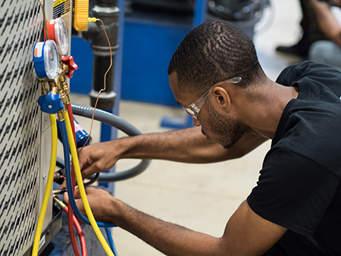

Article 2: 7 ways to reduce your business’s heating bill
Heating, ventilation and air conditioning (HVAC) uses around 40% of a building’s electricity. In fact, it’s one of the most significant factors in the operating expenses of a business. That’s why it pays to pinpoint HVAC energy waste and reduce it. Here are 7 popular ways to help your business become more energy-efficient and control costs.
Tip #1: Carefully assess the area around each vent for proper ventilation.
Is air flowing from the vent circulating freely throughout the room? If there are obstructions that prevent adequate airflow, such as cabinetry or drapes, move them to allow for clear circulation. Don’t keep vents closed to save energy. This can change the way air is distributed and cause an imbalance to the operation of the HVAC system.
Tips #2: Prevent dust and dirt from building up.
Replace air filters (or clean them if they’re reusable) monthly, especially during peak heating and cooling seasons. Keeping air filters clean can prevent dust and dirt from building up in the system. When dirt builds up, it can lead to expensive maintenance repairs or the need for a new system
Tip #3: Check your ducts.
Make sure all the ducts that run throughout your building have duct sealant or metal-backed (foil) tape over the seams and connections. You can work with a contractor to wrap the ducts in insulation to keep them from getting hot in the summer or cold in the winter. Contractors can perform verified duct sealing using a special fan to test duct system leakage before and after sealing efforts have been made.
Tip #4: Implement a consistent HVAC maintenance schedule.
Not all businesses require the same needs from their HVAC systems. Customized commercial HVAC maintenance plans may be offered by your preferred contractor, which will provide the specific care your system needs to boost performance.
Tips #5: Use heat-recovery technology to transfer energy from exhaust air to incoming outside air.
This greatly reduces the energy that’s required to heat or cool incoming air. A qualified contractor can educate customers on available recovery technologies. For example, an energy recovery ventilator (ERV) can be a suitable solution for maintaining comfortable temperature, depending on area location and climate.
Tip #6: Install advanced control sensors to improve a ventilation system’s operating power for energy efficiency.
These controls can count the number of people in a room and then adjust the heat and air conditioning accordingly. When the sensors are integrated into a building’s HVAC system, the advanced controls can reduce energy use by almost 40%.
Tip #7: Replace your old, worn-out HVAC.
If your HVAC system is more than 10 years old, there’s a good chance you’re spending too much to heat and cool your building. Have a professional contractor give your HVAC system a checkup and see if you should upgrade to high-efficiency ENERGY STAR®-qualified equipment.
For more ideas on how to lower your energy use, visit sdge.com/My-Business.

Social posts: 7 ways to reduce your business’s heating bill
Use any of the above tips and add:
For more ideas on how to lower your energy use, visit sdge.com/My-Business. #sdge #SDGEassist
Images: 7 ways to reduce your business’s heating bill

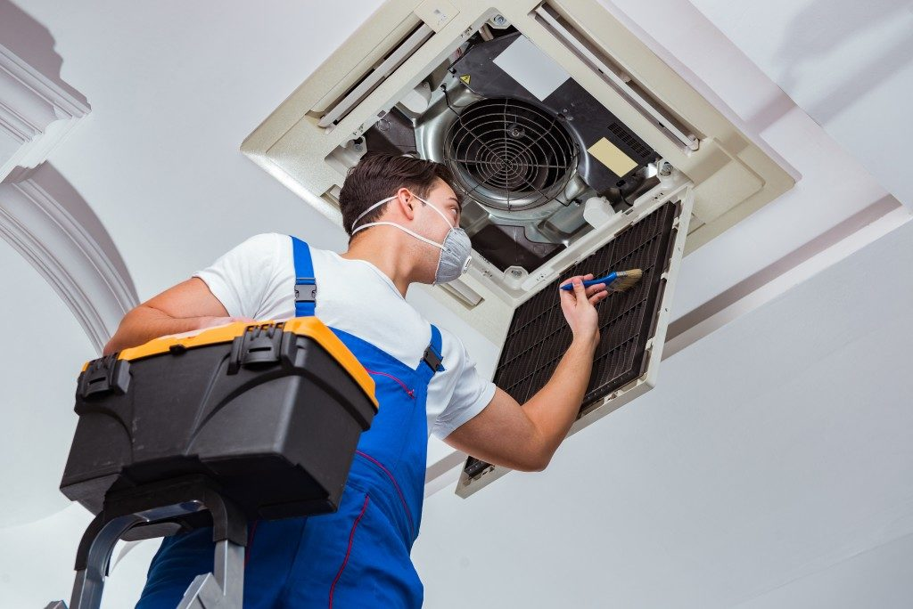
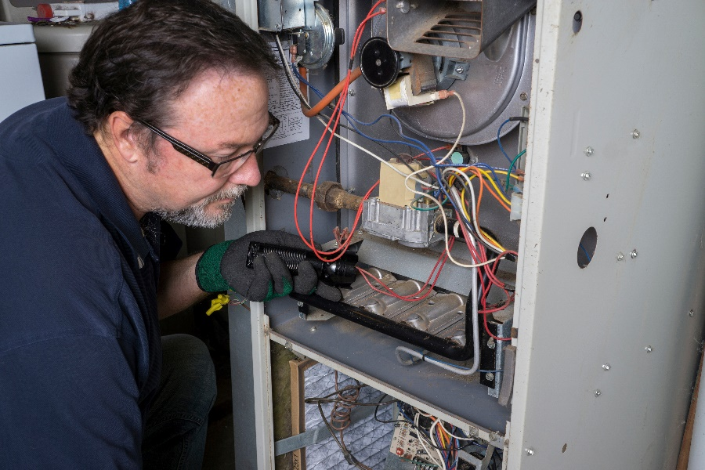

Article 3: TAKE ADVANTAGE OF NO-COST TRAINING FROM ENERGY EXPERTS
Did you know that SDG&E provides webinars for business owners and trade professionals, and most are at no cost? You or your employees can learn about the latest in green building practices, technology and energy-saving solutions from industry experts. Some of February’s topics include:
- Basics of Photovoltaic & Energy Storage Systems for Grid-Tied Applications
- Introduction to Commercial Heat Pump Water Heater
- Commercial Quality Maintenance & Installation of Economizers
Certifications and continuing education units are available for many of the classes. Check out the class listing at sdge.com/EIC.
Social posts: TAKE ADVANTAGE OF NO-COST TRAININGS FROM ENERGY EXPERTS
- Did you know SDG&E provides energy education and training webinars at no cost? These on-demand webinars are offered at introductory, intermediate and advanced levels. See the webinar list at sdge.com/EIC. #sdge #SDGEassist
- Learn the latest in green building design, operations, maintenance and technology at no-cost energy webinars led by industry experts. See the on-demand webinar list at sdge.com/EIC. #sdge #SDGEassist
- Enroll in a no-cost, on-demand energy topic webinar. Energy education and training can give you and your employees the knowledge and skills that customers value. Check out the webinar list at sdge.com/EIC. #sdge #SDGEassist
Images: TAKE ADVANTAGE OF NO-COST TRAININGS FROM ENERGY EXPERTS
