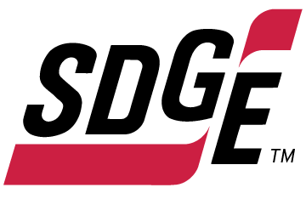

SDG&E RESIDENTIAL AND SMALL BUSINESS CONTENT PACKAGE | DECEMBER 2022
As a trusted community partner, we thank you for sharing our content and digital assets with your audiences – including residents, customers and employees – to help amplify our key messages in your email communications, websites or newsletters.
Best practices for using our content, social media posts and images
- Images
Choose images that are relevant for your audience and feel free to mix and match what we provide. For alternate images, Unsplash.com and Canva.com offer free images that you can download.
- SDG&E logo
You’re welcome to mention our name but, due to legal requirements, please do not use our logo in any marketing materials that you create. Please only use the SDG&E logo if we provide it to you in this package or it’s publicly available online like a social post or video. You can also retweet our public posts which you’ll find on twitter.com/sdge.
- Videos
We have a library of videos you can share in your communications and social posts when you visit youtube.com/c/SanDiegoGasElectric/videos. If you’d like to sort our videos by topic, visit youtube.com/c/SanDiegoGasElectric. Some videos are in Spanish. You’ll see some on TV, too!
Follow us
Find us on Facebook, Instagram, Twitter, YouTube and LinkedIn. When sharing our digital assets and content, feel free to tag SDG&E’s social media and direct your audience to sdge.com.

Article 1: BRIGHT IDEAS FOR SAFE AND ENERGY-EFFICIENT HOLIDAYS
It’s that time of the year when many of us are decorating our home, business or office inside and out with festive strings of lights. Examples include lights over the fireplace, lights wrapped around trees and bushes and lights hanging along roof lines and eaves.
To help you save money on lighting costs this season and avoid safety hazards, here’s a list of timely tips.
- Make smart lighting choices. LED holiday lights are the way to go! They use up to 80% less energy, are brighter and safer, and are cooler than incandescent lights. They’re easier to install—up to twenty-four strings of LEDs can be connected end-to-end without overloading a wall socket. Plus, they last ten times longer and have no filaments or glass to break.
- Get reflective. Shiny ornaments, tinsel and mirrors can multiply the effects of your lighting without using more energy. Reflective ornaments and tinsel are just as bright at night, so getting creative with your lighting display can multiply your resources for shine. (But be sure to keep tinsel away from pets.) Don't forget the ribbons, wreaths, garland and reflective menorahs for electricity-free traditions that bring holiday cheer.
- Limit energy use. Set timers for lights to turn on and off automatically. Keep light displays on during the evening and turn them off overnight using timers. You can save more by keeping light displays on only 8 hours of the evening (when you can see and appreciate them).
Here are some useful tips to keep you and your loved ones safe this holiday season.
- Hang lighting safely. Make sure that cords are not pinched by furniture or placed under rugs, furniture or other appliances. If covered, cords can overheat or become frayed which increases the risk of fire. Replace faulty lights instead of trying to repair them.
- Avoid electric hazards outdoors. Before climbing ladders to string outdoor lights, check for overhead power lines on your roof or attached to your home. Always stay at least 10 feet away from overhead lines. Never place yourself or any object, such as a string of lights, in a position that risks contact with a power line—the result can be fatal.
- Plan ahead. Avoid overloading extension cords and wall sockets by following the manufacturer’s limits for the number of light strings that can be safely connected.
- Put your tree in a safe location. Do not place your holiday tree near a heat source such as a fireplace or heat vent. The heat will dry out the tree, making it more susceptible to fires caused by heat, flame or sparks.
- Check the condition of lights. Inspect light strands for cracked or broken plugs, frayed insulation or bare wires. Worn cords can cause fires so discard damaged sets of lights.
- Check your environment outdoors. Before stringing lights on outdoor trees, make sure tree limbs haven’t grown into or near power lines. Branches, entire trees and even the ground adjacent to a tree can become energized when trees come in contact with power lines.
- Read the labels. Be sure to check each product label to see whether the lights are intended for indoor or outdoor use. Make sure lights have a tag indicating they have been evaluated by a recognized testing laboratory.
- Use GFCI outlets. Outdoor electric lights and decorations should be plugged into circuits protected by ground fault circuit interrupters (GFCIs). How do you know if it’s a GFCI? Look for the “test” and “reset” buttons. If circuits are not GFCI-protected, portable outdoor GFCIs can be purchased.

Visit sdge.com/MyEnergy-Winter for additional winter safety and energy-savings tips.

Social posts: BRIGHT IDEAS FOR SAFE AND ENERGY-EFFICIENT HOLIDAYS
Use any of the tips in the above article, then add:
Visit sdge.com/MyEnergy-Winter for additional winter safety and energy-savings tips. #sdge #SDGEassist”

Images: BRIGHT IDEAS FOR SAFE AND ENERGY-EFFICIENT HOLIDAYS









Article: SCAM ALERT: IMPOSTERS POSING AS SDG&E EMPLOYEES
With the holidays just around the corner – a time of the year when scammers often strike, San Diego Gas & Electric (SDG&E) is warning customers to be on the lookout for imposters who pretend to be SDG&E employees over the phone or in person, threatening service disconnections if payments are not made immediately.

Top targets of utility impersonators include limited-English speakers, the elderly and small businesses – particularly restaurants. Scammers are using increasingly advanced tactics and technologies to defraud their victims, including phone spoofing where they manipulate the caller ID to display SDG&E’s customer service number, so victims think that they are receiving a legitimate call.

Business both large and small must remain vigilant. Because of the sophistication of the fraud, an unsuspecting, well-intentioned business entity could easily fall into this trap and the losses are sometimes staggering.

How the ruse works
The ruse most often includes a caller posing as a utility collections employee. Victims are told their account is delinquent and that a technician will arrive within the hour to shut off their electricity if they do not pay the past due amount immediately. Victims are asked to pay with non-traceable Bitcoin, payment apps such as Zelle, Green Dot debit cards, or other non-traditional forms of payment that SDG&E does not use.

Scammers capitalize on victims whose livelihood depends on a consistent source of electricity. For example, they have been known to call restaurateurs just prior to the lunch hour to add pressure.

Tips to avoid becoming a victim
- Remember, SDG&E will never call you to demand immediate payments over the phone with the threat of immediate service disconnection. SDG&E provides a variety of payment assistance programs to customers and sends multiple notices to customers before disconnecting service.
- SDG&E will never ask customers to pay using digital payment apps or cryptocurrencies. The only bill payment options SDG&E uses are MyAccount, a Branch Office location, an Authorized Payment Location or BillMatrix, which accepts payment with a credit card via phone.
- SDG&E customers who are uncertain about their account status should call SDG&E or look up their bill and payment history via sdge.com/MyAccount. Never use the call back number provided by an unknown caller to verify billing information.
For more information, visit sdge.com/Avoid-Scams.

Social posts: SCAM ALERT: IMPOSTERS POSING AS SDG&E EMPLOYEES
- Stay vigilant and don’t be a victim of an SDG&E scam. Learn helpful tips to avoid fraud at sdge.com/Avoid-Scams. #sdge #SDGEassist
- If you receive a phone call from a person claiming to work for SDG&E and the caller asks for immediate payment, it’s a scam. SDG&E will never contact customers to tell them they must pay now or risk immediate disconnection. See more tips on staying safe at sdge.com/Avoid-Scams. #sdge #SDGEassist
- If someone claims to work for SDG&E and seeks to enter your home or business, make sure that person is wearing an SDG&E uniform and ask to see their company ID card. Look to see that person arrived in an SDG&E-marked vehicle or call SDG&E at 1-800-411-7343. #sdge #SDGEassist

(Translated article) ALERTA: ESTAFADORES QUE SE HACEN PASAR COMO EMPLEADOS
A medida que se acercan las fiestas de invierno, también se acerca la época del año en que los estafadores atacan. San Diego Gas & Electric (SDG&E) es advirtiendo a sus clientes que deben estar especialmente atentos a los estafadores que fingen ser empleados de SDG&E por teléfono o en persona, amenazando con desconexiones de servicio si no realizan un pago de inmediato.

Los imitadores de empresas de servicios públicos tienden a dirigirse específicamente a las personas que hablan poco inglés, las personas de la tercera edad y las pequeñas empresas, en particular los restaurantes. Los estafadores están utilizando tácticas y tecnologías cada vez más avanzadas para defraudar a sus víctimas, incluida la suplantación de identidad telefónica en la que manipulan el identificador de llamadas para mostrar el número de servicio al cliente de SDG&E, de modo que las víctimas piensen que están recibiendo una llamada legítima de la empresa.

Las empresas, tanto grandes como pequeñas, deben permanecer atentos. Debido a la sofisticación del fraude, un negocio desprevenido y bien intencionado podría caerse fácilmente en esta trampa y las pérdidas a veces son asombrosas.
Como funciona la estafa
La artimaña a menudo involucra a una persona que llama haciéndose pasar por un empleado de cobranza de la empresa de servicios públicos. A las víctimas de la estafa se les dice que su cuenta está atrasada y que un técnico llegará dentro de una hora para desconectar el servicio eléctrico si no pagan el monto vencido de inmediato. Se les pide a las víctimas que paguen con fuentes no rastreables como Bitcoin, aplicaciones de pago como Zelle, tarjetas de débito Green Dot u otras formas de pago que SDG&E no usa.
Los estafadores se aprovechan de las personas que dependen de una fuente constante de electricidad. Por ejemplo, se sabe que llaman a los dueños de los restaurantes justo antes de la hora del almuerzo para aumentar la presión.
Consejos para evitar ser víctima de una estafa
- SDG&E nunca le llamará exigiendo pagos inmediatos por teléfono con la amenaza de una desconexión inmediata del servicio. SDG&E ofrece una variedad de programas de asistencia de pago a sus clientes y envía múltiples avisos a los clientes antes de desconectar su servicio.
- SDG&E nunca pedirá a los clientes que paguen con aplicaciones móviles de pago digital o criptomonedas. Las únicas opciones de pago de facturas que acepta SDG&E son a través de MyAccount, en una sucursal, una ubicación de pago autorizada o a través de BillMatrix, que acepta pagos con tarjeta de crédito por teléfono.
- Los clientes de SDG&E que no estén seguros sobre el estado de su cuenta deben llamar a SDG&E o buscar su historial de facturas y pagos a través de sdge.com/MyAccount. Nunca utilice el número de devolución de llamada proporcionado por una persona desconocida para verificar la información de su cuenta de facturación.
Para más información, visite sdge.com/Avoid-Scams.

Postas sociales: ALERTA: ESTAFADORES QUE SE HACEN PASAR COMO EMPLEADOS
- Manténgase alerta y no sea víctima de una estafa de SDG&E. Aprenda consejos útiles para evitar el fraude en sdge.com/Avoid-Scams. #sdge #SDGEassist
- Si recibe una llamada telefónica de una persona que dice trabajar para SDG&E y la persona que llama solicita un pago inmediato, es una estafa. SDG&E nunca se pondrá en contacto con los clientes para decirles que deben pagar ahora o arriesgarse a la desconexión inmediata. Vea más consejos para mantenerse seguro en sdge.com/Avoid-Scams. #sdge #SDGEassist
- Si alguien dice trabajar para SDG & E y busca ingresar a su hogar o negocio, asegúrese de que esa persona esté usando un uniforme de SDG&E y solicite ver su tarjeta de identificación de la compañía. Mire para ver que esa persona llegó en un vehículo marcado por SDG&E o llame a SDG&E al 1-800-411-7343. #sdge #SDGEassist

Images: SCAM ALERT: IMPOSTERS POSING AS SDG&E EMPLOYEES


Social post: Rebates
The new Golden State Rebates give qualifying customers rebates toward the purchase of energy-efficient products such as smart thermostats, gas tank water heaters, heat pump water heaters and more. Learn more at sdge.com/rebates. #sdge #SDGEassist


Los nuevos reembolsos de Golden State brindan a los clientes calificados recibir reembolsos para la compra de productos de eficiencia energética, como termostatos inteligentes, calentadores de agua con tanque de gas, calentadores de agua con bomba de calor y más. Obtenga más información en sdge.com/rebates. #sdge #SDGEassist
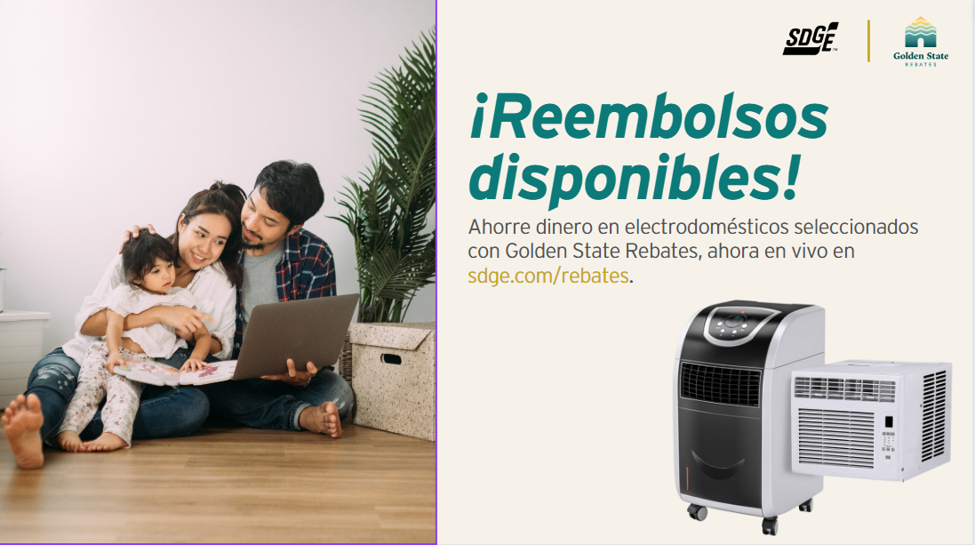

Article: NEED HELP WITH YOUR ENERGY BILL?
SDG&E recognizes that this can be a challenging time for many customers and may be able to help if you are having trouble paying your bill. You may be eligible for programs and services that can provide immediate financial assistance and help you avoid interruptions in your service. Flexible payment arrangements are available to help you pay down past due balances. Learn more at sdge.com/Payment-Arrangements.

Check out these energy assistance programs:
- California Alternate Rates for Energy (CARE) Program: Save 30% or more every month on your bill. Find out if you qualify at sdge.com/CARE.
- Family Electric Rate Assistance (FERA) Program: If you don’t qualify for CARE and your household has 3 or more people, you may qualify for FERA. You could receive an 18% discount on your electric bill. Visit sdge.com/FERA to learn more.
- Energy Savings Assistance (ESA) Program: You may qualify to receive free energy-saving improvements for your home, such as new appliances, lighting, insulation and more. Find details at sdge.com/ESA.
- Arrearage Management Plan (AMP): If you have outstanding bills and you are a CARE or FERA customer, you may be eligible for debt forgiveness. See if you qualify at sdge.com/AMP.
- Low-income Home Energy Assistance Program (LIHEAP): This program offers up to $1,000 towards your energy bill. This Federal assistance program also provides support for energy-related home improvements. Learn more at sdge.com/LIHEAP.
Even if you made a recent payment or set up a flexible payment plan with SDG&E, there may still be assistance programs available to help you. For a complete list of available offerings, visit sdge.com/assistance.

Social posts: NEED HELP WITH YOUR ENERGY BILL?
- If you’re behind on your energy bill, you may qualify for financial assistance. Learn more at sdge.com/assistance. #sdge #SDGEAssist
- Hardship is everywhere right now – the last thing you need to worry about is your energy bill. Get help with your bill at sdge.com/assistance. #sdge #SDGEAssist
- SDG&E provides assistance programs to help you with your monthly bill which can include up to a 30% discount. Find out if you qualify at sdge.com/assistance. #sdge #SDGEAssist
- Whether you rent or own, you could be eligible to receive no-cost, energy-efficient home improvements that can make your home more comfortable and help reduce your energy bill. Find out if you qualify at sdge.com/ESA. #sdge #SDGEAssist

Article (translated): ¿NECESITA AYUDA CON SU FACTURA DE ENERGÍA?
Usted puede calificar para un descuento en su factura o mejoras en el hogar. Los programas de asistencia de SDG&E ayudan a reducir su factura mensual de energía mientras mantiene su hogar cómodo.
- Programa de Tarifas Alternativas de Energía de California (CARE, por sus siglas en inglés): Ahorre un 30% o más cada mes en su factura. Averigüe si califica en sdge.com/CARE.
- Tarifa Eléctrica Familiar (FERA, por sus siglas en inglés): Si no califica para CARE y su hogar tiene 3 o más personas, puede calificar para FERA. Podría recibir un 18% de descuento en su factura de electricidad. Visite sdge.com/FERA para obtener más información.
- Programa de Asistencia para el Ahorro de Energía (ESA, por sus siglas en inglés): Puede calificar para recibir mejoras gratuitas para el ahorro de energía en su hogar, tales como electrodomésticos nuevos, iluminación, aislamiento y más. Encuentre los detalles en sdge.com/ESAP.
- Arrearage Management Plan (AMP): Si tiene facturas pendientes y es participante en el programa de CARE o FERA, puede ser elegible para la condonación de deudas. Averigüe si califica en sdge.com/AMP.
- Clientes comerciales: Configure un plan de pago flexible, para que pueda estar tranquilo sabiendo que está cubierto. Visite sdge.com/recovery para obtener más información.
Las aplicaciones en línea son fáciles, rápidas y convenientes. Para obtener más información, visite sdge.com/asistencia.

Postas sociales: ¿NECESITA AYUDA CON SU FACTURA DE ENERGÍA?
- Si está atrasado en su factura de energía, puede calificar para asistencia financiera. Obtenga más información en sdge.com/asistencia. #sdge #SDGEAssist
- En este momento, las dificultades se encuentran en todas partes - lo último que necesita es preocuparse por su factura de energía. Obtenga ayuda con su factura en sdge.com/asistencia. #sdge #SDGEAssist
- SDG&E ofrece programas de asistencia para ayudarle con su factura mensual que puede incluir hasta un 30% de descuento. Descubra si califica en sdge.com/asistencia. #sdge #SDGEAssist
- Si alquile o es propietario, podría ser elegible para recibir mejoras de eficiencia energética en su hogar, sin costo, que pueden hacer que su hogar sea más cómodo y ayuden reducir su factura de energía. Descubra si califica en sdge.com/ESA. #sdge #SDGEAssist
Images: NEED HELP WITH YOUR ENERGY BILL?
Twitter:

Instagram/Facebook:
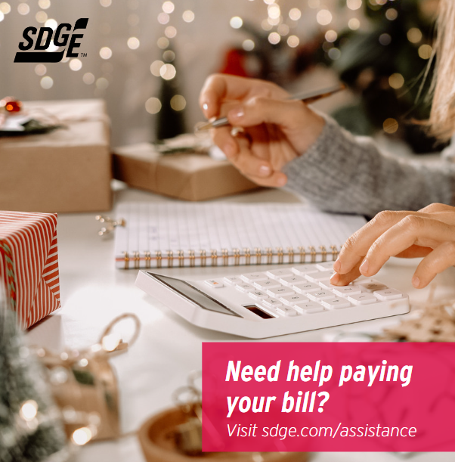
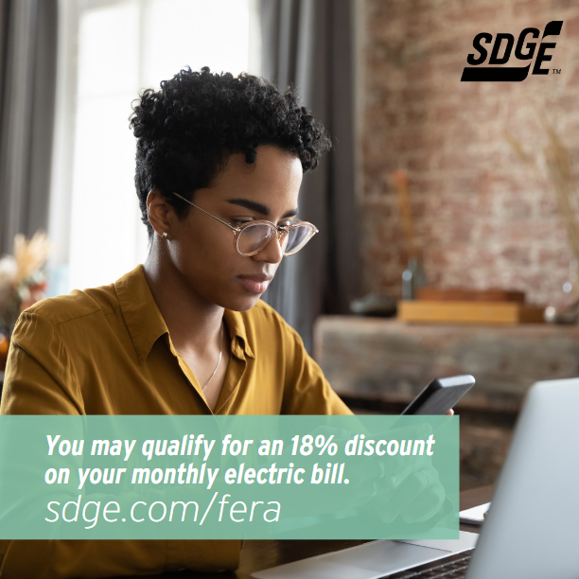

Article: WINTER ENERGY-SAVING TIPS FOR SMALL BUSINESSES
This winter don’t let the cold sneak up on your energy bill. SDG&E can help with energy-saving programs and tips to help keep your business’s energy costs low – and that can make a positive difference on your bottom line.
- Lower the temperature. Your business can keep comfortable without cranking up the heat. Adjust your thermostat by a few degrees to help reduce your energy bill. Don’t completely turn off your heat overnight though – you’ll use more energy to heat up the building again in the morning.
- Did you know ceiling fans help in the colder months too? Change the rotation of your fan blades to clockwise, which will pull warm air down and spread it throughout the room.
- Open blinds and sunshades to allow sunlight to heat up the room, especially on south- or west-facing windows. Natural light can warm the space and reduce the need for lighting. When you need to turn on lights, save energy by using energy-efficient LED bulbs.
- In work areas that get little use, like storage and conference rooms, install sensors so lights will automatically go off when employees are working elsewhere.
- Make sure cold air isn’t drifting into your building by checking weather stripping on your doors and caulking on your windows and other areas that outside air can seep inside. This is especially important in older buildings. You can also put clear, inexpensive plastic sheeting on your windows to add more insulation and reduce cold drafts.
- Get a tune-up on your heater to ensure your system is operating efficiently. New, clean air filters can improve airflow and heating. SDG&E has instant in-store rebates up to $500 on the purchase of new, qualifying energy-efficient electric heat pump water heaters and gas water heaters. Learn more at sdge.com/rebates.
- Make sure your heating air intake and outlet grilles are not blocked by furniture or paper. Obstructed grilles put more of a burden on the system’s fans to move heated air through an office. Also, check your ductwork for air leaks or any damage to insulation.
- Check your HVAC filters monthly and clean it or replace it if it’s dirty. Keeping your HVAC system properly maintained can help save on heating costs.
- Check if a door provides good insulation by placing your hand against it from the inside. If it feels cooler than the inside walls, it might be time to install a door that's better insulated.
Visit sdge.com/Business-Winter for more helpful energy-saving tips.

Social Posts: WINTER ENERGY-SAVING TIPS FOR SMALL BUSINESSES
- Check your HVAC filters monthly and clean it or replace it if it’s dirty. Keeping your HVAC system properly maintained can help save on heating costs. Visit sdge.com/Business-Winter for more helpful energy-saving tips. #sdge #SDGEassist
- Did you know ceiling fans help in the colder months too? Change the rotation of your fan blades to clockwise, which will pull warm air down and spread it throughout the room. Visit sdge.com/Business-Winter for more helpful energy-saving tips. #sdge #SDGEassist
- Lower your office’s temperature. Your business can keep comfortable without cranking up the heat. Adjust your thermostat by a few degrees to help reduce your energy bill. Don’t completely turn off your heat overnight though – you’ll use more energy to heat up the building again in the morning. Visit sdge.com/Business-Winter for more helpful energy-saving tips. #sdge #SDGEassist
- Open blinds and sunshades to allow sunlight to heat up the room, especially on south- or west-facing windows. Natural light can warm the space and reduce the need for lighting. When you need to turn on lights, save energy by using energy-efficient LED bulbs. Visit sdge.com/Business-Winter for more helpful energy-saving tips. #sdge #SDGEassist
- Is your business looking for ways to save energy during the colder months? Visit sdge.com/Business-Winter for helpful energy-saving tips. #sdge #SDGEassist
- Make sure cold air isn’t drifting into your building by checking weather stripping on your doors and caulking on your windows and other areas that outside air can seep inside. This is especially important in older buildings. You can also put clear, inexpensive plastic sheeting on your windows to add more insulation and reduce cold drafts. Visit sdge.com/Business-Winter for more helpful energy-saving tips. #sdge #SDGEassist

Images: WINTER ENERGY-SAVING TIPS FOR SMALL BUSINESSES 


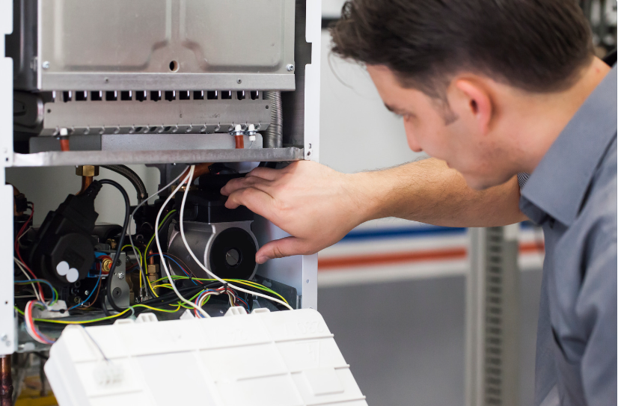
Article: TAKE ADVANTAGE OF NO-COST TRAINING FROM ENERGY EXPERTS
Did you know that SDG&E provides webinars for business owners and trade professionals, so you can learn new skills at your own pace? And most are at no cost. You or your employees can learn about the latest in green building practices, technology and energy-saving solutions from industry experts. Certifications and continuing education units are available for many classes. Check out the class listing at sdge.com/EnergyClasses.
Are you a Trade Professional? Join SDG&E’s Trade Professional Alliance at sdge.com/TradePro.
Some of December’s topics include:
- Non-residential Standards for Building Inspectors
- Single-family Standards for HVAC Contract Installers
- Non-residential Standards: What is Acceptance Testing?
- Zero is the New Black: The Path to Carbon Neutrality
- Lighting Fundamentals: Terminology, Vision and Color
- Lighting Fundamentals: Light Sources, Luminaires and Controls
- Specifying a Lighting Control System

Social posts: TAKE ADVANTAGE OF NO-COST TRAININGS FROM ENERGY EXPERTS
- Did you know SDG&E provides energy education and training webinars at no cost? These on-demand webinars are offered at introductory, intermediate and advanced levels. See the webinar list at sdge.com/EnergyClasses. #sdge #SDGEAssist
- Learn the latest in green building design, operations, maintenance and technology at no-cost energy webinars led by industry experts. See the on-demand webinar list at sdge.com/EnergyClasses. #sdge #SDGEAssist
- Enroll in a no-cost, on-demand energy topic webinar. Energy education and training can give you and your employees the knowledge and skills that customers value. Check out the webinar list at sdge.com/EnergyClasses. #sdge #SDGEAssist
Images: TAKE ADVANTAGE OF NO-COST TRAININGS FROM ENERGY EXPERTS
Twitter:


Instagram/Facebook:


Social Posts: Gas Appliance Checks
- With cooler weather moving in, now is the time to get your gas furnace inspected to ensure you and your family are safe. Schedule your no-cost SDG&E inspection in My Account. Login to sdge.com/MyAccount, select Services, Services Overview and then Gas Appliance Check. #sdge #SDGEassist
- Get your gas appliances evaluated to help prevent carbon monoxide poisoning. Schedule your no-cost SDG&E inspection in My Account. Login to sdge.com/MyAccount, select Services, Services Overview and then Gas Appliance Check. #sdge #SDGEassist
- SDG&E can inspect your gas appliances for safety, make minor adjustments and light heater pilots. Schedule your no-cost SDG&E inspection in My Account. Login to sdge.com/MyAccount, select Services, Services Overview and then Gas Appliance Check. #sdge #SDGEassist
- SDG&E will visit your home and check that your gas appliances are safe. Schedule your no-cost SDG&E inspection in My Account. Login to sdge.com/MyAccount, select Services, Services Overview and then Gas Appliance Check. #sdge #SDGEassist

Twitter:
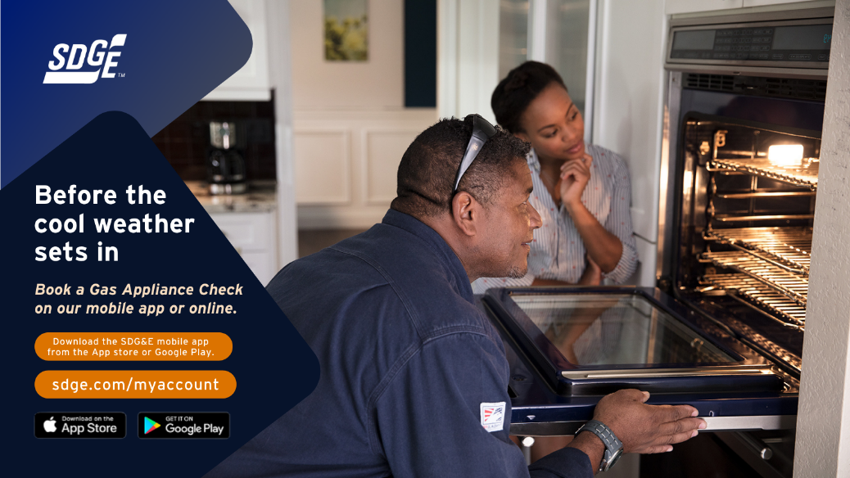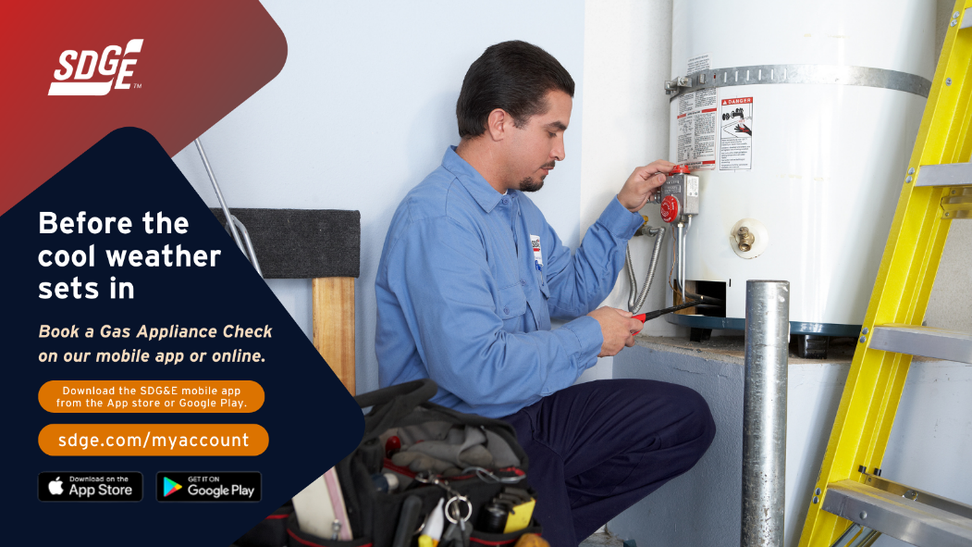
Article: IS HEAT HARMFUL TO YOUR HEALTH? Request this sdg&e alert.
If extreme heat is harmful to the health of anyone living in your home and a moderate indoor temperature is a must, enroll in SDG&E’s Temperature Sensitive Program. This no-cost service provides you with advanced notice of power outages (when possible). An automated phone call will alert you so that you can prepare for a temporary loss of air conditioning.
To sign up for the Temperature Sensitive Program, download the application at sdge.com/TempSensitive. If you participate in SDG&E’s Medical Baseline Program, then you’re already on the call list! Since you already receive the outage notices, you don’t need to enroll in the Temperature Sensitive Program. If you’d like to learn more about SDG&E’s Medical Baseline Program, please visit sdge.com/medical.
Social posts: IS HEAT HARMFUL TO YOUR HEALTH? Request this sdg&e alert!
- If extreme heat is harmful to you or anyone else’s health in your home, and you need a moderate temperature, enroll in SDG&E’s Temperature Sensitive Program at sdge.com/TempSensitive. #sdge #SDGEassist

