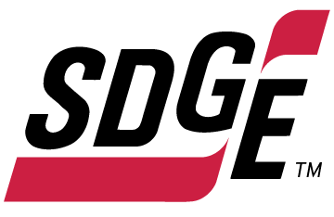

SDG&E RESIDENTIAL CONTENT PACKAGE | DECEMBER 2021
As a trusted community partner, we thank you in advance for sharing these digital assets with your audiences, including residents, customers and employees to help amplify our monthly messages. Here are social media posts, articles and photos you are welcome to use in email communications, websites or newsletters. There are several images with each posting. Please choose images that fit your audience and feel free to mix and match.

Follow Us
You can find us on Facebook, Instagram, Twitter, YouTube and LinkedIn. When sharing these messages in your social posts, feel free to tag SDG&E’s social media accounts and direct your audience to sdge.com.

This month’s topics: Energy-saving and safety tips at home, avoiding scams, customer assistance programs

Article 1: Bright Ideas for Safe and Energy-Efficient Holiday Lighting
It’s that time of the year when many of us are decorating our home, business or office inside and out with festive strings of lights. Lights over the fireplace, lights wrapped around trees and bushes and lights hanging along roof lines and eaves.
To help you save money on lighting costs this season and avoid safety hazards, here’s a list of timely tips.
Make smart lighting choices. LED holiday lights are the way to go! They use up to 80% less energy, are brighter and safer, as they are much cooler than incandescent lights. They’re easier to install—up to 24 strings of LEDs can be connected end-to-end without overloading a wall socket. They last ten times longer and have no filaments or glass to break.
Get reflective. Shiny ornaments, tinsel and mirrors can multiply the effects of your lighting without using more energy. Be sure to keep tinsel away from pets, though. Reflective ornaments and tinsel are just as bright at night, so getting creative with your lighting display can multiply your resources for shine. Don't forget the ribbons, wreaths, garland and reflective menorahs for electricity-free traditions that bring holiday cheer.
Limit energy use. Set timers for lights to turn on and off automatically. Keep light displays on during the evening and turn them off overnight. Set timers for lights to automatically turn on when it gets dark and off in the middle of the night. You can save more by keeping light displays on only 8 hours of the evening (when you can see and appreciate them).
Here are some great tips to keep you and your loved ones safe this holiday season.
Hang lighting safely. Make sure that no cords will be pinched by furniture or placed under rugs, furniture or other appliances. If covered, cords can overheat or become frayed which increases the risk of fire. Replace faulty lights instead of trying to repair them.
Avoid electric hazards outdoors. Before climbing ladders to string outdoor lights, check for overhead power lines on your roof or attached to your home. Always keep at least 10 feet away from overhead lines. Never place yourself or any object, such as a string of lights, in a position that risks contact with a power line—the result can be fatal.
Plan ahead. Avoid overloading extension cords and wall sockets by following the manufacturer’s limits for the number of light strings that can be safely connected.
Put your tree in a safe location. Do not place your holiday tree near a heat source such as a fireplace or heat vent. The heat will dry out the tree, making it more susceptible to fires caused by heat, flame or sparks.
Check the condition of lights. Inspect light strands for cracked or broken plugs, frayed insulation or bare wires. Worn cords can cause fires so discard damaged sets of lights.
Check your environment outdoors. Before stringing lights on outdoor trees, make sure tree limbs haven’t grown into or near power lines. Branches, entire trees and even the ground adjacent to a tree can become energized when trees contact power lines.
Read the labels. Be sure to check each product label to see whether the lights are intended for indoor or outdoor use. Make sure lights have a tag indicating they have been evaluated by a recognized testing laboratory.
Use GFCI outlets. Outdoor electric lights and decorations should be plugged into circuits protected by ground fault circuit interrupters (GFCIs). How do you know if it’s a GFCI? Look for the “test” and “reset” buttons. If circuits are not GFCI-protected, portable outdoor GFCIs can be purchased.
Visit sdge.com/winter for additional safety and energy-savings tips.

Social posts: Bright Ideas for Safe and Energy-Efficient Holiday Lighting
Use any of the tips in the above article, then add, “Visit sdge.com/winter for additional safety and energy-savings tips. #sdge #SDGEassist”
Images: Bright Ideas for Safe and Energy-Efficient Holiday Lighting
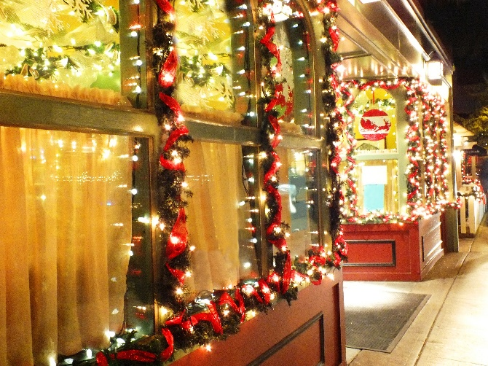

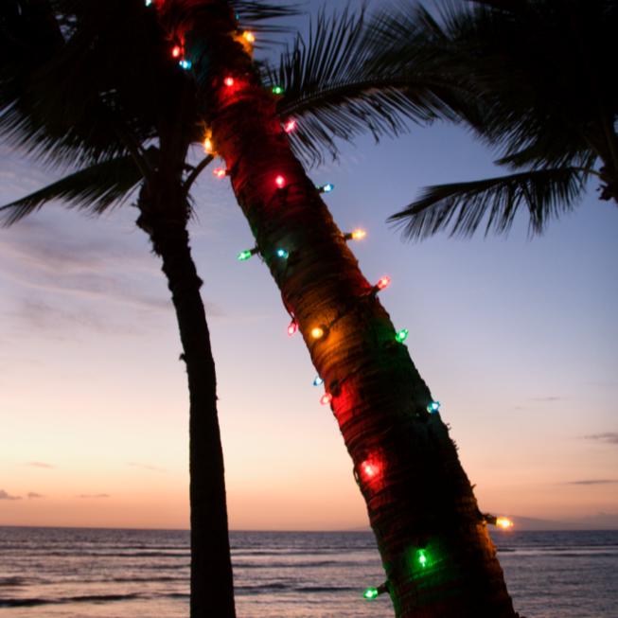

Article 2: end the call. end the scam.
Did you know that over 800 utility scams were reported to SDG&E over the past two years with losses totaling more than half a million dollars?! The number of scams has increased since the pandemic started. Scammers impersonate SDG&E employees and target vulnerable SDG&E customers facing financial difficulties and take advantage of their reliance on essential services.
Here are some tips on how to recognize common scam tactics:
- Scammers often threaten immediate service disconnections if a customer does not pay immediately. SDG&E will never contact customers to tell them they must pay now or risk immediate disconnection. The company works with customers on payment plans if they are struggling to pay past due balances and offers a variety of assistance programs. Visit sdge.com/assistance to learn more about these programs.
- Scammers often demand payment with cryptocurrency (such as Bitcoin), prepaid cards (such as Green Dot MoneyPak) or via third-party payment apps like Venmo or Zelle. SDG&E does not use these payment methods. SDG&E customers may receive communications to pay their bill online via their MyAccount at myaccount.sdge.com or the Billmatrix system, or to call their automated pay-by-phone option at 1-800-411-7343.
You can guard against fraud using these tips:
- Only provide financial information over the phone if you made the call.
- Make sure whoever is on the other line can verify they are with SDG&E or can verify your account information. If you are unsure, hang up and contact SDG&E directly.
- Every SDG&E employee on company business is required to carry a photo ID badge. If you encounter someone claiming to be an SDG&E employee, request to see his/her ID badge or call SDG&E at 1-800-411-7343.
- If you want to verify information about your account, including bills and payments, log in to your MyAccount portal at myaccount.sdge.com or use the convenient SDG&E mobile app. Learn more about the app at sdge.com/mobileapp.
Victims of utility scams are urged to call SDG&E immediately at 1-800-411-7343 to report it. Additional tips to avoid becoming a victim of utility scams can be found at sdge.com/avoid-scams.
Social posts: end the call. end the scam.
- Victims of utility scams are urged to call SDG&E immediately at 1-800-411-7343 to report it. Additional tips to avoid becoming a victim of utility scams can be found at sdge.com/avoid-scams. #sdge #SDGEassist
- Stay vigilant and don’t be a victim of an SDG&E scam. Learn helpful tips to avoid fraud at sdge.com/avoid-scams. #sdge #SDGEassist
- If you receive a phone call from a person claiming to work for SDG&E and the caller asks for immediate payment, it’s a scam. SDG&E will never contact customers to tell them they must pay now or risk immediate disconnection. See more tips on staying safe at sdge.com/avoid-scams. #sdge #SDGEassist
- If someone claims to work for SDG&E and seeks to enter your home or business, make sure that person is wearing an SDG&E uniform and ask to see their company ID card. Look to see that person arrived in an SDG&E-marked vehicle or call SDG&E at 1-800-411-7343. #sdge #SDGEassist
Images: end the call. end the scam.
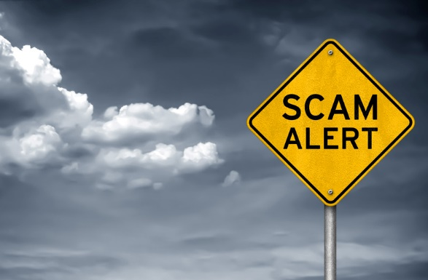

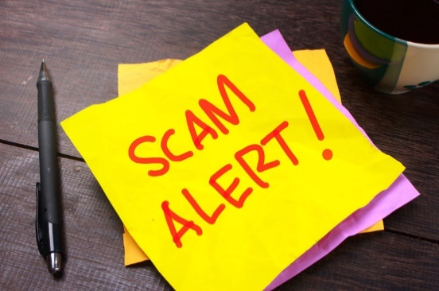

Article 3: NEED HELP WITH YOUR ENERGY BILL?
You may qualify for a bill discount or home improvements. SDG&E’s assistance programs can help you lower your energy use and/or monthly energy bill while keeping your home comfortable.
California Alternate Rates for Energy (CARE) Program: Save 30% or more every month on your energy bill. Find out if you qualify at sdge.com/CARE.
Family Electric Rate Assistance (FERA) Program: If you don’t qualify for CARE and your household has 3 or more people, you may qualify for FERA. You could receive an 18% discount on your electric bill. Visit sdge.com/FERA for more information.
Energy Savings Assistance (ESA) Program: You may qualify to receive no-cost, energy-saving improvements for your home, such as new appliances, furnace repair, lighting, insulation and more. Find details at sdge.com/ESAP.
Online applications are easy, fast and convenient. To learn more about SDG&E’s assistance programs, visit sdge.com/assistance.
Social posts: NEED HELP WITH YOUR ENERGY BILL?
- If you’re behind on your energy bill, you may qualify for financial assistance. Learn more at sdge.com/assistance. #sdge #SDGEassist
- Hardship is everywhere right now – the last thing you need is to worry about your energy bill. Get help with your bill at sdge.com/assistance. #sdge #SDGEassist
- SDG&E provides assistance programs to help you with your monthly bill which can include up to a 30% discount. Find out if you qualify at sdge.com/assistance. #sdge #SDGEassist
- Whether you rent or own, you could be eligible to receive no-cost, energy-efficient home improvements that can make your home more comfortable and reduce your energy bill. Find out if you qualify at sdge.com/ESAP. #sdge #SDGEassist
Article 3 (translated): ¿Necesita ayuda con su FACTURA de energía?
Usted puede calificar para un descuento en su factura o mejoras en el hogar. Los programas de asistencia de SDG&E ayudan a reducir su factura mensual de energía mientras mantiene su hogar cómodo.
Programa de Tarifas Alternativas de Energía de California (CARE, por sus siglas en inglés): Ahorre un 30% o más cada mes en su factura. Averigüe si califica en sdge.com/CARE.
Programa de Asistencia de Tarifa Eléctrica Familiar (FERA, por sus siglas en inglés): Si no califica para el programa de CARE y su hogar tiene 3 o más personas, puede calificar para FERA. Podría recibir un 18% de descuento en su factura de electricidad. Visite sdge.com/FERA para obtener más información.
Programa de Asistencia para el Ahorro de Energía (ESA, por sus siglas en inglés): Puede calificar para recibir mejoras gratuitas para el ahorro de energía en su hogar, tales como electrodomésticos nuevos, reparación de hornos, iluminación, aislamiento y más. Encuentre los detalles en sdge.com/ESAP.
Las aplicaciones en línea son fáciles, rápidas y convenientes. Para obtener más información, visite sdge.com/asistencia.
Postas sociales: ¿Necesita ayuda con su FACTURA de energía?
- Si está atrasado en su factura de energía, puede calificar para asistencia financiera. Obtenga más información en sdge.com/asistencia. #sdge #SDGEassist
- En este momento, las dificultades se encuentran en todas partes - lo último que necesita es preocuparse por su factura de energía. Obtenga ayuda con su factura en sdge.com/asistencia. #sdge #SDGEassist
- SDG&E ofrece programas de asistencia para ayudarle con su factura mensual que puede incluir hasta un 30% de descuento. Descubra si califica en sdge.com/asistencia. #sdge #SDGEassist
- Ya sea que alquile o sea propietario, podría ser elegible para recibir mejoras de eficiencia energética en su hogar, sin costo, que pueden hacer que su hogar sea más cómodo y reducir su factura de energía. Descubra si califica en sdge.com/ESAP. #sdge #SDGEassist

Images: NEED HELP WITH YOUR SDG&E BILL?

