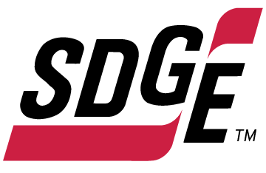
SDG&E BUSINESS CONTENT PACKAGE | DECEMBER 2021
As a trusted community partner, we thank you in advance for sharing these digital assets with your audiences, including residents, customers and employees to help amplify our monthly messages. Here are social media posts, articles and photos you are welcome to use in email communications, websites or newsletters. There are several images with each posting. Please choose images that fit your audience and feel free to mix and match.

Follow Us
You can find us on Facebook, Instagram, Twitter, YouTube and LinkedIn. When sharing these messages in your social posts, feel free to tag SDG&E’s social media accounts and direct your audience to sdge.com.

This month’s topics: winter energy-saving tips at work, safe and energy-efficient holiday light decorating, on-demand energy webinars

Article 1: WINTER Energy-saving tips for small businesses
This winter don’t let the cold sneak up on your energy bill. SDG&E can help with energy-saving programs and tips to help keep your business’s energy costs low – and that makes a difference for your bottom line.
- Lower the temperature. Your business can keep comfortable without cranking up the heat. Adjust your thermostat by a few degrees to help reduce your energy bill. Don’t completely turn off your heat overnight though – you’ll use more energy to heat up the building again in the morning.
- One of the easiest ways to save money is by controlling your thermostat. Smart thermostats can be adjusted remotely to run energy-efficient schedules. If you join SDG&E’s Smart Thermostat program, you’ll receive $50 per registered thermostat with a max of four thermostats for business and two for your home. Get details at sdge.com/MyBusiness.
- Did you know ceiling fans help in the colder months too? Change the rotation of your fan blades to clockwise, which will pull warm air down and spread it throughout the room.
- Open blinds and sunshades to allow sunlight to heat up the room, especially on south- or west-facing windows. Natural light can warm the space and reduce the need for lighting. When you need to turn on lights, save energy by using energy-efficient LED bulbs.
- In work areas that get little use, like storage and conference rooms, install sensors so lights will automatically go off when employees are working elsewhere.
- Make sure cold air isn’t drifting into your building by checking weather stripping on your doors and caulking on your windows and other areas that outside air can seep inside. This is especially important in older buildings. You can also put clear, inexpensive plastic sheeting on your windows to add more insulation and reduce cold drafts.
- Get a tune-up on your heater to ensure your system is operating efficiently. New, clean air filters can improve airflow and heating. SDG&E has instant in-store rebates up to $500 on the purchase of new, qualifying energy-efficient electric heat pump water heaters and gas water heaters. Learn more at sdge.com/rebates.
- Make sure your heating air intake and outlet grilles are not blocked by furniture or paper. Obstructed grilles put more of a burden on the system’s fans to move heated air through an office. Also, check your ductwork for air leaks or any damage to insulation.
- Check your HVAC filters monthly and clean it or replace it if it’s dirty. Keeping your HVAC system properly maintained can help save on heating costs.
- Check if a door provides good insulation by placing your hand against it from the inside. If it feels cooler than the inside walls, it might be time to install a door that's better insulated.
Visit sdge.com/MyBusiness for more helpful energy-saving tips.

Social Posts: WINTER Energy-saving tips for small businesses
- Check your HVAC filters monthly and clean it or replace it if it’s dirty. Keeping your HVAC system properly maintained can help save on heating costs. Visit sdge.com/MyBusiness for more helpful energy-saving tips. #sdge #SDGEassist
- Did you know ceiling fans help in the colder months too? Change the rotation of your fan blades to clockwise, which will pull warm air down and spread it throughout the room. Visit sdge.com/MyBusiness for more helpful energy-saving tips. #sdge #SDGEassist
- Lower your office’s temperature. Your business can keep comfortable without cranking up the heat. Adjust your thermostat by a few degrees to help reduce your energy bill. Don’t completely turn off your heat overnight though – you’ll use more energy to heat up the building again in the morning. Visit sdge.com/MyBusiness for more helpful energy-saving tips. #sdge #SDGEassist
- Open blinds and sunshades to allow sunlight to heat up the room, especially on south- or west-facing windows. Natural light can warm the space and reduce the need for lighting. When you need to turn on lights, save energy by using energy-efficient LED bulbs. Visit sdge.com/MyBusiness for more helpful energy-saving tips. #sdge #SDGEassist
- Is your business looking for ways to save energy during the colder months? Visit sdge.com/MyBusiness for helpful energy-saving tips. #sdge #SDGEassist
- Make sure cold air isn’t drifting into your building by checking weather stripping on your doors and caulking on your windows and other areas that outside air can seep inside. This is especially important in older buildings. You can also put clear, inexpensive plastic sheeting on your windows to add more insulation and reduce cold drafts. Visit sdge.com/MyBusiness for more helpful energy-saving tips. #sdge #SDGEassist
Images: WINTER Energy-saving tips for small businesses
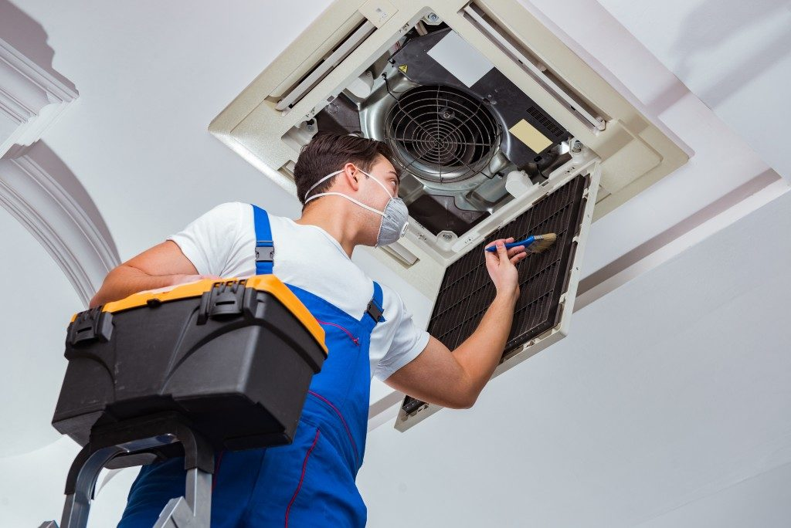

Article 2: KEEP HOLIDAY LIGHT DECORATING SAFE, ENERGY-EFFICIENT, FESTIVE AND FUN
Businesses enjoy lighting up their stores for the holidays to add a festive spirit but they don’t enjoy the increase in their electricity bill after all the holiday cheer and lights are gone.
Here are some ways to be energy-efficient this holiday season:
- Make smart lighting choices. LED holiday lights are the way to go! They use up to 80% less energy and are brighter and safer since they are much cooler than incandescent lights. They’re easier to install—up to 24 strings of LEDs can be connected end-to-end without overloading a wall socket. They last 10x longer and have no filaments or glass to break.
- Limit energy use. Set timers for lights to automatically turn on when it gets dark and off in the middle of the night. You can save more by keeping light displays on only 8 hours of the evening.
- Get reflective. Shiny ornaments, tinsel and mirrors can multiply the effects of your lighting without using more energy. Reflective ornaments and tinsel are just as bright at night, so getting creative with your lighting display can multiply your resources for shine. Don't forget the ribbons, wreaths, garland, and reflective menorahs for electricity- free, age-old traditions that bring holiday cheer.
Be sure to stay safe over the holidays. Here are some great tips to keep you, your customers and patrons safe.
- Limit the connection of light strands. Avoid overloading extension cords and wall sockets by following the manufacturer’s limits for the number of light strings that can be safely connected.
- Hang lighting safely. Make sure that no cords will be pinched by furniture or placed under rugs, furniture or other appliances. If covered, cords can overheat or become frayed, increasing the risk of fire. Replace faulty lights instead of trying to repair them.
- Avoid electric hazards outdoors. Before climbing ladders to string outdoor lights, check for overhead power lines on your roof or attached to your storefront. Always keep at least 10 feet away from overhead lines. Never place yourself or any object, such as a string of lights, in a position that risks contact with a power line—the result can be fatal.
- Use GFCI outlets. Outdoor electric lights and decorations should be plugged into circuits protected by ground fault circuit interrupters (GFCIs). How do you know if it’s a GFCI? Look for the “test” and “reset” buttons. If circuits are not GFCI-protected, portable outdoor GFCIs can be purchased.
- Check your environment outdoors. Before stringing lights on outdoor trees, make sure tree limbs haven’t grown into or near power lines. Branches, entire trees and even the ground adjacent to a tree can become energized when trees contact power lines.
- Put your tree in a safe location. Keep your holiday tree away from heat sources such as heat vents. The heat will dry out the tree, making it more susceptible to fires caused by heat, flame or sparks.
- Check the condition of lights. Inspect light strands for cracked or broken plugs, frayed insulation or bare wires. Worn cords can cause fires, so discard damaged sets of lights.
- Read the labels. Be sure to check each product label to see whether the lights are intended for indoor or outdoor use. Make sure lights have a tag indicating they have been evaluated by a recognized testing laboratory.
For more winter energy-saving and safety tips, visit sdge.com/business-winter.

Social posts: KEEP HOLIDAY LIGHT DECORATING SAFE, ENERGY-EFFICIENT, FESTIVE AND FUN
- LED holiday lights are the way to go! They use up to 80% less energy and are brighter, safer, more durable and last longer than traditional light strings. They’re easier to install too – up to 24 strings of LEDs can be connected end-to-end without overloading a wall socket. Get more tips at sdge.com/business-winter. #sdge #SDGEassist
- Before climbing ladders to string outdoor lights, check for overhead power lines on your roof. Always keep at least 10 feet away from overhead lines. Never place yourself or any object, such as a string of lights, in a position that risks contact with a power line—the result can be fatal. Get more tips at sdge.com/business-winter. #sdge #SDGEassist
- Set timers for holiday lights to turn on and off automatically. Keep light displays on during the evening and turn them off overnight while your business is closed. Get more tips at sdge.com/business-winter. #sdge #SDGEassist
- Before stringing lights on outdoor trees, make sure tree limbs haven’t grown into or near power lines. Branches, entire trees and even the ground adjacent to a tree can become energized when trees contact power lines. Get more tips at sdge.com/business-winter. #sdge #SDGEassist
- Get helpful winter energy-saving and safety tips at sdge.com/business-winter. #sdge #SDGEassist

Images: KEEP HOLIDAY LIGHT DECORATING SAFE, ENERGY-EFFICIENT, FESTIVE AND FUN

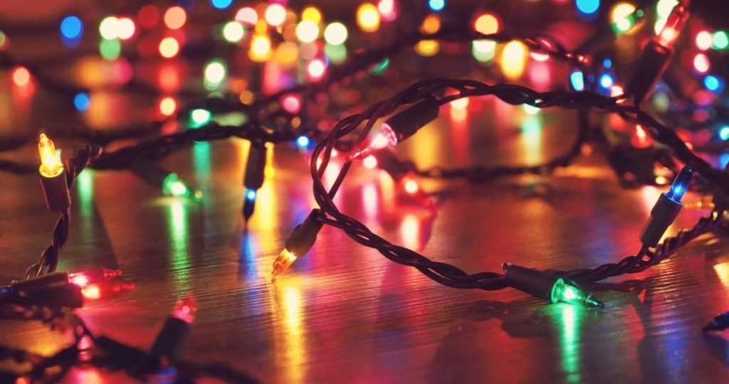

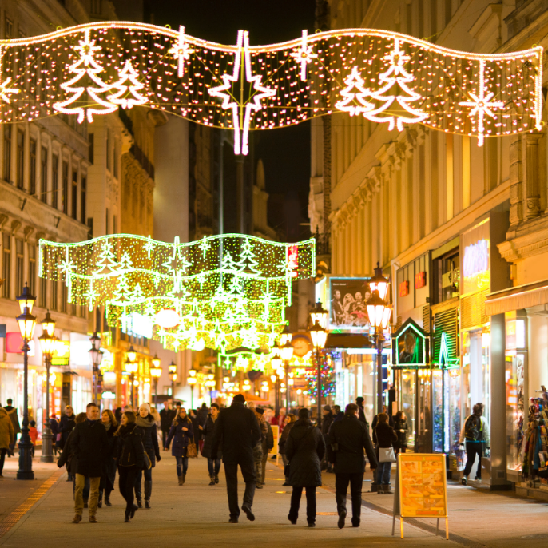

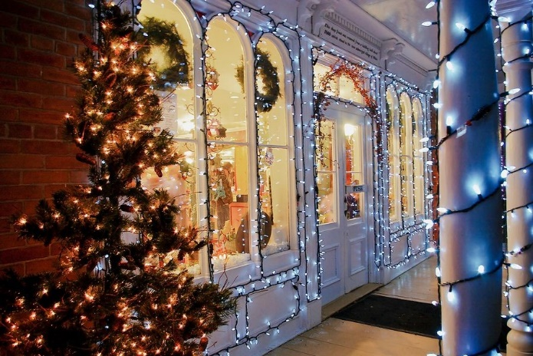

Article 3: TAKE ADVANTAGE OF NO-COST TRAINING FROM ENERGY EXPERTS
Did you know that SDG&E provides webinars for business owners and trade professionals, and most are at no cost? You or your employees can learn about the latest in green building practices, technology and energy-saving solutions from industry experts. Some of December’s topics include:
- HVAC system testing
- Residential electrification retrofits
- Analysis-based lighting recommendations
- Central heat pump water heater systems for multifamily housing
- Photovoltaic (PV) and energy storage systems (ESS) for code compliance
Certifications and continuing education units are available for many of the classes. Check out the class listing at sdge.com/EIC.
Social posts: TAKE ADVANTAGE OF NO-COST TRAININGS FROM ENERGY EXPERTS
- Did you know SDG&E provides energy education and training webinars at no cost? These on-demand webinars are offered at introductory, intermediate and advanced levels. See the webinar list at sdge.com/EIC. #sdge #SDGEassist
- Learn the latest in green building design, operations, maintenance and technology at no-cost energy webinars led by industry experts. See the on-demand webinar list at sdge.com/EIC. #sdge #SDGEassist
- Enroll in a no-cost, on-demand energy topic webinar. Energy education and training can give you and your employees the knowledge and skills that customers value. Check out the webinar list at sdge.com/EIC. #sdge #SDGEassist
Images: TAKE ADVANTAGE OF NO-COST TRAININGS FROM ENERGY EXPERTS
