QUESTION WMS1-1:

On Direct Testimony page 2, Overview III, Proposed Elimination of Regulatory accounts. Please see DRA Exhibits A-7-1 and A-7-2 showing summary of accounts.

Please provide workpaper proof of “Proposed Elimination regulatory Accounts Identified in DRA Exhibit A-7-1 and A-7-2.

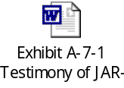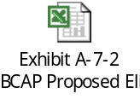

- Please provide justification of Proposal, proof of balances and status of transfers to other regulatory Accounts wherever applicable.

RESPONSE WMS1-1:

The attached table provides a summary of the regulatory accounts that SDG&E proposes to eliminate in the 2009 BCAP. The accounts are discussed in A.08-02-001 Attachment F, the prepared direct testimony of Mr. Roy. The first twelve accounts listed are discussed in Section IV.B titled “Regulatory Accounts – Proposed Elimination from Preliminary Statement” and the last account listed is discussed in Section IV.A titled “Regulatory Accounts – Forecasted Balances as of December 31, 2008.

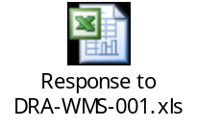

The justification for the proposed elimination of these accounts is discussed in Mr. Roy’s testimony. The attached table provides the recorded balance in each account as of December 31, 2007. The proof of each applicable balance is provided in the following attached documents from SDG&E’s SAP accounting system.

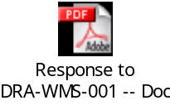

The attached table also summarizes where SDG&E proposes to transfer the December 31, 2008 regulatory account balances. The transfer of the balances is pending a Commission decision in the 2009 BCAP.

