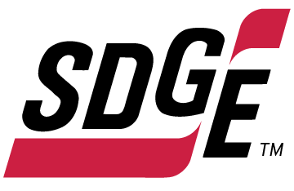

SDG&E RESIDENTIAL AND SMALL BUSINESS CONTENT PACKAGE | AUGUST 2022
As a trusted community partner, we thank you for sharing our content and digital assets with your audiences – including residents, customers and employees – to help amplify our key messages in your email communications, websites or newsletters.
Best practices for using our content, social media posts and images
- Images
Please choose images that are relevant for your audience and feel free to mix and match what we provide. For alternate images, Unsplash.com and Canva.com offer free images that you can download.
- SDG&E logo
You’re welcome to mention our name but, due to legal requirements, please do not use our logo in any marketing materials that you create. Please only use the SDG&E logo if we provide it to you in this package or it’s publicly available online like a social post or video. You can also retweet our public posts which you’ll find on twitter.com/sdge.
- Videos
We have a library of videos you can share in your communications and social posts when you visit youtube.com/c/SanDiegoGasElectric/videos. If you’d like to sort our videos by topic, visit youtube.com/c/SanDiegoGasElectric. Some videos are in Spanish. Our newest videos discuss the path to net zero, fire hardening and safety, public safety power shutoffs, 811 Dig Alert and more. You’ll see some on TV, too!
This month’s topics: Flex Alert notifications, customer assistance programs, business energy-saving tips, free energy-related webinars

Follow us
You can find us on Facebook, Instagram, Twitter, YouTube and LinkedIn. When sharing these digital assets and content, feel free to tag SDG&E’s social media accounts and direct your audience to sdge.com.
Article: Sign up for statewide Flex Alert notifications and help strengthen the grid
Did you know you can make a difference when it comes to rotating power outages? This summer, as temperatures rise and there is higher energy demand, you can help prevent rotating outages by conserving energy when a Flex Alert is called.
Flex Alerts are triggered by the state’s power grid operator, California ISO, when demand for energy is expected to exceed what is needed to power the state. This is particularly true in the summer when more Californians turn on their air conditioning, which puts more demand on the grid.
When a Flex Alert is called, customers are asked to voluntarily postpone higher energy-consuming activities until the Flex Alert has ended. This action could help the grid when it’s especially stressed and help avoid rotating outages. Simple steps, like turning off unused lighting or precooling your home before a Flex Alert begins, can make a big difference.
Sign up for Flex Alert notifications so you know when your conservation is critical. To learn more about Flex Alerts and sign up for notifications, visit FlexAlert.org.

Social posts: Sign up for statewide Flex Alert notifications and help strengthen the grid
- Did you know a Flex Alert is a call to conserve energy? An alert is triggered by the California ISO when the grid is stressed. The alert helps prevent rotating outages when everyone works together. Sign up for Flex Alert notifications so you know when to conserve energy. Find out more at FlexAlert.org. #sdge #SDGEAssist
- During hot summer days when we’re all using air conditioning to stay cool, the energy grid can become stressed by high demand. When this occurs, Flex Alerts are called for all of us to conserve energy to help prevent potential rotating outages. Volunteer to save energy and support the grid this summer. Sign up for Flex Alert notifications today at FlexAlert.org. #sdge #SDGEAssist
- When our energy grid is overwhelmed, the California ISO triggers a Flex Alert to notify us of preventable, rotating power outages. You can request to receive notifications in advance so you can prepare to reduce your electricity usage and relieve the grid. Want to participate? Sign up for Flex Alert notifications today at FlexAlert.org. #sdge #SDGEAssist
- Do you know about Flex Alerts? They notify us of preventable power outages and encourage us to conserve energy during times of high energy grid stress. Sign up for Flex Alert notifications so you’ll know when to voluntarily conserve electricity. Find out more at FlexAlert.org. #sdge #SDGEAssist
- When there is high energy demand, Flex Alerts notify us to conserve so we can avoid preventable power outages. They’re triggered by the California ISO, often in the summer, when everyone is using energy to stay cool. These alerts give us the opportunity to voluntarily conserve electricity. If you would like to support the grid, sign up for Flex Alert notifications today at FlexAlert.org. #sdge #SDGEAssist
- Did you know you can help California prevent rotating power outages? By volunteering to reduce your energy use during a statewide Flex Alert, you can make a difference during times of high grid-stress and emergencies. Find out more at FlexAlert.org. #sdge #SDGEAssist
Translated article: Regístrese para recibir notificaciones de Flex Alert y, ayude a fortalecer la red
¿Sabía que puede hacer una diferencia cuando se trata de apagones rotativos? Este verano, a medida que aumentan las temperaturas y hay una mayor demanda de energía, puede ayudar a evitar apagones rotativos conservando energía cuando se activa un Flex Alert.
Los Flex Alerts son activadas por el operador de la red eléctrica del estado, California ISO, cuando se anticipa que la demanda de energía excederá lo que está disponible para alimentar el estado. Esto es particularmente cierto en el verano, cuando más californianos usan su aire acondicionados, lo que pone más demanda en la red.
Cuando se activa un Flex Alert, se les pide a todos californianos que pospongan voluntariamente las actividades que consumen más energía hasta que el Flex Alert haya terminado. Esta acción podría ayudar a la red cuando está especialmente estresada y ayudar a evitar apagones rotativos. Tomando medidas simples, como apagar las luces que no está usando o enfriar su hogar antes de que comience un Flex Alert, puede hacer una gran diferencia.
Regístrese para recibir notificaciones de Flex Alert para saber cuándo su conservación es crítica. Para obtener más información sobre Flex Alerts y registrarse para recibir notificaciones, visite FlexAlert.org.

Postas sociales: Regístrese para recibir notificaciones de Flex Alert y, ayude a fortalecer la red
- ¿Sabías que un Flex Alert es un llamada para conservar energía? Una alerta es activada por la ISO de California cuando la red está especialmente estresada. La alerta ayuda a prevenir apagones rotativos cuando todos trabajamaos juntos. Regístrese para recibir notificaciones de Flex Alert para saber cuándo conservar energía. Obtenga más información en FlexAlert.org. #sdge #SDGEAssist
- Durante los calurosos días de verano, cuando todos usamos aire acondicinado para mantenernos frescos, la red puede verse estresada por la alta demanda de energía. Cuando esto ocurre, Flex Alerts son activados para que todos conservemos energía para ayudar a prevenir apagones rotativos. Este Verano, sea voluntario para ahorrar energía y apoyar la red. Regístrese para recibir notificaciones de Flex Alert en FlexAlert.org. #sdge #SDGEAssist
- Cuando nuestra red está sobrecargada, la ISO de California activa un Flex Alert para notificarnos de apagones rotativos prevenibles. Puede solicitar recibir notificaciones con anticipación para que pueda prepararse para reducir su consumo de electricidad y ayudar a aliviar la red. ¿Quiere participar? Regístrese para recibir notificaciones de Flex Alert hoy en FlexAlert.org. #sdge #SDGEAssist
- ¿Sabes que son Flex Alerts? Son alertas que nos notifican sobre apagones prevenibles y nos alientan a conservar energía durante momentos de alta tensión en la red. Regístrese para recibir notificaciones de Flex Alert para saber cuándo conservar electricidad voluntariamente. Obtenga más información en FlexAlert.org. #sdge #SDGEAssist
- Cuando hay una gran demanda de energía, Flex Alerts nos notifican sobre apagones prevenibles. Son activados por la ISO de California, muchas veces durante el verano, cuando todos estamos usando energía para mantenernos frescos. Estas alertas nos dan la oportunidad de conservar electricidad voluntariamente. Si desea apoyar la red, regístrese para recibir notificaciones de Flex Alert hoy en FlexAlert.org. #sdge #SDGEAssist
- ¿Sabía que puede ayudar a California a prevenir apagones rotativos? Al ofrecerse como voluntario para reducir su consumo de energía durante un Flex Alert estatal, puede hacer una diferencia en momentos de emergencia y de alta tensión en la red. Obtenga más información en FlexAlert.org. #sdge #SDGEAssist

Images: Sign up for statewide Flex Alert notifications and help strengthen the grid
Twitter:
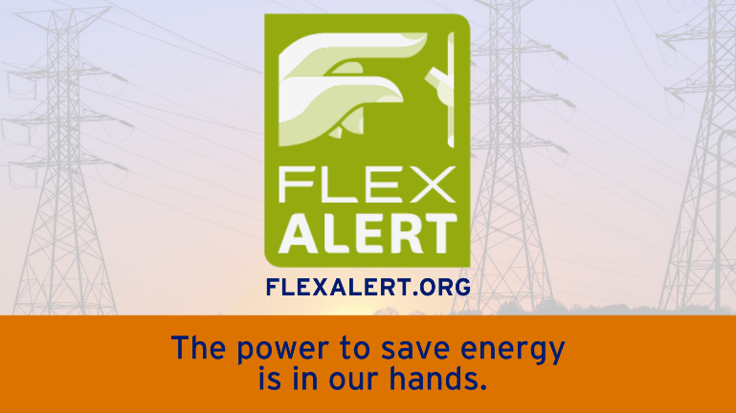
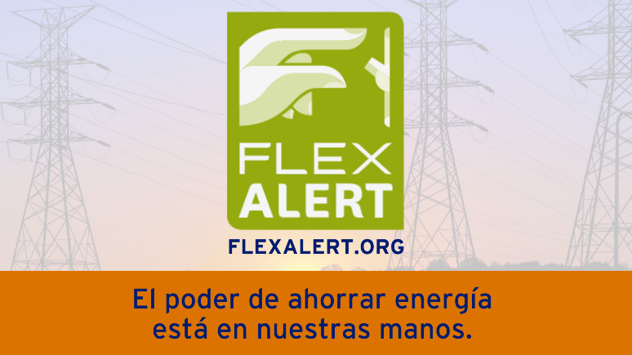
Facebook/Instagram:
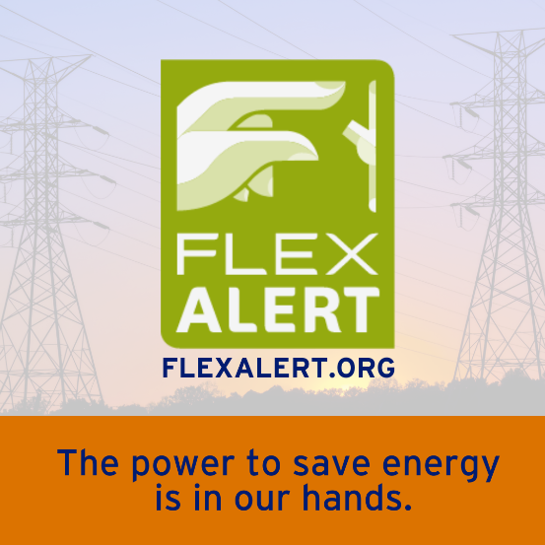
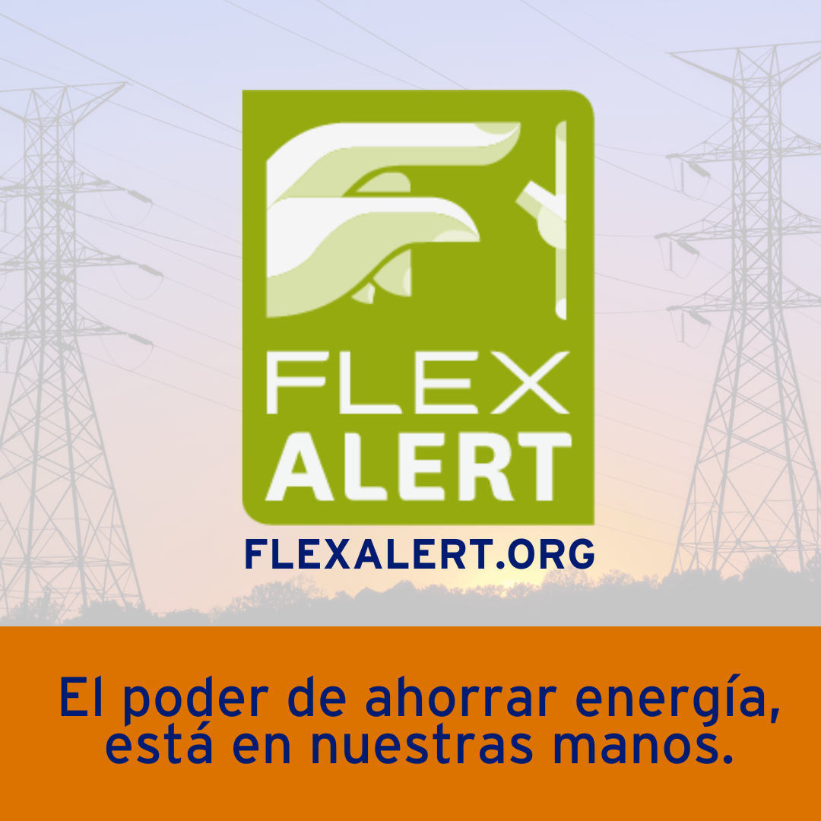
Article: NEED HELP WITH YOUR ENERGY BILL?
SDG&E recognizes that this can be a challenging time for many customers and may be able to help if you are having trouble paying your bill. You may be eligible for programs and services that can provide immediate financial assistance and help you avoid interruptions in your service. Flexible payment arrangements are available to help you pay down past due balances. Learn more at sdge.com/Payment-Arrangements.

Check out these energy assistance programs:
- California Alternate Rates for Energy (CARE) Program: Save 30% or more every month on your bill. Find out if you qualify at sdge.com/CARE.
- Family Electric Rate Assistance (FERA) Program: If you don’t qualify for CARE and your household has 3 or more people, you may qualify for FERA. You could receive an 18% discount on your electric bill. Visit sdge.com/FERA to learn more.
- Energy Savings Assistance (ESA) Program: You may qualify to receive free energy-saving improvements for your home, such as new appliances, lighting, insulation and more. Find details at sdge.com/ESA.
- Arrearage Management Plan (AMP): If you have outstanding bills and you are a CARE or FERA customer, you may be eligible for debt forgiveness. See if you qualify at sdge.com/AMP.
- Low-income Home Energy Assistance Program (LIHEAP): This program offers up to $1,000 towards your energy bill. This Federal assistance program also provides support for energy-related home improvements. Learn more at sdge.com/LIHEAP.
Even if you made a recent payment or set up a flexible payment plan with SDG&E, there may still be assistance programs available to help you. For a complete list of available offerings, visit sdge.com/assistance.

Social posts: NEED HELP WITH YOUR ENERGY BILL?
- If you’re behind on your energy bill, you may qualify for financial assistance. Learn more at sdge.com/assistance. #sdge #SDGEAssist
- Hardship is everywhere right now – the last thing you need to worry about is your energy bill. Get help with your bill at sdge.com/assistance. #sdge #SDGEAssist
- SDG&E provides assistance programs to help you with your monthly bill which can include up to a 30% discount. Find out if you qualify at sdge.com/assistance. #sdge #SDGEAssist
- Whether you rent or own, you could be eligible to receive no-cost, energy-efficient home improvements that can make your home more comfortable and help reduce your energy bill. Find out if you qualify at sdge.com/ESA. #sdge #SDGEAssist

Article (translated): ¿NECESITA AYUDA CON SU FACTURA DE ENERGÍA?
Usted puede calificar para un descuento en su factura o mejoras en el hogar. Los programas de asistencia de SDG&E ayudan a reducir su factura mensual de energía mientras mantiene su hogar cómodo.
- Programa de Tarifas Alternativas de Energía de California (CARE, por sus siglas en inglés): Ahorre un 30% o más cada mes en su factura. Averigüe si califica en sdge.com/CARE.
- Tarifa Eléctrica Familiar (FERA, por sus siglas en inglés): Si no califica para CARE y su hogar tiene 3 o más personas, puede calificar para FERA. Podría recibir un 18% de descuento en su factura de electricidad. Visite sdge.com/FERA para obtener más información.
- Programa de Asistencia para el Ahorro de Energía (ESA, por sus siglas en inglés): Puede calificar para recibir mejoras gratuitas para el ahorro de energía en su hogar, tales como electrodomésticos nuevos, iluminación, aislamiento y más. Encuentre los detalles en sdge.com/ESAP.
- Arrearage Management Plan (AMP): Si tiene facturas pendientes y es participante en el programa de CARE o FERA, puede ser elegible para la condonación de deudas. Averigüe si califica en sdge.com/AMP.
- Clientes comerciales: Configure un plan de pago flexible, para que pueda estar tranquilo sabiendo que está cubierto. Visite sdge.com/recovery para obtener más información.
Las aplicaciones en línea son fáciles, rápidas y convenientes. Para obtener más información, visite sdge.com/asistencia.

Postas sociales: ¿NECESITA AYUDA CON SU FACTURA DE ENERGÍA?
- Si está atrasado en su factura de energía, puede calificar para asistencia financiera. Obtenga más información en sdge.com/asistencia. #sdge #SDGEAssist
- En este momento, las dificultades se encuentran en todas partes - lo último que necesita es preocuparse por su factura de energía. Obtenga ayuda con su factura en sdge.com/asistencia. #sdge #SDGEAssist
- SDG&E ofrece programas de asistencia para ayudarle con su factura mensual que puede incluir hasta un 30% de descuento. Descubra si califica en sdge.com/asistencia. #sdge #SDGEAssist
- Si alquile o es propietario, podría ser elegible para recibir mejoras de eficiencia energética en su hogar, sin costo, que pueden hacer que su hogar sea más cómodo y ayuden reducir su factura de energía. Descubra si califica en sdge.com/ESA. #sdge #SDGEAssist

Images: NEED HELP WITH YOUR ENERGY BILL?

Twitter:
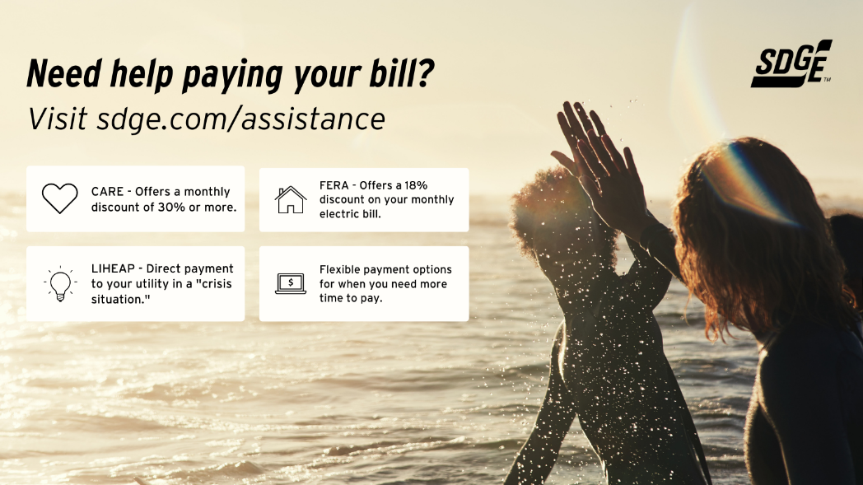
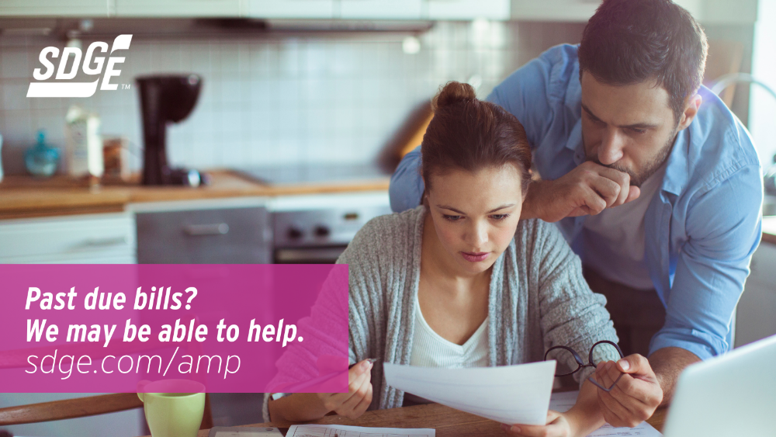
Instagram/Facebook:
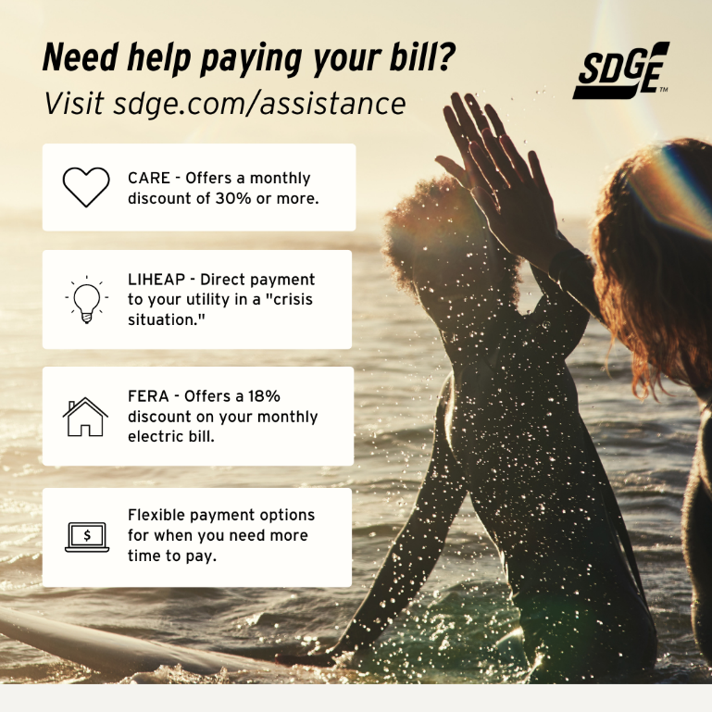
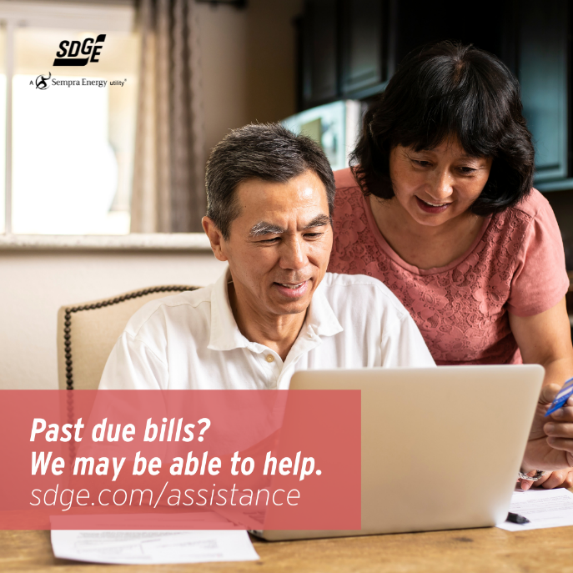

Business Article: GREET THE HEAT WITH SUMMER SAVINGS STRATEGIES
The summer heat is rising and your energy bill may follow along with it. Make sure your business is prepared and learn about SDG&E’s programs and pricing plans to help save.
Here are some tips to help you manage your energy use when temperatures rise:
- Use fans. Fans can help your business maintain a comfortable temperature. Moving air can make higher temperatures and humidity feel more comfortable and reduce the need for air conditioning. When the temperature outside feels more comfortable than inside, use a box fan in the window or a whole facility fan in the attic to pull in the comfortable air.
- Ensure efficient cooling. Cooling costs account for 40% of energy costs for commercial buildings. Regular maintenance on your HVAC based on the manufacturer’s recommendations can help you save.
- Monitors and computers are two culprits that continue to draw power even when they are switched off. Prevent “phantom” loads by using a power strip to cut power.
- If you’re a small or medium business and an SDG&E customer, you may qualify for customized business solutions that can help you reduce your energy costs and save money. Find out more on sdge.com/business-summer.
Want to connect with an energy specialist and learn how you can save? Take a quick survey on sdge.com/business/save-energy-and-money.

Social posts: GREET THE HEAT WITH SUMMER SAVINGS STRATEGIES
- Make it a regular practice to unplug all unused devices to lower energy costs and generate less heat indoors. Aside from preventing power surges, unplugging appliances is also a safer practice as it minimizes fire hazards in the workplace. For more energy-saving tips at work, visit sdge.com/business-summer. #sdge #SDGEAssist
- Use light sources well. Southern- and western-facing windows are usually best left closed with the blinds drawn to keep the sun from warming the room. Cool your building in the morning hours when demand for energy is lower and less expensive. For more energy-saving tips at work, visit sdge.com/business-summer. #sdge #SDGEAssist
- Invest in LED light bulbs. They cost a little more but LED light bulbs use energy far more efficiently than incandescent bulbs and produce less heat. LED bulbs are a good investment for reducing long-term energy costs. For more energy-saving tips at work, visit sdge.com/business-summer. #sdge #SDGEAssist
- Simple things such as the placement of your air conditioning unit can affect how well it cools the space it is in. Do not place devices that emit heat, such as lamps and televisions, beside your A/C unit since the higher temperatures could make your unit work harder to cool the room. For more energy-saving tips at work, visit sdge.com/business-summer. #sdge #SDGEAssist
- You don’t need to set the thermostat to the coolest temperature when you turn it on – it has no effect on how quickly a room becomes colder. For more energy-saving tips at work, visit sdge.com/business-summer. #sdge #SDGEAssist
- Do you need help paying your business’s SDG&E bill? Visit sdge.com/recovery for more information. #sdge #SDGEAssist
Images: GREET THE HEAT WITH SUMMER SAVINGS STRATEGIES

Article: TAKE ADVANTAGE OF NO-COST TRAINING FROM ENERGY EXPERTS
Did you know that SDG&E provides webinars for business owners and trade professionals, so you can learn new skills at your own pace? And most are at no cost. You or your employees can learn about the latest in green building practices, technology and energy-saving solutions from industry experts. Certifications and continuing education units are available for many classes. Check out the class listing at sdge.com/EnergyClasses.
Are you a Trade Professional? Join SDG&E’s Trade Professional Alliance at sdge.com/TradePro.
Some of August’s topics include:
- Various Title 24 and IHACI classes
- Home Energy Series
  - August 9: Part 1 – Your Home’s Energy Usage & Your Utility Bill
  - August 16: Part 2 – Home Comfort – Your Building Enclosure & Major Systems
  - August 23: Part 3 – Solar & Storage – Your Energy Generation & Storage Plan
- August 18: LEED Project Management
- August 18: Structural Insulated Panels (SIPs)
- August 18: Combination Ovens for Commissary Kitchens
- August 30: Introduction to the Passive House Standard
Social posts: TAKE ADVANTAGE OF NO-COST TRAININGS FROM ENERGY EXPERTS
- Did you know SDG&E provides energy education and training webinars at no cost? These on-demand webinars are offered at introductory, intermediate and advanced levels. See the webinar list at sdge.com/EnergyClasses. #sdge #SDGEAssist
- Learn the latest in green building design, operations, maintenance and technology at no-cost energy webinars led by industry experts. See the on-demand webinar list at sdge.com/EnergyClasses. #sdge #SDGEAssist
- Enroll in a no-cost, on-demand energy topic webinar. Energy education and training can give you and your employees the knowledge and skills that customers value. Check out the webinar list at sdge.com/EnergyClasses. #sdge #SDGEAssist

Images: TAKE ADVANTAGE OF NO-COST TRAININGS FROM ENERGY EXPERTS

