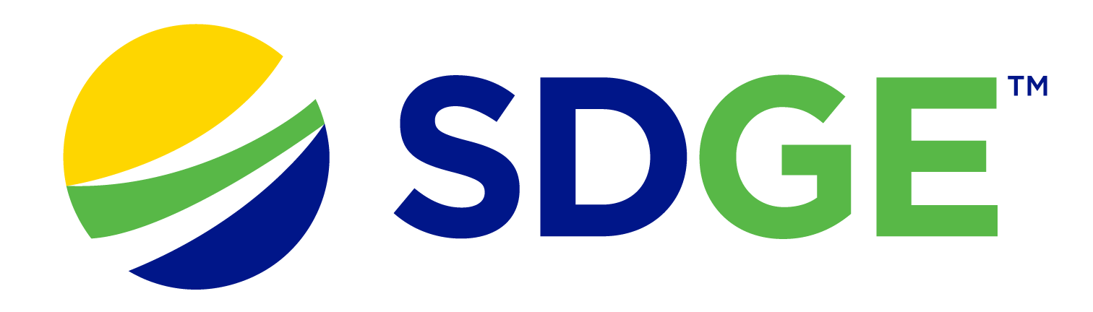

SDG&E® RESIDENTIAL AND SMALL BUSINESS CONTENT PACKAGE | AUGUST 2023
As a trusted community partner, we thank you for sharing our content and digital assets with your audiences – including residents, customers and employees – to help amplify our key messages in your email communications, websites or newsletters.
Best practices for using our content, social media posts and images
- IMAGES
Choose IMAGES that are relevant for your audience and feel free to mix and match what we provide. For alternate IMAGES, Unsplash.com and Canva.com offer free IMAGES that you can download.
- SDG&E logo
You’re welcome to mention our name but, due to legal requirements, please do not use our logo in any marketing materials that you create. Please only use the SDG&E logo if we provide it to you in this package or it’s publicly available online like a social post or video. You can also retweet our public posts which you’ll find on twitter.com/sdge.
- Videos
We have a library of videos you can share in your communications and SOCIAL POSTS when you visit youtube.com/c/SanDiegoGasElectric/videos. If you’d like to sort our videos by topic, visit youtube.com/c/SanDiegoGasElectric. Some videos are in Spanish. You’ll see some on TV, too!
Follow us
Find us on Facebook, Instagram, Twitter, YouTube and LinkedIn. When sharing our digital assets and content, feel free to tag SDG&E’s social media and direct your audience to sdge.com.

This month’s topics: Staying cool and saving energy tips, customer assistance, flex alerts, start/stop/move SDGE service, energy webinars. Articles and social posts translated in Spanish are in blue font.

NEW!
PODCAST: SDG&E Customer Assistance programs
English: youtu.be/bZTCCDdVBU0
A podcast where SDG&E delves into the complex and sometimes confusing world of utilities. Experts from SDG&E will uncover the mysteries of our energy systems, explore new solutions for everyday problems and provide unique insights into the industry that powers our lives. So, plug in and power up with us as we explore the mysteries beyond the meter and more on: THE CONNECTION.
Español: youtu.be/aHzsQn2505w
Un podcast de SDG&E donde platicamos con los expertos de la industria para conocer más sobre el mundo fascinante - y a veces confuso - de los servicios públicos. Nuestros invitados destaparán los misterios de nuestros sistemas de energía, explorarán nuevas soluciones para los problemas cotidianos y brindarán conocimientos únicos sobre la industria que impulsa nuestras vidas. Únase a nosotros mientras exploramos los misterios más allá del medidor y más en: LA CONEXIÓN.
ARTICLE: beat the summer heat
Record breaking heat waves have become a staple of summers in America. Those hardest hit are the most vulnerable – seniors, young children and people with chronic health conditions. Extreme heat kills more people in the United States than any other weather hazard. Extreme heat events in the United States are expected to become even more common, more severe and longer lasting.
Here’s a list of tips to help stay cool and safe. Visit sdge.com/MyEnergy for more tips.
- Visit a Cool Zone which is a network of free, air-conditioned facilities across San Diego County like libraries and community centers. If you’re unable to get to a Cool Zone, call 2-1-1 to be connected to a transportation service at no cost. Visiting Cool Zones is also a way to use less energy at home and help reduce your energy costs. Find a Cool Zone near you at sdge.com/Cool-Zones or bit.ly/43EdfKw.
- Learn about the Cool Zone Fan Program and find out if you qualify for a free fan at bit.ly/CoolZoneFans.
- Catch a movie in an air-conditioned theatre during hot afternoons. Ticket prices are usually less expensive earlier in the day too.
- Don’t forget about your pets. When outdoors, carry water for your fur baby, try to stay in the shade and keep their paws off hot asphalt and other hot surfaces. Never leave an animal in a hot vehicle. At home, put ice cubes in your pet’s water bowl and place a cool, damp towel down for them to lay on.
- Keep your home’s shades, curtains and blinds closed during the hottest part of the day to help keep the sun’s rays out.
- Your stove and oven can give off a lot of heat so make meals that don’t require heat, like salads and sandwiches.
- When temperatures cool in the evening, open windows to let the cooler air in.
- Run your ceiling fan counter-clockwise so it pushes cooler air down. Reverse your ceiling fan direction in the winter for the opposite effect.
- If you have a window air conditioning unit, seal any cracks. If you have central A/C, check the ducts for proper insulation and clean filters regularly.
- Shift your energy use outside of 4 p.m. to 9 p.m. to save. Energy costs are the highest during this time. Do your heat-generating chores like laundry or running the dishwasher before 4 p.m. or after 9 p.m.
SOCIAL POSTS: beat the summer heat
Use any of the bullets above and add: Get more tips at sdge.com/MyEnergy. #sdge #SDGEassist

IMAGES: beat the summer heat

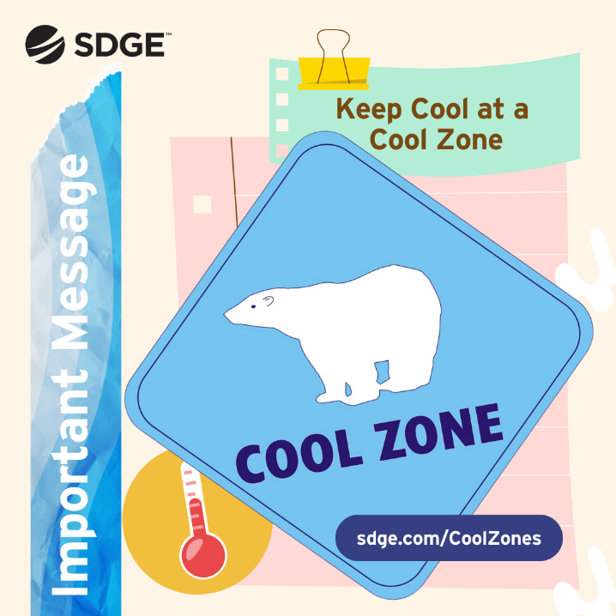

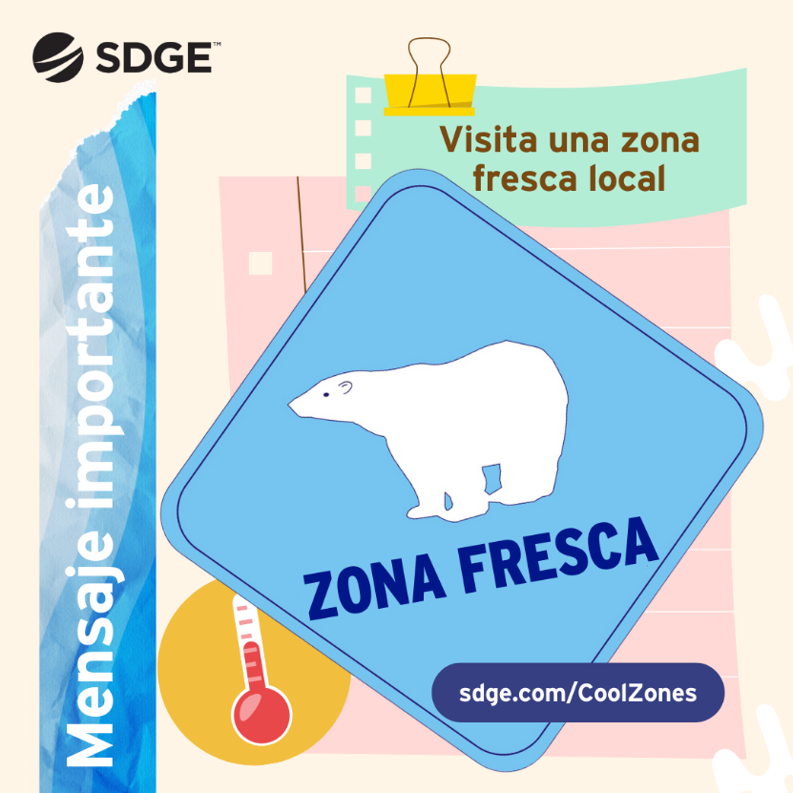
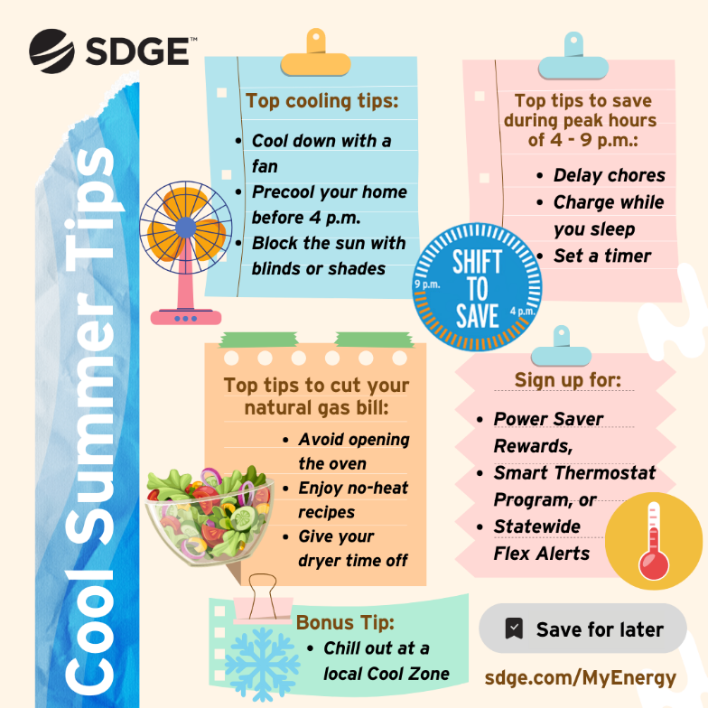
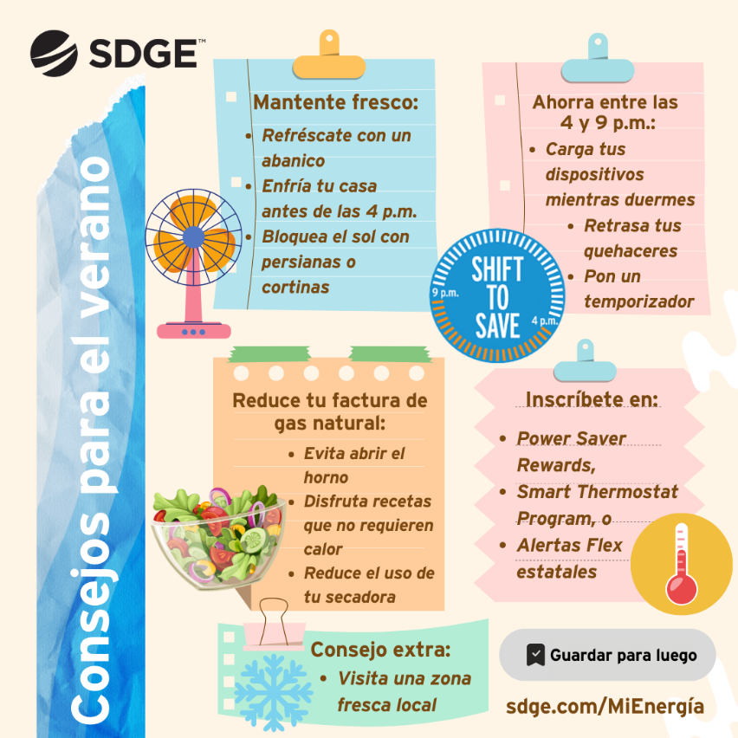

article: Need help paying your utility bills?
There are programs and services available to help manage your bills.
- Phone bill discount: The California LifeLine Program provides discounted phone services to eligible households. To learn more, visit CaliforniaLifeline.com or call 866-272-0349.
- Home internet discount service: You may be eligible for free or low-cost home internet service through the California’s Emerging Technology Fund. Get details at InternetForAllNow.org or call 866-519-8655.
- Low-income Household Water Assistance Program: This federal program provides financial assistance to low-income Californians to help manage their residential water utility costs. Since the federal grant provides the funding, you do not have to repay it. Learn more at bit.ly/3K7B4nd.
social posts: Need help paying your utility bills?
Use any of the three bullets above and add: #sdge #SDGEassist
article: ¿Necesitas ayuda para pagar las facturas de servicios públicos?
Hay programas y servicios disponibles para ayudarte a gestionar tus facturas.
- Descuento en la factura del teléfono: El programa California LifeLine ofrece servicios telefónicos con descuento a hogares elegibles. Para obtener más información, visita CaliforniaLifeline.com o llama al 866-272-0349.
- Servicio de descuento de internet en el hogar: Es posible que califiques para recibir servicio de internet gratuito o de bajo costo en tu hogar a través del Fondo para las Tecnologías Emergentes de California (California’s Emerging Technology Fund). Obtén más detalles en InternetForAllNow.org o llama al 866-519-8655.
- Programa de Asistencia para Hogares de Bajos Ingresos en el Pago del Agua: Este programa federal ofrece asistencia financiera a los californianos de bajos ingresos para ayudarles a gestionar los costos de servicios públicos de agua en sus hogares. No tienes que devolver el dinero ya que los fondos provienen de una subvención federal. Obtén más información en bit.ly/3K7B4nd.
translated social posts: ¿Necesitas ayuda para pagar las facturas de servicios públicos?
Utiliza cualquiera de los tres párrafos anteriores y agrega: #sdge #SDGEassist o #SDGEasistencia

IMAGES: Need help paying your utility bills?



Article: SIGN UP FOR STATEWIDE FLEX ALERT NOTIFICATIONS
Did you know you can make a difference when it comes to preventing rotating power outages? This summer, as temperatures rise and there is higher energy demand, you can help prevent rotating outages by conserving energy when a Flex Alert is called.

Flex Alerts are triggered by the state’s power grid operator, California ISO, when demand for energy is expected to exceed what is needed to power the state. This is particularly true in the summer when more Californians turn on their air conditioning, which puts more demand on the grid.

When a Flex Alert is called, customers are asked to conserve energy. This action could help the grid when it’s especially stressed and help avoid rotating outages. Simple steps, like turning off unused lighting or precooling your home before a Flex Alert begins, can make a big difference.
To learn more about Flex Alerts and sign up for notifications, visit FlexAlert.org.

Social posts: SIGN UP FOR STATEWIDE FLEX ALERT NOTIFICATIONS
1. Did you know a Flex Alert is a call to conserve energy? An alert is triggered by the California ISO when the grid is stressed. The alert helps prevent rotating outages when everyone works together. Sign up for Flex Alert notifications so you know when to conserve energy. Find out more at FlexAlert.org. #sdge #SDGEAssist
2. During hot summer days when we’re all using air conditioning to stay cool, the energy grid can become stressed by high demand. When this occurs, Flex Alerts are called for all of us to conserve energy to help prevent potential rotating outages. Volunteer to save energy and support the grid this summer. Sign up for Flex Alert notifications today at FlexAlert.org. #sdge #SDGEAssist
3. When our energy grid is overwhelmed, the California ISO triggers a Flex Alert to notify us of preventable, rotating power outages. You can request to receive notifications in advance so you can prepare to reduce your electricity usage and relieve the grid. Want to participate? Sign up for Flex Alert notifications today at FlexAlert.org. #sdge #SDGEAssist
4. Do you know about Flex Alerts? They notify us of preventable power outages and encourage us to conserve energy during times of high energy grid stress. Sign up for Flex Alert notifications so you’ll know when to voluntarily conserve electricity. Find out more at FlexAlert.org. #sdge #SDGEAssist
5. When there is high energy demand, Flex Alerts notify us to conserve so we can avoid preventable power outages. They’re triggered by the California ISO, often in the summer, when everyone is using energy to stay cool. These alerts give us the opportunity to voluntarily conserve electricity. If you would like to support the grid, sign up for Flex Alert notifications today at FlexAlert.org. #sdge #SDGEAssist
6. Did you know you can help California prevent rotating power outages? By volunteering to reduce your energy use during a statewide Flex Alert, you can make a difference during times of high grid-stress and emergencies. Find out more at FlexAlert.org. #sdge #SDGEAssist

Translated article: REGÍSTRATE PARA RECIBIR NOTIFICACIONES DE FLEX ALERTS
¿Sabías que puedes marcar la diferencia para ayudar a prevenir los apagones rotativos? Este verano, a medida que aumentan las temperaturas y hay una mayor demanda de energía, puedes ayudar a evitar los apagones rotativos conservando energía cuando se activa una Alerta Flex (o Flex Alert en inglés).

El operador de la red eléctrica del estado, conocido como el ISO de California, emite las Flex Alerts cuando se anticipa que la demanda de energía excederá lo que está disponible en todo el estado. Esto generalmente ocurre en el verano, cuando más californianos usan sus aparatos de aire acondicionado para mantenerse frescos, lo que ocasiona más demanda en la red eléctrica.

Cuando se activa una Flex Alert, se les pide a todos los californianos que conserven energía. El tomar medidas sencillas para conservar, como apagar las luces que no está usando o enfriar el hogar antes de que comience una Flex Alert podría ayudar a la red eléctrica cuando está especialmente estresada y ayudar a evitar los apagones rotativos. Para obtener más información sobre las Flex Alerts y registrarte para recibir notificaciones, visite FlexAlert.org/spanish.

postas sociales: REGÍSTRATE PARA RECIBIR NOTIFICACIONES DE FLEX ALERTS
1. ¿Sabías que una Flex Alert es un llamada para conservar energía? El ISO de California emita una alerta cuando la red eléctrica está especialmente estresada. La alerta ayuda a prevenir los apagones rotativos si todos trabajamos juntos para conservar. Regístrese para recibir notificaciones de Flex Alerts para saber cuándo debe conservar energía. Obtén más información en FlexAlert.org/spanish. #sdge #SDGEAssist #SDGEasistencia
2. Durante los calurosos días de verano, cuando todos usamos aire acondicionado para mantenernos frescos, es posible que la red eléctrica esté sobrecargada debido a la alta demanda de energía. Cuando esto ocurre, se emiten las Flex Alerts para que todos conservemos energía para ayudar a prevenir los apagones rotativos. Este verano, tome medidas voluntarias para ahorrar energía y apoyar la red. Regístrate para recibir notificaciones de Flex Alerts en FlexAlert.org/spanish. #sdge #SDGEAssist #SDGEasistencia
3. Cuando nuestra red eléctrica está sobrecargada, el ISO de California emite una Flex Alert para informarnos de apagones rotativos posibles y prevenibles. ¿Sabías que puedes recibir notificaciones con anticipación para que puedes prepararte para tomar medidas para reducir su consumo de electricidad y ayudar a aliviar la red? Regístrate para recibir notificaciones de Flex Alert hoy mismo en FlexAlert.org/spanish. #sdge #SDGEAssist #SDGEasistencia
4. ¿Sabes que son las Flex Alerts? Son alertas que nos informan sobre apagones prevenibles y nos alientan a tomar medidas para conservar energía cuando hay alta tensión en la red eléctrica. Regístrese para recibir notificaciones de Flex Alerts para saber cuándo debe conservar electricidad voluntariamente. Obtén más información en FlexAlert.org/spanish. #sdge #SDGEAssist #SDGEasistencia
5. Cuando hay una gran demanda de energía, las Flex Alerts nos informan sobre apagones prevenibles. El ISO de California emite las alertas muchas veces durante el verano, cuando todos estamos usando energía para mantenernos frescos. Estas alertas nos dan la oportunidad de conservar electricidad de forma voluntara. Si deseas apoyar la red, regístrate para recibir notificaciones de Flex Alert hoy mismo en FlexAlert.org. #sdge #SDGEAssist #SDGEasistencia
6. ¿Sabías que puedes ayudar a California a prevenir apagones rotativos? Al tomar medidas voluntarias para reducir su consumo de energía durante una Flex Alert estatal, puedes marcarla diferencia cuando hay una emergencia o alta tensión en la red eléctrica. Obtén más información en FlexAlert.org/spanish. #sdge #SDGEAssist #SDGEasistencia

IMAGES: SIGN UP FOR STATEWIDE FLEX ALERT NOTIFICATIONS

Twitter (X):
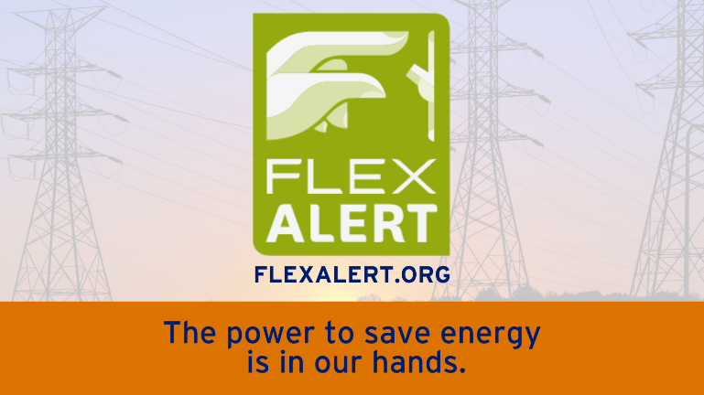
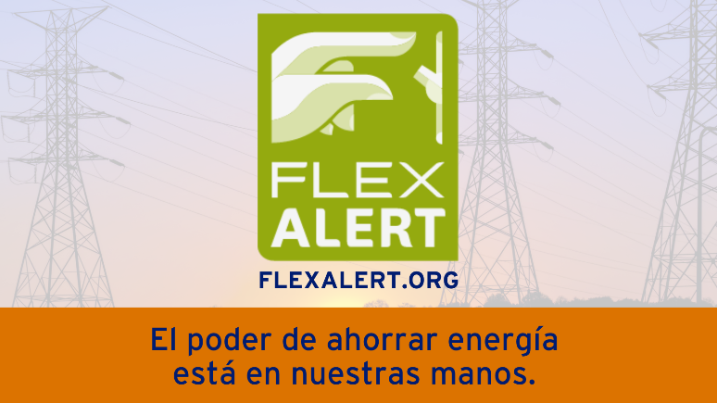

Facebook/Instagram:
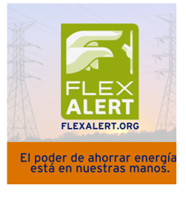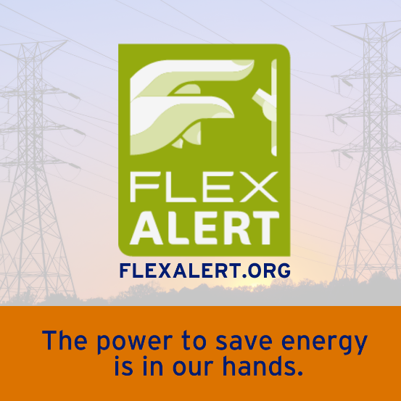

ARTICLE: MOVING? SCHEDULE YOUR SDG&E SERVICE REQUEST ONLINE
Take a little stress out of your move when you schedule your SDG&E service request online. Use SDG&E’s My Account to start, transfer or stop your service. It’s easy and only takes a minute. No need to call and no need to wait on the phone. Online scheduling shows you available dates that you can choose. If your plans change, simply update your request online. Get more information at sdge.com/move.
SOCIAL POSTS: MOVING? SCHEDULE YOUR SDG&E SERVICE REQUEST ONLINE
- Moving? Make moving easier with online scheduling tools. Visit sdge.com/move to start, transfer or stop your SDG&E service. #sdge #SDGEassist
- Moving made easy. Start, transfer or stop your SDG&E service online. Easy, convenient – no calls, no waiting. Get more information at sdge.com/move. #sdge #SDGEassist

IMAGES: MOVING? SCHEDULE YOUR SDG&E SERVICE REQUEST ONLINE

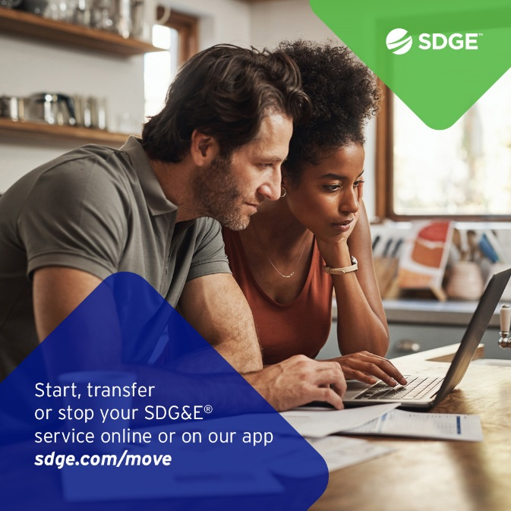

BUSINESS SECTION:
ARTICLE: wOULD YOUR BUSINESS ENJOY LOWER ENERGY BILLS?

Higher summer temperatures can mean higher energy bills and cause an extraordinary strain on the electrical grid. This can lead to a greater risk of grid emergencies and power outages. But it doesn't have to be this way.

During a grid emergency, businesses in SDG&E's service territory can participate in the Emergency Load Reduction Program (ELRP). By joining ELRP, businesses help support the grid when it's facing extra strain and can get a bill credit for their participation. ELRP is a flexible way to get incentives for using less energy.

Participating in ELRP allows qualified businesses to contribute to stabilizing the grid and reduce the risk of issues without worrying about any financial penalties. To gather more information about ELRP, visit sdge.com/ELRP.

Social posts: wOULD YOUR BUSINESS ENJOY LOWER ENERGY BILLS?
- The Emergency Load Reduction Program is a flexible way your business can get incentives for using less energy. Learn more at sdge.com/ELRP. #sdge #SDGEassist
- When your business participates in SDG&E’s ELRP program, you can earn financial incentives of $2 per kilowatt-hour when your business reduces energy during a grid emergency. Get more information at sdge.com/ELRP. #sdge #SDGEassist

imageS: wOULD YOUR BUSINESS ENJOY LOWER ENERGY BILLS?



ARTICLE: TAKE ADVANTAGE OF NO-COST TRAINING FROM ENERGY EXPERTS
Did you know that SDG&E provides webinars for business owners and trade professionals, so you can learn new skills at your own pace? And most are at no cost. You or your employees can learn about the latest in green building practices, technology and energy-saving solutions from industry experts. Certifications and continuing education units are available for many classes. Check out the class listing at sdge.com/EnergyClasses.

SOCIAL POSTS: TAKE ADVANTAGE OF NO-COST TRAININGS FROM ENERGY EXPERTS
- Did you know SDG&E provides energy education and training webinars at no cost? These on-demand webinars are offered at introductory, intermediate and advanced levels. See the webinar list at sdge.com/EnergyClasses. #sdge #SDGEassist
- Learn the latest in green building design, operations, maintenance and technology at no-cost energy webinars led by industry experts. See the on-demand webinar list at sdge.com/EnergyClasses. #sdge #SDGEassist
- Enroll in a no-cost, on-demand energy topic webinar. Energy education and training can give you and your employees the knowledge and skills that customers value. Check out the webinar list at sdge.com/EnergyClasses. #sdge #SDGEassist

imageS: TAKE ADVANTAGE OF NO-COST TRAININGS FROM ENERGY EXPERTS
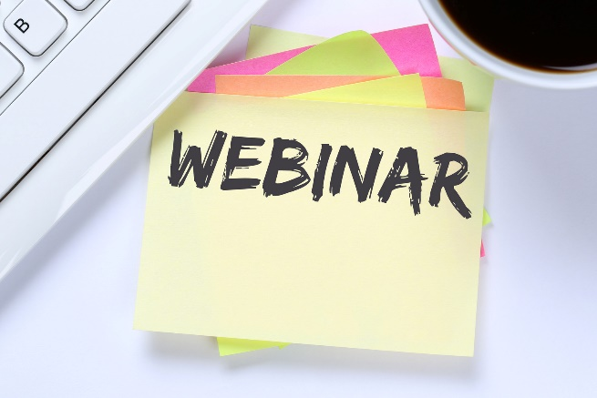

NEW SECTION!
JUST POSTS - Residential
- Tips on how to stay cool while keeping energy costs down are available at sdge.com/MyEnergy. You’ll also find tools for managing your energy use and bill. #sdge #SDGEassist
- Summer pricing is here and when you use energy matters. Using less energy from 4 p.m. to 9 p.m. is good for the environment and your budget. Find tips, resources and programs to help you manage your energy use and bill at sdge.com/MyEnergy. #sdge #SDGEassist
- Use a small air conditioner for smaller spaces. Correctly sizing the air conditioner for your home can result in energy savings. Get more tips at sdge.com/MyEnergy. #sdge #SDGEassist
- Find the magic number. For every degree higher you set your thermostat in the summer, you could save three percent on your cooling costs. Get more tips at sdge.com/MyEnergy. #sdge #SDGEassist
- Qualifying SDG&E customers can receive rebates toward the purchase of energy-efficient products for the home. Learn more about the Golden State Rebates program at sdge.com/rebates. #sdge #SDGEassist
- Get a bill credit on your SDG&E bill when you sign up for Power Saver Rewards and lower your energy use during occasional high-demand times. Get details at sdge.com/PowerSaver. #sdge #SDGEassist
- Manage your SDG&E bill when you sign up for energy use alerts. Receive a text or email notification when your energy usage reaches a dollar amount that you set. Get more info at sdge.com/alerts. #sdge #SDGEassist
- The Neighbor-to-Neighbor program provides eligible SDG&E customers with up to $600 to offset their outstanding energy bills. SDG&E customers may apply if they are experiencing serious illness, temporary unemployment, disability or unusual hardship. Learn more at sdge.com/NTN. #sdge #SDGEassist
- A new no-cost energy efficiency upgrade program for renters and owners of single-family homes is now available. Residential Energy Solutions has no income restrictions and has the potential to help local families achieve long-term savings on their energy bills. Get details at sdge.com/RES. #sdge #SDGEassist
- Install a whole house fan. It can help you save up to 90% on your cooling costs. It pulls fresh outdoor air into your home to keep you cool and pushes hot air out of your attic to keep your home comfortable longer. Get more tips at sdge.com/MyEnergy. #sdge #SDGEassist
- Use a programmable timer for your pool pump: Set a timer for your pool pump to run during off-peak hours when electricity rates are lower. Get more tips at sdge.com/MyEnergy. #sdge #SDGEassist
- Limit appliance usage during the most expensive peak hours of 4 p.m. to 9 p.m. Avoid using energy-intensive appliances like ovens, dishwashers and washing machines during the hottest parts of the day. Get more tips at sdge.com/MyEnergy. #sdge #SDGEassist

