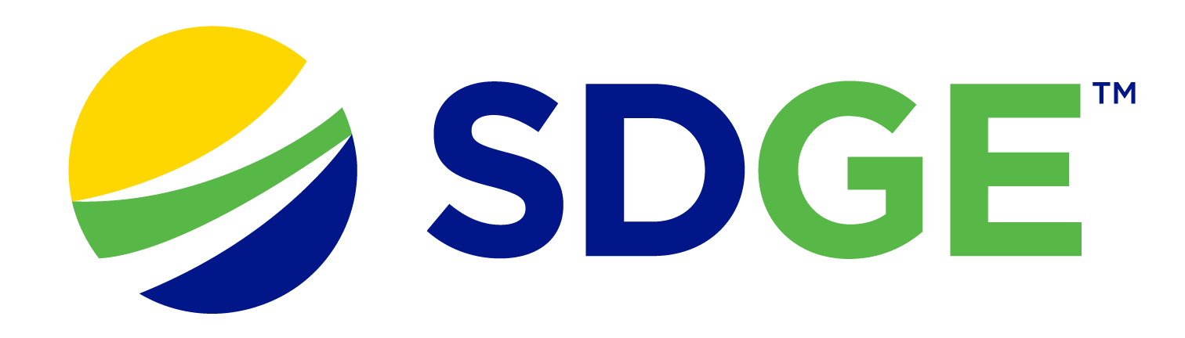

SDG&E® RESIDENTIAL AND SMALL BUSINESS CONTENT PACKAGE | APRIL 2024
As a trusted community partner, we thank you for sharing our content and digital assets with your audiences – including residents, customers and employees – to help amplify our key messages in your email communications, websites or newsletters.
Best practices for using our content, social media posts and images
- IMAGES
Choose IMAGES that are relevant for your audience and feel free to mix and match what we provide. For alternate images, Unsplash.com and Canva.com offer free images that you can download.
- SDG&E logo
You’re welcome to mention our name but, due to legal requirements, please do not use our logo in any marketing materials that you create. Please only use the SDG&E logo if we provide it to you in this package or it’s publicly available online like a social post or video. You can also retweet our public posts which you’ll find on facebook.com/sdge and twitter.com/sdge.
- Videos
We have a library of videos you can share in your communications and SOCIAL POSTS when you visit youtube.com/c/SanDiegoGasElectric/videos. If you’d like to sort our videos by topic, visit youtube.com/c/SanDiegoGasElectric. Some videos are in Spanish. You’ll see some on TV, too!
Follow us
Find us on Facebook, Instagram, Twitter, YouTube and LinkedIn. When sharing our digital assets and content, feel free to tag SDG&E’s social media and direct your audience to sdge.com.

This month’s topics: SDGE payment options, water and energy conservation, assistance programs, paperless billing, energy-savings tips for residential and business customers

article: With SDG&E, you choose how to pay YOUR ENERGY BILL
SDG&E offers convenient tools that allow you to choose how you’d like to pay your energy bill. Check out all the options:
- Pay Online – it’s quick and easy! Just log in to My Account at sdge.com/MyAccount.
- Auto Pay – an even easier way to pay is with Auto Pay! Enjoy the convenience of having your payment automatically deducted from your bank account. No checks, no fees, no late payments and no postage costs. Your time is valuable. Learn more at sdge.com/Auto-Pay.
- SDG&E Mobile App – a simple and quick way to pay your bill is with SDG&E’s app. Download it from the App Store or Google Play. Get more info at sdge.com/MobileApp.
- Text to Pay – does it get any easier? You can pay your bill by text. Just a one-time setup and you’re ready to go. It’s simple and secure. Learn more at sdge.com/Text2Pay.
- Mail a check – use the return envelope included with your paper bill. You will need to provide a stamp. Save time and money and go paperless! Get details at sdge.com/paperless.
- Pay with a credit or debit card or electronic check – SDG&E partners with BillMatrix who charges a $1.50 convenience fee per transaction. Go to BillMatrix.com to pay online or call the dedicated SDG&E payment line at 1-800-386-0067. Be aware of scams that offer to pay your SDG&E bill or ask for your personal information. Only use authorized payment channels to pay your energy bill. Learn more at sdge.com/scams.
- Need more time to pay? You can make payment arrangements online. Visit sdge.com/PaymentHelp.
- Get a more predictable energy bill each month with SDG&E’s Level Pay Plan. Learn more at sdge.com/LPP.
- Do you need help making payments? Find out if you qualify for any of SDG&E’s assistance programs at sdge.com/assistance.
For a summary of payment options, visit sdge.com/Pay-My-Bill.
social posts: With SDG&E, you choose how to pay YOUR ENERGY BILL
- Did you know you can pay your energy bill by text? Learn more at sdge.com/Text2Pay. #sdge #SDGEassist
- Simplify your life with Auto Pay. Make sure your energy bill is paid on time every month. Auto Pay is easy, secure and you can cancel any time. Get details at sdge.com/Auto-Pay. #sdge #SDGEassist
- Cut the clutter. Go paperless! You can sign up for convenient and secure paperless billing to pay your energy bill. Reduce your carbon footprint and manage your bill online. Find out more at sdge.com/paperless. #sdge #SDGEassist
- A simple and quick way to pay your energy bill is with SDG&E’s app. Download it from the App Store or Google Play. Get more info at sdge.com/MobileApp. #sdge #SDGEassist

images: With SDG&E, you choose how to pay YOUR ENERGY BILL

ARTICLE: Energy-efficient appliances make a splash in water conservation
California has a reason to celebrate! It has been declared drought-free thanks to a year of epic rains. But it’s still important to conserve water. Water and energy are closely connected. It takes energy to heat water, so you can save money on your energy bill when you use less water.
Energy-efficient appliances offer many benefits when it comes to conserving both water and energy. Here are some key advantages:
- Reduced energy use: Energy-efficient appliances typically consume less electricity compared to their conventional counterparts. For example, energy-efficient washing machines and dishwashers use advanced technologies such as improved insulation, better compressor designs or more efficient motors, which can result in significant energy savings over time.
- Lower energy bills: By using less energy, energy-efficient appliances can lead to lower energy bills. Although the initial purchase price of these appliances might be higher, the long-term savings on energy bills can often outweigh the upfront cost.
- Water conservation: Many energy-efficient appliances, particularly those used for washing clothes or dishes, are designed to use less water without sacrificing performance. For instance, high-efficiency washing machines typically use sensors and advanced water delivery systems to optimize water use, leading to significant water savings.
- Environmental benefits: Reduced energy and water use translate into lower greenhouse gas emissions and a smaller ecological footprint. By choosing energy-efficient appliances, you contribute to mitigating climate change and conserving natural resources.
- Future-Proofing: As energy efficiency standards continue to evolve and regulations become stricter, investing in energy-efficient appliances can future-proof your home against potential increases in energy costs or changes in regulatory requirements.
Overall, energy-efficient appliances offer a compelling combination of financial savings, environmental benefits and improved performance, making them a smart choice to reduce energy and water consumption.
SOCIAL POSTS: Energy-efficient appliances make a splash in water conservation
- Saving water saves energy: Reduced energy and water use translate into lower greenhouse gas emissions and a smaller ecological footprint. By choosing energy-efficient appliances, you contribute to mitigating climate change and conserving natural resources. Get more energy-saving tips at sdge.com/MyEnergy. #sdge #SDGEassist
- Saving water saves energy: Energy-efficient washing machines and dishwashers use advanced technologies such as improved insulation, better compressor designs or more efficient motors, which can result in significant water and energy savings over time. Get more energy-saving tips at sdge.com/MyEnergy. #sdge #SDGEassist
- Saving water saves energy: Many energy-efficient appliances, particularly those used for washing clothes or dishes, are designed to use less water without sacrificing performance. For instance, high-efficiency washing machines typically use sensors and advanced water delivery systems to optimize water use, leading to significant water savings. Get more energy-saving tips at sdge.com/MyEnergy. #sdge #SDGEassist

IMAGES: Energy-efficient appliances make a splash in water conservation
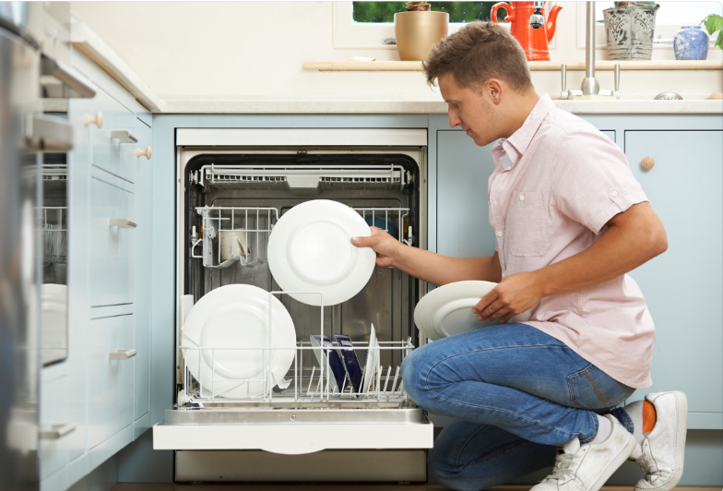
ARTICLE: NEED HELP WITH YOUR ENERGY BILL?

If you are having trouble paying your energy bill, you might be eligible for programs and services that can provide immediate financial assistance and help you avoid interruptions to your service. Flexible payment arrangements are also available to help you pay down past due balances. Learn more at sdge.com/Payment-Arrangements.
Check out these energy assistance programs:
- California Alternate Rates for Energy (CARE) Program: Save 30% or more every month on your bill. Find out if you qualify at sdge.com/CARE.
- Family Electric Rate Assistance (FERA) Program: If you do not qualify for CARE and your household has three or more people, you may qualify for FERA. You could receive an 18% discount on your electric bill. Visit sdge.com/FERA to learn more.
- Energy Savings Assistance (ESA) Program: You may qualify to receive free energy-saving improvements for your home, like new appliances, lighting, insulation and more. Find details at sdge.com/ESA.
- Arrearage Management Plan (AMP): If you have outstanding bills and you are a CARE or FERA customer, you may be eligible for debt forgiveness. See if you qualify at sdge.com/AMP.
Even if you made a recent payment or set up a flexible payment plan with SDG&E, there may still be assistance programs available to help you. For a complete list of available offerings, visit sdge.com/assistance.

SOCIAL POSTS: NEED HELP WITH YOUR ENERGY BILL?
- If you are behind on your energy bill, you may qualify for financial assistance. Learn more at sdge.com/assistance. #sdge #SDGEAssist
- Hardship can hit at any time – when it does, the last thing you need to worry about is your energy bill. Get help with your bill at sdge.com/assistance. #sdge #SDGEAssist
- SDG&E provides assistance programs to help you with your monthly energy bill which can include up to a 30% discount. Find out if you qualify at sdge.com/assistance. #sdge #SDGEAssist
- Whether you rent or own, you could be eligible to receive no-cost, energy-efficient home improvements that can make your home more comfortable and help reduce your energy bill. Find out if you qualify at sdge.com/ESA. #sdge #SDGEAssist

ARTICLE (translated): ¿NECESITA AYUDA CON SU FACTURA DE ENERGÍA?
Usted puede calificar para un descuento en su factura o mejoras en el hogar. Hay programas de asistencia que pueden ayudar a reducir su factura mensual de energía mientras mantiene su hogar cómodo.
- Programa de Tarifas Alternativas de Energía de California (CARE, por sus siglas en inglés): Ahorre un 30% o más cada mes en su factura. Averigüe si califica en sdge.com/CAREesp.
- Tarifa Eléctrica Familiar (FERA, por sus siglas en inglés): Si no califica para CARE y su hogar tiene 3 o más personas, puede calificar para FERA. Podría recibir un 18% de descuento en su factura de electricidad. Visite sdge.com/FERAesp para obtener más información.
- Programa de Asistencia para el Ahorro de Energía (ESA, por sus siglas en inglés): Puede calificar para recibir mejoras gratuitas para el ahorro de energía en su hogar, tales como electrodomésticos nuevos, iluminación, aislamiento y más. Encuentre los detalles en sdge.com/ESAesp.
- Arrearage Management Plan (AMP): Si tiene facturas pendientes y es participante en el programa de CARE o FERA, puede ser elegible para la condonación de deudas. Averigüe si califica en sdge.com/AMPesp.

Las aplicaciones en línea son fáciles, rápidas y convenientes. Para obtener más información, visite sdge.com/asistencia.

Publicaciones para compartir en las redes sociales: ¿NECESITA AYUDA CON SU FACTURA DE ENERGÍA?
- Si está atrasado en su factura de energía, puede calificar para asistencia financiera. Obtenga más información en sdge.com/asistencia. #sdge #SDGEAssist
- Dificultades pueden aparecer en cualquier momento – si aparecen, lo último que necesita es preocuparse por su factura de energía. Obtenga ayuda con su factura en sdge.com/asistencia. #sdge #SDGEAssist
- SDG&E ofrece programas de asistencia para ayudarle con su factura mensual que puede incluir hasta un 30% de descuento. Descubra si califica en sdge.com/asistencia. #sdge #SDGEAssist
- Si alquile o es propietario, podría ser elegible para recibir mejoras de eficiencia energética en su hogar, sin costo, que pueden hacer que su hogar sea más cómodo y ayuden reducir su factura de energía. Descubra si califica en sdge.com/ESAesp. #sdge #SDGEAssist

IMAGES: NEED HELP WITH YOUR ENERGY BILL?

ARTICLE: 5 GREAT REASONS TO CHOOSE PAPERLESS BILLING
Looking for a more convenient way to manage your bills? Enroll in paperless billing! It simplifies the way you manage your energy bill and helps contribute to a greener planet. Here are some key benefits of making the switch to paperless billing.
- Eco-friendly: Going paperless reduces your carbon footprint by cutting down on the amount of pollution caused by making paper, printing and transporting it.
- Convenient: Access your bills and statements online or on an app from anywhere, anytime.
- Saves time: No need to mail your bill, write a check or find a stamp.
- Less clutter: Reduce the mess associated with stacks of paper bills. No more piles of paper to deal with.
- More secure: There is less risk of lost mail or mail fraud. Paper bills sent through traditional mail are susceptible to theft, while digital statements are more secure.
Switch your energy bill to paperless billing at sdge.com/MyAccount or learn more at sdge.com/paperless.
SOCIAL POSTS: 5 GREAT REASONS TO CHOOSE PAPERLESS BILLING
- Why go paperless? It helps the environment. It is good for the planet because it reduces the need for paper. Enroll in paperless billing for your energy bill now at sdge.com/paperless. #SDGE #SDGEassist
- Why go paperless? It is convenient. Your bills and energy use info are available anytime online. Enroll in paperless billing now at sdge.com/paperless. #SDGE #SDGEassist
- Why go paperless? It saves time. No need to mail your energy bill, write a check or find a stamp. Enroll in paperless billing now at sdge.com/paperless. #SDGE #SDGEassist
- Why go paperless? It reduces clutter. No more stacks of paper to deal with. Enroll in paperless billing now at sdge.com/paperless. #SDGE #SDGEassist
- Why go paperless? Your information is safe and secure. Enroll in paperless billing now at sdge.com/paperless. #SDGE #SDGEassist
- Why go paperless? Less paper means less waste. Enroll in paperless billing now at sdge.com/paperless. #SDGE #SDGEassist
IMAGES: 5 GREAT REASONS TO CHOOSE PAPERLESS BILLING

ARTICLE: 10 WAYS YOUR BUSINESS CAN SAVE ON energy COSTS
It’s important for businesses to be both eco-friendly and cost-effective. From using energy-efficient technologies to making simple changes in how things are done every day, these tips can guide businesses towards a more planet- and budget-friendly path.
- Implement a paperless office policy to reduce energy usage associated with printing and copying. One great way to start is by signing up for paperless billing on all your bills. To enroll, visit sdge.com/paperless.
- Invest in energy-efficient server equipment and consider cloud-based solutions to reduce the need for physical servers.
- Conduct regular energy audits to identify areas for improvement. Did you know you can track your energy usage in SDG&E’s My Account? Visit sdge.com/MyAccount.
- Use natural light whenever possible by keeping windows unobstructed.
- Unplug chargers and other electronics when not in use to prevent phantom energy consumption.
- Use motion-activated lighting in low-traffic areas such as storage rooms or bathrooms.
- Invest in energy-efficient HVAC systems and regularly clean or replace air filters.
- Opt for laptops over desktop computers, as they typically consume less energy.
- Encourage remote work to reduce the need for office energy consumption.
- Set water heaters at lower temperatures and insulate hot water pipes to conserve energy. Check out water heater rebates up to $500 on the purchase of new, qualifying energy-efficient gas water heaters at sdge.com/rebates.

Implementing these energy-saving practices can lower energy costs and contribute to a more sustainable and environmentally friendly workplace. Visit sdge.com/MyBusiness for more helpful energy-saving tips, tools and programs for your business.

SOCIAL POSTS: 10 WAYS YOUR BUSINESS CAN SAVE ON energy COSTS
Use any of the tips above and then add:
Visit sdge.com/MyBusiness for more helpful energy-saving tips. #sdge #SDGEassist

IMAGES: 10 WAYS YOUR BUSINESS CAN SAVE ON ENERGY COSTS
JUST POSTS – Residential
- Enjoy the convenience of SDG&E’s Auto Pay with My Account online or on their app. Learn more at sdge.com/Auto-Pay. #sdge #SDGEAssist
- Enroll in SDG&E’s Auto Pay. It is an easy and secure way to make sure your energy bill is paid on time, automatically, each month. Learn more at sdge.com/Auto-Pay. #sdge #SDGEAssist
- Recognize Earth Month by going paperless. It’s good for the planet because it reduces the need for paper. Enroll in paperless billing for your energy bill now at sdge.com/paperless. #SDGE #SDGEassist
- Reduce your carbon footprint to celebrate Earth Month. Go paperless! Switch to paperless billing for your energy bill at sdge.com/paperless. #SDGE #SDGEassist
- Install thermal curtains to improve insulation and reduce heat loss during winter months, while also blocking out heat from the sun during summer, reducing the need for heating and cooling. Get more energy-saving tips at sdge.com/MyEnergy. #sdge #SDGEassist

JUST POSTS – Business
- Take action this Earth Month! Embrace digital collaboration platforms and video conferencing tools to reduce the need for business travel and lower associated carbon emissions. For more business energy-saving tips, visit sdge.com/MyBusiness. #sdge #SDGEassist
- Looking for ways to save energy at your business or office? Check out sdge.com/MyBusiness for tips. #sdge #SDGEassist
- Find the treasure! During an Energy Treasure Hunt, teams walk around a facility looking for quick ways to save energy. Those quick fixes can add up to big savings. Get your free Energy Star treasure map at bit.ly/4cAC5AS or visit sdge.com/MyBusiness for energy-saving tips at work. #sdge #SDGEassist
- Looking for ways to save energy at your business? Check out these tips from Energy Star at bit.ly/43pKv9M or visit sdge.com/MyBusiness for energy-saving tips at work. #sdge #SDGEassist
- Promote paperless operations: Embrace digital documentation and communication to reduce energy consumption associated with printing and paper use. Enroll in paperless billing for your energy bill at sdge.com/paperless. #SDGE #SDGEassist

