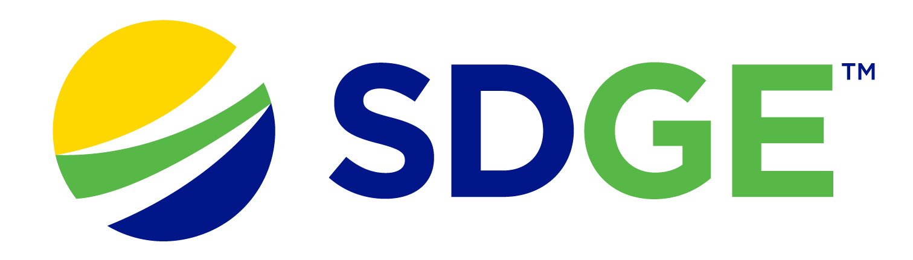

SDG&E® RESIDENTIAL AND SMALL BUSINESS CONTENT PACKAGE | APRIL 2023
As a trusted community partner, we thank you for sharing our content and digital assets with your audiences – including residents, customers and employees – to help amplify our key messages in your email communications, websites or newsletters.
Best practices for using our content, social media posts and images
- Images
Choose images that are relevant for your audience and feel free to mix and match what we provide. For alternate images, Unsplash.com and Canva.com offer free images that you can download.
- SDG&E logo
You’re welcome to mention our name but, due to legal requirements, please do not use our logo in any marketing materials that you create. Please only use the SDG&E logo if we provide it to you in this package or it’s publicly available online like a social post or video. You can also retweet our public posts which you’ll find on twitter.com/sdge.
- Videos
We have a library of videos you can share in your communications and social posts when you visit youtube.com/c/SanDiegoGasElectric/videos. If you’d like to sort our videos by topic, visit youtube.com/c/SanDiegoGasElectric. Some videos are in Spanish. You’ll see some on TV, too!
Follow us
Find us on Facebook, Instagram, Twitter, YouTube and LinkedIn. When sharing our digital assets and content, feel free to tag SDG&E’s social media and direct your audience to sdge.com.

This month’s topics: Smart thermostats, My Account energy alerts, customer assistance programs, business energy-saving tips, training

Article: save energy with sdg&e’s smart thermostat program
With the potential of another hot summer on the horizon, now is the perfect time to explore ways to keep your home at a comfortable temperature while minimizing energy costs.

One practical and cost-effective solution is SDG&E’s Smart Thermostat Program. Earn a $50 incentive for each smart thermostat you purchase and install (up to two thermostats) and enroll in SDG&E’s Smart Thermostat Program. By participating in the program, you’re also contributing to a more sustainable future.

Smart thermostats make it easy for you to control your HVAC system from anywhere using your smartphone or other connected devices. Smart thermostats allow you to create personalized schedules and temperature settings – which can help reduce energy use when you're not at home or during off-peak hours. Learn more about SDG&E’s Smart Thermostat Program at sdge.com/thermostat.

social posts: save energy with sdg&e’s smart thermostat program
- Enrolling in SDG&E’s Smart Thermostat Program can help lower your energy bill and it’s great for the environment. Let SDG&E’s Smart Thermostat program take your energy savings to a new level. Learn more at sdge.com/thermostat. #sdge #SDGEassist
- Using a smart thermostat can help lower your monthly energy bills without even thinking about it. Put your thermostat to work and earn a $50 incentive (up to 2 thermostats). Learn more about the SDG&E Smart Thermostat Program at sdge.com/thermostat. #sdge #SDGEassist

images: save energy with sdg&e’s smart thermostat program

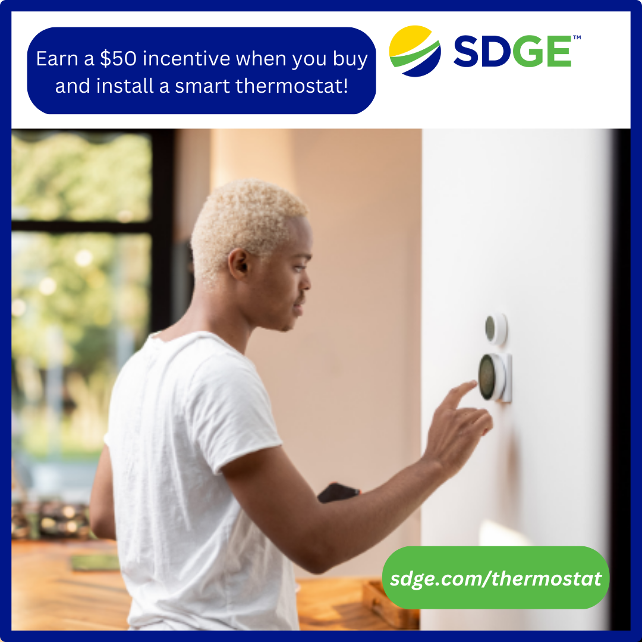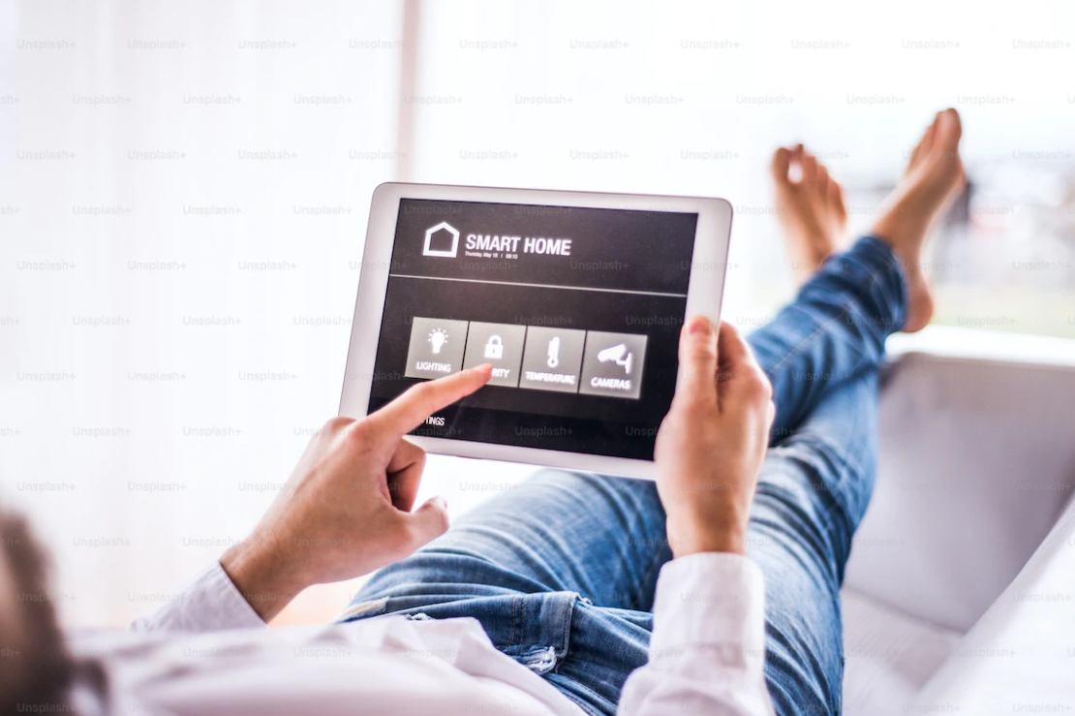

Article: Spring into action with sdg&e’s my account
SDG&E’s My Account tool makes it easy to manage your SDG&E account. You can view and pay your bill, schedule service requests and more. Use My Account online or with SDG&E’s mobile app. Learn more at sdge.com/about-my-account. Here are three tips to manage your account on the go!
- Sign up for weekly or spending limit energy alerts. Track your energy use and costs for your upcoming bill with Energy Alerts. You’ll receive an email or text (your choice) showing your projected bill, estimated charges and usage information. Learn more about Energy Alerts at sdge.com/alerts.
- Set payment reminders. Life gets busy. Sign up for friendly payment reminders to stay on top of your account. Simply update your notification preferences in SDG&E’s My Account tool. Get details at sdge.com/about-my-account.
- Download SDG&E’s mobile app. Everything you need to manage your account is just a few taps away! Visit sdge.com/mobileapp for more information.

social posts: Spring into action with sdg&e’s my account
Use any of the 3 tips above, then add: #sdge #SDGEassist

images: Spring into action with sdg&e’s my account

article: energy savings for renters and homeowners
To help its customers keep their energy costs down, SDG&E launched a new program for renters and owners of single-family homes. The Residential Energy Solutions (RES) program has no income restrictions. Eligible customers receive free products such as smart thermostats, low-flow showerheads, brushless fan motors, HVAC services like air duct testing and sealing – and more. SDG&E has also contracted with Synergy Companies to provide customers with energy efficiency audits from their experts. Customers can request a home visit at synergycompanies.com or by calling (888)-272-8394.

SDG&E offers other assistance programs too:
- Neighbor-to-Neighbor – customers may receive up to $600 toward their past due SDG&E bill
- LIHEAP – utility bill help that ranges from a few hundred up to a few thousand dollars
- CARE – customers can save 30% or more off their energy bill
- FERA – customers can receive an 18% discount on their electricity bill
- ESA – no-cost energy-efficiency upgrades to income-qualified customers
- Golden States Rebates program – incentives of $20 - $500 to buy high-efficiency water heaters, smart thermostats or room air conditioners
- Arrearage Management Payment (AMP) Plan – debt forgiveness for past due bills for CARE and FERA customers
To learn more about SDG&E’s bill assistance programs, visit sdge.com/assistance.

social posts: energy savings for renters and homeowners
- Visit sdge.com/assistance to find out if you qualify for SDG&E assistance programs and services including debt forgiveness, monthly discounts and payment arrangements. #sdge #SDGEassist
- The Neighbor-to-Neighbor program provides qualified customers with up to $600 towards their past due SDG&E bill. Get details at sdge.com/neighbor.
- The LIHEAP program helps eligible SDG&E customers with overdue bills. Help ranges from a few hundred up to a few thousand dollars. Learn more at sdge.com/LIHEAP. #sdge #SDGEassist
- Eligible SDG&E customers can save 30% or more on their energy bills. For more information, visit sdge.com/CARE. #sdge #SDGEassist
- Eligible SDG&E customers can receive an 18% discount on their electricity bill. Learn more at sdge.com/FERA. #sdge #SDGEassist
- SDG&E provides no-cost energy-efficiency upgrades to income-qualified customers. Get more information at sdge.com/ESA. #sdge #SDGEassist
- Receive incentives up to $500 to buy high-efficiency water heaters, smart thermostats or room air conditioners. Learn more at sdge.com/news. #sdge #SDGEassist
- If you’re an SDG&E CARE or FERA customer, you may be eligible for debt forgiveness for past due bills. Learn more at sdge.com/amp. #sdge #SDGEassist

article: AHORROs PARA INQUILINOS Y PROPIETARIOS
Para ayudar a sus clientes a mantener bajos sus costos de energía, SDG&E lanzó un nuevo programa para inquilinos y propietarios de viviendas unifamiliares llamado Soluciones de Energía Residencial (Residential Energy Solutions, RES). El programa no tiene restricciones de ingresos. Los clientes que califican para el programa recibirán productos gratuitos como termostatos inteligentes, cabezales de ducha de bajo flujo, motores de ventiladores sin escobillas, servicios para los sistemas HVAC como prueba y sellado de conductos de aire y más. Clientes también pueden solicitar una inspección de su vivienda por parte de un experto en eficiencia energética de Synergy Companies, una empresa que SDG&E ha contratado para administrar el programa. Para pedir una inspección, visite synergycompanies.com o llame al (888)-272-8394.
SDG&E también ofrece los siguientes programas de asistencia:
- CARE – Clientes pueden ahorrar un 30% o más en su factura de energía
- FERA – Clientes pueden recibir un 18% de descuento en su factura de electricidad
- ESA – ofrece actualizaciones de eficiencia energética en el hogar sin costo a clientes que califiquen según sus ingresos
- Programa Golden States Rebates – ofrece reembolsos entre $20 y $ 500 para comprar calentadores de agua de alta eficiencia, termostatos inteligentes o acondicionadores de aire para habitaciones
- Plan de Pago de Gestión de Administración de Atrasos (AMP, por sus siglas en inglés) – condonación de deudas por facturas vencidas para los clientes que están inscritos en CARE y FERA
Para obtener más información sobre los programas de asistencia de SDG&E, visite sdge.com/assistance.

social posts: AHORROs PARA INQUILINOS Y PROPIETARIOS
      - Visite sdge.com/assistance para ver si califica para los programas y servicios de asistencia de SDG&E, incluida la condonación de deudas, descuentos mensuales y arreglos de pago. #sdge #SDGEasistencia
      - El programa Neighbor-to-Neighbor ofrece hasta $600 en créditos para facturas vencidas a los clientes de SDG&E que califiquen. Obtenga más detalles en sdge.com/neighbor.
      - El programa LIHEAP ofrece de cientos a miles de dólares a los clientes elegibles de SDG&E para ayudarlos con sus facturas vencidas. Obtenga más información en sdge.com/LIHEAP. #sdge #SDGEasistencia
      - Los clientes de SDG&E que califiquen pueden ahorrar un 30% o más en sus facturas de energía. Para obtener más información, visite sdge.com/CARE. #sdge #SDGEasistencia
      - Los clientes de SDG&E que califiquen pueden recibir un descuento de 18% en sus facturas de electricidad. Obtenga más información en sdge.com/FERA. #sdge #SDGEasistencia
      - SDG&E ofrece actualizaciones de eficiencia energética en el hogar sin costo para clientes con ingresos que califican según sus ingresos. Obtenga más información en sdge.com/ESA. #sdge #SDGEasistencia
      - Reciba hasta $500 para comprar calentadores de agua de alta eficiencia, termostatos inteligentes o acondicionadores de aire para cuartos. Obtenga más información en sdgenews.com. #sdge #SDGEasistencia
      - Si es cliente de los programas CARE o FERA de SDG&E, puede ser elegible para la condonación de deudas por facturas vencidas. Obtenga más información en sdge.com/amp. #sdge #SDGEasistencia

images: energy savings for renters and homeowners

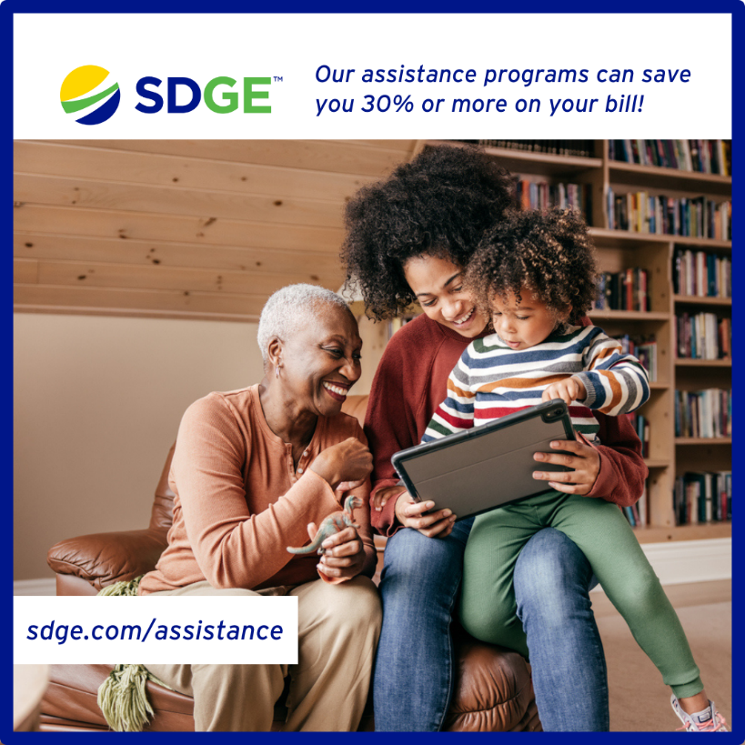

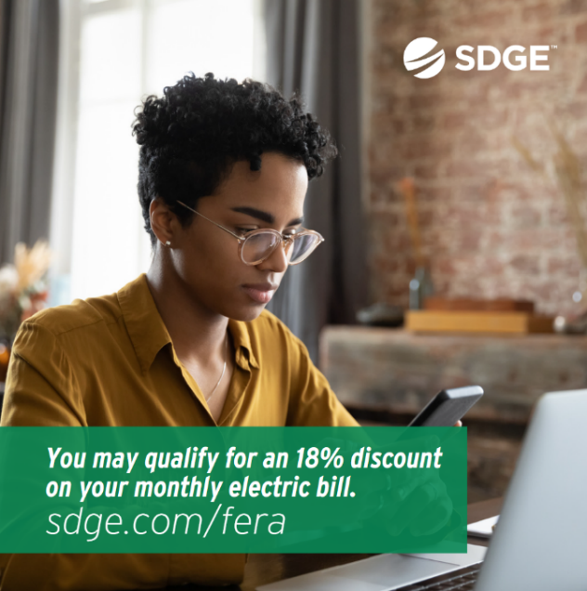

BUSINESS SECTION:
Article: save energy with sdg&e’s smart thermostat program
With the potential for another summer with higher-than-average temperatures, SDG&E’s Smart Thermostat Program can provide an effective and efficient way to conserve energy and reduce electricity costs for your business. No matter where you are, you can adjust your smart thermostats to run on energy-efficient schedules from your smartphone or other connected devices. As an added incentive, you’ll receive $50 per registered and installed thermostat (up to four thermostats) when you join SDG&E’s Smart Thermostat Program. Learn more about saving energy while contributing to a sustainable energy future at sdge.com/business-thermostat.
social posts: save energy with sdg&e’s smart thermostat program
- Using smart thermostats is good business. Control the temperature in your building from your smartphone from anywhere at any time. SDG&E’s Smart Thermostat Program can help you get started and rewarded too. Learn more at sdge.com/business-thermostat. #sdge #SDGEassist
- Why be satisfied with business as usual? Save more on your energy bill with less effort by enrolling in SDG&E’s Smart Thermostat Program. Just set it and forget it. Get details at sdge.com/business-thermostat. #sdge #SDGEassist

image: save energy with sdg&e’s smart thermostat program

ARTICLE: LOWER ENERGY USE IN YOUR PLACE OF BUSINESS
Did you know that the top energy consumers in a typical office are lighting, cooling and computers (energystar.gov)? Here are some ideas to help you save on your business’s energy use.
Save on cooling:
Cooling (and heating) makes up about 40% of the energy used in commercial buildings. To keep your HVAC system running efficiently, regularly change or clean HVAC filters every month during peak cooling or heating seasons. Dirty filters cost more to use, overwork the equipment and result in lower indoor air quality. Make sure that areas in front of vents are clear of furniture and paper. As much as 25 percent more energy is required to distribute air if your vents are blocked.
Save on lighting:
Use motion detectors to control lighting in frequently unoccupied areas and photocells to turn lights off automatically when enough daylight is detected. Install energy-efficient LEDs and task lighting to illuminate workspaces. Maximize daylight ― sunlight is free! Remove unnecessary lamps in overlit areas.
Save on equipment costs:
Turn off office equipment like monitors, printers and lights when not in use. Activate sleep settings on your office equipment. Consolidate the number of printers in your office. Use “smart” power strips to reduce the amount of energy used by electronic equipment.

Visit sdge.com/My-Business for more energy-saving tips.

Social Posts: LOWER ENERGY USE IN YOUR PLACE OF BUSINESS
- Want to save energy at the office? Turn off lights and electronic equipment like monitors and printers when the office is closed. Activate sleep settings on your office equipment. Consolidate the number of printers in your office. Use “smart” power strips. Visit sdge.com/My-Business for more energy-saving tips. #sdge #SDGEassist
- Energy-saving tip for the office: Make sure that areas in front of vents are clear of furniture and paper. As much as 25% more energy is required to distribute air if your vents are blocked. Visit sdge.com/My-Business for more energy-saving tips. #sdge #SDGEassist
- Looking for ways to reduce your energy use in the office? Use motion detectors to control lighting in frequently unoccupied areas and photocells to turn lights off automatically when enough daylight is detected. Install energy-efficient LEDs and task lighting to illuminate workspaces. Maximize daylight ― sunlight is free! Remove unnecessary lamps in overlit areas. Visit sdge.com/My-Business for more energy-saving tips. #sdge #SDGEassist
- The top energy consumers in a typical office are lighting, cooling and computers. Find tips to help you save energy at your workplace at sdge.com/My-Business. #sdge #SDGEassist
Image: LOWER ENERGY USE IN YOUR PLACE OF BUSINESS
ARTICLE: TAKE ADVANTAGE OF NO-COST TRAINING FROM ENERGY EXPERTS
Did you know that SDG&E provides webinars for business owners and trade professionals, so you can learn new skills at your own pace? And most are at no cost. You or your employees can learn about the latest in green building practices, technology and energy-saving solutions from industry experts. Certifications and continuing education units are available for many classes. Check out the class listing at sdge.com/EnergyClasses.
Social posts: TAKE ADVANTAGE OF NO-COST TRAININGS FROM ENERGY EXPERTS
- Did you know SDG&E provides energy education and training webinars at no cost? These on-demand webinars are offered at introductory, intermediate and advanced levels. See the webinar list at sdge.com/EnergyClasses. #sdge #SDGEassist
- Learn the latest in green building design, operations, maintenance and technology at no-cost energy webinars led by industry experts. See the on-demand webinar list at sdge.com/EnergyClasses. #sdge #SDGEassist
- Enroll in a no-cost, on-demand energy topic webinar. Energy education and training can give you and your employees the knowledge and skills that customers value. Check out the webinar list at sdge.com/EnergyClasses. #sdge #SDGEassist

image:
