2011 Statewide Evaluation of California Aggregator Demand Response Programs

Volume I: Ex Post and Ex Ante Impacts

Freeman, Sullivan & Co.  
101 Montgomery St., 15th Floor  
San Francisco, CA 94104  
fscgroup.com



June 1, 2012

Prepared for:

Pacific Gas and Electric (PG&E)

Southern California Edison (SCE)

San Diego Gas and Electric (SDG&E)

*Prepared by:*

Stephen George, Ph.D.

Josh Bode, M.P.P.

Jason Burwen, M.A., M.P.P.

Freeman, Sullivan & Co.

CALMAC ID: PGE0314.01

The FSC Group

Table of Contents

1 Executive Summary 1

1.1 Capacity Bidding Program 1

1.2 PG&E’s Aggregator Managed Portfolio Program 3

1.3 SCE’s Demand Response Resource Contract Program 4

2 Introduction and Program Summary 6

2.1 Program Summaries 7

2.1.1 Statewide Capacity Bidding Program 7

2.1.2 PG&E’s Aggregator Managed Portfolio 9

2.1.3 SCE’s Demand Response Resource Contracts 10

2.2 Report Organization 11

3 Methodology 12

3.1 Regression Model Selection 12

3.2 Accuracy of Regression Models 14

3.3 Ex Ante Load Impact Estimates 17

3.3.1 Ex Ante Impact Uncertainty 19

4 Load Impact Estimates for PG&E’s AMP and CBP Programs 20

4.1 2011 Event Day Characteristics 20

4.2 Aggregator Managed Portfolio Load Impacts 21

4.2.1 AMP Demand Reductions by Industry 23

4.2.2 AMP Demand Reductions by Local Capacity Area 24

4.2.3 AMP Demand Reductions by Customer Size 25

4.3 Capacity Bidding Program Load Impacts 26

4.3.1 CBP Demand Reductions by Industry 27

4.3.2 CBP Demand Reductions by Local Capacity Area 28

4.3.3 CBP Demand Reductions by Customer Size 29

4.4 Technical Incentive and AutoDR Realization Rates 30

5 Load Impact Estimates for SCE’s DRRC and CBP Programs 32

5.1 2011 Event Day Characteristics 32

5.2 Demand Response Resource Contract Load Impacts 34

5.2.1 DRRC Demand Reductions by Industry 35

5.2.2 DRRC Demand Reductions by Local Capacity Area 36

5.2.3 DRRC Demand Reductions by Customer Size 37

5.3 Capacity Bidding Program Load Impacts 38

5.3.1 CBP Demand Reductions by Industry 40

5.3.2 CBP Demand Reductions by Local Capacity Area 41

5.3.3 CBP Demand Reductions by Customer Size 41

5.4 Technical Incentive and AutoDR Realization Rates 42

6 Load Impact Estimates for SDG&E’s CBP Program 45

6.1 2011 Event Day Characteristics 45

6.2 Capacity Bidding Program Load Impacts 46

6.2.1 CBP Demand Reductions by Industry 48

6.2.2 CBP Demand Reductions by Customer Size 48

6.3 Technical Incentive and AutoDR Realization Rates 49

7 Ex Ante Load Impact Estimates for PG&E’s AMP and CBP Programs 51

7.1 Ex Ante Load Impact Estimates for the Aggregator Managed Portfolio Program 51

7.2 Ex Ante Load Impact Estimates for the Capacity Bidding Program 54

7.3 Comparison with Previous Ex Ante Estimates 58

8 Ex Ante Load Impact Estimates for SCE’s DRRC and CBP Programs 60

8.1 Ex Ante Load Impact Estimates for Demand Response Resource Contracts 60

8.2 Ex Ante Load Impact Estimates for the Capacity Bidding Program 62

8.3 Comparison with Previous Ex Ante Estimates 65

9 Ex Ante Load Impact Estimates for SDG&E’s CBP Program 66

9.1 Ex Ante Load Impact Estimates for the Capacity Bidding Program 66

9.2 Comparison with Previous Ex Ante Estimates 68

10 Recommendations 70

Appendix A. Detail on Model Selection 71

Appendix B. Proxy Event Day – Actual Event Day Comparison 78

Appendix C. Validity Assessment - Accuracy of Selected Model 80

Appendix D. Enrollments and Nominations 82

Appendix E. Resource Adequacy Tables 83

E.1. PG&E 84

E.2. SCE 86

E.3. SDG&E 88

# Executive Summary

This report documents the ex post load impact evaluation for program year 2011 for the aggregator demand response (DR) programs operated by the three California investor-owned utilities (IOUs): Pacific Gas and Electric (PG&E), Southern California Edison (SCE) and San Diego Gas and Electric (SDG&E). Specifically, the evaluation covers the statewide Capacity Bidding Program (CBP), which is operated by all three IOUs, PG&E’s Aggregator Managed Portfolio (AMP) and SCE’s Demand Response Resource Contracts (DRRC). Collectively, these programs are referred to as aggregator programs.

This volume documents the 2011 ex post evaluation and the estimated ex ante impacts for 2012 to 2022. The results are reported for each aggregator program and utility. Volume II provides an assessment of settlement baseline rules. In specific, it assesses whether specific changes to settlement baseline rules help improve the accuracy of the settlements. The analysis in Volume II is intended to comply with the CPUC decision D.12-04-045.

## Capacity Bidding Program

The statewide CBP program offers participants (customers or aggregators) monthly capacity payments based on the amount of load reduction they nominate and make available each month; plus additional energy payments (for bundled customers only) based on the kWh reduction when a CBP event is called. Nearly all customers enrolled in CBP participate through aggregators. The program allows aggregators to adjust their nomination each month and to select in which program options they nominate individual customers. The program options include both day-of and day-ahead advance notification of events for one of the following event duration windows: 1 to 4 hours, 2 to 6 hours or 4 to 8 hours. All customers nominated by an aggregator into a program option constitute a settlement portfolio. Currently, aggregators have not nominated any customer accounts to the 4 to 8 hour option.

Table 1-1 summarizes the average event day demand response for each utility and CBP product for 2011. Although the table contains estimates for each utility, direct cross-utility comparisons are not appropriate due to underlying differences in the number and timing of event days, the industry mix that is participating in each jurisdiction and other factors such as partial dispatch of resources. Due to the cooler-than-average temperatures in 2011, aggregator resources were rarely dispatched in full, if at all. For similar reasons, we have not added up the aggregate load reduction across utilities or product lines because the events underlying the averages were often called on different days and over different time periods. Ex ante estimates are additive across utilities because they are, by design, based on the same underlying event day conditions, but it is not appropriate to add up ex post estimates.

SCE called the day-ahead, 1-4 hour resource many more times (17 events) than did either PG&E (7 events) or SDG&E (5 events). However, the aggregate (3.8 MW) and percentage (24.8%) reduction across SCE’s numerous events is significantly lower than for either of the other utilities because the resource was partially dispatched for most events. PG&E had an average load reduction of 13.6 MW, or 28.7%, across seven events. On average, SDG&E accounts with day-ahead notification reduced demand by 11.3 MW, or 43.9%.

Table 1-1:

2011 Ex Post Load Impacts for Statewide Capacity Bidding Program   
Average Event by Utility and CBP Product

|  |  |  |  |  |
| --- | --- | --- | --- | --- |
| CBP Product | Measure (Average Event) | PG&E | SCE | SDG&E |
| Day-ahead 1-4 hr. | Events | 7 | 17 | 5 |
| Nominated Accounts | 150 | 89 | 48 |
| Nominated MW | 19.1 | 3.7 | 7.6 |
| Aggregate Load Impact (MW) | 13.6 | 3.8 | 11.3 |
| % Load Reduction | 28.7% | 24.8% | 43.9% |
| Day-ahead 2-6 hr. | Events | N/A | 10 | N/A |
| Nominated Accounts | N/A | 2 | N/A |
| Nominated MW | N/A | 0.1 | N/A |
| Aggregate Load Impact (MW) | N/A | 0 | N/A |
| % Load Reduction | N/A | 0.0% | N/A |
| Day-of 1-4 hr. | Events | 2 | 3 | 7 |
| Nominated Accounts | 139 | 215 | 245 |
| Nominated MW | 15.1 | 7.1 | 8.5 |
| Aggregate Load Impact (MW) | 12.8 | 6.8 | 6.9 |
| % Load Reduction | 22.4% | 16.7% | 16.4% |
| Day-of 2-6 hr. | Events | 1 | 2 | 7 |
| Nominated Accounts | 80 | 197 | 73 |
| Nominated MW | 4.0 | 7.7 | 2.6 |
| Aggregate Load Impact (MW) | 4.6 | 12.1 | 4.1 |
| % Load Reduction | 20.2% | 21.0% | 19.7% |

SCE is the only utility that has any participants in the day-ahead, 2-6 hour resource. However, there were only 2 participating accounts and average aggregate demand reduction across 10 events was not statistically significantly different from 0.

Day-of events were called less frequently by PG&E and SCE. The average aggregate reduction across PG&E’s 2 day-of, 1-4 hour events equaled 12.8 MW and the average for SCE’s 3 day-of, 1-4 hour events was 6.8 MW. SDG&E obtained an average reduction of 6.9 MW across seven such events. For the day-of, 2-6 hour product, PG&E saw a load reduction of 4.6 MW on the single event that was called; SCE saw an average response of 12.1 MW across 2 events; and SDG&E obtained an average response of 4.1 MW across 7 events.

Table 1-2 presents estimates of ex ante load impacts for statewide CBP resources in 2012. Ex ante load impacts reflect the estimated full load reduction capability of resource under a standard set of 1-in-2 and 1-in-10 weather conditions. Ex ante impacts are based on historical performance over multiple years and factor in projected changes in enrollments and the participant mix. They illustrate the resources available when all nominated accounts are solicited for an event—effectively the load reduction capability of the program should it be dispatched in full. Furthermore, the mix of customers will change over time as enrollments change. The 2012 ex ante impact estimates are very similar to ex post results because each utility generally dispatched all the resources available in each CBP product line each time a product was dispatched. In aggregate, the 2012 ex ante impacts are 10% to 15% larger (except for PG&E). They are based on the enrollments and nominations at the end of the 2011 summer season, which are typically higher than at the start of the season, and also factor in small incremental growth.

Table 1-2:

Ex Ante Load Impacts for Statewide Capacity Bidding Program   
2012 August Peak Day Event by Utility

|  |  |  |  |
| --- | --- | --- | --- |
| Measure | CBP | | |
| PG&E | SCE | SDG&E |
| Number of Nominated Accounts | 409 | 564 | 392 |
| Aggregate Load Impact (MW) | 29.6 | 26.2 | 25.0 |
| Avg. Per Customer Load Impact (kW) | 72.3 | 46.5 | 63.8 |
| % Load Reduction | 22.3% | 19.9% | 24.9% |

## PG&E’s Aggregator Managed Portfolio Program

PG&E’s AMP program is a price responsive DR program that allows third-party aggregators, who enter into bilateral contracts with PG&E resulting from a competitive bid, to establish aggregated DR programs of their own creation. The program operates from May through October. An AMP event may be called between 11 AM and 7 PM, Monday through Friday, excluding holidays. Participants can operate as either day-ahead or day-of resources.

Table 1-3 summarizes the event estimated event impacts for PG&E’s AMP program in 2011. PG&E called the AMP day-ahead resource on two days, August 25 and September 29, both of which were test events. The day-of resource was also called on two test event days, August 25 and September 8. All four events were conducted between 3 PM and 5 PM. The only instance when the full AMP resources were dispatched jointly was on August 25, when day-of resources delivered 141 MW and day-ahead resources delivered 46.4 MW, for an aggregate load reduction of 187 MW. On average, accounts with day-ahead notification reduced demand by just over 34%, or 186 kW per account on August 25. Accounts with same-day notification reduced demand by 26.9%, or 132 kW per account that day.

****Table 1-3****:

Estimated Ex Post Load Impacts by Event Day  
2011 PG&E AMP Event

|  |  |  |  |  |  |  |  |  |  |
| --- | --- | --- | --- | --- | --- | --- | --- | --- | --- |
| **Program** | **Event Date** | **Accts** | **Avg. Reference Load (kW)** | **Avg. Load Reduction (kW)** | **% Load Reduction** | **Aggregate Reference Load (MW)** | **Aggregate Load Impact (MW)** | **Avg. Temp During Event** | **Nominated MW\*** |
| AMP-DA 1-4 Hour | 08/25/2011 | 250 | 541.4 | 185.7 | 34.3% | 135.4 | 46.4 | 87.0 | 44.0 |
| 09/29/2011 | 248 | 710.0 | 238.4 | 33.6% | 176.1 | 59.1 | 85.6 | 44.0 |
| **Average Event** | **249** | **625.4** | **211.9** | **33.9%** | **155.7** | **52.8** | **86.3** | **44.0** |
| AMP-DO 1-4 Hour | 08/25/2011 | 1069 | 488.8 | 131.5 | 26.9% | 522.6 | 140.5 | 82.4 | 162.6 |
| 09/08/2011 | 475 | 636.3 | 172.3 | 27.1% | 302.2 | 81.8 | 86.8 | 77.0 |
| **Average Event** | **772** | **534.2** | **144.0** | **27.0%** | **412.4** | **111.2** | **83.8** | **119.8** |

Ex ante load impact estimates of AMP resources project that program resources will remain at 198.5 MW through 2022, as enrollment is forecast to remain unchanged. Ex ante estimates of AMP resources diverge from ex post load impact estimates for several reasons. The 2011 ex post estimates are based on actual AMP events called in 2011. As noted earlier, the PG&E did not always solicit resources from every aggregator for each event, though it did dispatch resources jointly once on August 25th and observed 187 MW reduction. The remaining different is due to the fact that ex-ante impacts factor in performance in 2010 and 2011 events (not just 2010) and that the ex ante projections are based on enrollments and nomination as of September 2011.

## SCE’s Demand Response Resource Contract Program

During 2011, SCE had multiple active bilateral DRRC contracts with third-party aggregators. The availability, dispatch terms, allowed event duration and MW reduction per month vary by contract; and some of these provisions are treated as confidential. Notification for event dispatch for the contracts is either day-of or day-ahead. Some of the DRRC contracts can be called year around, not just during the summer. A number of the operational and compensation provisions of the contracts are similar to SCE’s CBP program (e.g., delivered energy payment, delivered capacity payment and penalties).

In total, aggregators with DRRC contracts had committed to deliver between 215 MW and 230 MW of same-day resources and between 60 MW and 70 MW of day-ahead resources during the 2011 summer months (June-Sep). However, not all of the aggregators with DRRC contracts subscribed enough capacity to meet their contractual obligations and, as a result, were subject to penalties. SCE called the DRRC day-ahead resource twice in 2011 and the day-of resource four times, including an early event that occurred on April 21. For each event, customers were dispatched from 2 PM to 4 PM. SCE jointly dispatched the two aggregators providing day-ahead resources in each of the two events it called. The aggregators providing same day resources were not jointly dispatched on any single day. In other words, only part of the available same day resources were exercised during each event.

Table 1-4 summarizes the estimated impacts for SCE’s DRRC program in 2011. On average, the 275 average accounts participating in day-ahead events reduced demand by nearly 28%, or 63 kW per account. In aggregate, this resource provided 17 MW of average load reduction across the two event days.

In total, three aggregators have committed to deliver demand reductions with same-day event notice. Although SCE dispatched DRRC day-of resources from 2 PM to 4 PM on four occasions, it never dispatched all resources at the same time. As a result, the individual event days in 2011 do not reflect the full load reduction capability of DRRC day-of resources. The dispatch pattern explains the variation in load impacts across the 2011 events. A single aggregator was dispatched for the April 21 event and was not called on to deliver load reductions for the last three events. Although only 61 accounts participated in the April 21 event, they were large and primarily came from the manufacturing and water district industry segments. Collectively, these accounts reduced load by 68%, and delivered aggregate load reductions equal to 32 MW. In contrast, the number of participating accounts was higher and the percent load reductions were smaller during the remaining three events. None of these events included the aggregator dispatched for the April event. The last two events reflect the joint load reduction of two other aggregators. Had all DRRC same-day resources been called at once, they could have delivered approximately 135 MW of load reduction, a reduction of 28%.

****Table 1-4:****

****Estimated Ex Post Load Impacts by Event Day  
2011 SCE DRRC Events****

|  |  |  |  |  |  |  |  |  |  |
| --- | --- | --- | --- | --- | --- | --- | --- | --- | --- |
| **Program** | **Event Date** | **Accts** | **Avg. Reference Load**  **(kW)** | **Average Load Reduction (kW)** | **% Load Reduction** | **Aggregate Reference Load**  **(MW)** | **Aggregate Load Impact (MW)** | **Avg. Temp During Event** | **Nominated MW\*** |
| DRRC-DA | 07/28/2011 | 268 | 223.9 | 62.1 | 27.7% | 60.0 | 16.6 | 83.1 | 65.0 |
| 08/25/2011 | 282 | 232.0 | 64.2 | 27.7% | 65.4 | 18.1 | 89.5 | 70.0 |
| **Average Event** | **275** | **228.1** | **63.2** | **27.7%** | **62.7** | **17.4** | **86.4** | **67.5** |
| DRRC-DO | 04/21/2011 | 61 | 777.2 | 525.7 | 67.6% | 47.4 | 32.1 | 65.1 | 52.0 |
| 06/23/2011 | 940 | 305.2 | 92.4 | 30.3% | 286.9 | 86.9 | 83.9 | 110.0 |
| 07/28/2011 | 1242 | 331.8 | 74.1 | 22.3% | 412.2 | 92.0 | 83.7 | 145.0 |
| 08/25/2011 | 1298 | 346.6 | 88.4 | 25.5% | 449.9 | 114.7 | 93.2 | 150.0 |
| **Average Event** | **885** | **337.9** | **92.0** | **27.2%** | **299.1** | **81.4** | **86.9** | **114.3** |

Ex ante load impact estimates of DRRC resources project that program resources will grow from 167.1 MW in 2012 to just under 200 MW by 2014, due to increasing program enrollment. The ex ante estimates illustrate resources available when all nominated accounts are solicited for an event—effectively the load reduction capability of the program should it be dispatched in full. The 2012 numbers reflect the nominations submitted in May, 2012 and are adjusted for seasonality. The 2013 and 2014 numbers assume and incremental 10% growth per year in load reduction resources from aggregators. As with CBP, the DRRC ex ante impacts factor in how existing participants performed during 2010 and 2011 events.

# Introduction and Program Summary

This report documents the ex post load impact evaluation for program year 2011 for the aggregator DR programs operated by the three California IOUs. Specifically, the evaluation covers the statewide CBP, which is operated by all three IOUs, PG&E’s AMP and SCE’s DRRC. Collectively, these programs are referred to as aggregator programs. Ex ante estimates will be developed and documented in a combined report that is due in early June, following a final decision by the California Public Utilities Commission on the DR program applications of each utility. This decision is expected in April 2012.

In all of the aggregator programs, individual electric service accounts (customers) participate through aggregators, which pool risk across customers and interface with the utilities. Each aggregator forms a portfolio of individual customers that collectively provide DR resources that are bid into each utility’s program. Aggregators can group customers based on the amount of advanced notice and event duration, forming different products. They are responsible for specifying the demand reduction capability, meeting obligations when dispatched, receiving incentive payments and paying penalties. The financial arrangements between aggregators and individual customers are not disclosed to the utilities.

For each product line in an aggregator’s portfolio, there is a commitment to deliver a pre-specified demand reduction, if dispatched. In exchange, aggregators receive availability (capacity) payments for each megawatt of demand reduction committed. These payments are provided regardless of whether or not each product is dispatched. Aggregators also typically receive energy payments ($/MWh) for each hour they are dispatched. These financial incentives are tied to aggregator performance as determined by using day-matching baselines for settlement purposes, which provide a fast and transparent way of estimating performance. Failure to deliver the pre-specified demand reductions leads to payment reductions.

Like all demand response resources, aggregator programs provide insurance against extreme system loads and high market prices. The AMP and DRRC contracts are analogous to long-term contracts for new power plants, while CBP is more like a short-term contract for existing power plants. Both programs require a firm contractual commitment. Aggregators with AMP and DRRC contracts are effectively committed to recruiting enough customers to deliver the pre-specified demand reductions by specific dates. To use the analogy, they agree to build a set of power plants with a pre-specified schedule, nameplate capacity and resource delivery capabilities.[1] In evaluating the AMP and DRRC contracts, it is critical to distinguish between their ability to follow pre-specified schedules for building resources and the reliability and predictability of resources that are in existence. In contrast, CBP is more like a short-term contract that allows all aggregators to bid in resources that lack a long-term contract. It provides a standard offer that is open to all aggregators and only requires them to commit demand reduction resources one month at a time.

The aggregator programs have grown substantially between 2008 and 2011 and may continue to grow in the future. Between 2008 and June 2011, participation in the aggregator contracts across all three utilities grew from less than 1,000 to over 4,000 accounts.[2]

## Program Summaries

This subsection contains a brief overview of each of the aggregator programs evaluated in this report.

### Statewide Capacity Bidding Program

CBP is a statewide price-responsive program that was developed in 2006 and implemented in 2007, succeeding the California Power Authority Demand Reserves Partnership (CPA-DRP) program that was terminated in 2006. CBP is designed for customers with interval metering, offering participants (customers or aggregators) monthly capacity payments based on the amount of load reduction nominated and made available each month, plus additional energy payments (for bundled customers only) based on the kWh reduction when a CBP event is called. In 2011, all customers participated through aggregators. The program allows aggregators and direct participants to adjust their demand reduction commitments (nominated MW) each month, and to select the program options in which to nominate customer accounts in their portfolio. The program options include both day-of and day-ahead event notification for one of the following event windows: 1 to 4 hours, 2 to 6 hours or 4 to 8 hours.

CBP is available to bundled service, Direct Access, and Community Choice Aggregation customers; customers can participate through third-party aggregation or self-aggregation. Customers enrolled in CBP are allowed to participate in another demand response program, as long as the dual participation rules are met (*i.e.*, the other program must be an energy-payment program and the two programs cannot have the same notification, day-ahead or day-of). CBP may have minimum load criteria for participation, depending on the tariff of the utility.

A CBP event may be called between May 1 and October 31 between the hours of 11 AM and 7 PM Monday through Friday, excluding holidays. A CBP event can be triggered when electric generation facilities with heat rates of 15,000 Btu/kWh or greater are expected to be dispatched. The trigger may be caused by any of the following conditions:

* High temperatures;
* Resource limitations;
* A generating unit outage;
* Transmission constraints;
* An alert called by the California Independent System Operator (CAISO); or

A system emergency.

Participants in CBP are compensated with monthly capacity payments based on the amount of load reduction nominated each month (whether an event is called or not), plus bundled customers receive an additional energy payment based on the kWh reduction when a CBP event is called. More details about the CBP tariffs are available online at:

* PG&E – http://www.pge.com/tariffs/tm2/pdf/ELEC_SCHEDS_E-CBP.pdf
* SDG&E – http://sdge.com/tm2/pdf/ELEC_ELEC-SCHEDS_CBP.pdf

SCE – http://www.sce.com/cbp/forms.htm

Table 2-1 shows the average number of accounts nominated at each utility during the 2011 summer by notification lead time and industry segment.  The number of accounts nominated for the program does not necessarily match the number of accounts called for specific events or for the average event.  The number of nominated accounts is also often lower than the number of enrolled accounts because aggregators typically do not nominate all the enrolled customers to resource portfolios.

 Table 2‑‑: Average Number of Accounts Nominated for CBP, by Utility and Industry[3]

|  |  |  |  |  |  |
| --- | --- | --- | --- | --- | --- |
| **IOU** | **Industry** | **Day-Ahead** | | **Day-Of** | |
| **Accounts** | **Aggregate Avg. Summer Max Demand (MW)** | **Accounts** | **Aggregate Avg. Summer Max Demand (MW)** |
| PG&E | **All Customers** | **194** | 59.4 | 237 | 89.9 |
| Agriculture, Mining & Construction | 114 | 8.9 | 11 | 4.8 |
| Hotels and Apartment Buildings | 2 | 3.4 | 14 | 6.4 |
| Institutional/Government | 0 | - | 3 | 0.6 |
| Manufacturing | 16 | 26.9 | 13 | 13.3 |
| Offices, Finance, Services | 0 | - | 7 | 8 |
| Other or unknown | 2 | 0 | 0 | - |
| Retail stores | 50 | 12.3 | 175 | 50.4 |
| Schools | 1 | 3.3 | 1 | 2.1 |
| Water Districts | 1 | 0 | 5 | 1.8 |
| Wholesale, Transport, other utilities | 8 | 4.5 | 8 | 2.5 |
| SCE | **All Customers** | **113** | 20.7 | 435 | 106.8 |
| Institutional/Government | 0 | - | 42 | 5.8 |
| Manufacturing | 1 | 1.2 | 0 | - |
| Offices, Finance, Services | 4 | 1.7 | 0 | - |
| Retail stores | 107 | 17.1 | 392 | 100.7 |
| Wholesale, Transport, other utilities | 1 | 0.7 | 1 | 0.4 |
| SDG&E | **All Customers** | **54** | 27.4 | 351 | 74.4 |
| Agriculture, Mining & Construction | 0 | - | 1 | 1.1 |
| Hotels and Apartment Buildings | 0 | - | 15 | 4.1 |
| Institutional/Government | 3 | 0.6 | 39 | 4.5 |
| Manufacturing | 4 | 10.4 | 14 | 3.6 |
| Offices, Finance, Services | 29 | 10.3 | 15 | 3.1 |
| Other or unknown | 0 | - | 12 | 3.4 |
| Retail stores | 14 | 5.4 | 240 | 52.6 |
| Water Districts | 4 | 0.6 | 11 | 1.3 |
| Wholesale, Transport, other utilities | 0 | - | 4 | 0.7 |

Statewide, over three quarters of the accounts and load nominated for day-of resources come from the Retail sector. The Retail sector also accounts for almost half the customers providing day-ahead resources and about a third of the program load, with the remaining loads concentrated in the Manufacturing and Office sectors.

### PG&E’s Aggregator Managed Portfolio

PG&E’s AMP program is a price responsive DR program that allows third-party aggregators, who enter into bilateral contracts with PG&E resulting from a competitive bid process, to establish aggregated DR programs of their own creation. PG&E has contracts with five aggregators. Pursuant to these contracts, the aggregators were expected to provide approximately 200 MW of responsive load reduction capacity in 2011.

AMP participants in an aggregated group are non-residential customers who receive bundled service, Community Choice Aggregation service or Direct Access. Customers on full standby rates or net metering are not eligible for AMP. AMP has no provisions for direct enrollment of individual customers. Customers participating in AMP with day-ahead notification are allowed to be dually enrolled in PG&E’s Optional Binding Mandatory Curtailment (OBMC) program. AMP customers with day-of notification may also dually participate in the Demand Bidding Program (DBP) or Peak Day Pricing (PDP).

The AMP program operates from May through October. An AMP event may be called between 11 AM and 7 PM, Monday through Friday, excluding holidays. AMP events may be triggered by very high market prices and system emergencies, up to 50 hours each year including test events. AMP contracts specify the baseline used for calculating load reduction for settlement purposes. For most aggregators, the baseline is based on the same-hour average of the 10 weekdays.[4]

Table 2-2 shows the average number of accounts nominated during the 2011 summer by notification lead time and industry segment. The number of accounts nominated for the program does not necessarily match the number of accounts called for specific events or for the average event.  The number of nominated accounts is also often lower than the number of enrolled accounts because aggregators typically do not nominate all the enrolled customers to resource portfolios.

Customers from the Manufacturing sector account for roughly 40% of accounts and nearly 70% of load in the day-ahead option. Day-of resources are not highly concentrated in specific industry segments; no single industry sector accounts for more than a quarter of the number of accounts or of program load.

Table 2‑‑: Average Number of Accounts Nominated for PG&E’s Aggregator Managed Portfolio by Industry[5]

|  |  |  |  |  |  |
| --- | --- | --- | --- | --- | --- |
| IOU | Industry | Day-Ahead | | Day-Of | |
| Accounts | Aggregate Avg. Summer Max Demand (MW) | Accounts | Aggregate Avg. Summer Max Demand (MW)) |
| PG&E | **All Customers** | **244** | **150.4** | **1073** | **458.4** |
| Agriculture, Mining & Construction | 19 | 3.4 | 213 | 95.3 |
| Hotels and Apartment Buildings | 13 | 6.9 | 173 | 59.0 |
| Institutional/Government | 8 | 2.7 | 70 | 14.0 |
| Manufacturing | 103 | 102.5 | 130 | 101.9 |
| Offices, Finance, Services | 13 | 5.2 | 77 | 34.6 |
| Other or unknown | 1 | 0.4 | 2 | 0.2 |
| Retail stores | 28 | 10.8 | 236 | 55.8 |
| Schools | 41 | 12.1 | 33 | 29.7 |
| Water Districts | 1 | 0.1 | 50 | 33.5 |
| Wholesale, Transport, other utilities | 17 | 6.3 | 89 | 34.5 |

### SCE’s Demand Response Resource Contracts

For 2011, SCE has four active bilateral DRRC contracts with third-party aggregators authorized by the CPUC during 2007 through 2009. When the contracts were signed, the DRRC resource capacity was expected to range between 275 MW and 300 MW between June and September, 2011.

The availability, dispatch terms, allowed event duration and MW reduction per month vary by contract and some of these provisions are treated as confidential. Notification for the event dispatch for the contracts is either day-of or day-ahead. Three of the four DRRC contracts could be called year round, not just during the summer. A number of the operational and compensation provisions of the contracts are similar to SCE’s Capacity Bidding Program (e.g., calculations of baseline, delivered energy payment, delivered capacity and penalties).

Table 2-3 shows the average number of accounts nominated during the 2011 summer by product type and industry segment. The number of nominated accounts is typically higher than the number of accounts called for single events, particularly for same-day resources (DRRC-DO), because all aggregators were not dispatched jointly and because nominations vary slightly by month. In addition, aggregators did not nominate all accounts enrolled in the program into their resource portfolios.

For both day-ahead and day-of resources, customers are concentrated in the Retail, Manufacturing and Water District Sectors. The Retail sector accounts for roughly 25% of the program load in both the day-ahead and day-of options. Jointly, Manufacturing and Water Districts account for roughly another 35% of the program load in each program option.

Table 2‑‑: Average Number of Accounts Nominated for SCE’s   
Demand Response Resource Contracts , by Industry

|  |  |  |  |  |  |
| --- | --- | --- | --- | --- | --- |
| IOU | Industry | Day-Ahead | | Day-Of | |
| Accounts | Aggregate Avg. Summer Max Demand (MW) | Accounts | Aggregate Avg. Summer Max Demand (MW) |
| SCE | **All Customers** | **292** | **64.6** | **1399** | **482.9** |
| Agriculture, Mining & Construction | 100 | 7.1 | 55 | 10.0 |
| Institutional/Government | 3 | 0.2 | 19 | 19.3 |
| Manufacturing | 16 | 9.1 | 118 | 105.5 |
| Offices, Finance, Services | 19 | 8.3 | 119 | 36.8 |
| Other or unknown | 4 | 0.2 | 0 | - |
| Retail stores | 85 | 22.9 | 622 | 177.2 |
| Schools | 0 | - | 31 | 40.0 |
| Water Districts | 57 | 4.9 | 392 | 75.2 |
| Wholesale, Transport, other utilities | 8 | 11.8 | 43 | 18.9 |

## Report Organization

This report is the first of two volumes. This volume addresses the following research questions:

* What demand reductions were delivered for each utility and program for event in 2011?

How do impacts vary by industry, geographic area, customer size, type of dispatch (day-of versus day-ahead) and program type?

The remainder of this volume is organized as follows. Section 3 summarizes the methodology used to develop the ex post load impact estimates. It also contains a high level summary of the results of validation tests that were conducted to determine the best model specification and approach. Sections 4 through 6 contain the 2011 ex post results for each utility and program. The three appendices contain detailed information on the validation process. In addition, electronic spreadsheet files containing draft hourly load impact estimates for each utility for the day types and event conditions required by the CPUC Load Impact Protocols have been provided along with this report.

# Methodology

The protocols governing the development of load impact estimates were designed to help ensure that demand response resources could be directly compared with other resource alternatives (*i.e*., other DR resources, energy efficiency, renewables and generation). The ex post evaluation results reflect the demand reductions delivered during historical events, based on the conditions that were in effect during that time. In contrast, ex ante load impact estimates are designed to reflect the full load reduction capability of a DR resource under a standard set of weather conditions that drive the need for additional capacity.

Load impact estimates for historical events do not necessarily reflect the full demand reduction capability of aggregator programs. For many historical events, not all of the available resources were dispatched. Because historical demand reductions are tied to past conditions such as dispatch strategy, enrollment levels and customer mix, they may not reflect the full option value of a DR resource.

## Regression Model Selection

To calculate load reductions for demand response programs, customer’s load patterns in the absence of program participation – the reference load – must be estimated. Reference loads can be estimated using pre-enrollment data, by observing differences in behavior during event and non-event days (*i.e*., a “within subjects” design), by using an external control group or through a combination of the above. The most rigorous method for impact evaluation is a well executed experiment with random assignment to control and treatment conditions. Randomized experiments are rarely feasible for actual programs. In the absence of a controlled experiment, the best available method is a function of program characteristics, available data and the ability to incorporate research design elements into the analysis and statistical modeling.

With the aggregator programs, the primary intervention is present on some days and not on others, making it possible to observe behavior with and without events under similar conditions. This type of repeated treatment supports a “within subjects” analysis design in which impacts are determined by comparing differences in peak period electricity use on event days and on similar days when events are not called. This approach works if customer behavior on “event-like” days is similar to their behavior on event days. This underlying assumption can be made with reasonable confidence for weather insensitive customers. However, more caution is required in evaluating impacts for weather sensitive customers. The aggregator programs tend to be dispatched on high system load days when temperatures are well above average. A critical task of the evaluation is to ensure that factors that may correlate with hotter temperatures are not confounded with demand reductions.

Individual customer regressions were the primary method used to estimate ex post load impacts. The analysis consisted of applying regression models separately to each set of customer load data at the half-hourly level – 48 models for each customer.[6] An alternative specification would be to run a single model for each customer with every term interacted with each half-hour interval. Running 48 separate models produces coefficients and standard errors that are arithmetically equivalent to the outputs produced by the single model with half-hourly interactions, but the 48 separate models are easier to interpret and using this approach produces intermediate outputs that can be synthesized more quickly. The regression coefficients are specific to each customer and half-hour. Since each customer is analyzed individually, the approach accounts for factors that are constant for each customer, such as industry and geographic location. It also better explains the variation in individual customer production and/or occupancy patterns, weather sensitivity, price responsiveness, enrollment dates and event day dispatch patterns (which can vary by customer).

To determine the most accurate model specification, a two-step process was implemented. In step 1, the goal was to select the model that best explained electricity use patterns under event-like conditions using out-of-sample testing. In step 2, a false experiment was used to ensure that bias was minimized in the selected model. A false experiment model includes a treatment variable, like an aggregator dispatch day, for event-like days. If the model is correctly specified, the coefficients for false event-day variables should be insignificant and centered around zero because, in fact, there are no events.[7] If the coefficients are significantly different from zero, the regression model is confounding error with event impacts, leading to bias in the impact estimates.

The following model specification was used for ex post impact estimation:

${kw}_{h}=α_{h}+ β_{h}∙24hr{CDH}_{h}+β_{h}∙{CDH}_{h}+\sum_{i=1}^{3}{β_{i,h}∙{daytype}_{i}}+\sum_{i=5}^{10}{β_{i,h}∙{month}_{i}}+β_{h}∙{daylight}_{h}+β_{h}∙{morningload}_{h}+β_{h}∙{twoweekavg}_{h}+{\sum_{i=1}^{n}{β_{i,h}∙AMPorDRRCevent}}_{i}+\sum_{i=1}^{m}{β_{i,h}∙{CBPevent}_{i}}+ ε_{h}$

| Term | Description |
| --- | --- |
| $$α$$ | Represents the regression model constant for the interval. |
| $$β$$ | Represents regression model coefficients. |
| *24hrCDH* | Reflects the effect of heat build-up over the past 24 hours on electricity use. This is captured by calculating the total cooling degree hours over the past 24 hours, using a base of 65˚F. |
| *CDH* | Reflects current temperature by calculating current cooling degree hours, using a base of 65˚F. |
| *daytype* | Is an indicator of whether the interval in question falls on the first day of the business week, mid-week, or on the last day of the business week. Weekends and holidays were excluded from the ex post regression. |
| *month* | Is an indicator of the month of the year. It is included to capture seasonal variations in non-weather sensitive electricity use. |
| *daylight* | An indication of the percent of the interval in daylight (1 = full day, 0 = full night, fractions are during dusk and dawn). |
| *morningload* | Reflects the total kWh consumed between midnight and 9 AM; the same day of the interval in question. |
| *twoweekavg* | The average kW for the interval in question during all non-holiday, non-weekend, non-event days in the past two weeks. |
| *AMPorDRRCevent* | An indicator of whether an AMP or DRRC event was called that day. There is an indicator for each event specifically (*i.e.*, AMP event 1, AMP event 2). This variable takes into account whether the customer was nominated for participation. A customer that is not nominated for participation is assumed not to have been activated for the event. |
| *CBPEvent* | An indicator of whether a CBP event was called that day. There is an indicator for each event specifically (*i.e.*, CBP event 1, CBP event 2). This variable takes into account whether the customer was nominated for participation. A customer that is not nominated for participation is assumed not to have been activated for the event. |

Despite the math, the model is relatively intuitive. Electricity use at each interval of the day is predicted as a function of prior customer load patterns, weather, seasonality, rates and DR events. The above model estimates impacts for each event separately. Since error terms in this regression model are serially correlated, a generalized least-squares approach was used to estimate the model  parameters.

## Accuracy of Regression Models

This section contains a high-level overview of the model validation results and their implications. The appendices contain detailed results of the validity assessment that was done for all three utilities. As mentioned previously, two primary approaches were used to assess model accuracy: out-of-sample testing and false experiments. In both cases, the “true” answers are known and we effectively test if the regression models produce correct results.

Out-of-sample testing helps assess how well the regressions predict electricity use patterns during event-like days (also referred to as “proxy days”) and helps ensure that the results are not an artifact of model over-fitting. It is conducted by first estimating the regression models on a database that excludes selected proxy days from the estimation process. The estimated model is then used to predict loads on the excluded days to see how accurate the predictions are. If the predictions are close to the observed load on the days that are excluded from the estimation process, it illustrates that the model can predict accurately for days similar to those on which events are typically called.

Table 3-1 compares the system loads and temperatures for proxy days and actual event days for the various AMP, DRRC and CBP products that are available to be called by each utility. The table shows that the proxy days chosen for out-of-sample testing have similar system loads and average temperatures as the days on which events actually occurred. Because SCE called as few as 2 or as many as 19 events for each program and notification type (DA or DO), results are presented in a different format for SCE than for SDG&E and PG&E. For greater detail, see Appendix B. As seen in the table, both system load and average temperatures are comparable on proxy and actual event days, suggesting that the out-of-sample testing using the selected proxy days is a valid approach for assessing model accuracy under typical event conditions.

Table 3-1: Comparison of Event Day and Proxy Day System Loads and Temperatures

|  |  |  |  |  |  |
| --- | --- | --- | --- | --- | --- |
| **Utility** | **Program** | **Type** | **Day Type** | **Average Max MW** | **Average Max Temperature** |
| SCE | CBP | DA | Proxy | 18,679 | 77.7 |
| Actual | 18,552 | 77.2 |
| DO | Proxy | 18,621 | 77.1 |
| Actual | 19,782 | 78.9 |
| DRRC | DA | Proxy | 18,644 | 77.1 |
| Actual | 18,619 | 77.8 |
| DO | Proxy | 18,603 | 77.4 |
| Actual | 17,668 | 76.6 |
| PGE | CBP/AMP | DA/DO | Proxy | 16,513 | 72.0 |
| Actual | 16,696 | 71.9 |
| SDG&E | CBP | DA/DO | Proxy | 3,821 | 74.2 |
| Actual | 3,857 | 75.7 |

When the accuracy of the candidate regression models was assessed in out-of-sample testing, three questions were addressed:

* *How accurately does the model predict for the proxy event hours on the program level?* The main metric used to address this question was the program mean percent error – a metric for assessing if a model produces unbiased results on average.
* *Which model produces estimates with the least variance for proxy event hours on the program level?* An evaluation model can be accurate on average but perform poorly for individual event hours. This occurs when the errors cancel each other out. Here, we assessed the goodness-of-fit of the regression results using the mean absolute percent error.

*Are there are any systematic biases in the individual customer results?* To address this question, we calculated customer-specific estimates of bias (or lack thereof) and ensured there are no systematic biases for specific types of customers. In particular, we focused on the largest fifth of customers since they were expected to account for the majority of load  impacts.

Appendix A presents findings for each of these questions. In the remainder of this section, we summarize the findings for the particular model that was selected.

For PG&E and SCE, nine proxy event days were chosen from among the 2011 non event days with the highest system loads; for SDG&E, seven proxy event days were selected. Figure 3-1 summarizes the out-of-sample predictive accuracy of the models during days that are similar to actual event days – that is, proxy event days. The regression model produces highly accurate estimates of the actual load on proxy days. For PG&E, SCE and SDG&E, the difference between predicted and actual values across the 1 PM to 6 PM window is 0.03%, 0.49% and 0.96%, respectively. The high degree of accuracy for the out-of-sample proxy event day predictions provides confidence that the regressions will produce accurate estimates for reference loads on event days. Appendix C compares the actual and model predicted values over each hour for each proxy event day.

Figure 3-1: Out-of-sample Predictive Accuracy for Proxy Event Days



In addition to out-of-sample testing, we conducted a false experiment. False experiments test the accuracy of the impact estimates and whether the treatment variables confound load impacts with other factors under event-like conditions. To conduct a false experiment, a dummy variable is added to the model specification on proxy event days, effectively creating a “false” event day. The coefficients for the false event-day variables should center on zero because, in fact, there are no events.[8] If they do not, the regression model is confounding the effect of other variables with event conditions – that is, the model fails to distinguish the effect of the events from the effect of other variables, leading to bias in the impact estimates. Therefore, a false experiment provides an explicit test of whether or not treatment variables are unbiased under event-like conditions.

Table 3-2 presents the results of the false experiment and reflects whether or not the program level impacts exhibit bias. For PG&E, proxy event days diverge from other non-event days by -0.04% on average and by 0.16% during event hours. For SCE, proxy event days diverge from other non-event days by 0.31% on average and by 0.60% during event hours. For SDG&E, proxy event days diverge from other non-event days by -0.20% on average and by -0.35% during event hours. In essence, the false event coefficients correctly show zero impacts for the program during the false event days, indicating that the models do not confound load impacts with other factors. Appendix C presents these results in graphical form.

Table 3-2: Bias from False Event for Proxy Event Days

|  |  |  |  |  |  |  |  |  |  |
| --- | --- | --- | --- | --- | --- | --- | --- | --- | --- |
| Hour Ending | PG&E | | | SCE | | | SDG&E | | |
| Actual Avg kW | False Event Avg kW | Error (%) | Actual Avg kW | False Event Avg kW | Error (%) | Actual Avg kW | False Event Avg kW | Error (%) |
| 1 | 303.0 | 302.0 | -0.18% | 213.5 | 214.6 | 0.51% | 138.3 | 137.4 | -0.66% |
| 2 | 297.9 | 297.6 | -0.10% | 205.0 | 204.2 | -0.41% | 134.2 | 134.5 | 0.26% |
| 3 | 293.9 | 293.4 | -0.18% | 202.1 | 201.5 | -0.31% | 132.7 | 132.9 | 0.17% |
| 4 | 293.0 | 292.4 | -0.19% | 202.1 | 201.9 | -0.14% | 133.2 | 133.5 | 0.27% |
| 5 | 298.6 | 298.1 | -0.17% | 209.0 | 209.0 | 0.00% | 142.9 | 144.1 | 0.84% |
| 6 | 314.7 | 314.8 | 0.03% | 219.3 | 218.8 | -0.24% | 157.7 | 159.1 | 0.90% |
| 7 | 339.1 | 339.5 | 0.11% | 239.1 | 238.1 | -0.42% | 178.2 | 178.0 | -0.10% |
| 8 | 357.6 | 357.6 | 0.00% | 249.1 | 249.8 | 0.27% | 183.0 | 182.4 | -0.34% |
| 9 | 376.9 | 376.3 | -0.16% | 262.3 | 263.2 | 0.35% | 203.5 | 206.3 | 1.38% |
| 10 | 391.9 | 390.7 | -0.32% | 273.6 | 275.4 | 0.64% | 220.9 | 225.3 | 1.95% |
| 11 | 407.8 | 407.3 | -0.12% | 284.0 | 286.7 | 0.93% | 234.1 | 234.3 | 0.10% |
| 12 | 416.5 | 416.1 | -0.11% | 287.8 | 290.7 | 1.00% | 233.9 | 233.0 | -0.39% |
| 13 | 417.9 | 418.6 | 0.17% | 289.8 | 292.1 | 0.79% | 236.1 | 237.8 | 0.72% |
| 14 | 424.4 | 425.3 | 0.22% | 293.2 | 295.1 | 0.65% | 243.1 | 243.6 | 0.19% |
| 15 | 425.9 | 426.3 | 0.10% | 294.1 | 296.5 | 0.84% | 244.2 | 241.5 | -1.09% |
| 16 | 420.4 | 421.0 | 0.13% | 294.6 | 296.1 | 0.51% | 241.0 | 236.9 | -1.69% |
| 17 | 412.6 | 413.4 | 0.20% | 292.1 | 293.8 | 0.56% | 235.5 | 236.1 | 0.26% |
| 18 | 402.4 | 403.0 | 0.16% | 289.7 | 291.0 | 0.45% | 233.1 | 234.4 | 0.58% |
| 19 | 388.8 | 388.8 | 0.01% | 287.3 | 288.2 | 0.28% | 220.3 | 222.2 | 0.87% |
| 20 | 382.0 | 382.7 | 0.18% | 286.4 | 286.8 | 0.16% | 213.8 | 214.7 | 0.43% |
| 21 | 373.7 | 374.1 | 0.13% | 283.8 | 284.2 | 0.13% | 205.6 | 207.6 | 0.99% |
| 22 | 360.2 | 359.6 | -0.15% | 266.2 | 266.8 | 0.22% | 185.9 | 187.4 | 0.78% |
| 23 | 338.8 | 337.4 | -0.43% | 240.0 | 241.1 | 0.46% | 163.8 | 161.9 | -1.14% |
| 24 | 321.2 | 320.2 | -0.32% | 216.5 | 216.8 | 0.16% | 147.0 | 146.5 | -0.37% |
| **All hours** | **364.9** | **364.8** | **-0.04%** | **257.5** | **258.4** | **0.31%** | **194.2** | **194.6** | **0.20%** |
| **Event hours**  **1 - 6 PM** | **417.1** | **417.8** | **0.16%** | **292.7** | **294.5** | **0.60%** | **239.4** | **238.5** | **-0.35%** |

## Ex Ante Load Impact Estimates

The ex ante load impacts for aggregator programs describe the load reduction capability of existing resources under a standard set of 1-in-2 and 1-in-10 weather conditions. Whenever possible, ex ante load impacts are grounded on analysis of historical load impact performance. The ex ante predictions are based on the performance during actual 2010 and 2011 events by current participants. Some customers were not enrolled in aggregator programs in 2010, in which case we relied exclusively on the 2011 event data available. The reference loads were based on analysis of 2010 and 2011 load patterns during non-event days. We used a similar model as in the ex post analysis except that we excluded the lagged power consumption terms (*morningload* and *twoweekavg*).[9] The validation results included in Appendix A show that the model produces very similar reference loads as the version with lagged power consumption.

For customers already enrolled in aggregator programs, the ex ante impacts are reliable as long as there is a sufficiently long history of events under different weather conditions, including extreme ones. The ex ante estimates implicitly assume that past event performance is indicative of future customer behavior.  The primary source of uncertainty in ex ante impacts arises from program changes. These include growth in program participants, changes in program rules or tariff design and policy shifts. Put differently, it is much easier to estimate load impacts under a standard set of conditions for existing customers than it is to do so for a new set of customers, particularly if they differ substantially from existing ones.

To produce ex ante impacts, we did the following for each customer:

* Estimated the regression parameters from the ex post regression models. This included parameters that described customer hourly load patterns, individual event load impacts, and how load impacts varied for each event under different weather conditions;
* Calculated the average event hour impacts for each customer across all events, as well as the average load shift in the hours preceding and following an event (“event shoulders”). Additionally, we calculated the model error and performance variability of customers over many events;
* Assumed the 1-in-2 and 1-in-10 weather year conditions based on the location of each customer;
* Replicated the same variables used in the ex post regression models;
* Predicted the customer electricity use patterns absent event day response – reference loads – based on the regression coefficients and ex ante event-day conditions; and

Predicted the hourly electricity use pattern with event day response - the estimate load with DR – based on the average event hour impacts and the average pre- and post-event load shifting under ex ante event-day conditions.

Impacts were calculated as the difference in loads with and without DR. They were aggregated for the program as whole, for each local capacity area, and for each customer size category. For all utilities, load impacts were projected only for the months during which programs are active. For CBP and AMP, this includes May through October; for DRRC, this includes April through October. Finally, in all ex ante forecasts, we use counts of nominated customers, rather than all enrolled customers; for an explanation, see .

### Ex Ante Impact Uncertainty

Being predictions, ex ante load impact estimates are necessarily uncertain. There are several sources of uncertainty:

* Enrollment uncertainty – changes in program enrollment and nominations over time;
* Policy uncertainty – changes in program design over time, including cessation of the program;
* Performance variability – fluctuations in customer performance over time; and

Model error – closeness of fit of models to actual data.

The first two sources represent program-level uncertainty and are dealt with in the enrollment forecasts for each program. The latter two sources represent customer-level uncertainty and are dealt with in the modeling.

The sources of customer-level uncertainty warrant further explanation. Model error is the uncertainty range around the parameter values derived from ex post regressions and represents the closeness of “fit” of the model to any given day. Performance variability is the variation of customer event hour load reductions over the many events for which we have observations. It differs from model error in that it represents uncaptured variation of a customer’s event hour load reductions across events, rather than model fit. We presume that customers of aggregator programs seek to meet a target reduction in electricity demand that does not vary over time or in proportion to their loads. Since we observe each customer’s performance over several events and specify each event separately in the regression model we use, variation in event hour load reductions is not captured as “model error” and can be interpreted as variation in customer behavior outside of model prediction. Put another way, ex ante impacts seek to predict load impacts on representative days; therefore, the uncertainty range around estimates must incorporate observed variation over prior event hours to be realistic.

To calculate customer-level uncertainty ranges, we first isolated load reductions during each event hour of 2010 and 2011 for each individual customer. Since our ex post model specification treats each event and hour separately, each event hour for each customer has a unique observed load reduction and standard error; in this instance, the standard error represents model error. We then combined the variation in individual event day impacts with the model error using MonteCarlo simulation, a standard process for combining uncertainty. The Monte Carlo simulation relied on 1000 draws for each customer. This customer-specific standard error captures both within-hour variation (i.e., model error) and across-hour variation (i.e., performance variability). It more accurately represents the uncertainty range around ex ante estimates than if model error alone were used.

# Load Impact Estimates for PG&E’s AMP and CBP Programs

This section summarizes the ex post load impact estimates for PG&E’s AMP and CBP programs. In keeping with the requirements for ex post load impact evaluations, 2011 results were developed for each hour of each event day for the average customer and for all customers enrolled at the time of the event. Summary impact estimates are presented in this section and more detailed, hourly estimates are provided electronically along with this report. In addition to meeting the basic load impact protocol requirements, detailed analysis has been conducted to understand how load impacts vary across several factors, including:

* Industry;
* Local capacity area; and

Customer size.

AMP and CBP resources were dispatched on different days and hours. Within each program, resources with day-ahead notification were typically dispatched jointly.

## 2011 Event Day Characteristics

PG&E system peak loads were relatively low throughout 2011, and as a result, both AMP and CBP resources were dispatched solely for economic reasons or to test event operations and performance. AMP resources with day-ahead and day-of event notifications were each dispatched twice to test program performance, once each on separate days and once together. Likewise, CBP day-of resources were dispatched on two different days to test program performance. The four test events took place on days when system loads were high – ranging from the 5th to the 32nd highest system load day for 2011 – but not on the system peak day. CBP resources with day-ahead notification were dispatched seven times in 2011, including on the second and third highest system load days, July 5 and July 6. None of the program options were dispatched on PG&E’s 2011 annual system peak day, June 21, because there were sufficient resources available and because the peak occurred relatively early in the summer.

Table 4-1 summarizes the event day patterns for the nine days on which PG&E called CBP or AMP events in 2011. Events lasted between one and four hours, starting no earlier than 2 PM and ending no later than 6 PM. Events were called for AMP alone on two days, for CBP alone on six days and simultaneously for CBP and AMP on one day. On August 25, PG&E tested the load reduction capability for all five of its AMP contracts.  Under the contract terms, PG&E provided four of the aggregators with day-of notification while the remaining aggregator received notification a day in advance.  The four aggregators that received day-of notification had committed to reduce 162.6 MW in the month of August, while the fourth aggregator with day-ahead notification had committed to a reduction of 44.0 MW.  PG&E followed up the initial load reduction test with two re-tests, where a sub-set of aggregators had to demonstrate their load reduction capability again.  For the September 8 event, PG&E dispatched a single aggregator with a 77.0 MW reduction commitment.  On September 29, PG&E dispatched another aggregator with a 44.0 MW reduction commitment.

Table 4-1: Event Summary for PG&E’s CBP and AMP Programs for 2011

|  |  |  |  |  |  |  |  |
| --- | --- | --- | --- | --- | --- | --- | --- |
| **Program** | **Advance Notice** | **Product** | **Date** | **Day-of Week** | **Number of Aggregators Dispatched** | **Hours\*** | **Nominated MW** |
| AMP | Day-ahead | 1-4 Hour | 8/25/2011 | Thu | 1 | 3 - 5 PM | 44.0 |
| 9/29/2011 | Thu | 1 | 3 - 5 PM | 44.0 |
| Day-of | 1-4 Hour | 8/25/2011 | Thu | 4 | 3 - 5 PM | 162.6 |
| 9/8/2011 | Thu | 1 | 3 - 5 PM | 77.0 |
| CBP | Day-ahead | 1-4 Hour | 7/5/2011 | Tue | 6 | 2 - 5 PM | 17.9 |
| 7/6/2011 | Wed | 6 | 4 - 5 PM | 17.9 |
| 8/25/2011 | Thu | 7 | 3 - 5 PM | 19.1 |
| 8/26/2011 | Fri | 7 | 3 - 5 PM | 19.1 |
| 9/7/2011 | Wed | 7 | 3 - 6 PM | 19.9 |
| 9/21/2011 | Wed | 7 | 3 - 5 PM | 19.9 |
| 9/22/2011 | Thu | 7 | 3 - 5 PM | 19.9 |
| Day-of | 1-4 Hour | 7/5/2011 | Tue | 4 | 4 - 5 PM | 16.7 |
| 9/21/2011 | Wed | 4 | 3 - 5 PM | 13.5 |
| 2-6 Hour | 9/21/2011 | Wed | 1 | 3 - 5 PM | 4.0 |

## Aggregator Managed Portfolio Load Impacts

Table 4-2 provides the estimated ex post load impacts for each event day and for the average event in 2011. The results for each event day and for the average event are reported separately for each program and product type. All four events were test events where customers were dispatched for the period from 3 PM to 5 PM.

On average, accounts with day-ahead notification reduced demand by 52.8 MW, a 34% reduction in loads. They delivered larger demand reductions on September 29, when PG&E re-tested their performance. The two events for customers with day-of notification are not directly comparable. PG&E dispatched a single aggregator with a number of smaller accounts on September 8 that generally provided smaller percent demand reductions. The August 25 event better reflects the demand reduction capability for the program since all aggregators were jointly dispatched. In total, same-day notification customers delivered 141 MW and reduced demand by 26.9% during the event. On August 25, when both the day-of and day-ahead AMP resources were jointly dispatched, the program delivered an aggregate load reduction of 187 MW.

****Table 4-2: Estimated Ex Post Load Impacts by Event Day  
2011 PG&E AMP Event****

|  |  |  |  |  |  |  |  |  |  |
| --- | --- | --- | --- | --- | --- | --- | --- | --- | --- |
| Program | Event Date | Accts | Avg. Reference Load (kW) | Avg. Load Reduction (kW) | % Load Reduction | Aggregate Reference Load (MW) | Aggregate Load Impact (MW) | Avg. Temp During Event | Nominated MW* |
| AMP-DA 1-4 Hour | 08/25/2011 | 250 | 541.4 | 185.7 | 34.3% | 135.4 | 46.4 | 87.0 | 44.0 |
| 09/29/2011 | 248 | 710.0 | 238.4 | 33.6% | 176.1 | 59.1 | 85.6 | 44.0 |
| **Average Event** | **249** | **625.4** | **211.9** | **33.9%** | **155.7** | **52.8** | **86.3** | **44.0** |
| AMP-DO 1-4 Hour | 08/25/2011 | 1069 | 488.8 | 131.5 | 26.9% | 522.6 | 140.5 | 82.4 | 162.6 |
| 09/08/2011 | 475 | 636.3 | 172.3 | 27.1% | 302.2 | 81.8 | 86.8 | 77.0 |
| **Average Event** | **772** | **534.2** | **144.0** | **27.0%** | **412.4** | **111.2** | **83.8** | **119.8** |

Figure 4-1 shows the estimated hourly electricity patterns with and without DR on August 25, when both resources were dispatched from 3 PM to 5 PM. Both day-ahead and day-of resources continued to reduce demand levels for one or two hours after the event had ended. The electricity loads for customers in the day-ahead notification option are slightly higher than for customers dispatched on a day-of basis.

Figure 4-1: PG&E AMP Hourly Impacts for August 25, 2011

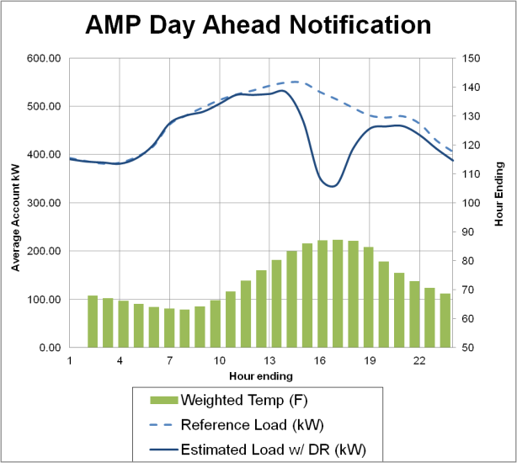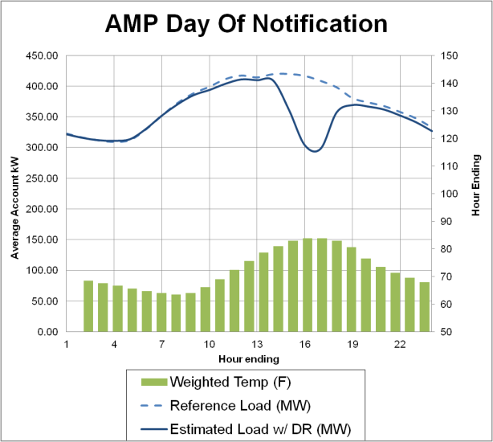

### AMP Demand Reductions by Industry

Table 4-3 shows load impacts by industry for the average 2011 AMP event. It reflects the mix of customers called during the 2011 events. Day-ahead resources come primarily from the Manufacturing sector, which accounted for 79% of the aggregate load reduction for day-ahead resources.

****Table 4-3: Estimated Ex Post Load Impacts by Industry  
Average 2011 PG&E AMP Event****

|  |  |  |  |  |  |  |  |  |
| --- | --- | --- | --- | --- | --- | --- | --- | --- |
| **Program** | **Industry** | **Accts** | **Avg. Reference Load (kW)** | **Avg. Load Reduction (kW)** | **% Load Reduction** | **Aggregate Reference Load (MW)** | **Aggregate Load Impact (MW)** | **Avg. Temp During Event** |
| AMP-DA | Agriculture, Mining & Construction | 19 | 180.0 | 61.7 | 34.3% | 3.4 | 1.2 | 89.8 |
| Hotels and Apartment Buildings | 14 | 537.7 | 189.3 | 35.2% | 7.5 | 2.7 | 70.9 |
| Institutional/Government | 8 | 336.4 | 188.2 | 55.9% | 2.7 | 1.5 | 93.1 |
| Manufacturing | 106 | 1011.6 | 392.3 | 38.8% | 107.2 | 41.6 | 86.2 |
| Offices, Finance, Services | 13 | 411.0 | 66.0 | 16.1% | 5.3 | 0.9 | 82.6 |
| Other or unknown | 1 | 357.1 | 33.9 | 9.5% | 0.4 | 0.0 | 76.6 |
| Retail stores | 30 | 388.2 | 50.4 | 13.0% | 11.6 | 1.5 | 85.6 |
| Schools | 42 | 290.6 | 56.0 | 19.3% | 12.2 | 2.4 | 89.0 |
| Water Districts | 1 | 97.6 | 13.6 | 13.9% | 0.1 | 0.0 | 93.3 |
| Wholesale, Transport, other utilities | 17 | 374.3 | 85.8 | 22.9% | 6.4 | 1.5 | 89.7 |
| **All Customers** | **249** | **625.4** | **211.9** | **33.9%** | **155.7** | **52.8** | **86.3** |
| AMP-DO | Agriculture, Mining & Construction | 170 | 438.9 | 174.9 | 39.8% | 74.6 | 29.7 | 90.9 |
| Hotels and Apartment Buildings | 120 | 545.1 | 64.0 | 11.7% | 65.4 | 7.7 | 71.8 |
| Institutional/Government | 39 | 777.1 | 142.9 | 18.4% | 30.3 | 5.6 | 74.4 |
| Manufacturing | 95 | 988.7 | 289.2 | 29.2% | 93.9 | 27.5 | 87.5 |
| Offices, Finance, Services | 44 | 517.2 | 87.0 | 16.8% | 22.8 | 3.8 | 74.4 |
| Other or unknown | 1 | 125.1 | 12.0 | 9.6% | 0.1 | 0.0 | 70.9 |
| Retail stores | 181 | 237.9 | 24.2 | 10.2% | 43.1 | 4.4 | 84.1 |
| Schools | 20 | 1346.7 | 173.8 | 12.9% | 26.9 | 3.5 | 84.4 |
| Water Districts | 39 | 762.0 | 403.6 | 53.0% | 29.7 | 15.7 | 88.9 |
| Wholesale, Transport, other utilities | 65 | 407.5 | 208.6 | 51.2% | 26.5 | 13.6 | 89.8 |
| **All Customers** | **772** | **534.2** | **144.0** | **27.0%** | **412.4** | **111.2** | **83.8** |

In contrast, resources with day-of notification are more diversely distributed across different business segments. Overall, approximately half of the aggregate load impact from day-of resources came from the combined Agriculture, Mining & Construction and Manufacturing segments, each of which accounted for roughly one quarter of the total aggregate demand response. Customers in these segments are larger than the program average. Water districts accounted for 12% of the aggregate demand response even though they only accounted for 8% of the enrolled accounts because they are typically larger accounts and reduced their loads by nearly 50% on event days. Other high responders included the Agriculture, Mining & Construction and Wholesale, Transport, Other utilities, both of which reduced load by more than 30%. The average reduction in the manufacturing segment was 24%. Relatively low, but still significant, demand reductions were provided by the Hotel, Retail, School and Office segments.

### AMP Demand Reductions by Local Capacity Area

Table 4-4 shows load impacts by local capacity area (LCA). Local capacity areas are geographic planning areas defined by the California Independent System Operator that reflect transmission constraints and the location of generators.

The day-ahead AMP customers demand reductions are concentrated in the Other category – typically in the Central Valley – and, to a much less extent, in the Greater Fresno and Greater Bay Area. Customers in the Other categories make up 29%, 45% and 62% of the day-ahead customers, reference load and demand reductions, respectively. The majority of customers in the Other category are energy-intensive Manufacturing businesses.

Day-of AMP resources are more widely distributed than day-ahead resources, but a larger share of demand reduction resources are still outside the primary load pockets. Overall, 37%, 20% and 19% of aggregate demand reductions came from the Other, Greater Fresno and Kern local capacity areas, respectively. The accounts in these areas are mainly in California’s Central Valley and reflect a higher concentration of customers in the Manufacturing, Agriculture & Construction and Wholesale & Transport business segments. Although 40% of the accounts with day-of notification were in the Greater Bay Area, they jointly made up only 11% of program resources, since Greater Bay Area customers reduced a smaller share of their electricity demand and were generally smaller.

****Table 4-4: Estimated Ex Post Load Impacts by Local Capacity Area  
Average 2011 PG&E AMP Event****

|  |  |  |  |  |  |  |  |  |
| --- | --- | --- | --- | --- | --- | --- | --- | --- |
| **Program** | **Local Capacity Area** | **Accts** | **Avg. Reference Load (kW)** | **Average Load Reduction (kW)** | **% Load Reduction** | **Aggregate Reference Load (MW)** | **Aggregate Load Impact (MW)** | **Avg. Temp During Event** |
| AMP-DA | Greater Bay Area | 78 | 495.6 | 82.2 | 16.6% | 38.7 | 6.4 | 74.9 |
| Greater Fresno | 38 | 822.3 | 306.9 | 37.3% | 31.2 | 11.7 | 97.1 |
| Kern | 2 | 503.4 | 81.5 | 16.2% | 1.0 | 0.2 | 97.1 |
| Northern Coast | 22 | 261.9 | 33.2 | 12.7% | 5.8 | 0.7 | 80.1 |
| Other | 71 | 993.7 | 458.2 | 46.1% | 70.6 | 32.5 | 90.4 |
| Sierra | 28 | 216.8 | 20.2 | 9.3% | 6.1 | 0.6 | 94.7 |
| Stockton | 12 | 276.4 | 79.5 | 28.8% | 3.3 | 1.0 | 92.1 |
| **All Customers** | **249** | **625.4** | **211.9** | **33.9%** | **155.7** | **52.8** | **86.3** |
| AMP-DO | Greater Bay Area | 305 | 390.9 | 39.9 | 10.2% | 119.2 | 12.2 | 73.6 |
| Greater Fresno | 123 | 390.0 | 180.6 | 46.3% | 48.0 | 22.2 | 98.4 |
| Humboldt | 5 | 818.4 | 225.0 | 27.5% | 4.1 | 1.1 | 63.0 |
| Kern | 87 | 532.8 | 244.9 | 46.0% | 46.4 | 21.3 | 97.1 |
| Northern Coast | 38 | 416.5 | 103.1 | 24.7% | 15.8 | 3.9 | 84.1 |
| Other | 156 | 994.8 | 262.9 | 26.4% | 155.2 | 41.0 | 82.0 |
| Sierra | 25 | 462.1 | 201.7 | 43.7% | 11.6 | 5.0 | 92.9 |
| Stockton | 35 | 371.9 | 132.9 | 35.7% | 13.0 | 4.7 | 91.8 |
| **All Customers** | **772** | **534.2** | **144.0** | **27.0%** | **412.4** | **111.2** | **83.8** |

### AMP Demand Reductions by Customer Size

Figure 4-2 shows load impacts by customer size. The average demand during weekday, summer peak hours (1 PM to 6 PM) was calculated for each customer and then divided into quintiles. As expected, the largest fifth of customers accounted for most of the aggregate reference load and load impact during AMP event days.

For day-ahead resources, the largest fifth of customers accounted for 71% of the program reference load and 83% of the load impacts. For day-of resources, the concentration is similar; the largest fifth of customers accounted for 71% of the reference load and 67% of the load impacts.

****Figure 4-2: Estimated Ex Post Load Impacts by Customer Size  
Average 2011 PG&E AMP Event****

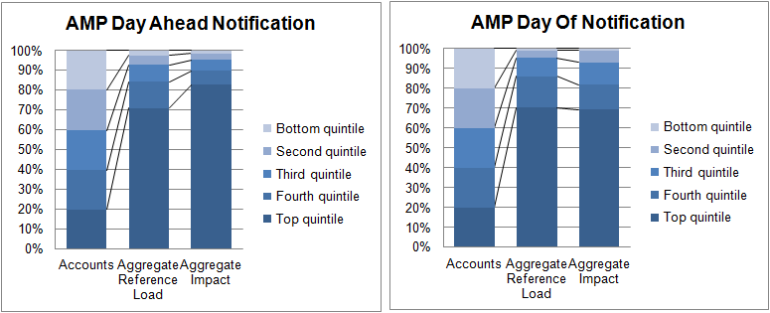

## Capacity Bidding Program Load Impacts

Table 4-5 contains the estimated ex post load impacts for each CBP event day and for the average event in 2011. CBP day-of resources were dispatched for two events starting at 3 PM and ending at 5 PM, while the event window for CBP day-ahead resources varied across the seven events that were called in 2011.

On average, day-ahead notification customers reduced demand by 29% and delivered 14 MW of demand reduction. Customers with same-day notification had smaller percent demand reductions. For the average event, customers on the 1-4 hour product reduced demand 22% and delivered 13 MW of aggregate demand reduction, whereas customers on the 2-6 hour product reduced demand 20% and delivered 4.6 MW of aggregate demand reduction. The estimated impacts are generally consistent across events, except for the July 5 day-of notification customers, which had the lowest percentage reduction of all the events, at 17%. This relatively low load reduction may have been due to the fact that July 5 was the day immediately after a holiday.

Figure 4-3 shows the estimated hourly electricity patterns with and without DR on September 21, when both day-of and day-ahead resources were dispatched from 3 PM to 5 PM. The responses of both resources are similar in magnitude and load reductions are tightly bounded to the event window.

****Table 4-5: Estimated Ex Post Load Impacts by Event Day  
2011 PG&E CBP Events****

|  |  |  |  |  |  |  |  |  |  |
| --- | --- | --- | --- | --- | --- | --- | --- | --- | --- |
| **Program** | **Event Date** | **Accts** | **Avg. Reference Load (kW)** | **Avg. Load Reduction (kW)** | **% Load Reduction** | **Aggregate Reference Load (MW)** | **Aggregate Load Impact (MW)** | **Avg. Temp During Event** | **Nominated MW\*** |
| CBP-DA 1-4 Hour | 07/05/2011 | 127 | 295.1 | 80.9 | 27.4% | 37.5 | 10.3 | 92.3 | 17.9 |
| 07/06/2011 | 127 | 286.9 | 92.4 | 32.2% | 36.4 | 11.7 | 94.2 | 17.9 |
| 08/25/2011 | 154 | 351.0 | 102.3 | 29.2% | 54.1 | 15.8 | 87.7 | 19.1 |
| 08/26/2011 | 154 | 349.3 | 116.5 | 33.3% | 53.8 | 17.9 | 87.4 | 19.1 |
| 09/07/2011 | 162 | 304.7 | 84.0 | 27.6% | 49.4 | 13.6 | 92.7 | 19.9 |
| 09/21/2011 | 162 | 308.0 | 85.0 | 27.6% | 49.9 | 13.8 | 91.1 | 19.9 |
| 09/22/2011 | 161 | 309.8 | 81.5 | 26.3% | 49.9 | 13.1 | 91.0 | 19.9 |
| **Average Event** | **150** | **315.7** | **90.7** | **28.7%** | **47.4** | **13.6** | **90.8** | **19.1** |
| CBP-DO 1-4 Hour | 07/05/2011 | 150 | 418.5 | 70.9 | 16.9% | 62.8 | 10.6 | 90.3 | 16.7 |
| 09/21/2011 | 127 | 405.8 | 104.3 | 25.7% | 51.5 | 13.3 | 90.4 | 13.5 |
| **Average Event** | **139** | **410.5** | **91.9** | **22.4%** | **57.1** | **12.8** | **90.3** | **15.1** |
| CBP-DO 2-6 Hour | 09/21/2011 | 80 | 284.2 | 57.5 | 20.2% | 22.7 | 4.6 | 88.8 | 4.0 |

Figure 4-3: PG&E CBP Hourly Impacts for September 21, 2011

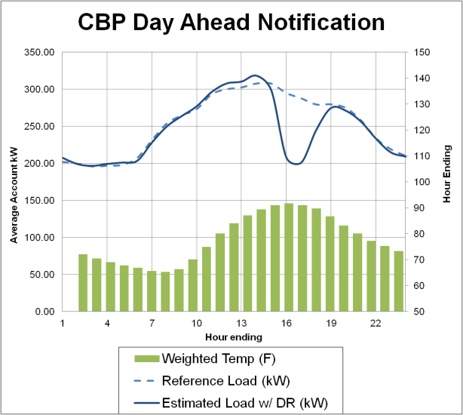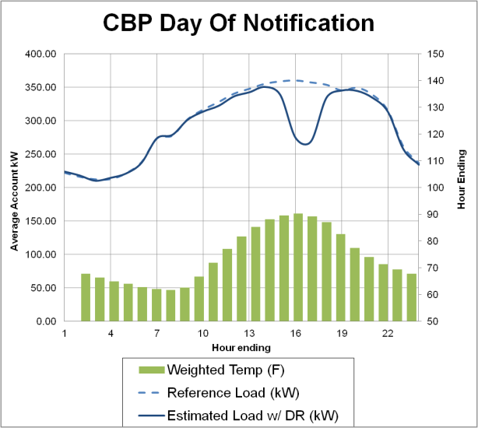

### CBP Demand Reductions by Industry

Table 4-6 shows load impacts by industry for the average PG&E CBP event. Results for industries with few customers may not be statistically significant and should be interpreted with caution. Day-ahead resources were mainly from the Manufacturing sector, which accounts for 9% of accounts, 44% of the event-day reference load and 40% of the aggregate impact. Agriculture, Mining & Construction accounted for an additional 38% of the aggregate load impact, despite having only 15% of the reference load; this customer segment reduced loads on average 72%, a far greater drop than other customer segments. In contrast, reductions from resources with day-of notification were concentrated in a different business segments. Retail stores, which made up 77% of day-of customers, accounted for 60% of the program reference load and 42% of the aggregate load impact.

****Table 4-6: Estimated Ex Post Load Impacts by Industry  
Average 2011 PG&E CBP Event****

|  |  |  |  |  |  |  |  |  |
| --- | --- | --- | --- | --- | --- | --- | --- | --- |
| **Program** | **Industry** | **Accts** | **Avg. Reference Load (kW)** | **Average Load Reduction (kW)** | **% Load Reduction** | **Aggregate Reference Load (MW)** | **Aggregate Load Impact (MW)** | **Avg. Temp During Event** |
| CBP-DA | **All Customers** | **150** | **315.7** | **90.7** | **28.7%** | **47.4** | **13.6** | **90.8** |
| Agriculture, Mining & Construction | 81 | 88.1 | 63.5 | 72.1% | 7.1 | 5.1 | 95.0 |
| Hotels and Apartment Buildings | 3 | 1757.3 | 199.8 | 11.4% | 5.3 | 0.6 | 74.3 |
| Manufacturing | 13 | 1583.3 | 421.7 | 26.6% | 20.6 | 5.5 | 89.5 |
| Other or unknown | 1 | 0.0 | 0.0 | -15.9% | 0.0 | 0.0 | 84.7 |
| Retail stores | 44 | 190.0 | 27.1 | 14.2% | 8.4 | 1.2 | 83.6 |
| Schools | 1 | 3291.8 | 236.1 | 7.2% | 3.3 | 0.2 | 97.0 |
| Water Districts | 1 | 41.4 | 41.8 | 100.9% | 0.0 | 0.0 | 98.6 |
| Wholesale, Transport, other utilities | 6 | 483.0 | 146.8 | 30.4% | 2.9 | 0.9 | 97.2 |
| CBP-DO | **All Customers** | **219** | **363.6** | **72.2** | **19.9%** | **79.6** | **15.8** | **89.9** |
| Agriculture, Mining & Construction | 8 | 453.6 | 363.9 | 80.2% | 3.6 | 2.9 | 99.2 |
| Hotels and Apartment Buildings | 10 | 459.9 | 31.3 | 6.8% | 4.6 | 0.3 | 84.8 |
| Institutional/Government | 3 | 192.6 | 41.0 | 21.3% | 0.6 | 0.1 | 98.0 |
| Manufacturing | 12 | 1088.4 | 225.3 | 20.7% | 13.1 | 2.7 | 95.4 |
| Offices, Finance, Services | 7 | 749.4 | 122.1 | 16.3% | 5.2 | 0.9 | 83.1 |
| Retail stores | 168 | 284.9 | 39.8 | 14.0% | 47.9 | 6.7 | 89.4 |
| Schools | 1 | 2149.1 | 45.4 | 2.1% | 2.1 | 0.0 | 97.8 |
| Water Districts | 5 | 350.3 | 229.3 | 65.5% | 1.8 | 1.1 | 86.7 |
| Wholesale, Transport, other utilities | 7 | 260.2 | 177.0 | 68.0% | 1.8 | 1.2 | 93.1 |

### CBP Demand Reductions by Local Capacity Area

Table 4-7 shows load impacts by local capacity area. Day-ahead CBP customers are concentrated in the Central Valley, although they are spread across three different LCAs – Other, Greater Fresno and Kern. Jointly, customers located in the Central Valley made up 74% of the accounts, 61% of the reference load and 89% of the aggregate demand reduction.

****Table 4-7: Estimated Ex Post Load Impacts by Local Capacity Area  
Average 2011 PG&E CBP Event****

|  |  |  |  |  |  |  |  |  |
| --- | --- | --- | --- | --- | --- | --- | --- | --- |
| **Program** | **Local Capacity Area** | **Accts** | **Avg. Reference Load (kW)** | **Average Load Reduction (kW)** | **% Load Reduction** | **Aggregate Reference Load (MW)** | **Aggregate Load Impact (MW)** | **Avg. Temp During Event** |
| CBP-DA | **All Customers** | **150** | **315.7** | **90.7** | **28.7%** | **47.4** | **13.6** | **90.8** |
| Greater Bay Area | 27 | 444.6 | 49.5 | 11.1% | 12.0 | 1.3 | 81.2 |
| Greater Fresno | 42 | 202.5 | 107.8 | 53.2% | 8.5 | 4.5 | 98.1 |
| Humboldt | 1 | 44.2 | 4.5 | 10.3% | 0.0 | 0.0 | 64.5 |
| Kern | 36 | 53.4 | 48.1 | 90.0% | 1.9 | 1.7 | 98.7 |
| Northern Coast | 5 | 1090.2 | 12.8 | 1.2% | 5.5 | 0.1 | 89.0 |
| Other | 33 | 556.5 | 178.1 | 32.0% | 18.4 | 5.9 | 81.4 |
| Sierra | 4 | 191.7 | 10.3 | 5.4% | 0.8 | 0.0 | 94.8 |
| Stockton | 2 | 92.7 | 5.5 | 6.0% | 0.2 | 0.0 | 95.9 |
| CBP-DO | **All Customers** | **219** | **363.6** | **72.2** | **19.9%** | **79.6** | **15.8** | **89.9** |
| Greater Bay Area | 93 | 365.7 | 37.3 | 10.2% | 34.0 | 3.5 | 86.9 |
| Greater Fresno | 23 | 385.7 | 177.5 | 46.0% | 8.9 | 4.1 | 99.1 |
| Humboldt | 2 | 161.2 | 15.9 | 9.8% | 0.3 | 0.0 | 63.8 |
| Kern | 13 | 299.6 | 74.5 | 24.9% | 3.9 | 1.0 | 99.6 |
| Northern Coast | 22 | 295.8 | 55.3 | 18.7% | 6.5 | 1.2 | 93.1 |
| Other | 43 | 390.0 | 97.9 | 25.1% | 16.8 | 4.2 | 83.9 |
| Sierra | 17 | 409.3 | 79.0 | 19.3% | 7.0 | 1.3 | 96.0 |
| Stockton | 7 | 382.0 | 57.6 | 15.1% | 2.7 | 0.4 | 98.3 |

Day-of CBP resources are more widely distributed than day-ahead resources, but the largest share of demand reduction resources are still outside the primary load pockets. Overall, 27% and 26% of aggregate demand reductions came from the Other and Greater Fresno local capacity areas, respectively. The accounts in these areas are mainly in California’s Central Valley and reflect a higher concentration of customers in Manufacturing, Agriculture & Construction and Wholesale & Transport business segments. Although 43% of accounts with day-of notification were in the Bay Area, they jointly made up only 22% of program resources. Greater Bay Area customers reduced a smaller share of their electricity demand and are generally smaller.

### CBP Demand Reductions by Customer Size

Figure 4-4 shows load impacts by customer size. The average demand during weekday, summer peak hours (1 PM to 6 PM) was calculated for each customer and then divided into quintiles. As was the case for the AMP program, the largest fifth of customers accounted for most of the aggregate reference load and load impact during CBP event days.

For day-ahead resources, the largest fifth of customers accounted for 80% of the program reference load and 62% of the load impacts. For day-of resources, the concentration is similar, although less intensive; the largest fifth of customers accounted for 44% of the reference load and 48% of the load  impacts.

****Figure 4-4: Estimated Ex Post Load Impacts by Customer Size  
Average 2011 PG&E CBP Event****



## Technical Incentive and AutoDR Realization Rates

TI and AutoDR are part of a multi-stage process for automating demand response. Customers can request an audit to identify opportunities to reduce power and determine the potential for automating load reductions via technology. A technical incentive (TI) is paid if a customer installs equipment or reconfigures processes to automate load reductions. The payment is provided after installation of the demand reduction technology is verified and the load reduction potential is measured onsite. The payment is based on the amount of load that can be automatically shed when the equipment or process is running – known as the approved load shed. With TI, the response is automated, but the customer still decides whether and when to drop load. AutoDR provides an incremental incentive to encourage customers to allow the utility to remotely dispatch the automated load reduction.

To date, most TI and AutoDR applications have occurred in conjunction with voluntary enrollment in DR programs.[10] Only a subset of customers enrolled in DR programs partakes in TI or AutoDR, and they do so voluntarily. As a result, participants in TI or AutoDR are likely different from other customers in DR programs. Success of TI and AutoDR programs should not be measured by whether participants provide smaller or larger reduction than the average customer in DR programs, precisely because participants in TI and AutoDR are likely to differ systematically from DR customers that do not participate. Similarly, TI participants are likely to differ systematically from AutoDR participants. TI and AutoDR participants may not represent the mix of industry segments participating in DR programs generally; for example, PG&E customers in TI and AutoDR are primarily from Manufacturing and Agriculture, Mining and Construction segments. Finally, it has rarely been possible to observe customer load reductions both before and after installing enabling technology, precluding the ability to analyze and compare reductions before and after automation.

Table 4‑8 shows the number of PG&E accounts with TI, AutoDR and no automation for each DR program and notification method. For TI and AutoDR, we also include the approved load shed upon which payment was based and the realization rate. The realization rate indicates the share of the approved load shed that is delivered on event days. The realization rate implicitly assumes that observed load reductions are due entirely to TI and AutoDR mechanisms. It is possible that customers may take actions other than those instigated by TI and AutoDR during events.

Table 4‑8: PG&E TI and AutoDR Program Results by Average Event Hour in 2011

|  |  |  |  |  |  |  |  |  |  |
| --- | --- | --- | --- | --- | --- | --- | --- | --- | --- |
| **Automation Type** | **Aggregator Program** | **Accts** | **Aggregate Reference Load (MW)** | **Aggregate Load Impact (MW)** | **% Load Reduction** | **Approved Load Shed (MW)** | **Realization %** | **90% confidence band** | |
| **Lower Bound** | **Upper Bound** |
| Technical Incentives | AMP - DA | 3 | 14.0 | 7.4 | 53.1% | 3.2 | 235.4% | 201.7% | 269.0% |
| AMP - DO | 13 | 16.9 | 1.4 | 8.1% | 11.6 | 11.8% | 7.8% | 15.8% |
| **TOTAL** | **16** | **31.2** | **9.0** | **28.9%** | **14.8** | **61.1%** | **53.2%** | **69.1%** |
| AutoDR | AMP - DO | 4 | 3.6 | 1.3 | 35.9% | 0.6 | 214.1% | 119.8% | 308.3% |
| CBP - DO | 1 | 0.3 | 0.1 | 27.9% | 0.0 | 158.1% | 80.4% | 235.8% |
| **TOTAL** | **5** | **3.9** | **1.4** | **35.5%** | **0.7** | **211.0%** | **125.2%** | **296.9%** |

The results for PG&E’s TI and AutoDR programs have a high degree of uncertainty due to the smaller sample sizes and lack of statistical power. At best, they are descriptive, not causal, and should be interpreted with caution. Overall, 61% ±8% of the approved TI load shed is actually shed during events. For TI, the realization rate depends on whether the equipment is typically used during event like conditions and whether the customer decides to drop load. The realization rate for AutoDR, at 211% ±85%, is higher than for TI. The high realization rates for PG&E may either be due to relatively small number of customers and error in the impact estimates or because customers are reducing loads from end-uses and processes that were not included in the TI or AutoDR program.

# Load Impact Estimates for SCE’s DRRC and CBP Programs

This section contains the ex post load impact estimates for SCE’s DRRC and CBP Programs. Ex post load impact estimates were developed for each hour of each event day for the average customer and for all customers enrolled at the time of the event. Summary impact estimates are presented in this section and more detailed, hourly estimates are provided electronically along with this report. Impact estimates are also provided by industry segment, local capacity area and customer size.

DRRC and CBP resources were dispatched on different days and hours. While the two programs and notification options overlap on occasion, we separately report the results for DRRC and CBP resources. The remainder of this section presents DRRC results followed by CBP results. For each program, we summarize results for each event day in 2011 and describe how impacts vary for specific customer segments.

## 2011 Event Day Characteristics

SCE called a large number of aggregator program events in 2011. Whereas the other utilities dispatched aggregator resources only by product, SCE dispatched program resources both by product and specific aggregator. On a given event day, SCE generally dispatched CBP resources only from a subset of aggregators participating in the program; as a result, SCE has more event days than other utilities.

DRRC resources with day-ahead and day-of event notifications were dispatched twice and four times, respectively. CBP resources with day-ahead and day-of event notifications were dispatched on 17 and 3 occasions, respectively.[11] Many events took place on days when system loads were high – events were called on 4 out of the 10 highest peak days for 2011, including the annual peak day on September 7. A number of events were also called for testing purposes on days when peak loads were not substantial.

Table 5-1 summarizes the 21 days on which SCE called CBP or DRRC events in the reporting year for 2011. Events lasted between one and five hours, starting no earlier than 1 PM and ending no later than 7 PM. Events were called for DRRC alone on two days, for CBP alone on 17 days, and simultaneously for CBP and DRRC on 2 days. The mix of resources called for each event varied as can be seen by the nominated MW and number of aggregators that were dispatched. As a result, the average event day impacts do not reflect the full load reduction capability of the program, particularly for DRRC day-of resources, as SCE never jointly dispatched all three aggregators with contracts.

Table 5-1: Event Summary for SCE’s CBP and DRRC Programs in 2011

|  |  |  |  |  |  |  |  |
| --- | --- | --- | --- | --- | --- | --- | --- |
| Program | Advance Notice | Product | Date | Day-of Week | Number of Aggregators Dispatched | Hours | Nominated MW |
| CBP | Day-ahead | 1-4 Hour | 6/22/2011 | Wed | 4 | 4 - 5 PM | 2.6 |
| 7/5/2011 | Tue | 2 | 2 - 6 PM | 0.3 |
| 7/6/2011 | Wed | 2 | 2 - 6 PM | 0.3 |
| 7/7/2011 | Thu | 2 | 3 - 4 PM | 0.3 |
| 8/1/2011 | Mon | 4 | 2 - 5 PM | 5.0 |
| 8/2/2011 | Tue | 4 | 2 - 5 PM | 5.0 |
| 8/3/2011 | Wed | 4 | 3 - 5 PM | 5.0 |
| 8/4/2011 | Thu | 4 | 3 - 4 PM | 5.0 |
| 8/16/2011 | Tue | 4 | 3 - 5 PM | 5.0 |
| 8/17/2011 | Wed | 4 | 3 - 5 PM | 5.0 |
| 8/18/2011 | Thu | 4 | 2 - 5 PM | 5.0 |
| 8/19/2011 | Fri | 4 | 3 - 5 PM | 5.0 |
| 8/22/2011 | Mon | 4 | 3 - 5 PM | 5.0 |
| 8/23/2011 | Tue | 4 | 3 - 5 PM | 5.0 |
| 8/24/2011 | Wed | 4 | 3 - 5 PM | 5.0 |
| 9/7/2011 | Wed | 3 | 1 - 5 PM | 2.5 |
| 9/8/2011 | Thu | 3 | 2 - 6 PM | 2.5 |
| 10/13/2011 | Thu | 2 | 2 - 5 PM | 1.1 |
| 10/14/2011 | Fri | 2 | 2 - 5 PM | 1.1 |
| 2-6 Hour | 8/1/2011 | Mon | 1 | 2 - 5 PM | 0.1 |
| 8/2/2011 | Tue | 1 | 2 - 5 PM | 0.1 |
| 8/3/2011 | Wed | 1 | 3 - 5 PM | 0.1 |
| 8/16/2011 | Tue | 1 | 3 - 5 PM | 0.1 |
| 8/17/2011 | Wed | 1 | 3 - 5 PM | 0.1 |
| 8/18/2011 | Thu | 1 | 2 - 5 PM | 0.1 |
| 8/19/2011 | Fri | 1 | 3 - 5 PM | 0.1 |
| 8/22/2011 | Mon | 1 | 3 - 5 PM | 0.1 |
| 8/23/2011 | Tue | 1 | 3 - 5 PM | 0.1 |
| 8/24/2011 | Wed | 1 | 3 - 5 PM | 0.1 |
| Day-of | 1-4 Hour | 7/28/2011 | Thu | 4 | 2 - 4 PM | 10.4 |
| 8/25/2011 | Thu | 3 | 2 - 4 PM | 5.8 |
| 9/7/2011 | Wed | 3 | 2 - 6 PM | 5.0 |
| 2-6 Hour | 8/25/2011 | Thu | 1 | 2 - 4 PM | 7.7 |
| 9/7/2011 | Wed | 1 | 1 - 7 PM | 7.7 |
| DRRC | Day-ahead | 1-4 Hour | 7/28/2011 | Thu | 2 | 2 - 4 PM | 65.0 |
| 8/25/2011 | Thu | 2 | 2 - 4 PM | 70.0 |
| Day-of | 1-4 Hour | 4/21/2011 | Thu | 1 | 2 - 4 PM | 52.0 |
| 6/23/2011 | Thu | 1 | 2 - 4 PM | 110.0 |
| 7/28/2011 | Thu | 2 | 2 - 4 PM | 145.0 |
| 8/25/2011 | Thu | 2 | 2 - 4 PM | 150.0 |

## Demand Response Resource Contract Load Impacts

SCE’s aggregators had jointly committed to deliver between 215 MW and 230 MW of same-day resources and between 60 MW and 70 MW of day-ahead resources during the 2011 summer months. However, no aggregators with DRRC contracts subscribed enough capacity to meet their contractual obligations and, as a result, were subject to penalties. Table 5-2 summarizes the estimated ex post load impacts for each DRRC event day and for the average event in 2011.

SCE jointly dispatched the two aggregators providing day-ahead resources from 2 PM to 4 PM in each of the two events called. On average, 275 accounts participated in the average day-ahead event and reduced demand by 17.4 MW, nearly a 28% reduction.

In total, three aggregators committed to deliver demand reductions with day-of event notice. Although SCE dispatched DRRC day-of resources from 2 PM to 4 PM on four occasions, it never jointly dispatched all resources at the same time. As a result, the individual event days in 2011 are not directly comparable and the variation in results is largely explained by the dispatch patterns.

Only 61 accounts participated in the April 21 event, but they were large and primarily came from the manufacturing and water district industry segments. Collectively, these accounts reduced load by 68%, and delivered aggregate load reductions equal to 32 MW. In contrast, the number of participating accounts was higher and the percent load reductions were smaller during the remaining three events. None of these events included the aggregator dispatched for the April event. The last two events reflect the joint load reduction of two other aggregators. Had all DRRC same-day resources been called together, they could have delivered 135 MW of load reduction, a reduction of 28%.

****Table 5-2: Estimated Ex Post Load Impacts by Event Day  
2011 SCE DRRC Events****

|  |  |  |  |  |  |  |  |  |  |
| --- | --- | --- | --- | --- | --- | --- | --- | --- | --- |
| **Program** | **Event Date** | **Accts** | **Avgerage Reference Load**  **(kW)** | **Average Load Reduction (kW)** | **% Load Reduction** | **Aggregate Reference Load**  **(MW)** | **Aggregate Load Impact (MW)** | **Avg. Temp During Event** | **Nominated MW\*** |
| DRRC-DA | 07/28/2011 | 268 | 223.9 | 62.1 | 27.7% | 60.0 | 16.6 | 83.1 | 65.0 |
| 08/25/2011 | 282 | 232.0 | 64.2 | 27.7% | 65.4 | 18.1 | 89.5 | 70.0 |
| **Average Event** | **275** | **228.1** | **63.2** | **27.7%** | **62.7** | **17.4** | **86.4** | **67.5** |
| DRRC-DO | 04/21/2011 | 61 | 777.2 | 525.7 | 67.6% | 47.4 | 32.1 | 65.1 | 52.0 |
| 06/23/2011 | 940 | 305.2 | 92.4 | 30.3% | 286.9 | 86.9 | 83.9 | 110.0 |
| 07/28/2011 | 1242 | 331.8 | 74.1 | 22.3% | 412.2 | 92.0 | 83.7 | 145.0 |
| 08/25/2011 | 1298 | 346.6 | 88.4 | 25.5% | 449.9 | 114.7 | 93.2 | 150.0 |
| **Average Event** | **885** | **337.9** | **92.0** | **27.2%** | **299.1** | **81.4** | **86.9** | **114.3** |

Figure 5-1 shows the estimated hourly electricity patterns with and without DR on July 28, when day-ahead resources were dispatched in full and two of the three aggregators providing day-of resources were dispatched. Both day-ahead and day-of notification resources started reducing load at least an hour before the event and sustained reduced demand levels for an hour or two after the event had  concluded.

Figure 5-1: SCE DRRC Hourly Impacts for July 28, 2011

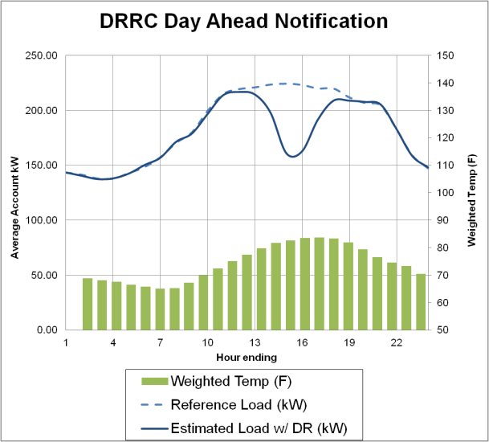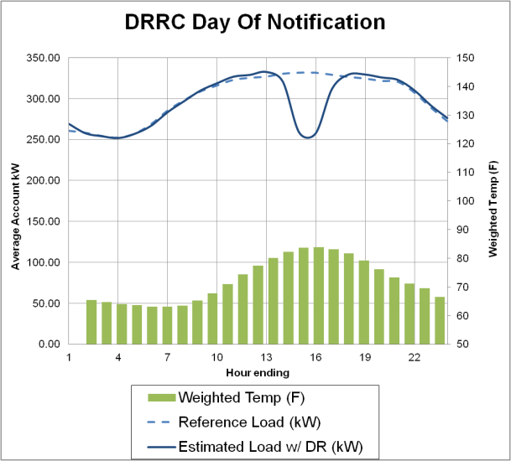

### DRRC Demand Reductions by Industry

Table 5-3 shows load impacts by industry for the average DRRC event. Both the day-ahead and day-of resource categories have broad representation across the various industry segments, but the percent of accounts and aggregate load reduction attributable to specific industries differ across the product lines. For example, for the day-ahead resource, Agriculture, Mining & Construction accounted for 35% of enrollment and 35% of aggregate load reduction. This same industry accounted for only 4% of total enrollment for day-of resources and 4% of aggregate demand response. This industry produced an 86% average demand reduction on a day-ahead basis in 2011 and a much smaller, although still quite impressive, 46% reduction on a day-of basis.

Water Districts were the largest contributor to aggregate demand response for the day-of resource. With an average load impact of 66%, these accounts provided 37% of the same day load reductions. On a day-ahead basis, Water Districts are able to almost completely shed their dedicated load, producing a 94% average load reduction and accounting for about 20% of the average aggregate day-ahead load reduction.

****Table 5-3: Estimated Ex Post Load Impacts by Industry  
Average 2011 SCE DRRC Event****

|  |  |  |  |  |  |  |  |  |
| --- | --- | --- | --- | --- | --- | --- | --- | --- |
| **Program** | **Industry** | **Accts** | **Avg. Reference Load**  **(kW)** | **Average Load Reduction (kW)** | **% Load Reduction** | **Aggregate Reference Load (MW)** | **Aggregate Load Impact (MW)** | **Avg. Temp During Event** |
| DRRC-DA | **All Customers** | **275** | **228.1** | **63.2** | **28%** | **62.7** | **17.4** | **86.4** |
| Agriculture, Mining & Construction | 95 | 74.1 | 63.8 | 86% | 7.0 | 6.1 | 88.7 |
| Institutional/Government | 3 | 93.5 | 46.7 | 50% | 0.3 | 0.1 | 78.1 |
| Manufacturing | 16 | 569.5 | 238.2 | 42% | 9.1 | 3.8 | 83.6 |
| Offices, Finance, Services, Hotels and Apartment Buildings | 18 | 426.2 | 9.1 | 2% | 7.7 | 0.2 | 70.1 |
| Other or Unknown | 4 | 60.7 | 59.7 | 98% | 0.2 | 0.2 | 97.8 |
| Retail stores | 85 | 269.9 | 30.2 | 11% | 22.9 | 2.6 | 84.8 |
| Water Districts (including Sewerage and Irrigation) | 47 | 79.1 | 74.0 | 94% | 3.7 | 3.5 | 90.9 |
| Wholesale, Transport, Other Utilities | 8 | 1475.1 | 122.5 | 8% | 11.8 | 1.0 | 87.8 |
| DRRC-DO | **All Customers** | **885** | **332.9** | **91.9** | **28%** | **294.6** | **81.4** | **87.0** |
| Agriculture, Mining & Construction | 36 | 185.4 | 84.4 | 46% | 6.7 | 3.0 | 90.3 |
| Institutional/Government | 9 | 880.7 | 80.2 | 9% | 7.9 | 0.7 | 82.9 |
| Manufacturing | 70 | 839.5 | 249.0 | 30% | 58.8 | 17.4 | 82.6 |
| Offices, Finance, Services, Hotels and Apartment Buildings | 55 | 387.6 | 100.0 | 26% | 21.3 | 5.5 | 83.8 |
| Retail stores | 400 | 281.0 | 33.4 | 12% | 112.4 | 13.3 | 85.5 |
| Schools | 15 | 1975.8 | 195.9 | 10% | 29.6 | 2.9 | 81.2 |
| Water Districts (including Sewerage and Irrigation) | 273 | 166.6 | 109.9 | 66% | 45.5 | 30.0 | 91.2 |
| Wholesale, Transport, other utilities | 28 | 478.8 | 309.1 | 65% | 13.4 | 8.7 | 82.5 |

The percent of total participation associated with Retail Store accounts is significant for both day-ahead and day-of resources. Retail stores accounted for 31% of participation in the day-ahead resource and 45% in the day-of resource, but provided smaller percent load reductions. Retail stores accounted for 15% of aggregate load reduction in the day-ahead category and 16% in the day-of category. Manufacturing had relatively few accounts in both resource categories but these accounts are large and make a significant contribution to both product lines, accounting for 22% of aggregate reduction for the day-ahead resource and 21% of aggregate reduction for the day-of resource.

### DRRC Demand Reductions by Local Capacity Area

Table 5-4 shows load impacts by local capacity area. LCAs reflect transmission constraints and the location of generators, which determine where resources are needed. Not surprisingly, the Los Angeles basin accounted for the vast majority of customers and load impacts for both day-ahead and day-of notification options. However, the mix of customers differs across the areas. The Ventura/Big Creek and Outside LA Basin capacity areas include a higher proportion of accounts in the Agricultural and Water District segments.

****Table 5-4: Estimated Ex Post Load Impacts by LCA  
Average 2011 SCE DRRC Event****

|  |  |  |  |  |  |  |  |  |
| --- | --- | --- | --- | --- | --- | --- | --- | --- |
| **Program** | **Local Capacity Area** | **Accounts** | **Average**  **Reference Load (kW)** | **Average Load Reduction (kW)** | **% Load Reduction** | **Aggregate Reference Load**  **(MW)** | **Aggregate Load Impact (MW)** | **Average Temp. During Event** |
| DRRC-DA | **All Customers** | **275** | **228.1** | **63.2** | **27.7%** | **62.7** | **17.4** | **86.4** |
| LA Basin | 166 | 315.0 | 75.3 | 23.9% | 52.3 | 12.5 | 83.6 |
| Ventura/Big Creek | 98 | 89.6 | 45.2 | 50.5% | 8.8 | 4.4 | 89.9 |
| Outside LA Basin | 11 | 150.6 | 39.8 | 26.4% | 1.7 | 0.4 | 95.9 |
| DRRC-DO | **All Customers** | **885** | **332.9** | **91.9** | **27.6%** | **294.6** | **81.4** | **87.0** |
| LA Basin | 683 | 332.2 | 93.1 | 28.0% | 226.9 | 63.6 | 86.3 |
| Ventura/Big Creek | 116 | 446.0 | 103.6 | 23.0% | 51.7 | 12.0 | 85.7 |
| Outside LA Basin | 85 | 183.5 | 66.8 | 36.4% | 15.6 | 5.7 | 93.7 |

### DRRC Demand Reductions by Customer Size

Figure 5-2 shows load impacts by customer size. The average demand during weekday, summer peak hours (1 PM to 6 PM) was calculated for each customer and then divided into quintiles.

For day-ahead resources, the largest fifth of customers accounted for 67% of the program reference load and 32% of the aggregate load impact. Interestingly, the next largest fifth of customers also provided 32% of load impacts, despite having less than 20% of program reference load – nearly a third less reference load than the top fifth of customers. This appears to be due to the greater number of Water District customers in the fourth quintile compared with the top quintile, since Water Districts showed the largest load reduction as a percent of reference load out of all customer segments. For day-of resources, load impacts are much more concentrated; the largest fifth of customers accounted for 62% of the reference load and 56% the aggregate load impact.

****Figure 5-2: Estimated Ex Post Load Impacts by Customer Size  
Average 2011 SCE DRRC Event****

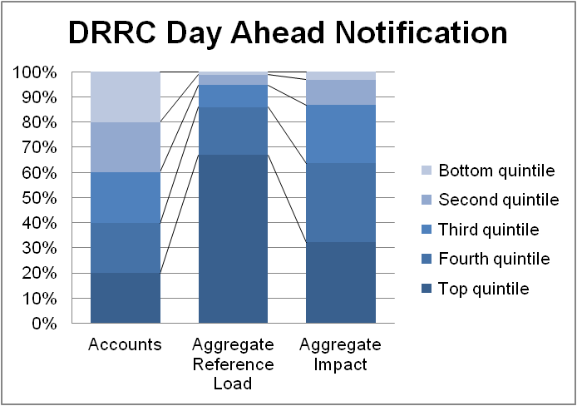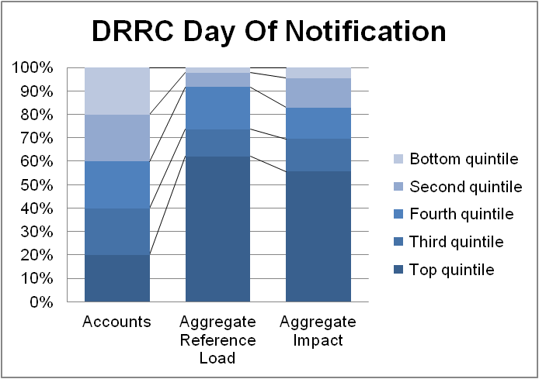

## Capacity Bidding Program Load Impacts

Table 5-5 contains the estimated ex post load impacts for each CBP event day and for the average event in 2011. On average, day-ahead notification customers reduced demand by 25% and delivered 3.8 MW of demand reduction. As was seen previously in Table 5-1, SCE did not dispatch all aggregators on every event day, and the committed load reductions vary across months. This explains the significant differences in load impacts across some of the events. For example, for the events on July 5, 6 and 7, only 2 aggregators and 3 accounts were nominated. The aggregate and percentage impacts across the August events varied from a low of 2 MW and 10.8% reduction on August 19 to a high of 6 MW and 30.8% reduction on August 24. The August 19 event day was the coolest of the summer and the only Friday event day. The event was only in effect for two hours, from 3 PM to 5 PM, when business activity may have been winding down on a Friday afternoon. The next lowest event impact was 3.7 MW on August 2, nearly twice as much as the August 19 estimate.

The number of nominated accounts for the same-day notification products was roughly twice as large as for the typical day-of event day. For the 1-4 hour product, the percent reduction was less than for most day-ahead events, averaging 16.7% compared with 24.8% for the day-ahead events. Aggregate load impacts averaged 6.8 MW. The percent reduction for the day-of, 2-6 hour product averaged 21.3%. Aggregate load impacts averaged 12.4 MW.

****Table 5-5: Estimated Ex Post Load Impacts by Event Day  
2011 SCE CBP Events****

| **Program** | **Event date** | **Accounts** | **Average Reference Load**  **(kW)** | **Average Load Reduction (kW)** | **% Load Reduction** | **Aggregate Reference Load**  **(MW)** | **Aggregate Load Impact (MW)** | **Average Temp. During Event** | **Nominated MW\*** |
| --- | --- | --- | --- | --- | --- | --- | --- | --- | --- |
| CBP-DA 1-4 Hour | 06/22/2011 | 77 | 102.3 | 7.8 | 7.6% | 7.9 | 0.6 | 80.9 | 2.6 |
| 07/05/2011 | 3 | 847.8 | 51.9 | 6.1% | 2.5 | 0.2 | 79.0 | 0.3 |
| 07/06/2011 | 3 | 862.3 | 109.0 | 12.6% | 2.6 | 0.3 | 78.8 | 0.3 |
| 07/07/2011 | 3 | 837.2 | 6.6 | 0.8% | 2.5 | 0.0 | 77.4 | 0.3 |
| 08/01/2011 | 112 | 172.2 | 38.1 | 22.1% | 19.3 | 4.3 | 85.0 | 5.0 |
| 08/02/2011 | 112 | 177.2 | 33.1 | 18.7% | 19.8 | 3.7 | 85.4 | 5.0 |
| 08/03/2011 | 112 | 175.8 | 47.9 | 27.2% | 19.7 | 5.4 | 82.2 | 5.0 |
| 08/04/2011 | 110 | 170.5 | 52.7 | 30.9% | 18.8 | 5.8 | 81.6 | 5.0 |
| 08/16/2011 | 112 | 171.2 | 49.9 | 29.1% | 19.2 | 5.6 | 81.3 | 5.0 |
| 08/17/2011 | 112 | 171.8 | 50.9 | 29.6% | 19.2 | 5.7 | 82.9 | 5.0 |
| 08/18/2011 | 112 | 171.7 | 44.1 | 25.7% | 19.2 | 4.9 | 81.6 | 5.0 |
| 08/19/2011 | 111 | 166.3 | 18.0 | 10.8% | 18.5 | 2.0 | 77.4 | 5.0 |
| 08/22/2011 | 111 | 169.2 | 50.8 | 30.0% | 18.8 | 5.6 | 80.7 | 5.0 |
| 08/23/2011 | 111 | 175.5 | 53.4 | 30.5% | 19.5 | 5.9 | 84.1 | 5.0 |
| 08/24/2011 | 111 | 175.4 | 54.0 | 30.8% | 19.5 | 6.0 | 83.9 | 5.0 |
| 09/07/2011 | 101 | 162.6 | 45.7 | 28.1% | 16.4 | 4.6 | 92.2 | 2.5 |
| 09/08/2011 | 101 | 162.0 | 42.5 | 26.2% | 16.4 | 4.3 | 87.8 | 2.5 |
| **Average Event** | **89** | **173.9** | **43.2** | **24.8%** | **15.5** | **3.8** | **84.2** | **3.7** |
| CBP-DA 2-6 Hour | 08/01/2011 | 2 | 155.4 | 7.2 | 4.6% | 0.3 | 0.0 | 66.7 | 0.1 |
| 08/02/2011 | 2 | 149.2 | -2.9 | -1.9% | 0.3 | 0.0 | 65.9 | 0.1 |
| 08/03/2011 | 2 | 144.5 | -3.2 | -2.2% | 0.3 | 0.0 | 63.6 | 0.1 |
| 08/16/2011 | 2 | 148.8 | 7.7 | 5.2% | 0.3 | 0.0 | 66.6 | 0.1 |
| 08/17/2011 | 2 | 147.0 | 1.6 | 1.1% | 0.3 | 0.0 | 66.4 | 0.1 |
| 08/18/2011 | 2 | 152.4 | -3.6 | -2.4% | 0.3 | 0.0 | 66.6 | 0.1 |
| 08/19/2011 | 2 | 144.3 | 1.9 | 1.3% | 0.3 | 0.0 | 66.8 | 0.1 |
| 08/22/2011 | 2 | 154.0 | 2.2 | 1.4% | 0.3 | 0.0 | 66.6 | 0.1 |
| 08/23/2011 | 2 | 146.3 | 2.8 | 1.9% | 0.3 | 0.0 | 65.8 | 0.1 |
| 08/24/2011 | 2 | 146.3 | -0.9 | -0.6% | 0.3 | 0.0 | 66.7 | 0.1 |
| **Average Event** | **2** | **149.3** | **1.1** | **0.8%** | **0.3** | **0.0** | **66.2** | **0.1** |
| CBP-DO 1-4 Hour | 07/28/2011 | 238 | 188.5 | 38.5 | 20.4% | 44.9 | 9.2 | 80.9 | 10.4 |
| 08/25/2011 | 203 | 185.7 | 26.0 | 14.0% | 37.7 | 5.3 | 91.4 | 5.8 |
| 09/07/2011 | 203 | 190.8 | 30.1 | 15.8% | 38.7 | 6.1 | 93.3 | 5.0 |
| **Average Event** | **215** | **188.9** | **31.5** | **16.7%** | **40.6** | **6.8** | **89.4** | **7.1** |
| CBP-DO 2-6 Hour | 08/25/2011 | 197 | 291.6 | 61.3 | 21.0% | 57.4 | 12.1 | 89.5 | 7.7 |
| 09/07/2011 | 197 | 298.5 | 63.8 | 21.4% | 58.8 | 12.6 | 91.4 | 7.7 |
| **Average Event** | **197** | **296.8** | **63.1** | **21.3%** | **58.5** | **12.4** | **90.9** | **7.7** |
|  | | | | | | | | | |

Figure 5-3 shows the estimated hourly electricity patterns with and without DR on September 7, when both day-ahead and day-of resources with 1-4 hour events were dispatched from 1 PM to 5 PM and 2 PM to 6 PM, respectively. The electricity load reductions of customers in the day-ahead notification option are comparable to those of customers dispatched on a same-day basis. For day-ahead resources, customers appeared to have shifted load to the hour immediately prior to the event.

Figure 5-3: SCE CBP Hourly Impacts for September 7, 2011

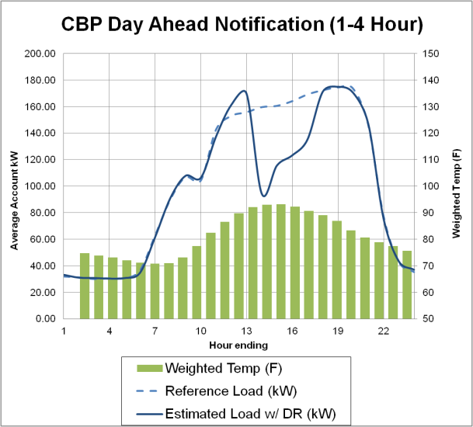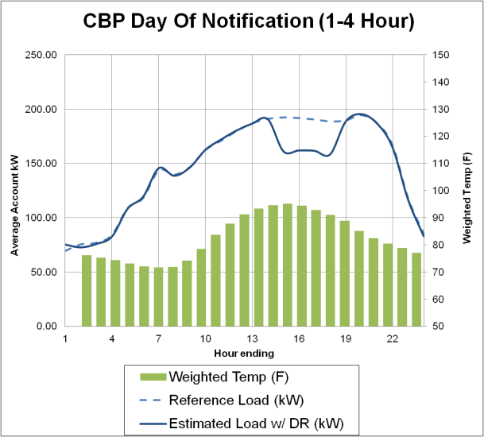

### CBP Demand Reductions by Industry

Table 5-6 shows load impacts by industry for SCE’s CBP program. Most of SCE’s CBP customers are retail stores; they account for nearly all accounts, reference loads and load impacts. Retail stores providing day-ahead resources, on average, reduced loads by 30%, while those on day-of notification reduced loads by 20%.

Table 5-6****: : Estimated Ex Post Load Impacts by Industry  
Average 2011 SCE CBP Event****

|  |  |  |  |  |  |  |  |  |
| --- | --- | --- | --- | --- | --- | --- | --- | --- |
| **Program** | **Industry** | **Accts** | **Avg. Reference Load (kW)** | **Avg. Load Reduction (kW)** | **% Load Reduction** | **Aggregate Reference Load (MW)** | **Aggregate Load Impact (MW)** | **Avg. Temp During Event** |
| CBP-DA | **All Customers** | **90** | **176.6** | **46.5** | **26.3%** | **15.9** | **4.2** | **84.2** |
| Manufacturing | 1 | 1182.8 | 214.7 | 18.1% | 1.2 | 0.2 | 72.2 |
| Offices, Finance, Services, Hotels and Apartment Buildings | 4 | 490.8 | 11.9 | 2.4% | 2.0 | 0.0 | 73.9 |
| Retail stores | 85 | 154.6 | 46.0 | 29.8% | 13.1 | 3.9 | 84.7 |
| CBP-DO | **All Customers** | **412** | **240.9** | **46.5** | **19.3%** | **99.3** | **19.2** | **90.1** |
| Institutional/Government | 42 | 137.2 | 15.4 | 11.2% | 5.8 | 0.6 | 87.8 |
| Retail stores | 369 | 252.5 | 49.4 | 19.5% | 93.2 | 18.2 | 90.4 |
| Wholesale, Transport, other utilities | 1 | 354.9 | 322.1 | 90.8% | 0.4 | 0.3 | 93.6 |

### CBP Demand Reductions by Local Capacity Area

Table 5-7 shows load impacts by local capacity area. Day-ahead and day-of CBP resources are located predominantly in the Los Angeles Basin. Customers are similar in size across capacity areas and program options and provide consistent percent load reductions.

Table 5-7****: Estimated Ex Post Load Impacts by CEC Climate Zone  
Average 2011 SCE CBP Event****

|  |  |  |  |  |  |  |  |  |
| --- | --- | --- | --- | --- | --- | --- | --- | --- |
| **Program** | **Local Capacity Area** | **Accounts** | **Average Reference Load (kW)** | **Average Load Reduction (kW)** | **% Load Reduction** | **Aggregate Reference Load**  **(MW)** | **Aggregate Load Impact (MW)** | **Average Temp. During Event** |
| CBP-DA | **All Customers** | **90** | **176.6** | **46.5** | **26.3%** | **15.9** | **4.2** | **84.2** |
| LA Basin | 71 | 171.2 | 45.1 | 26.3% | 12.2 | 3.2 | 84.3 |
| Ventura/Big Creek | 15 | 209.2 | 56.2 | 26.9% | 3.1 | 0.8 | 80.6 |
| Outside LA Basin | 4 | 150.1 | 34.5 | 23.0% | 0.6 | 0.1 | 96.0 |
| CBP-DO | **All Customers** | **412** | **240.9** | **46.5** | **19.3%** | **99.3** | **19.2** | **90.1** |
| LA Basin | 310 | 236.4 | 46.1 | 19.5% | 73.3 | 14.3 | 90.1 |
| Ventura/Big Creek | 71 | 252.3 | 47.5 | 18.8% | 17.9 | 3.4 | 87.2 |
| Outside LA Basin | 30 | 260.0 | 48.4 | 18.6% | 7.8 | 1.5 | 97.1 |

### CBP Demand Reductions by Customer Size

Figure 5-4 shows the concentration of program load and load impacts. The average demand during weekday, summer peak hours (1 PM to 6 PM) was calculated for each customer and then divided into quintiles. The largest fifth of day-ahead customers accounted for 57% of the program reference load and 49% of the load impacts. For day-of resources, the impacts were less concentrated, as the largest fifth of customers accounted for only 36% of the reference load and 31% the load impacts. Day-of notification customers, most of whom are retail stores, are fairly homogeneous in size and behavior; therefore, the difference in size between fourth quintile and top quintile customers is not as pronounced.

****Figure 5-4: Estimated Ex Post Load Impacts by Customer Size  
Average 2011 SCE CBP Event****

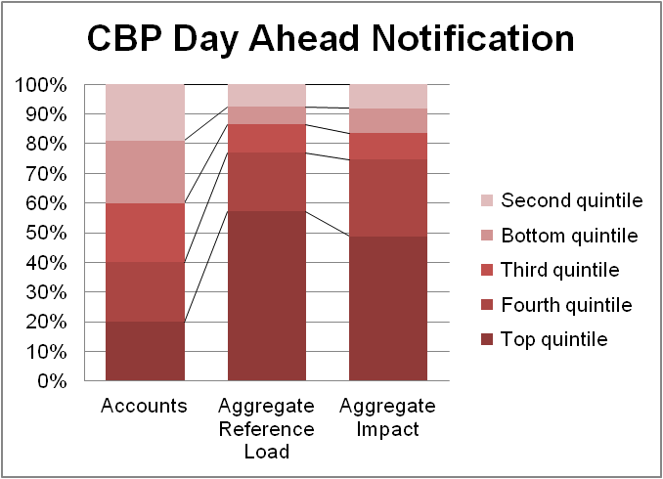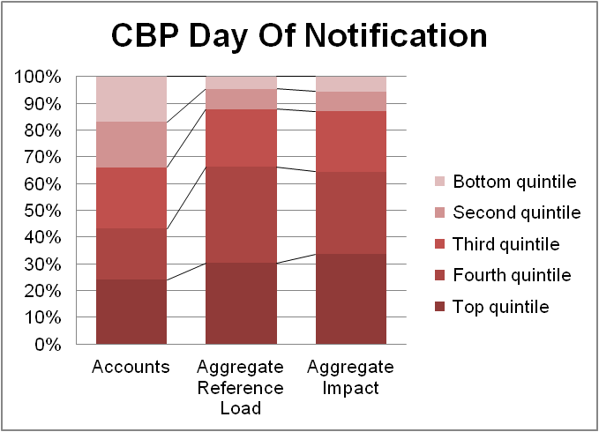

## Technical Incentive and AutoDR Realization Rates

To date, most TI and AutoDR applications have occurred in conjunction with voluntary enrollment in DR programs.[12] Only a subset of customers enrolled in DR programs partakes in TI or AutoDR, and they do so voluntarily. As a result, participants in TI or AutoDR are likely different from other customers in DR programs. Success of TI and AutoDR programs should not be measured by whether participants provide smaller or larger reduction than the average customer in DR programs, precisely because participants in TI and AutoDR are likely to differ systematically from DR customers that do not participate. Similarly, TI participants are likely to differ systematically from AutoDR participants. TI and AutoDR participants may not represent the mix of industry segments participating in DR programs generally. Finally, it has rarely been possible to observe customer load reductions both before and after installing enabling technology, precluding the ability to analyze and compare reductions before and after automation.Table 5-8 shows the number of SCE accounts with TI, AutoDR and no automation for each DR program and notification method. For TI and AutoDR, we also include the approved load shed upon which payment was based and the realization rate. The realization rate indicates the share of the approved load shed that is delivered on event days. The realization rate implicitly assumes that observed load reductions are due entirely to TI and AutoDR mechanisms. It is possible that customers may take actions other than those instigated by TI and AutoDR.

Table 5-8:

SCE TI and AutoDR Program Results by Average Event Hour in 2011

|  |  |  |  |  |  |  |  |  |  |
| --- | --- | --- | --- | --- | --- | --- | --- | --- | --- |
| **Automation Type** | **Aggregator Program** | **Accts** | **Aggregate Reference Load (MW)** | **Aggregate Load Impact (MW)** | **% Load Reduction** | **Approved Load Shed (MW)** | **Realization %** | **90% confidence band** | |
| **Lower Bound** | **Upper Bound** |
| Technical Incentives | CBP - DO | 37 | 8.5 | 1.7 | 20.4% | 1.8 | 94.0% | 87.2% | 100.7% |
| DRRC - DO | 151 | 48.4 | 6.6 | 13.7% | 12.2 | 54.0% | 48.4% | 59.7% |
| **TOTAL** | **188** | **57** | **8.3** | **14.7%** | **14.1** | **59.3%** | **53.9%** | **64.7%** |
| AutoDR | CBP - DA | 51 | 11.7 | 3.2 | 27.6% | 3.7 | 88.3% | 64.2% | 112.4% |
| CBP - DO | 137 | 15.9 | 3.2 | 20.2% | 4.4 | 72.3% | 66.8% | 77.8% |
| DRRC - DA | 1 | 0.2 | 0.1 | 95.5% | 0.2 | 78.1% | 39.5% | 116.7% |
| DRRC - DO | 13 | 16.9 | 4.1 | 24.2% | 9.5 | 43.2% | 34.1% | 52.4% |
| **TOTAL** | **202** | **45.6** | **11.8** | **25.8%** | **16.1** | **73.2%** | **56.0%** | **90.5%** |

Overall, 59% ±5% of the approved TI load shed is actually shed during events. For TI, the realization rate depends on whether the equipment is typically used during event like conditions and whether the customer decides to drop load. The realization rate for AutoDR, at 73% ±17%, is comparable to that of TI.

# Load Impact Estimates for SDG&E’s CBP Program

This section contains the ex post load impact estimates for SDG&E’s CBP program. Results were developed for each hour of each event day in 2011 for the average customer and for all customers enrolled at the time of the event. Estimates are also provided by industry and customer size. Estimates by local capacity area are not applicable since all of SDG&E’s territory falls within a single LCA.

## 2011 Event Day Characteristics

CBP resources were dispatched on 6 of the 12 highest system load days for SDG&E, including their annual system peak day (September 7). CBP resources were also dispatched on September 8, when a system-wide outage that day effectively eliminated system demand and the ability to reduce demand. As a result, September 8 was not included in the analysis. After the system wide outage, power was restored gradually and some customers did not have power until the early morning hours of September 9. Despite the unusual circumstances, customers still delivered demand reductions on September 9.

Table 6-1 summarizes the 7 CBP event days called by SDG&E in 2011. All events lasted four hours, starting no earlier than 1 PM and ending no later than 6 PM. Events were called for CBP day-of notification customers alone on two days, with the remaining five events involving calls of both day-of and day-ahead customers. SDG&E dispatched resources in full for almost all events, leading to less variation across event days.

Table 6-1: Events for SDG&E’s CBP Programs in 2011

|  |  |  |  |  |  |  |  |
| --- | --- | --- | --- | --- | --- | --- | --- |
| **Program** | **Advance Notice** | **Product** | **Date** | **Day-of Week** | **Number of Aggregators Dispatched** | **Hours** | **Nominated MW** |
| CBP | DA | 1-4 Hour | 7/5/2011 | Tue | 3 | 2 - 4 PM | 8.0 |
| 8/26/2011 | Fri | 4 | 2 - 5 PM | 8.0 |
| 9/7/2011 | Wed | 4 | 3 - 6 PM | 7.6 |
| 10/12/2011 | Wed | 4 | 2 - 5 PM | 7.2 |
| 10/13/2011 | Thu | 4 | 2 - 5 PM | 7.2 |
| DO | 1-4 Hour | 7/5/2011 | Tue | 5 | 3 - 6 PM | 8.9 |
| 7/6/2011 | Wed | 5 | 2 - 5 PM | 8.9 |
| 8/26/2011 | Fri | 5 | 3 - 6 PM | 8.2 |
| 9/7/2011 | Wed | 5 | 3 - 6 PM | 8.3 |
| 9/9/2011 | Fri | 5 | 3 - 6 PM | 8.3 |
| 10/12/2011 | Wed | 5 | 1 - 4 PM | 8.4 |
| 10/13/2011 | Thu | 5 | 2 - 5 PM | 8.4 |
| 2-6 Hour | 7/5/2011 | Tue | 1 | 3 - 6 PM | 2.6 |
| 7/6/2011 | Wed | 1 | 2 - 5 PM | 2.6 |
| 8/26/2011 | Fri | 1 | 3 - 6 PM | 2.6 |
| 9/7/2011 | Wed | 1 | 3 - 6 PM | 2.6 |
| 9/9/2011 | Fri | 1 | 3 - 6 PM | 2.6 |
| 10/12/2011 | Wed | 1 | 1 - 4 PM | 2.6 |
| 10/13/2011 | Thu | 1 | 2 - 5 PM | 2.6 |

## Capacity Bidding Program Load Impacts

Table 6-2 shows the estimated ex post load impacts for each CBP event day and for the average event in 2011. On average, day-ahead notification customers reduced demand by 44% and delivered 11.3 MW of demand reduction. Customers with day-of notification provided smaller percent demand reductions. For the average event, customers on the 1-4 Hour product reduced demand 17% and delivered 7.2 MW of aggregate demand reduction, whereas customers on the 2-6 Hour product reduced demand 20% and delivered 4.1 MW of aggregate demand reduction. The impact estimates are fairly consistent across events. The CBP event of September 9 is an exception, showing somewhat lower reductions; however, this may be the result of interference with customer behavior from the system-wide outage on the previous day.

**F**igure 6-1 shows the estimated hourly electricity patterns with and without DR on September 7, when the SDG&E system reached its annual peak and both day-ahead and day-of resources were dispatched from 3 PM to 6 PM, respectively. Participants in all program options delivered the largest reductions on the annual peak day. In aggregate, they reduced demand by 29.6 MW. The electricity load reductions of customers in the day-ahead notification option began two hours prior to the event. For day-of resources, load reductions occurred wholly within event hours. Reference loads and load reductions were much greater for day-ahead customers than day-of customers.

Figure 6-1: SDG&E CBP Hourly Impacts for September 7, 2011 (Annual Peak)

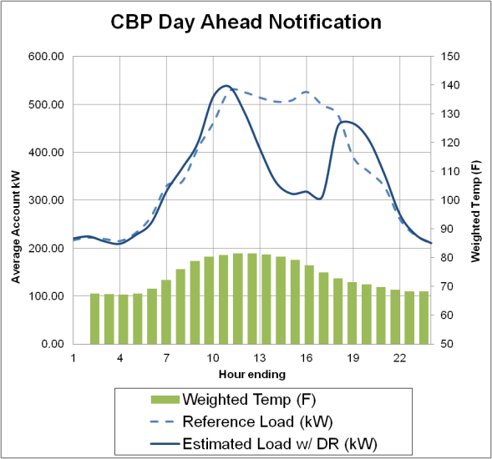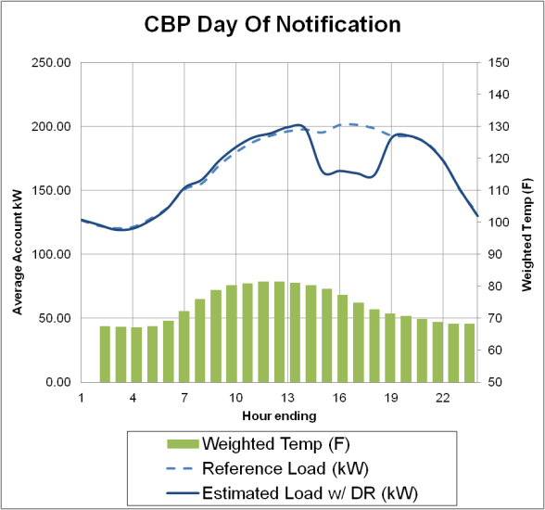

****Table 6-2: Estimated Ex Post Load Impacts by Event Day  
2011 SDG&E CBP Events****

|  |  |  |  |  |  |  |  |  |  |
| --- | --- | --- | --- | --- | --- | --- | --- | --- | --- |
| **Program** | **Event Date** | **Accounts** | **Average Reference Load**  **(kW)** | **Average Load Reduction (kW)** | **% Load Reduction** | **Aggregate Reference Load**  **(MW)** | **Aggregate Load Impact (MW)** | **Average Temp. During Event** | **Nominated MW** |
| CBP-DA 1-4 Hour | 07/05/2011 | 40 | 528.7 | 206.3 | 39.0% | 21.1 | 8.3 | 76.5 | 8.0 |
| 08/26/2011 | 51 | 510.3 | 197.6 | 38.7% | 26.0 | 10.1 | 76.2 | 8.0 |
| 09/07/2011 | 50 | 602.6 | 280.8 | 46.6% | 30.1 | 14.0 | 82.5 | 7.6 |
| 10/12/2011 | 50 | 541.6 | 266.5 | 49.2% | 27.1 | 13.3 | 83.7 | 7.2 |
| 10/13/2011 | 50 | 503.1 | 223.9 | 44.5% | 25.2 | 11.2 | 74.2 | 7.2 |
| **Average Event** | **48** | **537.5** | **236.1** | **43.9%** | **25.8** | **11.3** | **78.7** | **7.6** |
| CBP-DO 1-4 Hour | 07/05/2011 | 247 | 174.0 | 29.6 | 17.0% | 43.0 | 7.3 | 75.6 | 8.9 |
| 07/06/2011 | 247 | 175.7 | 30.9 | 17.6% | 43.4 | 7.6 | 76.8 | 8.9 |
| 08/26/2011 | 236 | 171.8 | 30.2 | 17.6% | 40.5 | 7.1 | 75.3 | 8.2 |
| 09/07/2011 | 247 | 192.0 | 43.0 | 22.4% | 47.4 | 10.6 | 83.0 | 8.3 |
| 09/09/2011* | 247 | 160.3 | 23.1 | 14.4% | 39.6 | 5.7 | 64.2 | 8.3 |
| 10/12/2011 | 247 | 174.1 | 26.2 | 15.1% | 43.0 | 6.5 | 87.3 | 8.4 |
| 10/13/2011 | 247 | 168.7 | 23.8 | 14.1% | 41.7 | 5.9 | 74.8 | 8.4 |
| **Average Event** | **245** | **173.8** | **29.5** | **17.0%** | **42.6** | **7.2** | **76.7** | **8.5** |
| CBP-DO 2-6 Hour | 07/05/2011 | 72 | 292.9 | 60.2 | 20.5% | 21.1 | 4.3 | 75.8 | 2.6 |
| 07/06/2011 | 72 | 292.1 | 57.0 | 19.5% | 21.0 | 4.1 | 76.9 | 2.6 |
| 08/26/2011 | 72 | 293.5 | 58.1 | 19.8% | 21.1 | 4.2 | 75.6 | 2.6 |
| 09/07/2011 | 73 | 309.9 | 68.2 | 22.0% | 22.6 | 5.0 | 83.2 | 2.6 |
| 09/09/2011* | 73 | 274.4 | 55.2 | 20.1% | 20.0 | 4.0 | 64.3 | 2.6 |
| 10/12/2011 | 73 | 286.3 | 56.0 | 19.6% | 20.9 | 4.1 | 87.6 | 2.6 |
| 10/13/2011 | 73 | 280.4 | 58.9 | 21.0% | 20.5 | 4.3 | 75.1 | 2.6 |
| **Average Event** | **73** | **289.9** | **59.1** | **20.4%** | **21.2** | **4.3** | **76.9** | **2.6** |
| * Due to the system outage (and thus, lack of data) on September 8, figures for September 9 were generated using the model specification without autoregressive terms (*i.e.*, *twoweekavg* and *morningload*). | | | | | | | | | |

### CBP Demand Reductions by Industry

Table 6-3 shows the estimated load impacts by industry. Although day-ahead accounts are distributed across several segments, this resource is concentrated among four large Manufacturing customers who shed on average 90% of their loads; this group accounts for 8% of the customers, 42% of the event day reference load and 84% of the load impacts. In contrast, resources with same-day notification come primarily from smaller customers in the Retail stores segment, which accounts for 70% of customers, 73% of event day reference load and 67% of impacts.

****Table 6-3: Estimated Ex Post Load Impacts by Industry  
Average 2011 SDG&E CBP Event****

|  |  |  |  |  |  |  |  |  |
| --- | --- | --- | --- | --- | --- | --- | --- | --- |
| **Program** | **Industry** | **Accounts** | **Average Reference Load**  **(kW)** | **Average Load Reduction (kW)** | **% Load Reduction** | **Aggregate Reference Load (MW)** | **Aggregate Load Impact (MW)** | **Average Temp. During Event** |
| CBP-DA | **All Customers** | **48** | **537.5** | **236.1** | **43.9%** | **25.8** | **11.3** | **78.7** |
| Institutional/Government | 3 | 207.4 | 87.5 | 42.2% | 0.6 | 0.3 | 81.0 |
| Manufacturing | 4 | 2669.3 | 2389.8 | 89.5% | 10.7 | 9.6 | 79.5 |
| Offices, Finance, Services | 29 | 352.5 | 27.9 | 7.9% | 10.2 | 0.8 | 77.9 |
| Retail stores | 11 | 379.8 | 37.5 | 9.9% | 4.2 | 0.4 | 79.6 |
| Water Districts | 2 | 226.5 | 218.9 | 96.6% | 0.5 | 0.4 | 80.2 |
| CBP-DO | **All Customers** | **318** | **200.3** | **36.3** | **18.1%** | **63.7** | **11.5** | **76.8** |
| Agriculture, Mining & Construction | 1 | 1210.9 | 279.4 | 23.1% | 1.2 | 0.3 | 75.9 |
| Hotels and Apartment Buildings | 10 | 285.4 | 24.5 | 8.6% | 2.9 | 0.2 | 75.9 |
| Institutional/Government | 38 | 108.3 | 32.8 | 30.2% | 4.1 | 1.2 | 76.6 |
| Manufacturing | 8 | 261.0 | 41.7 | 16.0% | 2.1 | 0.3 | 77.2 |
| Offices, Finance, Services | 13 | 170.4 | 2.7 | 1.6% | 2.2 | 0.0 | 76.5 |
| Other or unknown | 12 | 286.7 | 96.2 | 33.5% | 3.4 | 1.2 | 77.0 |
| Retail stores | 223 | 208.2 | 34.7 | 16.7% | 46.4 | 7.7 | 76.8 |
| Water Districts | 11 | 118.8 | 56.7 | 47.7% | 1.3 | 0.6 | 77.5 |
| Wholesale, Transport, other utilities | 3 | 166.9 | -3.6 | -2.2% | 0.5 | 0.0 | 76.1 |

### CBP Demand Reductions by Customer Size

Figure 6-2 shows the concentration of demand reductions. The average demand during weekday, summer peak hours (1 PM to 6 PM) was calculated for each customer and then divided into quintiles. The largest fifth of day-ahead customers accounted for 67% of the program reference load and 89% of the load impacts. The program option is not highly diversified, although the participants provide large percent demand reductions. For day-of resources, the impacts are more widely distributed, as the largest fifth of customers accounted for only 43% of the reference load and 43% the load impacts. Same-day notification customers, most of whom are retail stores, are fairly homogeneous in size and behavior compared to day-ahead customers.

****Figure 6-2: Estimated Ex Post Load Impacts by Customer Size  
Average 2011 SDG&E CBP Event****



## Technical Incentive and AutoDR Realization Rates

To date, most TI and AutoDR applications have occurred in conjunction with voluntary enrollment in DR programs.[13] Only a subset of customers enrolled in DR programs partakes in TI or AutoDR, and they do so voluntarily. As a result, participants in TI or AutoDR are likely different from other customers in DR programs. Success of TI and AutoDR programs should not be measured by whether participants provide smaller or larger reduction than the average customer in DR programs, precisely because participants in TI and AutoDR are likely to differ systematically from DR customers that do not participate. Similarly, TI participants are likely to differ systematically from AutoDR participants. TI and AutoDR participants may not represent the mix of industry segments participating in DR programs generally. Finally, it has rarely been possible to observe customer load reductions both before and after installing enabling technology.

Table 6-4 shows the number of SDG&E accounts with TI, AutoDR and no automation for each DR program and notification method. For TI and AutoDR, we also include the approved load shed upon which payment was based and the realization rate. The realization rate indicates the share of the approved load shed that is delivered on event days. The realization rate implicitly assumes that observed load reductions are due entirely to TI and AutoDR mechanisms. It is possible that customers may take actions other than those instigated by TI and AutoDR during events.

Table 6‑4:

SDG&E TI and AutoDR Program Results by Average Event Hour in 2011

|  |  |  |  |  |  |  |  |  |  |
| --- | --- | --- | --- | --- | --- | --- | --- | --- | --- |
| **Automation Type** | **Aggregator Program** | **Accts** | **Aggregate Reference Load (MW)** | **Aggregate Load Impact (MW)** | **% Load Reduction** | **Approved Load Shed (MW)** | **Realization %** | **90% confidence band** | |
| **Lower Bound** | **Upper Bound** |
| Technical Incentives | CBP - DA | 6 | 4.4 | 0.3 | 7.4% | 0.9 | 35.0% | -14.6% | 84.7% |
| CBP - DO | 57 | 15.6 | 2.3 | 14.8% | 3.9 | 59.8% | 47.7% | 71.9% |
| **TOTAL** | **63** | **19.2** | **2.6** | **13.6%** | **4.7** | **56.2%** | **42.0%** | **70.3%** |
| AutoDR | CBP - DA | 3 | 2.5 | 0.2 | 7.4% | 0.5 | 34.1% | -34.9% | 103.0% |
| CBP - DO | 81 | 6.9 | 1 | 14.4% | 3.7 | 26.5% | 19.1% | 33.8% |
| **TOTAL** | **84** | **8.7** | **1.1** | **13.0%** | **4.2** | **27.2%** | **16.7%** | **37.6%** |

Overall, 56% ±14% of the approved TI load shed is actually shed during events. For TI, the realization rate depends on whether the equipment is typically used during event like conditions and whether the customer decides to drop load. The realization rate for AutoDR, at 27% ±11%, is significantly less than that of TI.

# Ex Ante Load Impact Estimates for PG&E’s AMP and CBP Programs

This section presents ex ante load impact estimates for PG&E's CBP and AMP programs. The main purpose of ex ante load impact estimates is to reflect the load reduction capability of a DR resource under a standard set of conditions that align with system planning. These estimates are used in assessing alternatives for meeting peak demand, cost-effectiveness comparisons and long-term planning.

The remainder of this section separately presents the ex ante load impact projections for AMP and CBP customers projected to be nominated for DR resources. The load reduction capability is summarized during annual system peak day conditions for a 1-in-2 and a 1-in-10 weather year for the 2012 to 2022 period. In addition, this section illustrates how impacts per customer vary by geographic location, customer size and month under the standardized ex ante conditions.

Note that ex ante load impacts can differ substantially from ex post load impacts. Ex ante estimates illustrate resources available when all nominated accounts are solicited for an event and reflect historical performance by customers over multiple years. In contrast, during individual events, utilities do not always solicit resources from every aggregator or product. For many events, only a subset of available resources is dispatched. Ex ante impacts also reflect expected changes in enrollment the participant mix. For example, customers from another PG&E DR program, PeakChoice, will transition to CBP starting in 2013. These customers tend to be smaller than current CBP participants.

## Ex Ante Load Impact Estimates for the Aggregator Managed Portfolio Program

presents annual enrollment and nominations forecasts for the AMP program through 2022. PG&E assumes no program growth for AMP. We assume that the proportion of customers nominated for a given event will match the average proportion observed during events in 2010 and 2011.

Table 7‑‑:

PG&E’s Enrollment and Nominations Projections for AMP by Forecast Year

|  |  |  |  |  |
| --- | --- | --- | --- | --- |
| Forecast Year | AMP | | | |
| DA | | DO | |
| Enrolled | Nominated | Enrolled | Nominated |
| 2012 | 249 | 221 | 1872 | 1370 |
| 2013 | 249 | 221 | 1872 | 1370 |
| 2014 - 2022 | 249 | 221 | 1872 | 1370 |

below illustrates predicted load impacts in 2012 for a typical August event day during a 1-in-2 weather year. For both day-ahead and day-of notification, AMP customers begin reducing loads approximately an hour prior to the event window, and maintain load below normal levels for one to two hours following the event window. There is not significant load shifting either preceeding or following the event window.

Figure 7‑:

PG&E AMP Hourly Event Day Impacts for Typical Event Day

1-in-2 Weather Year for August 2012

AMP-DA AMP-DO

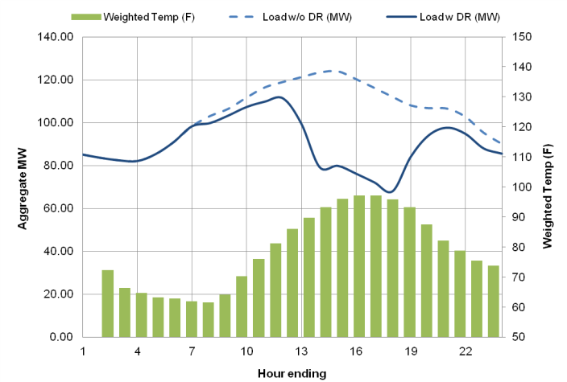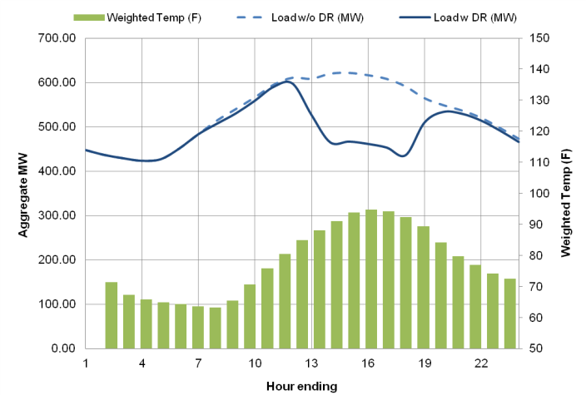  
 presents the ex ante aggregate peak day load impacts for AMP customers for years 2012 to 2022. The historic event day period is assumed as starting at 1 PM and ending at 6 PM. Results are presented for typical event days under 1-in-2 system peaking conditions and by degree of advance notification. In total, there are 44 MW of day-ahead notification resources and 154.5 MW of same-day notification resources. On a given August system peak day, AMP customers can provide a 26 - 27% load reduction, providing just under 200 MW of DR resources. On percentage basis, the results are very similar to the reductions observed during actual historical events. There is no variation in impact over time since program enrollment is not expected to change going forward.

Although reference load vary with weather conditions, the expected demand reductions do not vary by month or with weather conditions for several reasons. Since we expect aggregators to meet a contractually determined amount of demand reduction, AMP resources are not expected to vary with weather or reference loads. Part of the role of the aggregator is to account for the volatility of customer loads and performance to ensure consistent performance. We carefully analyzed the nomination patterns and did not observe any clear seasonal patterns in either the number of accounts nominated or in demand reductions nominated by aggregators. Finally, the demand reduction do not vary with weather because the event history for most individual participants is limited, making it difficult to conclusively determine if variation in event performance is due to weather or simply random.

Table ‑:

Aggregate Ex Ante Annual Peak Day Load Impacts for PG&E AMP

(Hourly Average Reduction Available from 1 to 6 PM)

|  |  |  |  |  |  |  |  |
| --- | --- | --- | --- | --- | --- | --- | --- |
| Weather Year | Year | Nominated Accts (Forecast) | Agg. Reference Load (MW) | Agg. Estimated Load w DR (MW) | Agg. Load Impact (MW) | % Load Reduction | Weighted Temp (F) |
| AMP-DA | 2012 | 221 | 120.4 | 76.4 | 44.0 | 36.5% | 98.3 |
| 2013 | 221 | 120.4 | 76.4 | 44.0 | 36.5% | 98.3 |
| 2014 - 2022 | 221 | 120.4 | 76.4 | 44.0 | 36.5% | 98.3 |
| AMP-DO | 2012 | 1370 | 623.9 | 469.4 | 154.5 | 24.8% | 96.4 |
| 2013 | 1370 | 623.9 | 469.4 | 154.5 | 24.8% | 96.4 |
| 2014 - 2022 | 1370 | 623.9 | 469.4 | 154.5 | 24.8% | 96.4 |

The average load impact is an estimate, based on predictions informed by the ex post model. presents a range of uncertainty for AMP ex ante load impacts, incorporating model error, performance variability and enrollment uncertainty. We find that the 10th and 90th percentile aggregate load impact estimates diverge from the ex ante load impact point estimate by 20%.

Table ‑:

Aggregate Ex Ante Annual Peak Day Load Impacts for PG&E AMP

(Hourly Average Reduction from 1 PM to 6 PM)

|  |  |  |  |
| --- | --- | --- | --- |
| Year | Agg. Load Impact (MW) | Impact Uncertainty | |
| 10th percentile | 90th percentile |
| 2012 | 198.5 | 158.7 | 238.3 |
| 2013 | 198.5 | 158.7 | 238.3 |
| 2014 - 2022 | 198.5 | 158.7 | 238.3 |

PG&E is comprised of seven geographic planning zones known as local capacity areas (LCAs). An eighth region, deemed “Other,” is comprised of customers that are not located in any of the seven LCAs. The ex ante load impacts differ by geographic location due to differences in the total population, industry mix and, to a lesser extent, climate.

The impacts vary by geographic location and size and reflect the patterns observed in demand reductions during actual historical events. summarizes the ex ante load reduction capability of AMP customers by LCA and customer size during an August system peak day in 2012. PG&E expects a reduction of 199 kW and 113 kW per customer for customers enrolled in the same day and day-ahead resources, respectively. The impacts vary by geographic location and size and reflect the patterns observed in demand reductions during actual historical events.

Table ‑:

2012 Aggregate Annual Peak Day Load for PG&E AMP by LCA and Customer Size

(Hourly Average Reduction from 1 to 6 PM)

|  |  |  |  |  |  |  |  |  |  |
| --- | --- | --- | --- | --- | --- | --- | --- | --- | --- |
| Customer Subcategory | | AMP-DA | | | | AMP-DO | | | |
| Expected Aggregate Load Impact (MW) | Number of Nominated Customers | Expected Customer Avg. Load Impact (kW) | % Load Reduction | Expected Aggregate Load Impact (MW) | Number of Nominated Customers | Expected Customer Avg. Load Impact (kW) | % Load Reduction |
| LCA | Greater Bay Area | 5.8 | 77 | 75.1 | 15.7% | 19.4 | 557 | 34.8 | 10.2% |
| Greater Fresno | 9.3 | 36 | 259.6 | 57.6% | 41.2 | 284 | 145.2 | 38.7% |
| Humboldt | 0.1 | 1 | 69.2 | 14.5% | 1.9 | 9 | 205.6 | 39.7% |
| Kern | 0.6 | 19 | 29.2 | 12.0% | 22.2 | 143 | 155.6 | 25.4% |
| Northern Coast | 26.8 | 54 | 496.9 | 49.7% | 5.9 | 63 | 94.4 | 24.4% |
| Other | 0.5 | 20 | 22.5 | 8.7% | 52.8 | 234 | 225.6 | 29.5% |
| Sierra | 1.0 | 14 | 68.8 | 30.0% | 4.9 | 27 | 183.0 | 40.7% |
| Stockton | 0.7 | 35 | 19.6 | 18.8% | 6.1 | 53 | 115.0 | 30.6% |
| Size | Greater than 200 kW | 43.3 | 168 | 257.8 | 37.1% | 142.6 | 829 | 172.0 | 24.2% |
| 20 kW to 199.99 kW | 0.7 | 35 | 19.6 | 18.8% | 10.5 | 399 | 26.2 | 34.5% |
| Less than 20 kW | 0.0 | 18 | 0.1 | 67.4% | 1.4 | 142 | 10.2 | 40.9% |
| All Customers | | 44.0 | 221 | 199.4 | 36.5% | 154.5 | 1370 | 112.8 | 24.8% |

## Ex Ante Load Impact Estimates for the Capacity Bidding Program

Table 7‑5 presents annual enrollment and nominations forecasts for PG&E’s CBP program through 2022. The Brattle Group has projected the number of nominated customers for CBP through 2022. We assume the growth comes from CBP products and customer segments proportional to those observed in 2011. We also assume that the proportion of customers nominated for a given event will match the average proportion observed during events in 2010 and 2011.

Table ‑:

PG&E’s Enrollment and Nominations Projections for CBP by Forecast Year

|  |  |  |  |  |
| --- | --- | --- | --- | --- |
| Forecast Year | CBP | | | |
| DA | | DO | |
| Enrolled | Nominated | Enrolled | Nominated |
| 2012 | 213 | 185 | 255 | 224 |
| 2013 | 259 | 225 | 312 | 274 |
| 2014 | 258 | 224 | 309 | 272 |
| 2015 | 259 | 225 | 310 | 273 |
| 2016 | 261 | 227 | 312 | 274 |
| 2017 | 264 | 230 | 315 | 277 |
| 2018 | 268 | 233 | 319 | 281 |
| 2019 | 274 | 238 | 325 | 286 |
| 2020 | 278 | 242 | 331 | 291 |
| 2021 | 284 | 247 | 338 | 297 |
| 2022 | 291 | 253 | 345 | 303 |

below illustrates predicted load impacts in 2012 for a typical August event day during a 1-in-2 weather year. For both day-ahead and day-of notification, CBP customers reduce loads precisely inside the event window. There is not significant load shifting either preceding or following the event window.

Figure ‑:

PG&E CBP Hourly Event Day Impacts for Typical Event Day

1-in-2 Weather Year for August 2012

CBP-DA CBP-DO

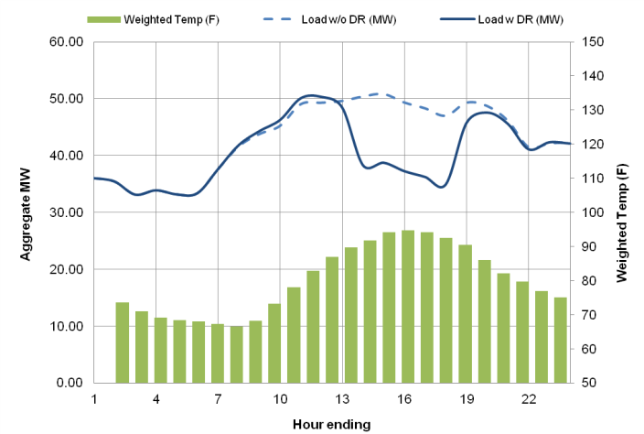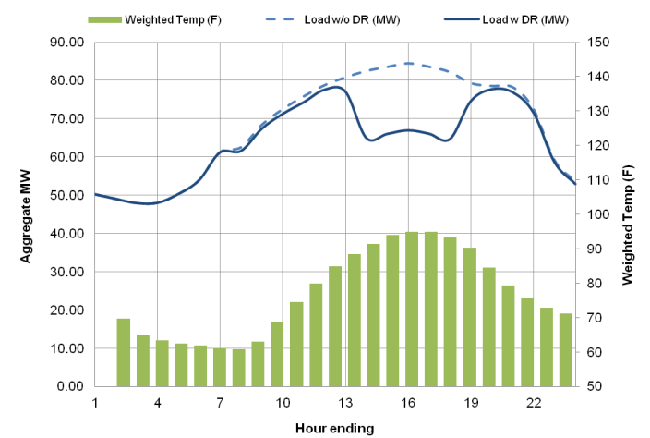

presents the ex ante aggregate peak day load impacts for CBP customers for years 2012 to 2022. The tables show the load reduction capability starting at 1 PM and ending at 6 PM. Results are presented for typical event days under 1-in-2 and 1-in-10 system peaking conditions. CBP customers can provide a 17 - 24% load reduction, depending on the program option. As a result of program growth over time, in aggregate, CBP resources increase from 29.6 MW in 2012 to 40.2 MW in 2022. In 2012, PG&E expects to have 12.1 MW of day-ahead resources and 17.5 MW of same day resources for a 1-in-2 system peak day. Initially, the aggregate load impacts rise more slowly than the number of nominated accounts, because of the expected migration of smaller customer from the PeakChoice in 2013. From there, the aggregate load impacts rise proportionally with the number of nominated accounts, indicating per customer load reductions and the customer mix are expected to remain consistent.

Table ‑:

Aggregate Ex Ante Annual Peak Day Load Impacts for PG&E CBP

(Hourly Average Reduction from 1 to 6 PM)

|  |  |  |  |  |  |  |  |
| --- | --- | --- | --- | --- | --- | --- | --- |
| Weather Year | Year | Nominated Accts (Forecast) | Agg. Reference Load (MW) | Agg. Estimated Load w DR (MW) | Agg. Load Impact (MW) | % Load Reduction | Weighted Temp (F) |
| CBP-DA | 2012 | 185 | 50.0 | 37.9 | 12.1 | 24.1% | 99.3 |
| 2013 | 225 | 74.8 | 60.6 | 14.2 | 19.0% | 98.0 |
| 2014 | 224 | 72.3 | 58.0 | 14.3 | 19.8% | 98.3 |
| 2015 | 225 | 70.7 | 56.3 | 14.5 | 20.4% | 98.4 |
| 2016 | 227 | 69.8 | 55.2 | 14.7 | 21.0% | 98.6 |
| 2017 | 230 | 69.5 | 54.6 | 14.9 | 21.4% | 98.7 |
| 2018 | 233 | 69.7 | 54.5 | 15.2 | 21.8% | 98.8 |
| 2019 | 238 | 70.2 | 54.7 | 15.5 | 22.0% | 98.8 |
| 2020 | 242 | 70.9 | 55.1 | 15.8 | 22.3% | 98.9 |
| 2021 | 247 | 71.9 | 55.8 | 16.1 | 22.4% | 98.9 |
| 2022 | 253 | 73.1 | 56.6 | 16.5 | 22.6% | 99.0 |
| CBP-DO | 2012 | 224 | 84.3 | 66.8 | 17.5 | 20.8% | 94.9 |
| 2013 | 274 | 116.4 | 96.1 | 20.3 | 17.4% | 94.4 |
| 2014 | 272 | 113.7 | 93.3 | 20.4 | 18.0% | 94.5 |
| 2015 | 273 | 112.2 | 91.5 | 20.7 | 18.4% | 94.5 |
| 2016 | 274 | 111.7 | 90.7 | 21.0 | 18.8% | 94.6 |
| 2017 | 277 | 111.9 | 90.5 | 21.4 | 19.1% | 94.6 |
| 2018 | 281 | 112.7 | 90.9 | 21.8 | 19.3% | 94.7 |
| 2019 | 286 | 113.9 | 91.7 | 22.2 | 19.5% | 94.7 |
| 2020 | 291 | 115.5 | 92.8 | 22.7 | 19.6% | 94.7 |
| 2021 | 297 | 117.4 | 94.2 | 23.2 | 19.7% | 94.7 |
| 2022 | 303 | 119.6 | 95.9 | 23.7 | 19.8% | 94.8 |

The average load impact is an estimate, based on predictions informed by the ex post model. presents a range of uncertainty for CBP ex ante load impacts, incorporating model error and performance variability. We find that the 10th and 90th percentile aggregate load impact estimates diverge from the ex ante load impact point estimate by 32%.

Table ‑:

Aggregate Ex Ante Annual Peak Day Load Impacts for PG&E CBP

(Hourly Average Reduction from 1 PM to 6 PM)

|  |  |  |  |
| --- | --- | --- | --- |
| Year | Agg. Load Impact (MW) | Impact Uncertainty | |
| 10th percentile | 90th percentile |
| 2012 | 29.6 | 21.3 | 37.8 |
| 2013 | 34.5 | 24.2 | 44.8 |
| 2014 | 34.7 | 24.0 | 45.5 |
| 2015 | 35.2 | 24.1 | 46.2 |
| 2016 | 35.7 | 24.3 | 47.0 |
| 2017 | 36.3 | 24.6 | 47.8 |
| 2018 | 36.9 | 25.1 | 48.7 |
| 2019 | 37.7 | 25.6 | 49.7 |
| 2020 | 38.5 | 26.2 | 50.7 |
| 2021 | 39.3 | 26.8 | 51.8 |
| 2022 | 40.2 | 29.3 | 51.2 |

PG&E is comprised of seven geographic planning zones known as local capacity areas (LCAs). An eighth region, deemed “Other,” is comprised of customers that are not located in any of the seven LCAs. The ex ante load impacts differ by geographic location due to differences in the total population, industry mix and, to a lesser extent, climate.

summarizes the ex ante load reduction capability of CBP customers by LCA and customer size during an August system peak day in 2012. Customers outside of the seven LCAs account for the largest fraction of ex ante load reductions, totaling 34% of resources. Customers in the Greater Fresno LCA contribute the next largest proportion of CBP resources, accounting for 25% of ex ante load reductions. Large customers (i.e., greater than 200 kW average demand) account for 89% of ex ante load reductions.

Table ‑:

2012 Ex Ante Annual Peak Load Impacts for PG&E CBP by LCA and Customer Size

(Hourly Average Reduction Available from 1 PM to 6 PM)

|  |  |  |  |  |  |  |  |  |  |
| --- | --- | --- | --- | --- | --- | --- | --- | --- | --- |
| Customer Subcategory | | CBP-DA | | | | CBP-DO | | | |
| Expected Aggregate Load Impact (MW) | Number of Nominated Customers | Expected Customer Avg. Load Impact (kW) | % Load Reduction | Expected Aggregate Load Impact (MW) | Number of Nominated Customers | Expected Customer Avg. Load Impact (kW) | % Load Reduction |
| LCA | Greater Bay Area | 1.4 | 29 | 47.1 | 12.1% | 3.8 | 84 | 45.0 | 10.8% |
| Greater Fresno | 2.9 | 45 | 65.0 | 29.9% | 4.5 | 24 | 189.6 | 43.3% |
| Humboldt | 0.0 | 1 | 4.6 | 9.9% | 0.0 | 2 | 16.2 | 9.7% |
| Kern | 2.2 | 62 | 35.7 | 59.8% | 0.9 | 14 | 61.2 | 21.7% |
| Northern Coast | 0.1 | 5 | 13.1 | 1.5% | 1.5 | 24 | 60.6 | 26.3% |
| Other | 5.4 | 36 | 151.1 | 27.4% | 4.8 | 49 | 98.3 | 26.2% |
| Sierra | 0.0 | 5 | 8.4 | 6.1% | 1.6 | 18 | 86.7 | 20.7% |
| Stockton | 0.0 | 3 | 3.8 | 5.2% | 0.5 | 7 | 64.9 | 14.7% |
| Size | Greater than 200 kW | 10.0 | 68 | 146.9 | 22.2% | 16.4 | 179 | 91.5 | 20.6% |
| 20 kW to 199.99 kW | 2.1 | 66 | 32.5 | 42.9% | 0.9 | 36 | 24.4 | 19.9% |
| Less than 20 kW | -0.1 | 51 | -1.4 | N/A | 0.2 | 8 | 30.2 | N/A |
| All Customers | | 12.1 | 185 | 65.2 | 24.1% | 17.5 | 224 | 78.1 | 20.8% |

## Comparison with Previous Ex Ante Estimates

For the 2010 evaluation, Christensen Associates Energy Consulting produced ex ante load impact estimates for PG&E’s CBP and AMP programs.

Table 7‑9 compares CAEC’s ex ante load impact estimates for 2012 to those developed by FSC this year. During the year that elapsed, a substantial number of customers migrated between programs, with CBP customers transferring to AMP. These customers are smaller than prior AMP customers but larger than remaining CBP customers—and so they cause AMP per-customer impacts to go down on average. This combination of changing enrollments and customer mix within each program are largely responsible for the changes in the ex ante aggregate impacts for each program.

The ex ante estimates assumed that the customer mix would be similar. Across all aggregator programs that is largely true.  However, the mix for specific program options changed with the migration of participants across options. The ex ante results from this year factor in those shifts. Across all aggregator programs, last year forecast predicted 243.5 MW for 2012 and this year’s forecast predicts 228.2 MW, or 94% of last year’s forecast, for 2012.

Table ‑:

Comparison of 2012 Ex Ante Load Impact Estimates for PG&E

|  |  |  |  |  |  |  |
| --- | --- | --- | --- | --- | --- | --- |
| Program | 2012 Per Customer Impacts (kW) | | 2012 Nominations | | 2012 Aggregate Impacts (MW) | |
| 2010 CAEC | 2011 FSC | 2010 CAEC | 2011 FSC | 2010 CAEC | 2011 FSC |
| AMP | 190.3 | 124.8 | 993 | 1591 | 189.0 | 198.6 |
| CBP | 50.0 | 72.3 | 1090 | 409 | 54.5 | 29.6 |

# Ex Ante Load Impact Estimates for SCE’s DRRC and CBP Programs

This section presents ex ante load impact estimates for SCE's CBP and DRRC programs. The main purpose of ex ante load impact estimates is to reflect the load reduction capability of a DR resource under a standard set of conditions that align with system planning. These estimates are used in assessing alternatives for meeting peak demand, cost-effectiveness comparisons and long-term planning.

The remainder of this section separately presents the ex ante load impact projections for DRRC and CBP customers projected to be nominated for DR resources. The load reduction capability is summarized during annual system peak day conditions for a 1-in-2 and a 1-in-10 weather year for the 2012 to 2022 period. In addition, this section illustrates how impacts per customer vary by geographic location, customer size and month under the standardized ex ante conditions.

Note that ex ante load impacts will differ from ex post load impacts. Ex post estimates are based on actual DRRC and CBP events called in 2010 and 2011, which did not always solicit resources from every nominated account. In contrast, ex ante estimates illustrate resources available when all nominated accounts are solicited for an event.

## Ex Ante Load Impact Estimates for Demand Response Resource Contracts

presents annual enrollment and nominations forecasts for the DRRC program through 2022. SCE forecasts 10% growth in DRRC nominations through 2014, at which point enrollments remain unchanged. We assume the growth comes from CBP products and customer segments proportional to those observed in 2011. We also assume that the proportion of customers nominated for a given event will match the average proportion observed during events in 2010 and 2011.

Table ‑:

SCE’s August Enrollment and Nominations Projections for DRRC by Forecast Year

|  |  |  |  |  |
| --- | --- | --- | --- | --- |
| Forecast Year | DRRC | | | |
| DA | | DO | |
| Enrolled | Nominated | Enrolled | Nominated |
| 2012 | 286 | 214 | 2532 | 1670 |
| 2013 | 286 | 214 | 2786 | 1837 |
| 2014 - 2022 | 286 | 214 | 3065 | 2021 |

below illustrates predicted load impacts in 2012 for a typical August event day during a 1-in-2 weather year. For both day-ahead and day-of notification, DRRC customers begin reducing loads an hour prior to the event window, and loads remain reduced for an hour following the event window. There is not significant load shifting either preceding or following the event window.

Figure ‑:

SCE DRRC Hourly Event Day Impacts for Typical Event Day

1-in-2 Weather Year for August 2012

DRRC-DA DRRC-DO

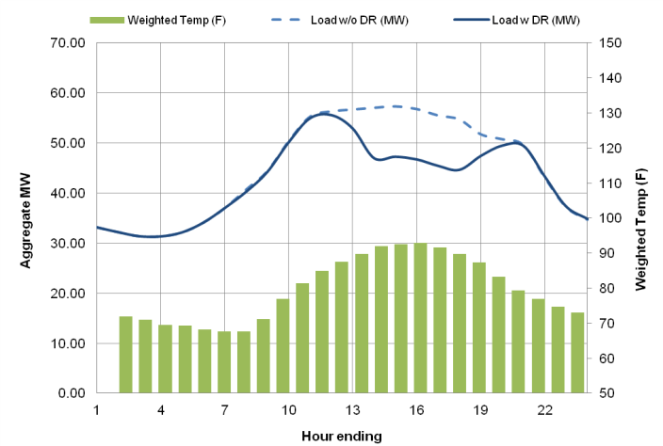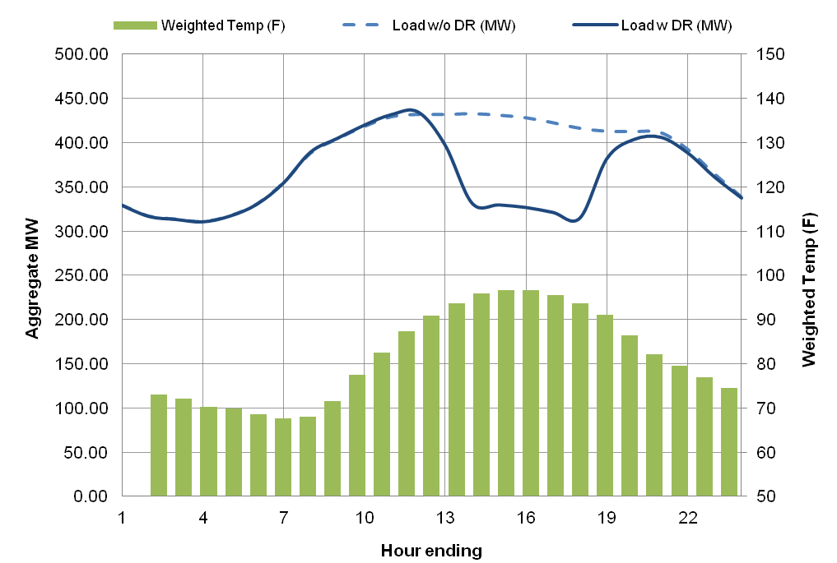

presents the ex ante aggregate peak day load impacts for DRRC customers for years 2012 to 2022. The event day period is assumed as starting at 1 PM and ending at 6 PM. Results are presented for the annual peak day (August) under 1-in-2 system peaking conditions. On a given event day, DRRC same-day notification customers can provide approximately a 23% load reduction; day-ahead notification typically reduce demand by 18%. Overall, DRRC resources are expected to increase from 167 MW in 2012 to 199 MW in 2014, due to program growth.

Table ‑:

Aggregate Ex Ante Annual Peak Day Load Impacts for SCE DRRC

(Hourly Average Reduction from 1 to 6 PM)

|  |  |  |  |  |  |  |  |
| --- | --- | --- | --- | --- | --- | --- | --- |
| Weather Year | Year | Nominated Accts (Forecast) | Agg. Reference Load (MW) | Agg. Estimated Load w DR (MW) | Agg. Load Impact (MW) | % Load Reduction | Weighted Temp (F) |
| DRRC-DA | 2012 | 214 | 76.5 | 63.0 | 13.5 | 17.7% | 93.1 |
| 2013 | 214 | 76.5 | 63.0 | 13.5 | 17.7% | 93.1 |
| 2014 - 2022 | 214 | 76.5 | 63.0 | 13.5 | 17.7% | 93.1 |
| DRRC-DO | 2012 | 1670 | 657.2 | 503.7 | 153.5 | 23.4% | 97.2 |
| 2013 | 1837 | 723.0 | 554.1 | 168.9 | 23.4% | 97.2 |
| 2014 - 2022 | 2021 | 795.4 | 609.6 | 185.8 | 23.4% | 97.2 |

The average load impact is an estimate, based on predictions informed by the ex post model. Table 8‑3 presents uncertainty around ex ante load impacts between years 2012 and 2022. Incorporating model error and performance variability, we find that in an 80% confidence interval aggregate ex ante load impacts range by ±7%. Note that this range does not incorporate enrollment forecast uncertainty. SCE will be requesting bids from aggregator contracts over the next few years. It will both allow aggregator to realign their bids to their existing demand reduction capabilities and allow SCE to procure additional cost-effective DR from aggregators, as directed by the CPUC.

Table ‑:

Aggregate Ex Ante Annual Peak Day Load Impact Uncertainty for SCE CBP

(Hourly Average Reduction from 1 to 6 PM)

|  |  |  |  |
| --- | --- | --- | --- |
| Year | Agg. Load Impact (MW) | Impact Uncertainty | |
| 10th percentile | 90th percentile |
| 2012 | 167.1 | 156.1 | 178.0 |
| 2013 | 182.4 | 170.4 | 194.4 |
| 2014 - 2022 | 199.3 | 186.2 | 212.4 |

SCE is comprised of several geographic planning zones known as local capacity areas (LCAs). SCE expects a reduction of 63 kW and 92 kW per customer for customers enrolled in day-ahead and same-day resources, respectively. The ex ante load impacts differ by geographic location due to differences in the total population, industry mix and, to a lesser extent, climate. The impacts vary by geographic location and size and reflect the patterns observed in demand reductions during actual historical events. summarizes the ex ante load reduction capability of DRRC customers by LCA and customer size during an August system peak day in 2012 under 1-in-2 weather conditions.

Table ‑:

2012 Ex Ante Annual Peak Day Load Impacts for SCE DRRC by LCA and Customer Size

(Hourly Average Reduction from 1 to 6 PM)

|  |  |  |  |  |  |  |  |  |  |
| --- | --- | --- | --- | --- | --- | --- | --- | --- | --- |
| Customer Subcategory | | DRRC-DA | | | | DRRC-DO | | | |
| Aggregate Load Impact (MW) | Nominated Accts | Avg. Load Impact  per Acct  (kW) | % Load Reduction | Aggregate Load Impact (MW) | Nominated Accts | Avg. Load Impact  per Acct  (kW) | % Load Reduction |
| LCA | LA Basin | 9.8 | 130 | 75.3 | 19.5% | 121.0 | 1300 | 93.1 | 23.3% |
| Outside LA | 0.3 | 8 | 39.8 | 22.6% | 10.3 | 154 | 66.8 | 32.3% |
| Ventura | 3.4 | 75 | 45.2 | 19.1% | 22.4 | 216 | 103.6 | 19.9% |
| Size | Greater than 200 kW | 9.1 | 92 | 99.4 | 20.6% | 136.1 | 1216 | 111.9 | 22.4% |
| 20 kW to 199.99 kW | 4.4 | 119 | 36.6 | 47.4% | 16.0 | 442 | 36.2 | 45.1% |
| Less than 20 kW | 0.0 | 0 | 0.0 | 0.0% | 0.0 | 12 | 0.2 | 84.2% |
| All Customers | | 13.5 | 214 | 63.2 | 17.7% | 153.5 | 1670 | 91.9 | 23.4% |

## Ex Ante Load Impact Estimates for the Capacity Bidding Program

presents annual enrollment and nominations forecasts for SCE’s CBP program through 2022. SCE forecasts a 3% growth in CBP enrollments 2012 to 2013 and a 6% growth 2013 to 2014, at which point enrollments remain unchanged. We assume the growth comes from CBP products and customer segments proportional to those observed in 2011. We also assume that the proportion of customers nominated for a given event will match the average proportion observed during events in 2010 and 2011.

Table ‑:

SCE’s Enrollment and Nominations Projections for CBP by Forecast Year

|  |  |  |  |  |
| --- | --- | --- | --- | --- |
| Forecast Year | CBP | | | |
| DA | | DO | |
| Enrolled | Nominated | Enrolled | Nominated |
| 2012 | 117 | 116 | 453 | 448 |
| 2013 | 124 | 123 | 480 | 475 |
| 2014 - 2022 | 124 | 123 | 480 | 475 |

below illustrates predicted load impacts in 2012 for a typical August event day during a 1-in-2 weather year. For both day-ahead and day-of notification, CBP customers reduce loads precisely within the event window. There is a small but noticeable amount of load shifting in the hour prior to the event window and no significant load shifting following the event window.

Figure ‑:

SCE CBP Hourly Event Day Impacts for Typical Event Day

1-in-2 Weather Year for August 2012

CBP-DA CBP-DO

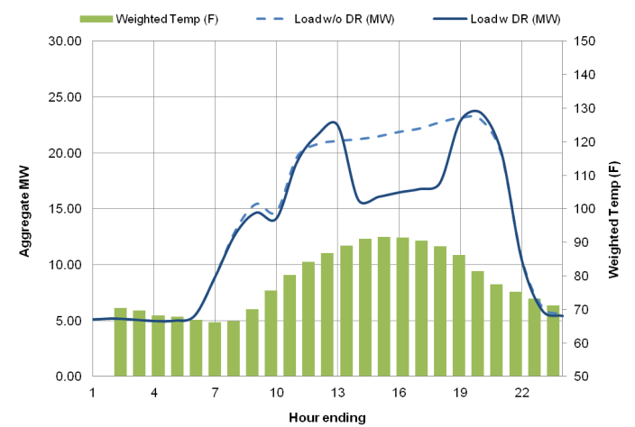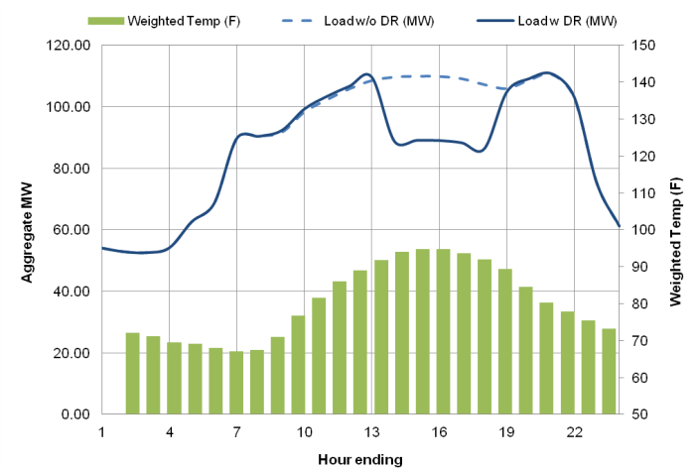

presents the ex ante aggregate peak day load impacts for CBP customers for years 2012 to 2022. The event day period is assumed as starting at 1 PM and ending at 6 PM. Results are presented for typical event days under 1-in-2 and 1-in-10 system peaking conditions. Most of the CBP resources can be dispatched with same day notice. In aggregate, CBP customers can provide a 20% load reduction; as a result of program growth over time, CBP resources increase from 26.2 MW in 2012 to 27.8 MW in 2014.

Table ‑:

Aggregate Ex Ante Annual Peak Day Load Impacts for SCE CBP

(Hourly Average Reduction from 1 to 6 PM)

|  |  |  |  |  |  |  |  |
| --- | --- | --- | --- | --- | --- | --- | --- |
| Weather Year | Year | Nominated Accts (Forecast) | Avg. Reference Load (MW) | Avg. Estimated Load w DR (MW) | Load Impact (MW) | % Load Reduction | Weighted Temp (F) |
| CBP-DA | 2012 | 116 | 22.3 | 17.0 | 5.4 | 24.1% | 92.2 |
| 2013 | 123 | 23.7 | 18.0 | 5.7 | 24.1% | 92.2 |
| 2014 - 2022 | 123 | 23.7 | 18.0 | 5.7 | 24.1% | 92.2 |
| CBP-DO | 2012 | 448 | 110.9 | 90.1 | 20.9 | 18.8% | 95.5 |
| 2013 | 475 | 117.6 | 95.5 | 22.1 | 18.8% | 95.5 |
| 2014 - 2022 | 475 | 117.6 | 95.5 | 22.1 | 18.8% | 95.5 |

The average load impact is an estimate, based on predictions informed by the ex post model. presents uncertainty around ex ante load impacts between years 2012 and 2022. Incorporating model error and performance variability, we find that in an 80% confidence interval aggregate ex ante load impacts range by ±6%. Note that this range does not incorporate enrollment forecast uncertainty.

Table ‑:

Aggregate Ex Ante Annual Peak Day Load Impact Uncertainty for SCE CBP

(Hourly Average Reduction from 1 to 6 PM)

|  |  |  |  |
| --- | --- | --- | --- |
| Year | Avg. Load Impact (MW) | Impact Uncertainty | |
| 10th percentile | 90th percentile |
| 2012 | 26.2 | 24.7 | 27.8 |
| 2013 | 27.8 | 26.2 | 29.4 |
| 2014 - 2022 | 27.8 | 26.2 | 29.4 |

SCE is comprised of several geographic planning zones known as local capacity areas (LCAs). A majority of customers live in the Los Angeles Basin and Ventura LCAs. The ex ante load impacts differ by geographic location due to differences in the total population, industry mix and, to a lesser extent, climate.

summarizes the ex ante load reduction capability of CBP customers by LCA and customer size during an August system peak day in 2012. LA Basin customers account for 75% of ex ante load reductions, and large customers (i.e., greater than 200 kW average demand) account for 87% of ex ante load reductions. Per customer reductions do not vary significantly by LCA, owing to the similar customer mix in CBP across regions.

Table ‑:

2012 Aggregate Ex Ante Annual Peak Day Load Impacts for SCE CBP

By LCA and Customer Size

(Hourly Average Reduction from 1 to 6 PM)

|  |  |  |  |  |  |  |  |  |  |
| --- | --- | --- | --- | --- | --- | --- | --- | --- | --- |
| Customer Subcategory | | CBP-DA | | | | CBP-DO | | | |
| Expected Aggregate Load Impact (MW) | Number of Nominated Customers | Expected Customer Avg. Load Impact (kW) | % Load Reduction | Expected Aggregate Load Impact (MW) | Number of Nominated Customers | Expected Customer Avg. Load Impact (kW) | % Load Reduction |
| LCA | LA Basin | 4.1 | 91 | 45.1 | 24.0% | 15.6 | 338 | 46.1 | 19.0% |
| Outside LA | 0.2 | 5 | 34.5 | 20.9% | 1.5 | 32 | 48.4 | 17.5% |
| Ventura | 1.2 | 21 | 56.2 | 25.4% | 3.7 | 78 | 47.5 | 17.8% |
| Size | Greater than 200 kW | 4.1 | 39 | 104.0 | 24.7% | 18.6 | 302 | 61.7 | 18.3% |
| 20 kW to 199.99 kW | 1.5 | 77 | 19.6 | 24.5% | 2.6 | 146 | 17.9 | 18.9% |
| All Customers | | 5.4 | 116 | 46.5 | 24.1% | 20.9 | 448 | 46.5 | 18.8% |

## Comparison with Previous Ex Ante Estimates

In 2011, Christensen Associates Energy Consulting produced ex ante load impact estimates for PG&E’s CBP and AMP programs. Table 8‑9 compares CAEC’s 2012 ex ante load impact estimates to those developed by FSC this year. The differences are due to increases in enrollment observed over the past year. While the total contracted load reduction in DRRC were similar in the 2010 and 2011 evaluation years, enrollment in 2011 expanded substantially as did the demand reductions delivered. The current ex ante estimated factor in performance in 2010 and 2011 for customer that were enrolled in each program at the end of the 2011 seasons. In addition, SCE based the 2012 forecast based on actual nominations submitted in May 2012, adjusted for seasonal variations.

Table ‑:

Comparison of 2012 Ex Ante Load Impact Estimates for SCE

|  |  |  |  |  |  |  |
| --- | --- | --- | --- | --- | --- | --- |
| **Program** | **2012 Per Customer Impacts (kW)** | | **2012 Nominations** | | **2012 Aggregate Impacts (MW)** | |
| **2010 CAEC** | **2011 FSC** | **2010 CAEC** | **2011 FSC** | **2010 CAEC** | **2011 FSC** |
| DRRC | 66.0 | 88.7 | 1572 | 1884 | 103.7 | 167.1 |
| CBP | 33.3 | 46.5 | 588 | 564 | 19.6 | 26.2 |

# Ex Ante Load Impact Estimates for SDG&E’s CBP Program

This section presents ex ante load impact estimates for SDG&E's CBP program. The main purpose of ex ante load impact estimates is to reflect the load reduction capability of a DR resource under a standard set of conditions that align with system planning. These estimates are used in assessing alternatives for meeting peak demand, cost-effectiveness comparisons and long-term planning.

The remainder of this section separately presents the ex ante load impact projections for CBP customers projected to be nominated for DR resources. The load reduction capability is summarized during annual system peak day conditions for a 1-in-2 and a 1-in-10 weather year for the 2012 to 2022 period. In addition, this section illustrates how impacts per customer vary by geographic location, customer size and month under the standardized ex ante conditions.

Note that ex ante load impacts can differ from ex post load impacts. Ex ante estimates illustrate resources available when all nominated accounts are solicited for an event and reflect historical performance by customers over multiple years. In contrast, during individual events, utilities are able to solicit resources from specific aggregators or products; they do not have to deploy all available resources. For example, SDG&E can dispatch customers in the CBP same-day 2-6 hour product on different days or hours than customers in the same day 1-4 hour product. Ex ante impacts also reflect expected changes in enrollment the participant mix.

## Ex Ante Load Impact Estimates for the Capacity Bidding Program

presents annual enrollment and nominations forecasts for SDG&E’s CBP program through 2022. SDG&E forecasts a 10% growth in CBP enrollments 2012 to 2013 and a 5% annual growth 2013 to 2015, at which point enrollments remain unchanged. We assume the growth comes from CBP products and customer segments proportional to those observed in 2011. We also assume that the proportion of customers nominated for a given event will match the average proportion observed during events in 2010 and 2011.

Table ‑:

SDG&E’s Enrollment and Nominations Projections for CBP by Forecast Year

|  |  |  |  |  |
| --- | --- | --- | --- | --- |
| Forecast Year | CBP | | | |
| DA | | DO | |
| Enrolled | Nominated | Enrolled | Nominated |
| 2012 | 78 | 54 | 573 | 338 |
| 2013 | 82 | 57 | 605 | 357 |
| 2014 - 2022 | 87 | 60 | 635 | 375 |

below illustrates predicted load impacts in 2012 for a typical August event day during a 1-in-2 weather year. For both day-ahead and day-of notification, CBP customers reduce loads one to two hours preceding the event window; for day-ahead notification, customers also maintain reduced loads for an hour following the event window. There is no appreciable load shifting in the hours prior to or following the event window.

Figure ‑:

SDG&E CBP Hourly Event Day Impacts for Typical Event Day

1-in-2 Weather Year for August 2012

CBP-DA CBP-DO

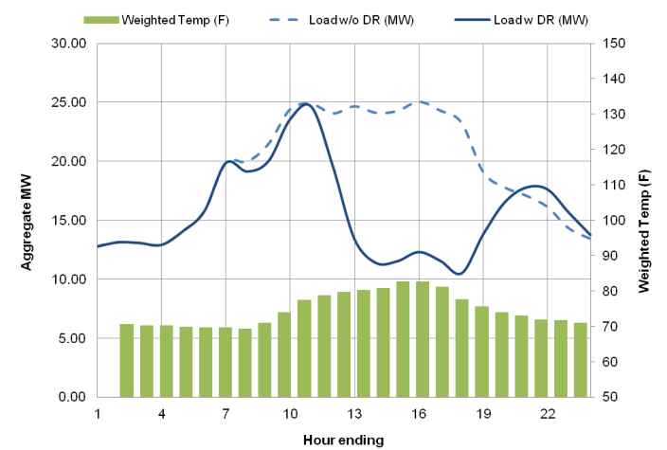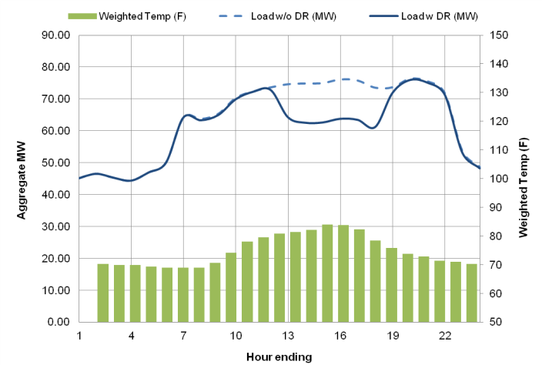

presents the ex ante aggregate peak day load impacts for CBP customers for years 2012 to 2022. The event day period is assumed as starting at 1 PM and ending at 6 PM. Results are presented for the August monthly peak days under 1-in-2 weather conditions. The demand reduction are nearly evenly split between resources that require notice a day in advance and those that respond with same day notice. On aggregate 25 MW of CBP resources are available in 2012. The program is expected to grow incrementally, reaching 28 MW in 2014. The percent demand reductions vary substantially between day-ahead and same day resources. This reflects the current customer mix which is projected to remain similar in the future.

Table ‑:

Aggregate Ex Ante Annual Peak Day Load Impacts for SDG&E CBP

(Hourly Average Reduction from 1 to 6 PM)

|  |  |  |  |  |  |  |  |
| --- | --- | --- | --- | --- | --- | --- | --- |
| Weather Year | Year | Nominated Accts (Forecast) | Agg. Reference Load (MW) | Agg. Estimated Load w DR (MW) | Agg. Load Impact (MW) | % Load Reduction | Weighted Temp (F) |
| CBP-DA | 2012 | 54 | 24.5 | 11.8 | 12.7 | 52.0% | 82.4 |
| 2013 | 57 | 25.9 | 12.4 | 13.5 | 52.0% | 82.4 |
| 2014 - 2022 | 60 | 27.3 | 13.1 | 14.2 | 52.0% | 82.4 |
| CBP-DO | 2012 | 338 | 75.0 | 62.8 | 12.3 | 16.3% | 82.1 |
| 2013 | 357 | 79.3 | 66.3 | 12.9 | 16.3% | 82.1 |
| 2014 - 2022 | 375 | 83.3 | 69.7 | 13.6 | 16.3% | 82.1 |

The aggregate load impact is an estimate, based on predictions informed by the ex post model. presents uncertainty around ex ante load impacts between years 2012 and 2022. Incorporating model error and performance variability, we find that the 10th percentile and 90th percentile estimates diverge from the point estimate of aggregate ex ante load impacts range by ±19%. Note that this range does not incorporate enrollment forecast uncertainty.

Table ‑:

Aggregate Ex Ante Annual Peak Day Load Impact Uncertainty for SDG&E CBP

(Hourly Average Reduction from 1 to 6 PM)

|  |  |  |  |
| --- | --- | --- | --- |
| Year | Agg. Load Impact (MW) | Impact Uncertainty | |
| 10th percentile | 90th percentile |
| 2012 | 25.0 | 20.3 | 29.7 |
| 2013 | 26.4 | 21.5 | 31.3 |
| 2014 - 2022 | 27.8 | 22.6 | 33.0 |

summarizes the ex ante load reduction capability of CBP customers by customer size during an August system peak day in 2012. Large customers (i.e., greater than 200 kW average demand) account for over 90% of ex ante load reductions. There is no breakdown by LCA, as SDG&E’s territory falls entirely in a single LCA.

Table ‑:

Aggregate Ex Ante Annual Peak Day Load Impacts for SDG&E CBP by Customer Size

(Hourly Average Reduction from 1 to 6 PM)

|  |  |  |  |  |  |  |  |  |  |
| --- | --- | --- | --- | --- | --- | --- | --- | --- | --- |
| **Customer Subcategory** | | **CBP-DA** | | | | **CBP-DO** | | | |
| **Aggregate Load Impact (MW)** | **Nominated Accts** | **Load Impact per Acct (kW)** | **% Load Reduction** | **Aggregate Load Impact (MW)** | **Nominated Accts** | **Load Impact per Acct (kW)** | **% Load Reduction** |
| Size | Greater than 200 kW | 13.4 | 33.0 | 715.3 | 56.6% | 10.8 | 194.0 | 291.1 | 19.1% |
| 20 kW to 199.99 kW | 0.0 | 21.0 | 44.0 | 4.2% | 1.8 | 142.0 | 144.2 | 8.9% |
| Less than 20 kW | 0.0 | 0 | 0.0 | 0.0% | 0.0 | 3.0 | 14.2 | 13.3% |
| All Customers | | 12.7 | 54.0 | 454.3 | 52.0% | 12.3 | 338.0 | 224.6 | 16.2% |

## Comparison with Previous Ex Ante Estimates

In 2011, Christensen Associates Energy Consulting produced ex ante load impact estimates for SDG&E’s CBP programs. Table 9‑5 compares CAEC’s ex ante load impact estimates to those developed by FSC this year for a 1-in-2 weather year in 2012. The aggregate impacts for 2012 , 25.0 MW, are similar to those produced last year, 22.7 MW. However, the project nominations and demand reductions per customer differ. The differences reflect actual changes in enrollment observed in the past year. In general, SDG&E has retained the demand reductions from its larger customers and sustained its overall load reduction capability despite changes in the underlying customer mix.

Table ‑:

Comparison of 2012 August Monthly Ex Ante Load Impact Estimates for SDG&E

|  |  |  |  |  |  |  |
| --- | --- | --- | --- | --- | --- | --- |
| Program | Per Customer Impacts (kW) | | Nominated Accts | | Aggregate Impacts (MW) | |
| 2010 CAEC | 2011 FSC | 2010 CAEC | 2011 FSC | 2010 CAEC | 2011 FSC |
| CBP | 44.5 | 63.8 | 510 | 392 | 22.7 | 25.0 |

# Recommendations

Jointly, the aggregator programs can deliver over 300 MW of demand reduction under peaking conditions. In the past two years, the program has grown and the settlement baseline rules have changed. In addition, over the course of the next two years, the existing aggregator contracts held by SCE and/or PG&E will expire.

We have two main recommendations:

* *Retain the Capacity Bidding Program during the upcoming transition phase*. The CBP program provides aggregators without utility long term capacity contracts a means to bid resources into the market. The program provides a market entry point for new aggregators and incentives for existing aggregators to develop additional resources. CBP and long term capacity contracts (for example, AMP) are closely linked. CBP provides aggregators the opportunity to develop new resources, test load reduction capabilities and refine their portfolios and bid quantities. It also provides utilities a useful data on how well different aggregators perform. Many customers that start in CBP and are eventually transferred to the long term contract portfolios. Absent CBP, competition for long term contracts would likely be limited.

*Dispatch aggregator resources at least twice per year*. Both PG&E and SCE dispatch AMP and DRRC resources infrequently. This may be due to how the current contracts are currently structured. As a result, there is insufficient data to determine if the performance by aggregators with utility contracts improves, deteriorates or remains constant under different weather conditions. Resources provided by each aggregator should be dispatched at least twice per year to develop a better history about their performance and enable utilities to analyze if performance varies with weather conditions or due to other factors.

1. Detail on Model Selection

To identify the best model for load impact estimation, 15 different model specifications were examined. These models consist of five different specifications of weather variables and three different specifications of electricity consumption (two autoregressive and one non-autoregressive). The models are listed in Table A-1, and terms are explained in Table A-2.

Table A-1: List of Models Considered

|  |  |
| --- | --- |
| Model | Description |
| 1 | ${kw}_{h}=α_{h}+β_{h}∙{CDH}_{h}+β_{h}∙{CDHsqr}_{h}+\sum_{i=1}^{3}{β_{i,h}∙{daytype}_{i}}+\sum_{i=5}^{10}{β_{i,h}∙{month}_{i}}+β_{h}∙{daylight}_{h}+β_{h}∙{rateblock}_{h}+\sum_{i=1}^{n}{{β_{i,h}∙AMPorDRRCevent}_{i}}+\sum_{i=1}^{m}{β_{i,h}∙{CBPevent}_{i}}+ ε_{h}$ |
| 2 | ${kw}_{h}=α_{h}+β_{h}∙{CDH}_{h}+β_{h}∙{CDHsqr}_{h}+\sum_{i=1}^{3}{β_{i,h}∙{daytype}_{i}}+\sum_{i=5}^{10}{β_{i,h}∙{month}_{i}}+β_{h}∙{daylight}_{h}+β_{h}∙{morningload}_{h}+\sum_{i=1}^{n}{{β_{i,h}∙AMPorDRRCevent}_{i}}+\sum_{i=1}^{m}{β_{i,h}∙{CBPevent}_{i}}+ ε_{h}$ |
| 3 | ${kw}_{h}=α_{h}+β_{h}∙{CDH}_{h}+β_{h}∙{CDHsqr}_{h}+\sum_{i=1}^{3}{β_{i,h}∙{daytype}_{i}}+\sum_{i=5}^{10}{β_{i,h}∙{month}_{i}}+β_{h}∙{daylight}_{h}+β_{h}∙{morningload}_{h}+β_{h}∙{twoweekavg}_{h}+\sum_{i=1}^{n}{{β_{i,h}∙AMPorDRRCevent}_{i}}+\sum_{i=1}^{m}{β_{i,h}∙{CBPevent}_{i}}+ ε_{h}$ |
| 4 | ${kw}_{h}=α_{h}+β_{h}∙{CDD}_{h}+β_{h}∙{CDDsqr}_{h}+\sum_{i=1}^{3}{β_{i,h}∙{daytype}_{i}}+\sum_{i=5}^{10}{β_{i,h}∙{month}_{i}}+β_{h}∙{daylight}_{h}+β_{h}∙{rateblock}_{h}+\sum_{i=1}^{n}{{β_{i,h}∙AMPorDRRCevent}_{i}}+\sum_{i=1}^{m}{β_{i,h}∙{CBPevent}_{i}}+ ε_{h}$ |
| 5 | ${kw}_{h}=α_{h}+β_{h}∙{CDD}_{h}+β_{h}∙{CDDsqr}_{h}+\sum_{i=1}^{3}{β_{i,h}∙{daytype}_{i}}+\sum_{i=5}^{10}{β_{i,h}∙{month}_{i}}+β_{h}∙{daylight}_{h}+β_{h}∙{morningload}_{h}+\sum_{i=1}^{n}{{β_{i,h}∙AMPorDRRCevent}_{i}}+\sum_{i=1}^{m}{β_{i,h}∙{CBPevent}_{i}}+ ε_{h}$ |
| 6 | ${kw}_{h}=α_{h}+β_{h}∙{CDD}_{h}+β_{h}∙{CDDsqr}_{h}+\sum_{i=1}^{3}{β_{i,h}∙{daytype}_{i}}+\sum_{i=5}^{10}{β_{i,h}∙{month}_{i}}+β_{h}∙{daylight}_{h}+β_{h}∙{morningload}_{h}+β_{h}∙{twoweekavg}_{h}+\sum_{i=1}^{n}{{β_{i,h}∙AMPorDRRCevent}_{i}}+\sum_{i=1}^{m}{β_{i,h}∙{CBPevent}_{i}}+ ε_{h}$ |
| 7 | ${kw}_{h}=α_{h}+ β_{h}∙total{CDH}_{h}+β_{h}∙{totalCDHsqr}_{h}+\sum_{i=1}^{3}{β_{i,h}∙{daytype}_{i}}+\sum_{i=5}^{10}{β_{i,h}∙{month}_{i}}+β_{h}∙{daylight}_{h}+β_{h}∙{rateblock}_{h}+\sum_{i=1}^{n}{{β_{i,h}∙AMPorDRRCevent}_{i}}+\sum_{i=1}^{m}{β_{i,h}∙{CBPevent}_{i}}+ ε_{h}$ |
| 8 | ${kw}_{h}=α_{h}+ β_{h}∙total{CDH}_{h}+β_{h}∙{totalCDHsqr}_{h}+\sum_{i=1}^{3}{β_{i,h}∙{daytype}_{i}}+\sum_{i=5}^{10}{β_{i,h}∙{month}_{i}}+β_{h}∙{daylight}_{h}+β_{h}∙{morningload}_{h}+\sum_{i=1}^{n}{{β_{i,h}∙AMPorDRRCevent}_{i}}+\sum_{i=1}^{m}{β_{i,h}∙{CBPevent}_{i}}+ ε_{h}$ |
| 9 | ${kw}_{h}=α_{h}+ β_{h}∙total{CDH}_{h}+β_{h}∙{totalCDHsqr}_{h}+\sum_{i=1}^{3}{β_{i,h}∙{daytype}_{i}}+\sum_{i=5}^{10}{β_{i,h}∙{month}_{i}}+β_{h}∙{daylight}_{h}+β_{h}∙{morningload}_{h}+β_{h}∙{twoweekavg}_{h}+\sum_{i=1}^{n}{{β_{i,h}∙AMPorDRRCevent}_{i}}+\sum_{i=1}^{m}{β_{i,h}∙{CBPevent}_{i}}+ ε_{h}$ |
| 10 | ${kw}_{h}=α_{h}+ β_{h}∙24hr{CDH}_{h}+β_{h}∙{24hrCDHsqr}_{h}+\sum_{i=1}^{3}{β_{i,h}∙{daytype}_{i}}+\sum_{i=5}^{10}{β_{i,h}∙{month}_{i}}+β_{h}∙{daylight}_{h}+β_{h}∙{rateblock}_{h}+\sum_{i=1}^{n}{{β_{i,h}∙AMPorDRRCevent}_{i}}+\sum_{i=1}^{m}{β_{i,h}∙{CBPevent}_{i}}+ ε_{h}$ |
| 11 | ${kw}_{h}=α_{h}+ β_{h}∙24hr{CDH}_{h}+β_{h}∙{24hrCDHsqr}_{h}+\sum_{i=1}^{3}{β_{i,h}∙{daytype}_{i}}+\sum_{i=5}^{10}{β_{i,h}∙{month}_{i}}+β_{h}∙{daylight}_{h}+β_{h}∙{morningload}_{h}+\sum_{i=1}^{n}{{β_{i,h}∙AMPorDRRCevent}_{i}}+\sum_{i=1}^{m}{β_{i,h}∙{CBPevent}_{i}}+ ε_{h}$ |
| 12 | ${kw}_{h}=α_{h}+ β_{h}∙24hr{CDH}_{h}+β_{h}∙{24hrCDHsqr}_{h}+\sum_{i=1}^{3}{β_{i,h}∙{daytype}_{i}}+\sum_{i=5}^{10}{β_{i,h}∙{month}_{i}}+β_{h}∙{daylight}_{h}+β_{h}∙{morningload}_{h}+β_{h}∙{twoweekavg}_{h}+\sum_{i=1}^{n}{{β_{i,h}∙AMPorDRRCevent}_{i}}+\sum_{i=1}^{m}{β_{i,h}∙{CBPevent}_{i}}+ ε_{h}$ |
| 13 | ${kw}_{h}=α_{h}+ β_{h}∙24hr{CDH}_{h}+β_{h}∙{CDH}_{h}+\sum_{i=1}^{3}{β_{i,h}∙{daytype}_{i}}+\sum_{i=5}^{10}{β_{i,h}∙{month}_{i}}+β_{h}∙{daylight}_{h}+β_{h}∙{rateblock}_{h}+\sum_{i=1}^{n}{{β_{i,h}∙AMPorDRRCevent}_{i}}+\sum_{i=1}^{m}{β_{i,h}∙{CBPevent}_{i}}+ ε_{h}$ |
| 14 | ${kw}_{h}=α_{h}+ β_{h}∙24hr{CDH}_{h}+β_{h}∙{CDH}_{h}+\sum_{i=1}^{3}{β_{i,h}∙{daytype}_{i}}+\sum_{i=5}^{10}{β_{i,h}∙{month}_{i}}+β_{h}∙{daylight}_{h}+β_{h}∙{morningload}_{h}+\sum_{i=1}^{n}{{β_{i,h}∙AMPorDRRCevent}_{i}}+\sum_{i=1}^{m}{β_{i,h}∙{CBPevent}_{i}}+ ε_{h}$ |
| 15 | ${kw}_{h}=α_{h}+ β_{h}∙24hr{CDH}_{h}+β_{h}∙{CDH}_{h}+\sum_{i=1}^{3}{β_{i,h}∙{daytype}_{i}}+\sum_{i=5}^{10}{β_{i,h}∙{month}_{i}}+β_{h}∙{daylight}_{h}+β_{h}∙{morningload}_{h}+β_{h}∙{twoweekavg}_{h}+\sum_{i=1}^{n}{{β_{i,h}∙AMPorDRRCevent}_{i}}+\sum_{i=1}^{m}{β_{i,h}∙{CBPevent}_{i}}+ ε_{h}$ |

Table A-2: List of Terms in Models

| Term | Description |
| --- | --- |
| *kw* | Electricity demand (kW) in the current interval *h*. |
| $$α$$ | Represents the regression model constant for the interval. |
| $$β$$ | Represents regression model coefficients. |
| *CDD* | Reflects daily temperature by calculating cooling degree days, using a base of 65˚F. |
| *CDH* | Reflects current temperature by calculating current cooling degree hours, using a base of 65˚F. |
| *totalCDH* | Reflects the effect of heat build-up over the current day on electricity use. This is captured by calculating the total cooling degree hours over the course of the day, using a base of 65˚F. |
| *24hrCDH* | Reflects the effect of heat build-up over the past 24 hours on electricity use. This is captured by calculating the total cooling degree hours over the past 24 hours, using a base of 65˚F. |
| *daytype* | An indication of whether the interval in question falls on the first day-of the business week, mid-week, or on the last day-of the business week. Weekends and holidays were excluded from the ex post regression. |
| *month* | An indication of the month of the year. It is included to capture seasonal variations in non-weather sensitive electricity use. |
| *daylight* | An indication of the percent of the interval in daylight (1 = full day, 0 = full night, fractions are during dusk and dawn). |
| *rateblock* | An indication of the current rate period: either peak, part-peak, or off-peak. |
| *morningload* | Reflects the total kWh consumed between midnight and 9 AM the same day-of the interval in question. |
| *twoweekavg* | Average kW for the interval in question during all non-holiday, non-weekend, non-event days in the past two weeks. |
| *AMPorDRRCevent* | An indication of whether an AMP or DRRC event was called that day. Each event is its own variable; thus the coefficient represents impacts for the particular event. These variables take into account whether the customer was nominated for participation. A customer that is not nominated for participation is assumed not to have been activated for the event. |
| *CBPEvent* | An indication of whether a CBP event was called that day. Each event is its own variable; thus the coefficient represents impacts for the particular event. This variable takes into account whether the customer was nominated for participation. A customer that is not nominated for participation is assumed not to have been activated for the event. |
| *-sqr* | Suffix indicates that the term is squared. |

FSC ran all 15 of these individual regressions while excluding event days and a set of proxy event days. Proxy event days are non-event days that matched event days in terms of maximum temperature and maximum system load. Once the regressions were run, FSC used the estimated coefficients to predict electricity demand for every customer during all intervals on proxy event days. These out-of-sample predictions were then compared to actual electricity demand for each customer on proxy event days.

We used two separate measures of accuracy: mean percent error (MPE) as an indicator of bias and mean absolute percent error (MAPE) as an indicator of goodness-of-fit. The MPE described the extent to which a model tends to over or under predict. It is based on the percent difference between average predicted and average observed electricity demand over the relevant time period. Because errors can take negative and positive values due to under prediction or over prediction, respectively, consistently under predicting or over predicting would cause the MPE to be further away from zero. Thus, MPE represents a measure of bias. MAPE reflects how closely the predictions match the actual values and can be interpreted as the average size of the errors in percentage terms.[14] A lower value indicates a better fit. It is calculated by averaging the absolute percent difference between predicted and observed electricity demand across the relevant intervals. Since percent errors are all converted to positive values, errors of under prediction and over prediction will not cancel each other out; as such, the MAPE represents an absolute measure of accuracy, regardless of the direction of bias.

The model was selected based on three criteria, ranked in order of importance:

* *Does the model tend to over or under predict aggregate results for out-of-sample event like days?* The main metric used to address this question was the program MPE – a metric for assessing if a model produces unbiased results on average.
* *Which model’s predictions of program loads most closely match actual aggregate loads in the out-of-sample test?* A regression model can be accurate on average but perform poorly for individual event hours. This occurs when the errors cancel each other out. Here, we assessed the goodness-of-fit of the regression results using the program level MAPE value.

*Are there are any systematic biases in the individual customer results?* To address this question, we calculated customer-specific estimates of bias, MPE values, and analyzed them into three different ways. First, we ensured there were no systematic biases for specific industries and customer size categories. Second, we assessed instances where the out-of-sample tests indicated bias for large customers – those in the largest fifth – since they account for the majority of load impacts. Third, we analyzed the range of individual customer results.

Table A-3 summarizes the results across all utilities. It presents the aggregate metric of bias (Aggregate MPE), goodness-of-fit (Aggregate MAPE), as well as individual customer bias and goodness-of-fit. The metrics were calculated for the out-of-sample event like days for the peak hours of 1 PM to 6 PM. The model selected, Model 15, is presented in bold.

All the models produce very similar results, though there are subtle differences. Substituting one model for another would not lead to substantively different load impacts. Model 15 was selected for several reasons. It exhibited less than a 0.2% bias for event-like hours. It produced the out-of-sample predictions that most closely matched actual loads, as can be seen by the aggregate goodness-of-fit metric. It also performed better for individual customers. The model did not produce any bias for the median customer and had a smaller range of over and under predictions for individual customers. It also had the smaller errors for individual customers. Finally, Model 15 performed well across all three utilities.

Tables A-4, A-5 and A-6 show the bias and goodness-of-fit metrics for PG&E, SCE and SDG&E. Model 15 is among the best of models for each utility. It generally produces aggregate results without bias, small individual hour errors and consistent individual customer results.

Table A-3: Bias and Goodness-of-Fit Metrics by Model All IOU’s Combined

|  |  |  |  |  |  |  |  |  |
| --- | --- | --- | --- | --- | --- | --- | --- | --- |
| **Utility** | **Model** | **Aggregate Bias (MPE)** | **Aggregate Goodness-of-Fit (MAPE)** | **Individual Customer MPE** | | | **Individual Customer MAPE** | |
| **Median** | **10th Percentile** | **90th Percentile** | **Median** | **75th Percentile** |
| ALL UTILITIES | 1 | -1.1% | 4.3% | -0.3% | -9.4% | 8.7% | 7.1% | 25.2% |
| 2 | -1.1% | 3.1% | -0.8% | -9.6% | 7.4% | 7.3% | 22.8% |
| 3 | -0.6% | 2.9% | -0.4% | -8.1% | 7.6% | 6.7% | 21.6% |
| 4 | -0.8% | 4.2% | -0.3% | -9.2% | 8.6% | 7.2% | 24.2% |
| 5 | -1.0% | 3.1% | -0.8% | -10.2% | 7.4% | 7.7% | 22.3% |
| 6 | -0.5% | 2.6% | -0.5% | -8.2% | 7.0% | 6.9% | 20.6% |
| 7 | -1.0% | 4.3% | -0.2% | -9.9% | 9.0% | 7.1% | 24.5% |
| 8 | -0.9% | 3.0% | -0.6% | -9.9% | 7.5% | 7.4% | 22.6% |
| 9 | -0.5% | 2.7% | -0.3% | -8.4% | 7.5% | 6.7% | 20.9% |
| 10 | -1.1% | 3.9% | -0.7% | -9.3% | 8.5% | 7.1% | 24.1% |
| 11 | -0.9% | 2.9% | -1.0% | -9.3% | 7.2% | 7.2% | 22.1% |
| 12 | -0.7% | 2.7% | -0.8% | -8.0% | 7.2% | 6.8% | 20.6% |
| 13 | -0.2% | 3.7% | 0.1% | -8.3% | 9.2% | 6.7% | 24.2% |
| 14 | -0.2% | 2.6% | -0.3% | -7.6% | 8.2% | 7.1% | 22.2% |
| 15 | 0.2% | 2.6% | 0.0% | -6.6% | 8.7% | 6.6% | 20.4% |

Table A-4: PG&E Bias and Goodness-of-Fit Metrics by Model

|  |  |  |  |  |  |  |  |  |
| --- | --- | --- | --- | --- | --- | --- | --- | --- |
| **Utility** | **Model** | **Aggregate Bias (MPE)** | **Aggregate Goodness-of-Fit (MAPE)** | **Individual Customer MPE** | | | **Individual Customer MAPE** | |
| **Median** | **10th Percentile** | **90th Percentile** | **Median** | **75th Percentile** |
| PG&E | 1 | -0.1% | 3.7% | -0.3% | -10.3% | 9.3% | 9.1% | 28.3% |
| 2 | -0.4% | 2.1% | -0.5% | -9.8% | 8.6% | 8.9% | 26.2% |
| 3 | -0.1% | 1.9% | -0.2% | -7.8% | 8.5% | 8.4% | 24.5% |
| 4 | 0.1% | 3.7% | 0.0% | -8.8% | 9.0% | 9.1% | 26.9% |
| 5 | -0.4% | 2.1% | -0.6% | -8.9% | 8.4% | 9.3% | 24.3% |
| 6 | -0.1% | 2.0% | -0.1% | -7.3% | 8.1% | 8.5% | 23.0% |
| 7 | 0.1% | 3.8% | 0.0% | -9.3% | 9.4% | 9.0% | 26.9% |
| 8 | -0.3% | 2.2% | -0.2% | -9.3% | 8.8% | 8.9% | 25.2% |
| 9 | 0.0% | 2.0% | 0.1% | -7.1% | 8.4% | 8.3% | 23.2% |
| 10 | -0.4% | 3.5% | -0.8% | -9.3% | 9.2% | 9.2% | 26.5% |
| 11 | -0.7% | 2.3% | -1.1% | -8.8% | 8.1% | 9.1% | 24.5% |
| 12 | -0.4% | 2.0% | -0.8% | -7.2% | 8.0% | 8.5% | 23.0% |
| 13 | 0.0% | 3.4% | 0.0% | -8.7% | 9.5% | 8.9% | 26.9% |
| 14 | -0.2% | 2.0% | -0.2% | -7.2% | 9.2% | 8.8% | 24.3% |
| 15 | 0.0% | 2.0% | 0.1% | -6.5% | 8.8% | 8.3% | 22.9% |

Table A-5: SCE Bias and Goodness-of-Fit Metrics by Model

|  |  |  |  |  |  |  |  |  |
| --- | --- | --- | --- | --- | --- | --- | --- | --- |
| **Utility** | **Model** | **Aggregate Bias (MPE)** | **Aggregate Goodness of Fit (MAPE)** | **Individual Customer MPE** | | | **Individual Customer MAPE** | |
| **Median** | **10th Percentile** | **90th Percentile** | **Median** | **75th Percentile** |
| SCE | 1 | -0.4% | 2.8% | 0.3% | -8.9% | 10.3% | 6.1% | 26.9% |
| 2 | -0.5% | 1.8% | -0.6% | -8.4% | 7.5% | 6.0% | 25.1% |
| 3 | -0.3% | 1.7% | -0.4% | -8.0% | 7.6% | 5.5% | 23.0% |
| 4 | -0.2% | 2.9% | -0.2% | -9.1% | 9.8% | 5.9% | 26.5% |
| 5 | -0.4% | 1.8% | -0.7% | -9.1% | 7.6% | 6.3% | 24.6% |
| 6 | -0.3% | 1.8% | -0.6% | -8.0% | 7.2% | 5.8% | 23.5% |
| 7 | -0.1% | 2.8% | 0.0% | -9.2% | 10.3% | 5.8% | 26.1% |
| 8 | -0.4% | 1.8% | -0.6% | -8.6% | 7.5% | 5.9% | 24.9% |
| 9 | -0.2% | 1.7% | -0.4% | -7.6% | 7.6% | 5.5% | 23.1% |
| 10 | -0.4% | 2.6% | -0.3% | -9.5% | 9.8% | 5.6% | 26.5% |
| 11 | -0.5% | 1.8% | -0.7% | -8.5% | 7.5% | 5.8% | 24.9% |
| 12 | -0.4% | 1.9% | -0.6% | -7.6% | 7.3% | 5.5% | 23.3% |
| 13 | -0.3% | 2.4% | 0.1% | -9.2% | 10.4% | 5.8% | 26.2% |
| 14 | -0.5% | 1.8% | -0.7% | -8.8% | 8.1% | 6.1% | 25.3% |
| 15 | -0.3% | 1.8% | -0.4% | -8.0% | 8.1% | 5.5% | 23.7% |

Table A-6: SDG&E Bias and Goodness-of-Fit Metrics by Model

|  |  |  |  |  |  |  |  |  |
| --- | --- | --- | --- | --- | --- | --- | --- | --- |
| **Utility** | **Model** | **Aggregate Bias (MPE)** | **Aggregate Goodness of Fit (MAPE)** | **Individual Customer MPE** | | | **Individual Customer MAPE** | |
| **Median** | **10th Percentile** | **90th Percentile** | **Median** | **75th Percentile** |
| SDG&E | 1 | -2.8% | 6.5% | -2.9% | -9.0% | 3.0% | 6.5% | 10.4% |
| 2 | -2.3% | 5.3% | -2.7% | -11.4% | 3.1% | 6.9% | 11.6% |
| 3 | -1.3% | 5.1% | -1.4% | -9.1% | 4.6% | 6.5% | 10.5% |
| 4 | -2.3% | 6.0% | -2.2% | -10.3% | 4.5% | 6.9% | 11.3% |
| 5 | -2.2% | 5.3% | -2.9% | -16.1% | 3.9% | 7.6% | 14.2% |
| 6 | -1.2% | 4.2% | -1.9% | -10.3% | 4.7% | 6.4% | 11.0% |
| 7 | -3.0% | 6.1% | -2.6% | -11.5% | 3.9% | 7.2% | 11.8% |
| 8 | -2.1% | 5.1% | -2.9% | -13.8% | 3.3% | 7.7% | 13.0% |
| 9 | -1.2% | 4.3% | -2.1% | -12.1% | 4.4% | 6.9% | 12.1% |
| 10 | -2.6% | 5.7% | -2.3% | -9.2% | 4.1% | 6.6% | 10.4% |
| 11 | -1.7% | 4.5% | -2.4% | -11.2% | 3.8% | 6.9% | 11.3% |
| 12 | -1.3% | 4.1% | -1.8% | -9.8% | 3.9% | 6.5% | 11.0% |
| 13 | -0.3% | 5.2% | 0.2% | -4.9% | 6.4% | 5.7% | 9.4% |
| 14 | 0.2% | 3.9% | 0.5% | -4.4% | 6.6% | 5.9% | 9.2% |
| 15 | 0.8% | 4.0% | 1.9% | -3.8% | 9.0% | 6.2% | 9.7% |

Most program impacts come from customers with the largest loads and the accuracy of the model among these customers can affect the program results. We examined the degree of bias (MPE) and fit, specifically for the largest fifth of customers to ensure that the chosen model would be optimal for the customers likely to account for the greater share of load reductions. Tables A-7, A-8 and A-9 show the bias and goodness-of-fit for the largest fifth of customers in each utility. As in the prior tables, we show bias and goodness-of-fit for the aggregate load and the distribution of individual customer results. The model selected, Model 15, performs relatively well for larger customers in each of the utilities.

Table A-7: PG&E Mean Percent Error of Models for Largest Fifth of Customers

|  |  |  |  |  |  |  |  |  |
| --- | --- | --- | --- | --- | --- | --- | --- | --- |
| **Utility** | **Model** | **Aggregate Bias (MPE)** | **Aggregate Goodness-of-Fit (MAPE)** | **Individual Customer MPE** | | | **Individual Customer MAPE** | |
| **Median** | **10th Percentile** | **90th Percentile** | **Median** | **75th Percentile** |
| PG&E | 1 | 0.0% | 1.2% | -0.2% | -5.2% | 4.2% | 6.7% | 14.6% |
| 2 | -0.4% | 0.7% | -0.5% | -4.6% | 3.5% | 6.2% | 12.5% |
| 3 | -0.1% | 0.5% | -0.3% | -3.9% | 3.1% | 6.0% | 11.4% |
| 4 | 0.1% | 1.2% | 0.0% | -4.6% | 4.4% | 6.8% | 13.9% |
| 5 | -0.5% | 0.8% | -0.7% | -5.4% | 3.6% | 6.3% | 12.7% |
| 6 | -0.2% | 0.6% | -0.3% | -4.4% | 3.0% | 6.1% | 11.6% |
| 7 | 0.1% | 1.3% | 0.0% | -4.8% | 4.6% | 6.7% | 14.3% |
| 8 | -0.3% | 0.7% | -0.3% | -5.0% | 3.8% | 6.1% | 11.7% |
| 9 | -0.1% | 0.5% | -0.1% | -3.9% | 3.5% | 5.9% | 11.4% |
| 10 | -0.3% | 1.3% | -0.6% | -5.1% | 3.9% | 6.8% | 14.3% |
| 11 | -0.6% | 1.1% | -1.1% | -5.4% | 3.1% | 6.4% | 11.8% |
| 12 | -0.4% | 0.9% | -0.8% | -4.8% | 2.8% | 6.2% | 11.3% |
| 13 | 0.0% | 1.1% | 0.1% | -4.8% | 4.9% | 6.4% | 14.8% |
| 14 | -0.3% | 0.7% | -0.3% | -4.5% | 3.5% | 6.3% | 11.9% |
| **15** | **0.0%** | **0.5%** | **-0.1%** | **-4.1%** | **3.5%** | **5.9%** | **11.2%** |

Table A-8: SCE Mean Percent Error of Models for Largest Fifth of Customers

|  |  |  |  |  |  |  |  |  |
| --- | --- | --- | --- | --- | --- | --- | --- | --- |
| **Utility** | **Model** | **Aggregate Bias (MPE)** | **Aggregate Goodness-of-Fit (MAPE)** | **Individual Customer MPE** | | | **Individual Customer MAPE** | |
| **Median** | **10th Percentile** | **90th Percentile** | **Median** | **75th Percentile** |
| SCE | 1 | -0.6% | 1.6% | 0.0% | -3.6% | 4.2% | 4.1% | 7.2% |
| 2 | -0.5% | 0.9% | -0.7% | -3.9% | 2.7% | 4.2% | 7.6% |
| 3 | -0.3% | 0.8% | -0.6% | -3.2% | 2.2% | 3.9% | 6.9% |
| 4 | -0.5% | 1.7% | -0.5% | -4.1% | 2.8% | 4.0% | 7.1% |
| 5 | -0.4% | 0.9% | -0.8% | -4.5% | 2.4% | 4.3% | 8.0% |
| 6 | -0.3% | 0.9% | -0.7% | -3.7% | 2.0% | 4.0% | 7.0% |
| 7 | -0.4% | 1.6% | -0.3% | -4.0% | 3.0% | 3.8% | 7.2% |
| 8 | -0.4% | 0.9% | -0.7% | -3.9% | 2.4% | 4.0% | 7.6% |
| 9 | -0.3% | 0.9% | -0.6% | -3.7% | 2.1% | 3.8% | 6.8% |
| 10 | -0.6% | 1.3% | -0.7% | -4.1% | 2.6% | 3.9% | 7.2% |
| 11 | -0.5% | 1.0% | -0.9% | -3.9% | 2.0% | 4.3% | 7.5% |
| 12 | -0.4% | 1.0% | -0.9% | -3.5% | 1.8% | 4.0% | 7.2% |
| 13 | -0.4% | 1.4% | -0.2% | -3.9% | 3.4% | 3.9% | 7.3% |
| 14 | -0.4% | 0.9% | -0.6% | -4.3% | 2.7% | 4.2% | 7.9% |
| **15** | **-0.3%** | **0.9%** | **-0.5%** | **-3.7%** | **2.5%** | **3.9%** | **7.2%** |

Table A-9: SCE Mean Percent Error of Models for Largest Fifth of Customers

|  |  |  |  |  |  |  |  |  |
| --- | --- | --- | --- | --- | --- | --- | --- | --- |
| **Utility** | **Model** | **Aggregate Bias (MPE)** | **Aggregate Goodness-of-Fit (MAPE)** | **Individual Customer MPE** | | | **Individual Customer MAPE** | |
| **Median** | **10th Percentile** | **90th Percentile** | **Median** | **75th Percentile** |
| SDG&E | 1 | -2.8% | 4.2% | -2.4% | -8.2% | 2.1% | 6.0% | 9.1% |
| 2 | -1.6% | 3.5% | -1.4% | -9.5% | 2.6% | 5.7% | 10.1% |
| 3 | -1.3% | 3.7% | -1.2% | -8.6% | 4.6% | 5.6% | 9.2% |
| 4 | -2.2% | 4.0% | -2.0% | -9.6% | 2.7% | 5.6% | 10.1% |
| 5 | -1.8% | 3.9% | -1.9% | -13.7% | 2.6% | 6.2% | 11.9% |
| 6 | -1.4% | 3.4% | -1.3% | -9.3% | 4.3% | 5.6% | 9.6% |
| 7 | -2.9% | 4.6% | -2.4% | -10.5% | 2.5% | 6.1% | 10.8% |
| 8 | -1.7% | 3.9% | -2.0% | -11.1% | 2.4% | 6.4% | 11.3% |
| 9 | -1.5% | 3.6% | -1.3% | -9.8% | 3.6% | 5.3% | 9.6% |
| 10 | -2.9% | 4.4% | -2.3% | -8.1% | 2.5% | 5.5% | 9.0% |
| 11 | -1.5% | 3.6% | -1.7% | -8.0% | 2.9% | 5.6% | 9.1% |
| 12 | -1.6% | 3.8% | -1.1% | -8.3% | 3.0% | 5.4% | 8.8% |
| 13 | -0.5% | 3.0% | 0.5% | -3.5% | 4.9% | 4.4% | 6.8% |
| 14 | 0.3% | 2.7% | 0.7% | -2.3% | 6.0% | 4.9% | 7.8% |
| **15** | **0.6%** | **2.7%** | **1.7%** | **-2.2%** | **6.7%** | **4.9%** | **7.5%** |

1. Proxy Event Day – Actual Event Day Comparison

Tables B-1 through B-3 compare actual event days and proxy dates by their maximum temperature and system peak (in MW) for each IOU. Dates are ranked according to their relative standing to all other days of 2011.

Table B-1: PG&E Actual and Proxy Event Days

|  |  |  |  |  |  |  |  |  |
| --- | --- | --- | --- | --- | --- | --- | --- | --- |
| Event | Actual | | | | Proxy | | | |
| MW Rank | Max MW | Temp Rank | Max Temp | MW Rank | Max MW | Temp Rank | Max Temp |
| 1 | 2 | 17,749 | 4 | 75.1 | 4 | 17,324 | 5 | 73.5 |
| 2 | 3 | 17,700 | 2 | 75.6 | 7 | 17,013 | 15 | 72.4 |
| 3 | 5 | 17,269 | 17 | 72.0 | 11 | 16,831 | 9 | 72.8 |
| 4 | 10 | 16,831 | 13 | 72.6 | 15 | 16,699 | 11 | 72.8 |
| 5 | 16 | 16,687 | 19 | 71.4 | 17 | 16,601 | 6 | 73.5 |
| 6 | 23 | 16,263 | 25 | 70.7 | 19 | 16,352 | 31 | 70.1 |
| 7 | 25 | 16,082 | 28 | 70.5 | 22 | 16,344 | 22 | 71.0 |
| 8 | 27 | 15,921 | 43 | 69.1 | 26 | 15,996 | 34 | 69.5 |
| 9 | 29 | 15,761 | 29 | 70.5 | 35 | 15,457 | 16 | 72.0 |
| **Average** | **15.6** | **16,696** | **20.0** | **71.9** | **17.3** | **16,513** | **16.6** | **72.0** |

Because SCE called as few as 2 or as many as 19 events for each program and notification type (DA or DO), results are presented in a different format than for SDG&E and PG&E. Each combination of program and DA/DO had nine proxy events, some of which were shared by each combination. As a result, maximum temperature, system peak and associated rankings represent an average of the actual and proxy events for each program and notification type.

Table B-2: SCE Actual and Proxy Event Days

|  |  |  |  |  |  |  |
| --- | --- | --- | --- | --- | --- | --- |
| Program | DA/DO | Day Type | Avg MW Rank | Avg Max MW | Avg Temp Rank | Avg Max Temp |
| CBP | DA | Proxy | 15.3 | 18,679 | 14.6 | 77.7 |
| Actual | 16.9 | 18,552 | 16.9 | 77.2 |
| DO | Proxy | 15.0 | 18,621 | 17.6 | 77.1 |
| Actual | 12.0 | 19,782 | 11.0 | 78.9 |
| DRRC | DA | Proxy | 15.6 | 18,644 | 17.9 | 77.1 |
| Actual | 17.5 | 18,619 | 15.5 | 77.8 |
| DO | Proxy | 15.0 | 18,603 | 14.6 | 77.4 |
| Actual | 29.7 | 17,668 | 21.7 | 76.6 |

Because the seventh event called by SDG&E differs significantly from the other six events in terms of system load and average temperature, we show average results including this day (in the “average” row) and excluding this day (the “average, no outlier” row).

Table B-3: SDG&E Actual and Proxy Event Days

|  |  |  |  |  |  |  |  |  |
| --- | --- | --- | --- | --- | --- | --- | --- | --- |
| Number | Actual | | | | Proxy | | | |
| MW Rank | Max MW | Temp. Rank | Max Temp. | MW Rank | Max MW | Temp. Rank | Max Temp. |
| 1 | 1 | 4,372 | 1 | 79.6 | 2 | 4,320 | 2 | 78.9 |
| 2 | 4 | 3,865 | 3 | 75.9 | 3 | 3,906 | 4 | 75.8 |
| 3 | 6 | 3,849 | 5 | 75.2 | 5 | 3,851 | 14 | 72.4 |
| 4 | 9 | 3,709 | 8 | 74.7 | 7 | 3,772 | 7 | 74.7 |
| 5 | 10 | 3,683 | 6 | 74.8 | 11 | 3,671 | 15 | 71.7 |
| 6 | 12 | 3,663 | 10 | 73.9 | 13 | 3,616 | 13 | 72.5 |
| 7 | 45 | 3,036 | 53 | 66.5 | 14 | 3,614 | 11 | 73.7 |
| **Average** | **12.4** | **3739.6** | **12.3** | **74.4** | **7.9** | **3821.4** | **9.4** | **74.2** |
| **Average (no outlier)** | **7.0** | **3856.8** | **5.5** | **75.7** | **7.9** | **3821.4** | **9.4** | **74.2** |

1. Validity Assessment - Accuracy of Selected Model

Table C-1 below presents average hourly performance of the selected model across all hours of proxy event days. These figures should be interpreted as a measure of model accuracy.

Table C-1:

Out-of-sample Predictive Accuracy for Proxy Event Days

|  |  |  |  |  |  |  |  |  |  |
| --- | --- | --- | --- | --- | --- | --- | --- | --- | --- |
| **Hour ending** | **PG&E** | | | **SCE** | | | **SDG&E** | | |
| **Observed kW** | **Predicted kW** | **Absolute Error (%)** | **Observed kW** | **Predicted kW** | **Absolute Error (%)** | **Observed kW** | **Predicted kW** | **Absolute Error (%)** |
| 1 | 283.7 | 284.6 | 0.32% | 210.4 | 209.7 | 0.33% | 147.5 | 146.9 | 0.41% |
| 2 | 278.8 | 279.7 | 0.32% | 200.1 | 200.9 | 0.40% | 142.4 | 143.5 | 0.77% |
| 3 | 274.7 | 275.9 | 0.43% | 197.4 | 197.9 | 0.25% | 139.8 | 140.9 | 0.78% |
| 4 | 273.9 | 275.0 | 0.40% | 197.7 | 197.9 | 0.10% | 139.6 | 140.7 | 0.78% |
| 5 | 279.4 | 280.3 | 0.32% | 204.6 | 204.5 | 0.05% | 146.4 | 147.7 | 0.88% |
| 6 | 295.2 | 295.6 | 0.14% | 214.3 | 214.7 | 0.19% | 159.5 | 159.9 | 0.25% |
| 7 | 320.0 | 320.0 | 0.00% | 233.3 | 234.2 | 0.38% | 179.9 | 181.1 | 0.66% |
| 8 | 340.1 | 340.0 | 0.03% | 244.8 | 244.3 | 0.20% | 195.0 | 193.9 | 0.57% |
| 9 | 358.8 | 359.8 | 0.28% | 257.8 | 257.0 | 0.31% | 216.1 | 215.1 | 0.46% |
| 10 | 372.8 | 374.5 | 0.45% | 269.7 | 268.1 | 0.60% | 233.1 | 231.0 | 0.91% |
| 11 | 388.7 | 389.7 | 0.26% | 280.7 | 278.5 | 0.79% | 246.6 | 240.8 | 2.41% |
| 12 | 396.8 | 397.4 | 0.15% | 284.2 | 281.7 | 0.89% | 245.0 | 237.5 | 3.16% |
| 13 | 399.3 | 399.1 | 0.05% | 285.1 | 283.2 | 0.67% | 245.1 | 240.7 | 1.83% |
| 14 | 405.7 | 405.3 | 0.10% | 287.9 | 286.4 | 0.52% | 247.9 | 243.3 | 1.89% |
| 15 | 406.7 | 406.7 | 0.00% | 289.0 | 287.0 | 0.70% | 245.5 | 241.2 | 1.78% |
| 16 | 401.4 | 401.5 | 0.02% | 288.5 | 287.3 | 0.42% | 241.9 | 238.9 | 1.26% |
| 17 | 393.3 | 393.1 | 0.05% | 286.1 | 284.8 | 0.46% | 236.3 | 236.6 | 0.13% |
| 18 | 381.6 | 381.2 | 0.10% | 283.5 | 282.3 | 0.43% | 231.0 | 230.7 | 0.13% |
| 19 | 363.7 | 363.9 | 0.05% | 280.7 | 280.2 | 0.18% | 218.3 | 215.3 | 1.39% |
| 20 | 358.3 | 357.9 | 0.11% | 279.8 | 279.6 | 0.07% | 211.4 | 208.6 | 1.34% |
| 21 | 349.8 | 349.9 | 0.03% | 277.4 | 277.3 | 0.04% | 203.1 | 202.3 | 0.40% |
| 22 | 335.9 | 336.9 | 0.30% | 260.7 | 260.2 | 0.19% | 184.4 | 185.3 | 0.49% |
| 23 | 316.1 | 317.8 | 0.53% | 236.1 | 235.2 | 0.38% | 169.1 | 167.5 | 0.96% |
| 24 | 300.9 | 302.0 | 0.36% | 212.5 | 212.3 | 0.09% | 158.5 | 156.5 | 1.28% |
| All hours | 344.8 | 345.3 | 0.20% | 252.6 | 251.9 | 0.36% | 199.3 | 197.7 | 1.04% |
| Event Hours 1 - 6 PM | 397.7 | 397.6 | 0.03% | 287.0 | 285.6 | 0.49% | 238.2 | 240.5 | 0.96% |

Figure C-1 below presents results of the false experiment, comparing predictions on non-event days against predictions on the “false event” proxy days. These figures should be interpreted as a measure of model bias.

Figure C-1:

False Experiment Results for Weather Specification 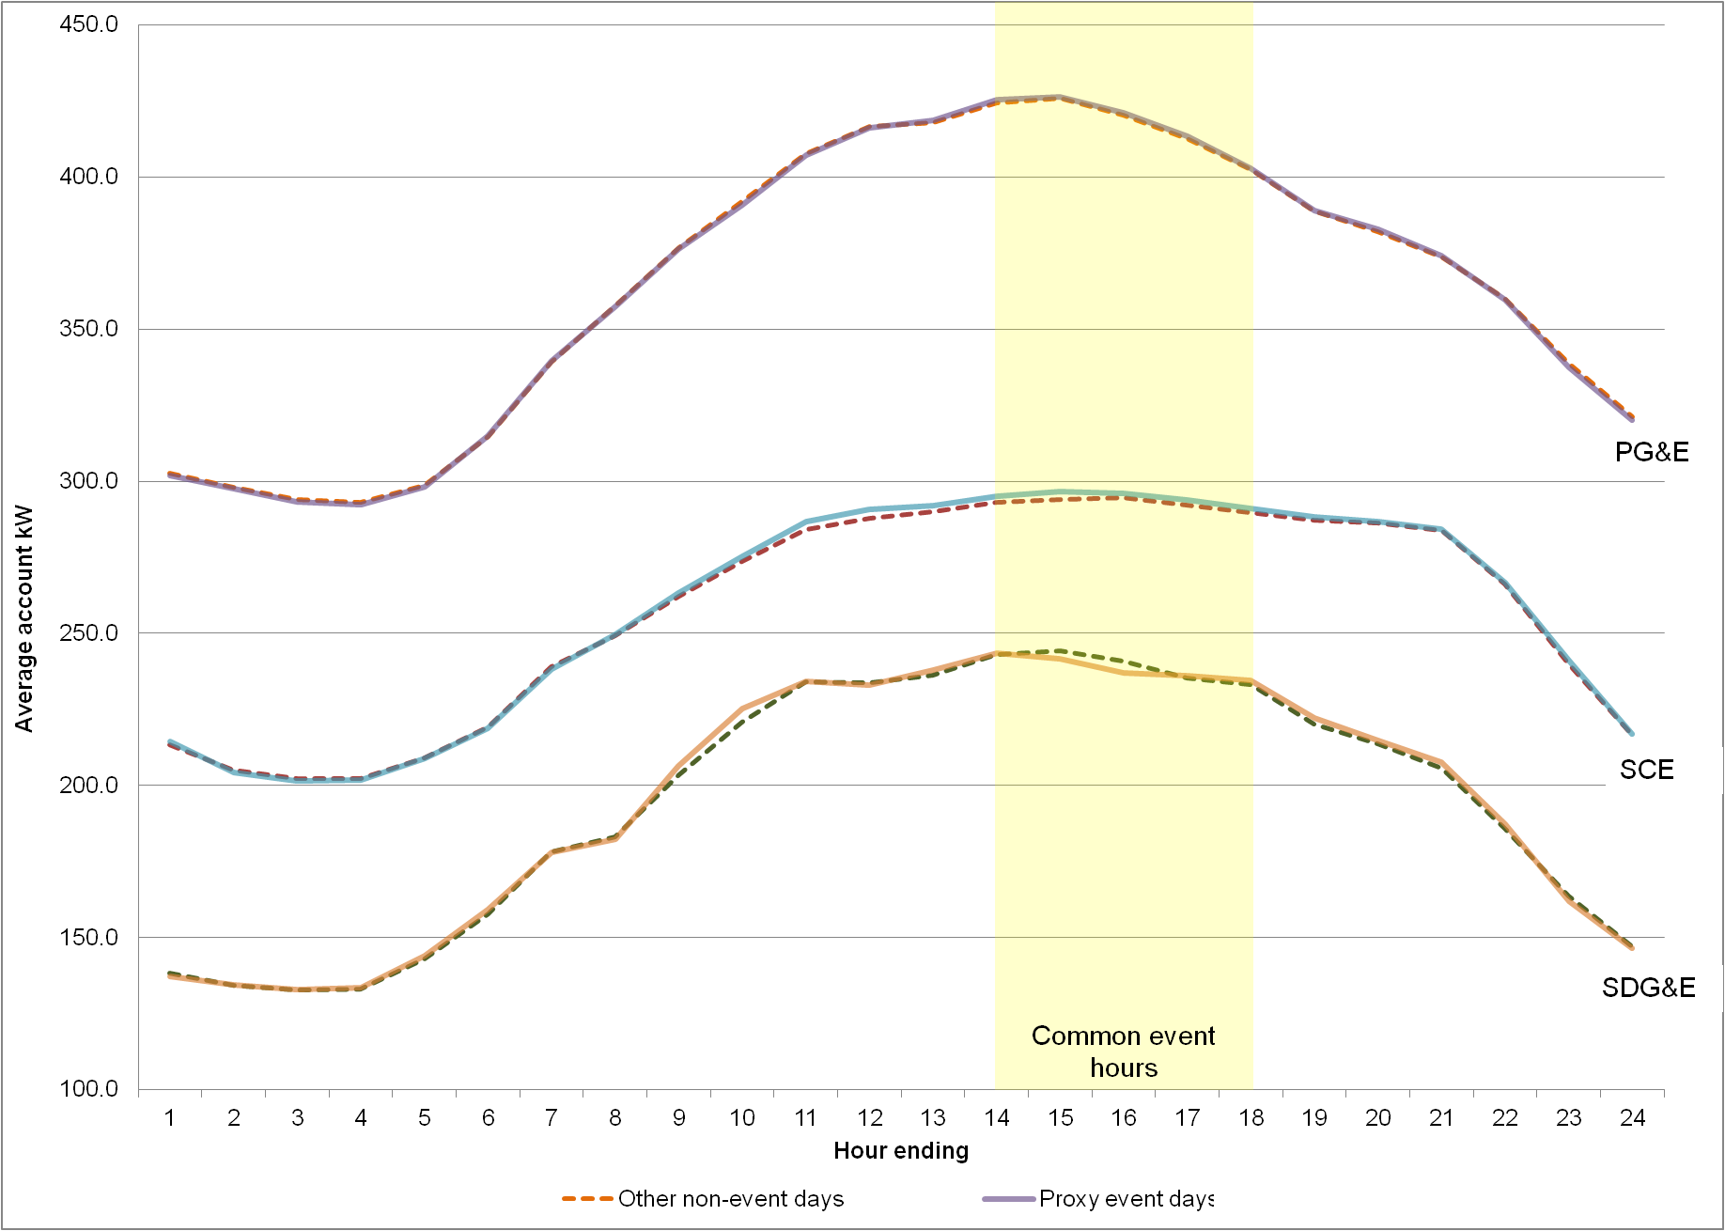

1. Enrollments and Nominations

The findings in this report center on the data associated with customers nominated for load reductions as part of CBP, AMP, and DRRC. However, the number of nominated customers at any given time will not necessarily match the number of customers enrolled in a particular program, as listed in the Interruptible Load and Demand Response Programs (ILP) reports filed monthly by each utility. This is because program enrollment alone does not make customers responsible for load reductions. Each aggregator nominates enrolled customers to be responsible for load reductions if necessary in the coming month; an aggregator may choose only to nominate a subsection of enrollees, or a number of enrolled customers may not be able or willing to accept nomination in the coming month. Enrollment numbers, therefore, are less accurate than nomination numbers when forecasting DR resources from aggregator programs.

Table D-1 below presents the proportion of program enrollees nominated in a given month for each program and utility. These figures represent the average proportions of enrollees nominated in the months May through October for 2010 and 2011.

Table D-1:

Average Percent of Program Enrollees Nominated in a Given Month

|  |  |  |
| --- | --- | --- |
| IOU | Program | Avg. % of Enrollees Nominated |
| PG&E | AMP - DA | 89% |
| AMP - DO | 73% |
| CBP - DA | 87% |
| CBP - DO | 88% |
| SCE | CBP - DA | 99% |
| CBP - DO | 99% |
| DRRC - DA | 75% |
| DRRC - DO | 66% |
| SDG&E | CBP - DA | 69% |
| CBP - DO | 59% |

1. Resource Adequacy Tables

This appendix contains summary tables of ex ante load estimates over the resource adequacy window – 1 PM to 6 PM during summer months – for CBP, AMP, and DRRC. Program resources are presented by utility. The demand reductions are only presented for May to October due to the limited event experience outside of those months. However, several aggregator contracts can be called year round.

Note that the ex ante load estimates for 1-in-2 and 1-in-10 weather years are identical, as load reductions from aggregators are relative to their contract obligation rather than as a function of reference loads, and thus weather. The tables also summarize both portfolio and program specific load impacts, which are identical, since the aggregator programs require firm commitments.

* 1. PG&E

Table E-1:

AMP-DA

|  |  |  |  |  |  |  |  |  |  |  |  |  |
| --- | --- | --- | --- | --- | --- | --- | --- | --- | --- | --- | --- | --- |
|  | **Month and Resource Adequacy Window** | | | | | | | | | | | |
|  | **Jan** | **Feb** | **Mar** | **Apr** | **May** | **Jun** | **Jul** | **Aug** | **Sep** | **Oct** | **Nov** | **Dec** |
| **1 - 6 PM** | | | | | | | | | | | |
| 2012 | - | - | - | - | 44.0 | 44.0 | 44.0 | 44.0 | 44.0 | 44.0 | - | - |
| 2013 | - | - | - | - | 44.0 | 44.0 | 44.0 | 44.0 | 44.0 | 44.0 | - | - |
| 2014 | - | - | - | - | 44.0 | 44.0 | 44.0 | 44.0 | 44.0 | 44.0 | - | - |
| 2015 | - | - | - | - | 44.0 | 44.0 | 44.0 | 44.0 | 44.0 | 44.0 | - | - |
| 2016 | - | - | - | - | 44.0 | 44.0 | 44.0 | 44.0 | 44.0 | 44.0 | - | - |
| 2017 | - | - | - | - | 44.0 | 44.0 | 44.0 | 44.0 | 44.0 | 44.0 | - | - |
| 2018 | - | - | - | - | 44.0 | 44.0 | 44.0 | 44.0 | 44.0 | 44.0 | - | - |
| 2019 | - | - | - | - | 44.0 | 44.0 | 44.0 | 44.0 | 44.0 | 44.0 | - | - |
| 2020 | - | - | - | - | 44.0 | 44.0 | 44.0 | 44.0 | 44.0 | 44.0 | - | - |
| 2021 | - | - | - | - | 44.0 | 44.0 | 44.0 | 44.0 | 44.0 | 44.0 | - | - |
| 2022 | - | - | - | - | 44.0 | 44.0 | 44.0 | 44.0 | 44.0 | 44.0 | - | - |

*Impacts are the same for 1-in-10 and 1-in-2 weather years. Program specific and portfolio impacts are identical.

Table E-2:

AMP-DO

|  |  |  |  |  |  |  |  |  |  |  |  |  |
| --- | --- | --- | --- | --- | --- | --- | --- | --- | --- | --- | --- | --- |
|  | **Month and Resource Adequacy Window** | | | | | | | | | | | |
|  | **Jan** | **Feb** | **Mar** | **Apr** | **May** | **Jun** | **Jul** | **Aug** | **Sep** | **Oct** | **Nov** | **Dec** |
| **1 - 6 PM** | | | | | | | | | | | |
| 2012 | - | - | - | - | 154.5 | 154.5 | 154.5 | 154.5 | 154.5 | 154.5 | - | - |
| 2013 | - | - | - | - | 154.5 | 154.5 | 154.5 | 154.5 | 154.5 | 154.5 | - | - |
| 2014 | - | - | - | - | 154.5 | 154.5 | 154.5 | 154.5 | 154.5 | 154.5 | - | - |
| 2015 | - | - | - | - | 154.5 | 154.5 | 154.5 | 154.5 | 154.5 | 154.5 | - | - |
| 2016 | - | - | - | - | 154.5 | 154.5 | 154.5 | 154.5 | 154.5 | 154.5 | - | - |
| 2017 | - | - | - | - | 154.5 | 154.5 | 154.5 | 154.5 | 154.5 | 154.5 | - | - |
| 2018 | - | - | - | - | 154.5 | 154.5 | 154.5 | 154.5 | 154.5 | 154.5 | - | - |
| 2019 | - | - | - | - | 154.5 | 154.5 | 154.5 | 154.5 | 154.5 | 154.5 | - | - |
| 2020 | - | - | - | - | 154.5 | 154.5 | 154.5 | 154.5 | 154.5 | 154.5 | - | - |
| 2021 | - | - | - | - | 154.5 | 154.5 | 154.5 | 154.5 | 154.5 | 154.5 | - | - |
| 2022 | - | - | - | - | 154.5 | 154.5 | 154.5 | 154.5 | 154.5 | 154.5 | - | - |

*Impacts are the same for 1-in-10 and 1-in-2 weather years. Program specific and portfolio impacts are identical.

Table E-3:

CBP-DA

|  |  |  |  |  |  |  |  |  |  |  |  |  |
| --- | --- | --- | --- | --- | --- | --- | --- | --- | --- | --- | --- | --- |
|  | **Month and Resource Adequacy Window** | | | | | | | | | | | |
|  | **Jan** | **Feb** | **Mar** | **Apr** | **May** | **Jun** | **Jul** | **Aug** | **Sep** | **Oct** | **Nov** | **Dec** |
| **1 - 6 PM** | | | | | | | | | | | |
| 2012 | - | - | - | - | 12.0 | 12.0 | 12.0 | 12.1 | 12.1 | 12.1 | - | - |
| 2013 | - | - | - | - | 13.9 | 14.1 | 14.2 | 14.1 | 14.1 | 14.1 | - | - |
| 2014 | - | - | - | - | 14.0 | 14.2 | 14.3 | 14.3 | 14.2 | 14.2 | - | - |
| 2015 | - | - | - | - | 14.2 | 14.4 | 14.4 | 14.4 | 14.4 | 14.4 | - | - |
| 2016 | - | - | - | - | 14.4 | 14.6 | 14.6 | 14.6 | 14.6 | 14.6 | - | - |
| 2017 | - | - | - | - | 14.7 | 14.8 | 14.9 | 14.9 | 14.8 | 14.8 | - | - |
| 2018 | - | - | - | - | 15.0 | 15.1 | 15.1 | 15.1 | 15.1 | 15.1 | - | - |
| 2019 | - | - | - | - | 15.3 | 15.4 | 15.4 | 15.4 | 15.4 | 15.4 | - | - |
| 2020 | - | - | - | - | 15.6 | 15.7 | 15.8 | 15.8 | 15.8 | 15.8 | - | - |
| 2021 | - | - | - | - | 15.9 | 16.0 | 16.1 | 16.1 | 16.1 | 16.1 | - | - |
| 2022 | - | - | - | - | 16.3 | 16.4 | 16.5 | 16.5 | 16.5 | 16.5 | - | - |

*Impacts are the same for 1-in-10 and 1-in-2 weather years. Program specific and portfolio impacts are identical.

Table E-4:

CBP-DO

|  |  |  |  |  |  |  |  |  |  |  |  |  |
| --- | --- | --- | --- | --- | --- | --- | --- | --- | --- | --- | --- | --- |
|  | **Month and Resource Adequacy Window** | | | | | | | | | | | |
|  | **Jan** | **Feb** | **Mar** | **Apr** | **May** | **Jun** | **Jul** | **Aug** | **Sep** | **Oct** | **Nov** | **Dec** |
| **1 - 6 PM** | | | | | | | | | | | |
| 2012 | - | - | - | - | 17.4 | 17.4 | 17.5 | 17.5 | 17.5 | 17.6 | - | - |
| 2013 | - | - | - | - | 20.2 | 20.3 | 20.3 | 20.3 | 20.3 | 20.1 | - | - |
| 2014 | - | - | - | - | 20.3 | 20.4 | 20.5 | 20.4 | 20.5 | 20.4 | - | - |
| 2015 | - | - | - | - | 20.6 | 20.7 | 20.7 | 20.7 | 20.7 | 20.6 | - | - |
| 2016 | - | - | - | - | 20.9 | 21.0 | 21.0 | 21.0 | 21.0 | 21.0 | - | - |
| 2017 | - | - | - | - | 21.2 | 21.3 | 21.4 | 21.4 | 21.4 | 21.3 | - | - |
| 2018 | - | - | - | - | 21.6 | 21.7 | 21.8 | 21.8 | 21.8 | 21.8 | - | - |
| 2019 | - | - | - | - | 22.0 | 22.1 | 22.2 | 22.2 | 22.2 | 22.2 | - | - |
| 2020 | - | - | - | - | 22.5 | 22.6 | 22.7 | 22.7 | 22.7 | 22.7 | - | - |
| 2021 | - | - | - | - | 23.0 | 23.1 | 23.2 | 23.2 | 23.2 | 23.2 | - | - |
| 2022 | - | - | - | - | 23.5 | 23.6 | 23.7 | 23.7 | 23.7 | 23.7 | - | - |

*Impacts are the same for 1-in-10 and 1-in-2 weather years. Program specific and portfolio impacts are identical.

* 1. SCE

Table E-5:

DRRC-DA

|  |  |  |  |  |  |  |  |  |  |  |  |  |
| --- | --- | --- | --- | --- | --- | --- | --- | --- | --- | --- | --- | --- |
|  | **Month and Resource Adequacy Window** | | | | | | | | | | | |
|  | **Jan** | **Feb** | **Mar** | **Apr** | **May** | **Jun** | **Jul** | **Aug** | **Sep** | **Oct** | **Nov** | **Dec** |
| **1 - 6 PM** | | | | | | | | | | | |
| 2012 | - | - | - | - | 10.0 | 10.2 | 12.6 | 13.5 | 14.3 | 14.5 | - | - |
| 2013 | - | - | - | - | 10.0 | 10.2 | 12.6 | 13.5 | 14.3 | 14.5 | - | - |
| 2014 | - | - | - | - | 10.0 | 10.2 | 12.6 | 13.5 | 14.3 | 14.5 | - | - |
| 2015 | - | - | - | - | 10.0 | 10.2 | 12.6 | 13.5 | 14.3 | 14.5 | - | - |
| 2016 | - | - | - | - | 10.0 | 10.2 | 12.6 | 13.5 | 14.3 | 14.5 | - | - |
| 2017 | - | - | - | - | 10.0 | 10.2 | 12.6 | 13.5 | 14.3 | 14.5 | - | - |
| 2018 | - | - | - | - | 10.0 | 10.2 | 12.6 | 13.5 | 14.3 | 14.5 | - | - |
| 2019 | - | - | - | - | 10.0 | 10.2 | 12.6 | 13.5 | 14.3 | 14.5 | - | - |
| 2020 | - | - | - | - | 10.0 | 10.2 | 12.6 | 13.5 | 14.3 | 14.5 | - | - |
| 2021 | - | - | - | - | 10.0 | 10.2 | 12.6 | 13.5 | 14.3 | 14.5 | - | - |
| 2022 | - | - | - | - | 10.0 | 10.2 | 12.6 | 13.5 | 14.3 | 14.5 | - | - |

*Impacts are the same for 1-in-10 and 1-in-2 weather years. Program specific and portfolio impacts are identical.

Table E-6:

DRRC-DO

|  |  |  |  |  |  |  |  |  |  |  |  |  |
| --- | --- | --- | --- | --- | --- | --- | --- | --- | --- | --- | --- | --- |
|  | **Month and Resource Adequacy Window** | | | | | | | | | | | |
|  | **Jan** | **Feb** | **Mar** | **Apr** | **May** | **Jun** | **Jul** | **Aug** | **Sep** | **Oct** | **Nov** | **Dec** |
| **1 - 6 PM** | | | | | | | | | | | |
| 2012 | - | - | - | - | 127.9 | 137.4 | 144.2 | 153.5 | 159.0 | 161.1 | - | - |
| 2013 | - | - | - | - | 140.7 | 151.0 | 158.6 | 168.9 | 175.0 | 177.2 | - | - |
| 2014 | - | - | - | - | 154.7 | 166.1 | 174.5 | 185.8 | 192.5 | 194.9 | - | - |
| 2015 | - | - | - | - | 154.7 | 166.1 | 174.5 | 185.8 | 192.5 | 194.9 | - | - |
| 2016 | - | - | - | - | 154.7 | 166.1 | 174.5 | 185.8 | 192.5 | 194.9 | - | - |
| 2017 | - | - | - | - | 154.7 | 166.1 | 174.5 | 185.8 | 192.5 | 194.9 | - | - |
| 2018 | - | - | - | - | 154.7 | 166.1 | 174.5 | 185.8 | 192.5 | 194.9 | - | - |
| 2019 | - | - | - | - | 154.7 | 166.1 | 174.5 | 185.8 | 192.5 | 194.9 | - | - |
| 2020 | - | - | - | - | 154.7 | 166.1 | 174.5 | 185.8 | 192.5 | 194.9 | - | - |
| 2021 | - | - | - | - | 154.7 | 166.1 | 174.5 | 185.8 | 192.5 | 194.9 | - | - |
| 2022 | - | - | - | - | 154.7 | 166.1 | 174.5 | 185.8 | 192.5 | 194.9 | - | - |

*Impacts are the same for 1-in-10 and 1-in-2 weather years. Program specific and portfolio impacts are identical.

Table E-7:

CBP-DA

|  |  |  |  |  |  |  |  |  |  |  |  |  |
| --- | --- | --- | --- | --- | --- | --- | --- | --- | --- | --- | --- | --- |
|  | **Month and Resource Adequacy Window** | | | | | | | | | | | |
|  | **Jan** | **Feb** | **Mar** | **Apr** | **May** | **Jun** | **Jul** | **Aug** | **Sep** | **Oct** | **Nov** | **Dec** |
| **1 - 6 PM** | | | | | | | | | | | |
| 2012 | - | - | - | - | 5.4 | 5.4 | 5.4 | 5.4 | 5.4 | 5.4 | - | - |
| 2013 | - | - | - | - | 5.7 | 5.7 | 5.7 | 5.7 | 5.7 | 5.7 | - | - |
| 2014 | - | - | - | - | 5.7 | 5.7 | 5.7 | 5.7 | 5.7 | 5.7 | - | - |
| 2015 | - | - | - | - | 5.7 | 5.7 | 5.7 | 5.7 | 5.7 | 5.7 | - | - |
| 2016 | - | - | - | - | 5.7 | 5.7 | 5.7 | 5.7 | 5.7 | 5.7 | - | - |
| 2017 | - | - | - | - | 5.7 | 5.7 | 5.7 | 5.7 | 5.7 | 5.7 | - | - |
| 2018 | - | - | - | - | 5.7 | 5.7 | 5.7 | 5.7 | 5.7 | 5.7 | - | - |
| 2019 | - | - | - | - | 5.7 | 5.7 | 5.7 | 5.7 | 5.7 | 5.7 | - | - |
| 2020 | - | - | - | - | 5.7 | 5.7 | 5.7 | 5.7 | 5.7 | 5.7 | - | - |
| 2021 | - | - | - | - | 5.7 | 5.7 | 5.7 | 5.7 | 5.7 | 5.7 | - | - |
| 2022 | - | - | - | - | 5.7 | 5.7 | 5.7 | 5.7 | 5.7 | 5.7 | - | - |

*Impacts are the same for 1-in-10 and 1-in-2 weather years. Program specific and portfolio impacts are identical.

Table E-7:

CBP-DO

|  |  |  |  |  |  |  |  |  |  |  |  |  |
| --- | --- | --- | --- | --- | --- | --- | --- | --- | --- | --- | --- | --- |
|  | **Month and Resource Adequacy Window** | | | | | | | | | | | |
|  | **Jan** | **Feb** | **Mar** | **Apr** | **May** | **Jun** | **Jul** | **Aug** | **Sep** | **Oct** | **Nov** | **Dec** |
| **1 - 6 PM** | | | | | | | | | | | |
| 2012 | - | - | - | - | 20.9 | 20.9 | 20.9 | 20.9 | 20.9 | 20.9 | - | - |
| 2013 | - | - | - | - | 22.1 | 22.1 | 22.1 | 22.1 | 22.1 | 22.1 | - | - |
| 2014 | - | - | - | - | 22.1 | 22.1 | 22.1 | 22.1 | 22.1 | 22.1 | - | - |
| 2015 | - | - | - | - | 22.1 | 22.1 | 22.1 | 22.1 | 22.1 | 22.1 | - | - |
| 2016 | - | - | - | - | 22.1 | 22.1 | 22.1 | 22.1 | 22.1 | 22.1 | - | - |
| 2017 | - | - | - | - | 22.1 | 22.1 | 22.1 | 22.1 | 22.1 | 22.1 | - | - |
| 2018 | - | - | - | - | 22.1 | 22.1 | 22.1 | 22.1 | 22.1 | 22.1 | - | - |
| 2019 | - | - | - | - | 22.1 | 22.1 | 22.1 | 22.1 | 22.1 | 22.1 | - | - |
| 2020 | - | - | - | - | 22.1 | 22.1 | 22.1 | 22.1 | 22.1 | 22.1 | - | - |
| 2021 | - | - | - | - | 22.1 | 22.1 | 22.1 | 22.1 | 22.1 | 22.1 | - | - |
| 2022 | - | - | - | - | 22.1 | 22.1 | 22.1 | 22.1 | 22.1 | 22.1 | - | - |

*Impacts are the same for 1-in-10 and 1-in-2 weather years. Program specific and portfolio impacts are identical.

* 1. SDG&E

Table E-8:

CBP-DA

|  |  |  |  |  |  |  |  |  |  |  |  |  |
| --- | --- | --- | --- | --- | --- | --- | --- | --- | --- | --- | --- | --- |
|  | **Month and Resource Adequacy Window** | | | | | | | | | | | |
|  | **Jan** | **Feb** | **Mar** | **Apr** | **May** | **Jun** | **Jul** | **Aug** | **Sep** | **Oct** | **Nov** | **Dec** |
| **1 - 6 PM** | | | | | | | | | | | |
| 2012 | - | - | - | - | 12.5 | 12.5 | 12.7 | 12.7 | 13.0 | 13.0 | - | - |
| 2013 | - | - | - | - | 13.2 | 13.5 | 13.5 | 13.5 | 13.5 | 13.7 | - | - |
| 2014 | - | - | - | - | 13.9 | 13.9 | 14.2 | 14.2 | 14.2 | 14.2 | - | - |
| 2015 | - | - | - | - | 13.9 | 13.9 | 14.2 | 14.2 | 14.2 | 14.2 | - | - |
| 2016 | - | - | - | - | 13.9 | 13.9 | 14.2 | 14.2 | 14.2 | 14.2 | - | - |
| 2017 | - | - | - | - | 13.9 | 13.9 | 14.2 | 14.2 | 14.2 | 14.2 | - | - |
| 2018 | - | - | - | - | 13.9 | 13.9 | 14.2 | 14.2 | 14.2 | 14.2 | - | - |
| 2019 | - | - | - | - | 13.9 | 13.9 | 14.2 | 14.2 | 14.2 | 14.2 | - | - |
| 2020 | - | - | - | - | 13.9 | 13.9 | 14.2 | 14.2 | 14.2 | 14.2 | - | - |
| 2021 | - | - | - | - | 13.9 | 13.9 | 14.2 | 14.2 | 14.2 | 14.2 | - | - |
| 2022 | - | - | - | - | 13.9 | 13.9 | 14.2 | 14.2 | 14.2 | 14.2 | - | - |

*Impacts are the same for 1-in-10 and 1-in-2 weather years. Program specific and portfolio impacts are identical.

Table E-8:

CBP-DO

|  |  |  |  |  |  |  |  |  |  |  |  |  |
| --- | --- | --- | --- | --- | --- | --- | --- | --- | --- | --- | --- | --- |
|  | **Month and Resource Adequacy Window** | | | | | | | | | | | |
|  | **Jan** | **Feb** | **Mar** | **Apr** | **May** | **Jun** | **Jul** | **Aug** | **Sep** | **Oct** | **Nov** | **Dec** |
| **1 - 6 PM** | | | | | | | | | | | |
| 2012 | - | - | - | - | 12.0 | 12.0 | 12.2 | 12.3 | 12.3 | 12.4 | - | - |
| 2013 | - | - | - | - | 12.8 | 12.9 | 12.9 | 12.9 | 13.0 | 13.1 | - | - |
| 2014 | - | - | - | - | 13.5 | 13.5 | 13.6 | 13.6 | 13.7 | 13.7 | - | - |
| 2015 | - | - | - | - | 13.5 | 13.5 | 13.6 | 13.6 | 13.7 | 13.7 | - | - |
| 2016 | - | - | - | - | 13.5 | 13.5 | 13.6 | 13.6 | 13.7 | 13.7 | - | - |
| 2017 | - | - | - | - | 13.5 | 13.5 | 13.6 | 13.6 | 13.7 | 13.7 | - | - |
| 2018 | - | - | - | - | 13.5 | 13.5 | 13.6 | 13.6 | 13.7 | 13.7 | - | - |
| 2019 | - | - | - | - | 13.5 | 13.5 | 13.6 | 13.6 | 13.7 | 13.7 | - | - |
| 2020 | - | - | - | - | 13.5 | 13.5 | 13.6 | 13.6 | 13.7 | 13.7 | - | - |
| 2021 | - | - | - | - | 13.5 | 13.5 | 13.6 | 13.6 | 13.7 | 13.7 | - | - |
| 2022 | - | - | - | - | 13.5 | 13.5 | 13.6 | 13.6 | 13.7 | 13.7 | - | - |

*Impacts are the same for 1-in-10 and 1-in-2 weather years. Program specific and portfolio impacts are identical.

1. These contracts are negotiated individually between aggregators and utilities and typically include penalties for delays in the schedule for building the DR power plants.
2. Based on PG&E, SCE and SDG&E 2008 to 2011 Monthly Reports On Interruptible Load and Demand Response Programs.
3. The number of accounts nominated for the program does not necessarily match the number of accounts called for specific events or for the average event.  The number of participants in events differs because 1) resources are often times not dispatched in full, 2) nominations vary by month, and 3) accounts may be nominated to different products or switch between CBP and aggregator contracts during the course of the summer. 
4. See Volume 2 for a detailed discussion of baseline methods.
5. The number of accounts nominated for the program does not necessarily match the number of accounts called for specific events or for the average event.  The number of participants in events differs because 1) resources are often times not dispatched in full, 2) nominations vary by month, and 3) accounts may be nominated to different products or switch between CBP and aggregator contracts during the course of the summer. 
6. Since SCE provided only hourly load data, regression models were applied separately to each set of customer load data at the hourly level, producing 24 models for each customer.
7. More specifically, the false event coefficients should be statistically insignificant for 95% of customers.
8. In addition, 95% of individual results should be statistically insignificant. It is possible for the average value of the false event coefficients to be near zero, indicating no bias in the program level results, but for more than 5% of the individual results to be significant. This typically indicates bias for individual customer segments that offset each other in the aggregate.
9. Ex ante estimates are based on representative weather days; since we do not have customer energy consumption preceding these representative weather days, it is not feasible to include lagged power consumption variables in the ex ante model. However, we did include lagged weather variables (*cdh24hr*) from the ex post model in the ex ante model since we have this data for representative weather days. Finally, we specified that all ex ante representative weather days occurred mid-week, thereby fixing the value of the *daytype* variable.
10. It is possible that customers who otherwise would not enroll might do so because of the option of automating load reductions. However, this cannot be assessed quantitatively given the data available and lack of randomized experiment.
11. CBP resources were dispatched an additional three times in October 2011; however, these events are not considered part of the 2011 evaluation year and have been excluded from the analysis.
12. It is possible that customers who otherwise would not enroll might do so because of the option of automating load reductions. However, this cannot be assessed quantitatively given the data available and lack of randomized experiment.
13. It is possible that customers who otherwise would not enroll might do so because of the option of automating load reductions. However, this cannot be assessed quantitatively given the data available and lack of randomized experiment.
14. There are many metrics for goodness-of-fit such as root mean square error, normalized root mean squared error, chi-squared, etc, all of which typically lead to the same conclusions. MAPE was used because it’s a normalized metric that describes the average magnitude of the errors.