SCHEDULE B - SYSTEM FUNCTIONALITY AND SITE CONFORMANCE REQUIREMENTS
- SDG&E is seeking energy storage in lieu of traditional substation upgrades. Company expects to provide capacity support totaling 3MW/12MWh to one or more 12kV circuits from a single Contractor. The project’s interconnection voltage is 12kV.
- Bidder shall engineer, procure and construct the ESS (e.g., battery, inverter and associated control systems and all required transformers, pads, conduits and cables) to the low side of the step up transformer.
- Bidder shall install communications interface to accommodate monitoring and control of the AES from a remote controller, in addition to local control capabilities.
- The System shall be inclusive of all control algorithms and software programming required to direct and support specified System modes of operation and System internal management (including Battery Management System or equivalent, if applicable). This requirement includes program applications running on the System controller platform, as well as applications residing on remote computer systems necessary for remote monitoring and control. SDG&E will provide remote computer hardware and communication links, but vendor is expected to provide, test and commission software necessary to perform required functions initiated from both remote points as well as on site.
- Geotechnical Studies and Surveying: Bidders are responsible for any geotechnical studies and surveying required for the project.
- Interconnection: Bidders are responsible for procuring and installing all switchgear and step-up transformers to the site-specific interconnection voltage. Bidders shall include these interconnection cost estimates in their bids. SDG&E is responsible for construction and costs associated with interconnecting the project from the high side of the step-up transformer to the grid. SDG&E will develop cost estimates for this interconnection activity, and will include those costs in each offer.
- Permitting: Project permitting responsibilities will be split between the Bidder and SDG&E.
  - SDG&E is responsible for obtaining discretionary and/or major-use environmental permitting, and will develop a permitting plan and cost estimates for these activities. SDG&E is responsible for any compensatory mitigation and mitigation monitoring and compliance costs associated with any environmental permit it obtains.
  - Bidders are responsible for obtaining all other permits (building, transportation, etc.), and must include a permitting plan and cost estimates related to these activities. Bidders are responsible for all costs associated with these ministerial permits, and is responsible for compliance, mitigation measures or other conditions of approval associated with those permits.
- Site conformance
  - The ESS shall be constructed not to exceed a footprint of 4,000 square feet, although smaller footprints are highly encouraged. Exact site dimensions are subject to final civil engineering and environmental review and will be provided at a later date.
  - The ESS project boundaries shall observe at 20’ easement around the existing underground sewer line running parallel to the proposed project site. See attached photo
  - Jersey barriers: the project’s sites northwest and northeast barriers abut and parallel an active thoroughfare. Bidders shall price in Jersey barriers or other solution costs to insulate the project from vehicles.

Photos of Proposed Project Area:
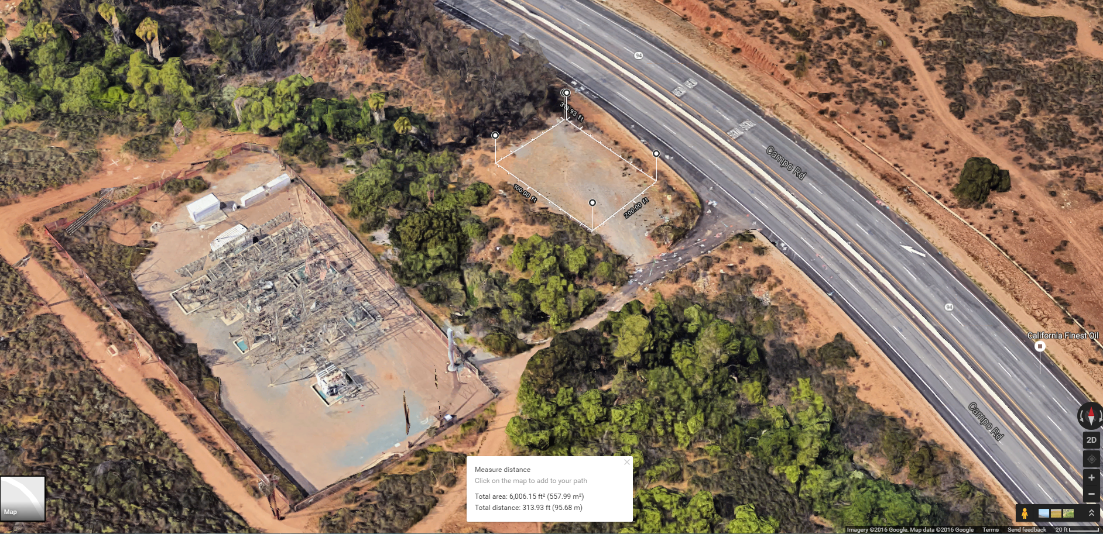
Proposed project site (red rectangle). Black line represents existing underground sewer line. Project boundaries must observe a 20’ easement around the sewer line
